NAME……………………….……………………………………CLASS……….ADM:..................
DATE…………………………….………………………………. SIGNATURE…………………...

312/1
GEOGRAPHY Paper 2

Time: 2¾ hours

Kenya Certificate of Secondary Education
312/1
GEOGRAPHY Paper 2

INSTRUCTIONS TO CANDIDATES
- This paper has two sections: A and B
- Answer ALL the questions in section A.
- In section B, answer questions 6 and any other TWO questions.
- All the answers must be written on the foolscaps provided after page 4.
- Candidates must answer the questions in English.

FOR EXAMINER’S USE ONLY

Section | Questions | Maximum  Score | Candidate’s  Score
A | 1 - 5 | 25
B | 6 | 25
 |  | 25
 |  | 25
Total Score

This paper consists of 4 printed pages. Candidates should check the question paper to ascertain that all pages are printed as indicated and that no questions/pages are missing.

SECTION A
2. (a) What is management of forests? (2 marks)
(b) State three reasons why agroforestry is encouraged in Kenya. (3 marks)

2. (a) Name two categories of agricultural processing industries in Kenya. (2 marks)
(b) State three similarities between the cottage industry of India and the Jua Kali industry in Kenya. (3 marks)
3. (a) Differentiate between settlement and urbanization. (2 marks)
(b) State four characteristics of central business district of a town. (4 marks)
4. (a) Name two types of environment. (2 marks)
(b) State three consequences of water pollution. (3 marks)
5. The map below shows the Great Lakes and St. Lawrence Seaway. Use it to answer question (a) and (b).
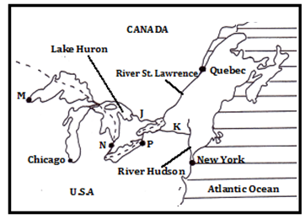
(a) Name the canals marked J and K. (2 marks)
(b) Name the towns marked M and N. (2 marks)

SECTION B
6. Study the table below and use it to answer questions (a) and (b)
Value of leading imports to Kenya from 2015 to 2019 (Ksh million)
MPORT | 2016 | 2017 | 2018 | 2019
Industrial machinery | 253,500 | 238,400 | 252,400 | 257,600
Petroleum products | 183,800 | 234,900 | 295,100 | 307,500
Iron and Steel | 75,500 | 83,600 | 97,700 | 104,100

(a) (i) What is the difference between the value of petroleum products imports between year 2018 and year 2016? (2 marks)
(ii) Calculate the percentage increase between the value of industrial machinery imported between year 2017 and the year 2019. (2 marks)
(b) (i) Apart from comparative bar graphs, give three other statistical methods that can be used to present the data in the table. (3 marks)
(ii) Using a vertical scale of 1cm to represent Ksh 30 Billion, draw a comparative bar graph to present the data in the table. Use the graph paper provided. (9 marks)
(c) State three advantages of using comparative bar graphs to present statistical data. (3 marks)
(d) Explain three reasons for low volume of trade between the countries in Africa. (6 marks)

7. (a) (i) Define the term mining? (2 marks)
(ii) Give four methods of underground mining. (4 marks)
(b) Explain how the following factors influence mining:
(i) Level of technology (4 marks)
(ii) Quality of the ore (2 marks)
(c) Explain four benefits of trona mining at Lake Magadi to Kenya. (8 marks)
(d) State five negative effects of mining on the environment. (5 marks)

8. (a) (i) State three physical factors that favour tea growing in Kericho County. (3 marks
(ii) Describe the stages involved in tea processing at the factory. (7 marks)
(b) Outline three ways in which tea is marketed in Kenya. (3 marks)
(c) Explain three physical problems facing small scale tea farmers in Kenya. (6 marks)
(d) Your Geography class carried out a field study on a tea plantation.
(i) Give three reasons why it is important to prepare a route map of the area. (3 marks)
(ii) State three methods that the class would have used to present data. (3 marks)
9. The map below shows the major fishing grounds of the world. Use it to answer question (a) (i), (ii) and (iii)
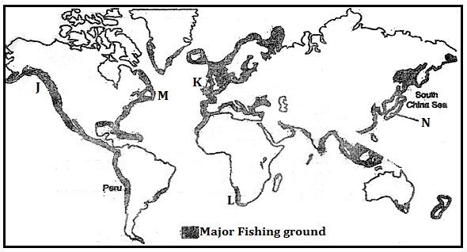
(a) (i) Name the fishing ground marked J,K,L and M (4 marks)
(ii) Name the two ocean currents that converge at region M (2 marks)
(iii) Explain three physical factors that have favoured fishing in country N. (6 marks)
(b) (i) Describe how trawling as a method of fishing is carried out. (5 marks)
(ii) Explain four measures being undertaken in Kenya to reduce overfishing of the natural water fisheries (8 marks)
10. (a) (i) Name three non-renewable sources of energy. (3 marks)
(ii) State four advantages of solar energy. (4 marks)
(b) The diagram below shows the Kenya’s hydroelectric power stations along River Tana.
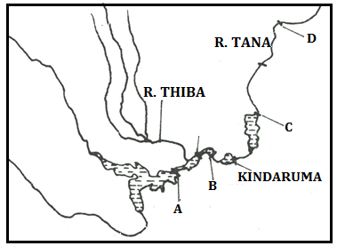
(i) Name the H.E.P stations marked A, B and C. (3 marks)
(ii) The proposed H.E.P dam site marked D. (1 mark)
(iii) Explain four challenges hindering hydroelectric power generation in Kenya (8 marks)
(d) (i) What is an energy crisis. (2 marks)
(ii) Explain the effects of an energy crisis in the following sectors.
- Agriculture (2 marks)
- Industries (2 marks)

