Name:…………………………………………………………………….Class:…………Adm No:……..

AGRICULTURE
MID-TERM EXAM
2ND TERM 2021
FORM 2

INSTRUCTIONS.
Answer all the questions in the spaces provided.
- Define nomadic pastoralism. (1mk)

b) State four disadvantages of carrying out nomadic pastoralism. (2mks)

- List four biotic factors that affect agricultural production. (2mks)

- State two implements used during primary tillage. (2mks)

- Outline four practices that can lead to achievement of minimum tillage. (4mks)

- List four factors that determine the choice of pipe for water conveyance. (2mks)

- State two advantages of plastic pipes. (1mk)

- List four factors that determine the choice of a particular irrigation system. (2mks)

- State two problems associated with farm yard manure. (1mk)

- Give three characteristics of goats that make them perform better in dry parts of the country. (3mks)

- When is opportunity cost equal to zero? (1mk)

- State two effects of applying excess nitrogen to crops. (2mks)

- List four methods of fertilizer application. (2mks)
- A maize farmer has a plot measuring 40m by 60m. Calculate the number of maize plants he will have on his plot if he used a spacing of 75cm x 75cm. (3mks)

- The diagrams below represent two methods used in soil sampling study them carefully and answer the questions that follow.
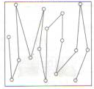
Q
P
- Name methods (2mks)
P
Q
- State two precautions observed when carrying out the above two methods. (2mks)

- The following is a list of plant nutrients copper, calcium, nitrogen, molybdenum, zinc, phosphorous, carbon, sulphur, iron and magnesium which of the above plant nutrients are: (4mks)
- Macro-nutrient

- Micro-nutrients

- Fertilizer elements
- Liming elements

- State two methods of breaking seed dormancy. (2mks)

- Differentiate between oversowing and undersowing. (2mks)

- State three factors to consider in choosing seed rates. (3mks)

- The diagrams labeled A,B,C below illustrate materials and methods used in crop propagation. Study them and use them for to answer questions that follow.
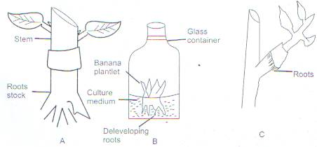
- Identify the methods (3mks)
A
B
C
- State two importance of carrying out method B. (2mks)

- Define crop rotation. (1mk)
b) State four advantages of carrying out crop rotation. (2mks)

c) Outline four factors to consider before designing a crop program. (2mks)

- Differentiate the following terms.
a) Inter cropping and mixed cropping
b) Thinning and rogueing. (2mks)

c) The diagram below shows a routine management practice carried out in tomato production.
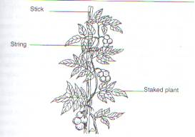

i. Identify the routine management practice. (1mk)

ii. State two importance of carrying out the practice mentioned in c (i) above. (2mks)

