FORM THREE BIOLOGY
MID TERM EXAM
TERM 2,2021
1(a)What is meant by each of the following ecological terms:
(i) Population (1mk)
Population- total number of organisms of a given species occupying an
area at a certain trophic level

(ii) community (1mk)
It is the total number of plants and animals of different species living together in an area.

(iii) Ecosystem (1mk)

b)Name the equipment used to measure the following factors in an ecosystem:
i) light penetration in water. (1mk)
Seechi disc
ii) Wind velocity (1mk)
Anemometer

iii) Atmospheric pressure (1mk)
Barometer
2 (a)A millipede,grasshopper and crayfish all belong to phylum arthropoda.
State Two major characteristics that they have in common. (2mks)
- Segmented bodies
- Jointed appendages
- Exoskeleton
- Body divided into parts
(b)List two characteristics that are used to sub-divide arthropoda into classes. (2mks)
- Number of body parts
- Number of legs
- Number of wings
- Number of antennae
(c) Name the spore bearing structure in the members of division pteridophyta. (1mk)
Sorus
3 The diagram below shows a phenomenon which occurs during cell division.
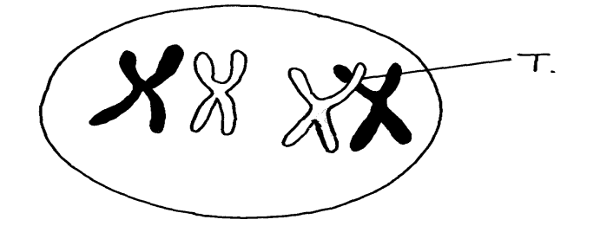

- Name the part labeled T. (1mk)
Chiasmata
- (i) State the biological importance of the part labelled T. (1mk)
Site of exchange of genetic materials
(ii) Identify the type of cell division in which this phenomenon occurs. (1mk)
Meiosis
4. The diagram below represents a human foetus in a uterus

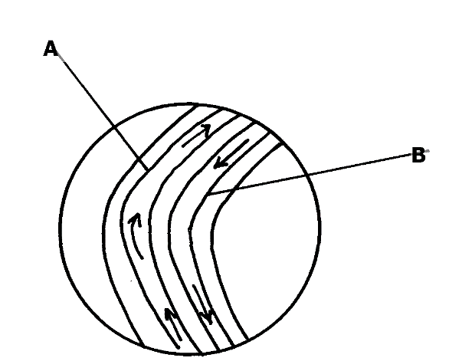
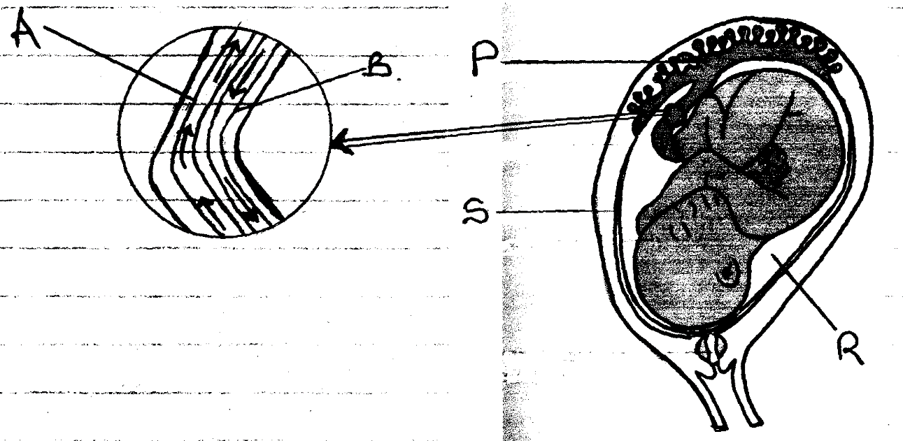
S
PO
BO
RO

(a) Name the part labelled S (1mk)
amniotic membrane/Amnion

(b) (i) Name the blood vessels labelled A and B (1mk)
A………Umblical vein
B.............Umblical artery
(ii) State one difference in composition of blood found in vessels A and B (1mk) Umblical vein – rich in nutrients and oxygen.
Umblical artery – rich in CO₂ and waste like urea.

(c) State the role of the part labelled P (1mk)

Cushions foetus against shock
Supports the foetus
Keeps foetus moist (prevent dehydration

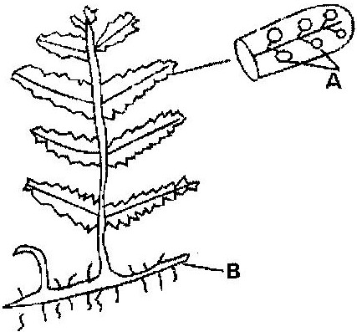
5. The diagram below represents a fern

Name
(a) Parts labeled A and B ( 2 marks)
A ………..Sori
B…………rhizome
(b) The division which the plant belongs ( 1 mark)
Pteridophyta
An organism with an exoskeleton, segmented body, two pairs of legs per segment, a pair of eyes and a pair of short antennae belongs to the phylum (1mk)
Diplopoda

6. Below is a diagram of an organelle that is involved in aerobic respiration.
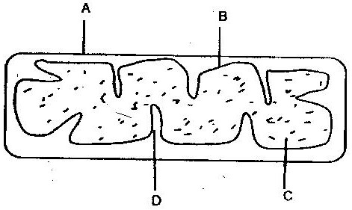

a) Name the organelle (1mk)
Mitochondrion
b) Name the parts labeled A, B, and C. (3mks)
A…….Outer membrane
B…….Inner membrane
C……Matrix/Stroma
c) What is the purpose of the folding labeled D? (1mk)
Increases surface area for attachment of respiratory enzymes
d) Give the chemical compound which is formed in the organelle and
forms the immediate source of energy (1mk)
Adenosinetriphosphate

7. The figure represents a feeding relationship in an ecosystem
Grasshopper
Grass
Guinea fowls
Termites
Gazelles
Leopards
Vulture

- Write down the food chain in which the Guinea Fowls are secondary consumers (1mk)
Grass Grasshopper Guinea fowls

Grass Termites Guinea fowls

(b) What would be the short term effects on the ecosystem if lions invaded the area (1mk)
Lions would complete with leopards
Gazelle number would reduce
Grass would be increased

(c) Name the organism through which energy from the sun enters the food web (1mk)
Grass
8.(a) Name the class in the phylum arthropoda which has the largest number of individuals Insecta ( 1 mark)
(b)give two reasons why the organisms named in the class above has the largest population (2mks) lay many eggs
Inhabit all ecological niches
Wide variety of foods

9. (a) The specific name of Irish potato is solanum Tuberrasum
(i) Identify two errors that have been made when writing the name (2mks)
-Second name should be in small letter.
- The names should be underlined separately
(ii) What is the species name of Irish potato? (1mk)
tuberrasum
- An ecologist came across a plant with the following characteristics, green in colour, non- flowering, compound leaves and sori on the underside of the leaflets. State the probable division of the plant ? ( 1 mark)
Division pteridophyta
10 .The number and distribution of stomata on three different leaves are shown in
the table below
Leaf | Number of stomata
 | Upper epidermis | Lower Epidermis
A  B  C | 300  150  02 | 0  200  13
(a)Suggest the possible habitat of the plants from which the leaves were obtained.( 3mks)
Leaf Habitat
A…………..-Aquatic/Fresh water
B-………….. Forest
C-…………… Arid- Semi Arid
(b) State the modification found in the stomata of leaf C (1mk)
- Sunken stomata,
- Reversed rhythm
- Small stomatal pores

11.The following is a simplified drawing of nitrogen cycle.
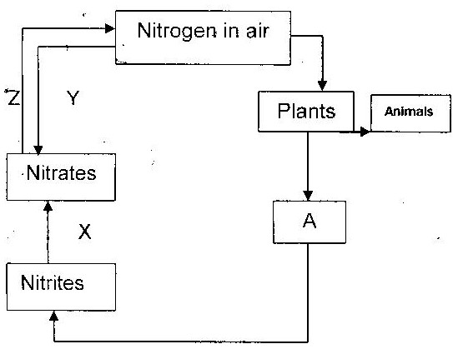

(a) Identify the compound named A ( 0.5 mk)
Ammonia
(b) Name the processes (1.5mks)
X ______nitrification
Y ______nitrogen fixation by ligtning
Z ______Denitrification

12.The diagram below represents a stage during cell division
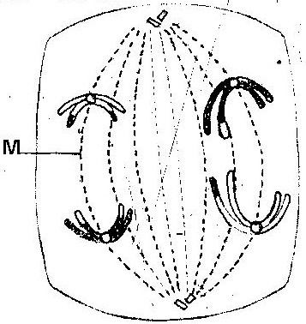

(a) (i) Identify the stage of cell division ( 1 mark)
Anaphase 1
(ii) Give two reasons for your answer (a) (i) above ( 2 marks)
- Homologous chromosomes separate at the equator.
Chromosomes start migrating to opposite poles
Sister chromatids attached at the centromere
(b) Name the structure labeled M ( 1 mark)
Spindle fibres
13. Explain 3 ways through which xerophytes are adapted to their habitat. (3mks)
Deep rooted to absorbs water from lower water table
Needle like leaves to reduce surface area of water loss
Few stomata to reduce stomatal transpiration
Thick succulent stem,leaves,roots for water storage

