NAME_____________________________ADMISSION NO.__________CLASS________

231
BIOLOGY (Theory)
DECEMBER 2021
2$\frac{1}{2}$ Hours
KENYA CERTIFICATE OF SECONDARY EDUCATION
FORM THREE BIOLOGY PAPER
Instructions to Candidates
- Write your Name and admission Number in the Spaces Provided.
- Sign and write date of examination in the spaces provided.
- This paper consists of three sections A, B and C.
- Answer all the questions in Sections A, B and C in the spaces provided.
- You should check the question paper to ascertain that all the pages are printed as indicated and that no questions are missing.
SECTION A
1a.Distinguish between homoiotherms and poikilotherms {2 marks}
Homoitherms-

Poikilotherms-

b) (i) How is energy stored in a cell? {1 mk}

(ii). How is the energy released when the cell needs it? {1mk}

2. Name three kingdoms apart from Plantae and Animalia in order of decreasing complexity
{3 marks}

3. When preparing a temporary slide of black jack stem, Kamau was asked to carry out the following steps. Give a reason why each step was carried out.
a). Use a sharp razor to obtain a thin slice of the stem {1 mk}

b), Place a drop of water on the slice on the microscope slide {1 mk}

c). Add a drop of methylene blue dye on to the specimen on the microscope slide {1 mk}

d) Lower the cover slip gently onto the place over the slice of the stem {1 mk}

4. List down two factors that maintain populations of animals carrying capacity {2 marks}

5. State three ways in which atmospheric nitrogen can be”fixed” into nitrates{3 marks}

6(a).Reproduction is a characteristic of living things. State two importance of it in living things {2 marks}

(b) State two ways in which flowering plants prevent self-pollination {2 marks}

(c) What is the importance of cross pollination? {1 mk}

7. List down four symptoms of diabetes mellitus {4 marks}

8. Why are plants able to accumulate most of their waste products for long {2 marks}

9.List down four roles of liver in homeostasis in the human body {4 marks}

10. (a) Give one physiological difference between a plant cell wall and a cell membrane (1mk)

(b) State two structural differences between a cell wall and a cell membrane (2mks)

11. (a) Give reasons why muscle cells, sperm cells and kidney cells have large numbers of mitochondria. (2mks)

(b) State the role of cristae found in the mitochondria. (1 mk)

- Name the chemical reaction in which glucose is broken down to form pyruvic acid (1mk)

12. a) What is the significance of diffusion to plant pollination (1 mark)

b) Explain why movement of air molecules is not energy driven process (1mark)

13.A student added equal amounts of blood to equal volumes of salt solutions of different concentrations. She observed and counted the red blood cells under the microscope at the beginning of the experiment and at the end of the experiment. The results were as shown below.
Set up | Concentration of salt | Beginning | After 30 min.
A | 0.1% | Normal | Normal but small
B | 0.05% | Normal | Very few but large
Account for the results in set up.
(i) Set up A (2mk)

(ii) Set up B (2mk)

14.An experiment was set up as show below.
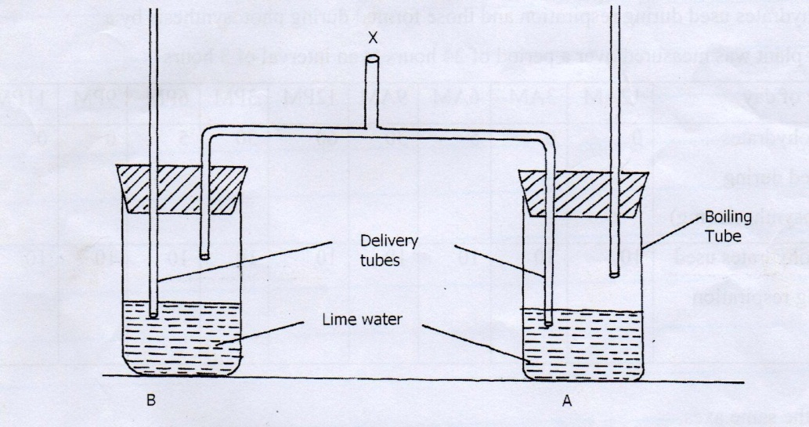
- A student blew air in and out through point X. Using arrows indicate how air gets in and out of the set up [2mks]
(b) [i] In which of the tube would lime water turn milky first. [1mk]

ii] Give a reason. [1mk]

15.Photosynthesis is an enzyme controlled process which occurs within the chloroplasts in plant cells. Where in the chloroplast;
i)Is chlorophyll located? (1mk)

ii)are enzymes located? (1mk)

iii)in what form are carbohydrates transported in the phloem? (1mk)

16.study the photographs below and answer the questions that follow.
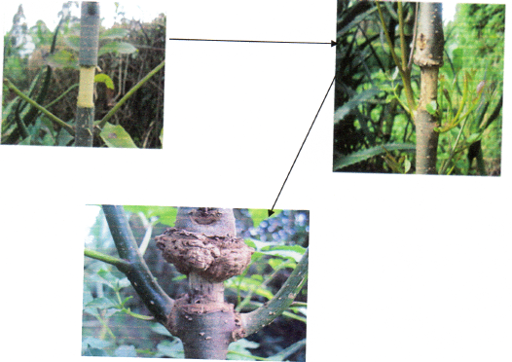

i) Name the process being investigated. (1 mark)

ii) Name the plant tissue involved in the physiological process illustrated above. (1 mark)

iii) Name the physiological process involved in the process illustrated above .(1 mark)

iv) list one adaptation of the tissue named in (ii) above (1 mark)

SECTION B
17. You are provided with photographs of plants labeled E, F, G, H, I, J and K
Use them to answer question that follows.

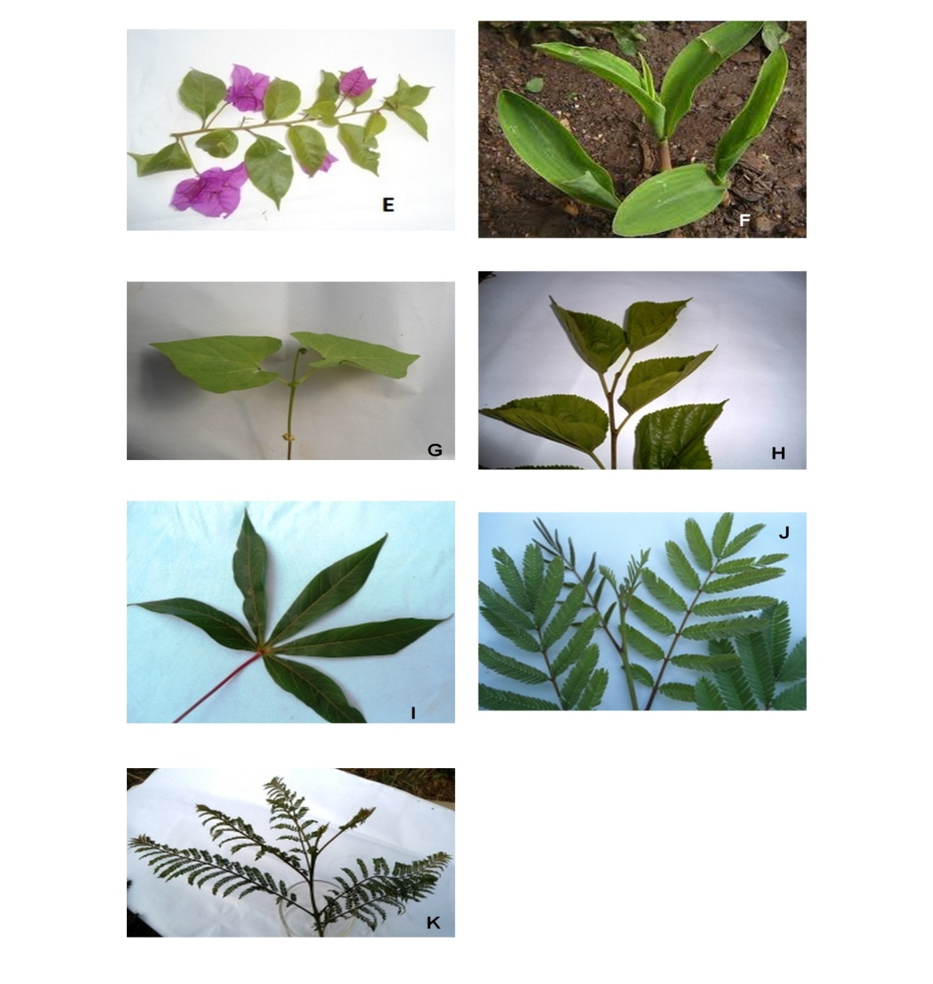
(i). Complete the dichotomous key below using observable features in the photograph given. (4mks)
1(a] simple leaf………………………………………………………………..go to 2
(b) Compound leaf………………………………………………………….. go to 5
2(a) Leaf with parallel veins……………………………………………… Poaceae
(b) ………………………………………………………................................... go to 3
3[a] leaf notched at the base ……………………………………….………. Phaseolus
b] Leaf not notched at the base………………………………………..…… go to 4
4 Leaf with smooth margin……………………………………………. Nyctaginaceae
(b) ________________________................................................................ Rosaceae
5(a) Leaf palmate………………………………..……………………….. Euphorbiaceae
(b)___________________________ ……………………………………..…….. go to 6
6(a)___________________________ …………………………………….……… Fabaceae
(b) Leaflets rounded at the …………………………………………… Bignoniaceae

(ii) Use the completed dichotomous key to identify the plant (7 mks)
Specimen Steps Followed Identify
E ……………………………………….. ……………………………………..…………
F ……………..……………………….. ………………………………………………
G …………………………………….. ……………………………………………

18. Below are the only types of human teeth found in an individual. Use them to answer the questions
that follow
A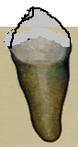 B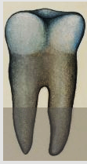 C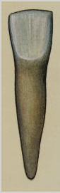
a) Write the order in which the teeth appear from front to back. 1mk

b) What is the role of teeth in human digestion? 2mks

c) Are the teeth above from a nursery pupil or a secondary school student? 1mk

d) The pancreas of a patient was surgically removed. What was the effect on
i) Food digestion? 2mks

ii) Blood sugar regulation? 2mks

19. a) Name the essential parts of a flower. (2mks)
.

b)i)At what stage of mitosis do chromosomes replicate to form daughter chromatids (1mark)

ii)State three differences between mitosis and meiosis (3marks)
Mitosis | Meiosis

c) . How are female parts of wind pollinated flowers adapted to perform their function? (2marks)

20. Describe how xerophytic plants are structurally adapted to their habitat. (20marks)

