NAME:………………………………………………………….CLASS:……….ADM NO:…….

FORM THREE BIOLOGY
MID TERM EXAM
TERM 2,2021

INSTRUCTIONS .
Answer all the questions in the spaces provided.

1(a)What is meant by each of the following ecological terms:
(i) Population (1mk)

(ii) community (1mk)

(iii) Ecosystem (1mk)

b)Name the equipment used to measure the following factors in an ecosystem:
i) light penetration in water. (1mk)

ii) Wind velocity (1mk)

iii) Atmospheric pressure (1mk)

2(a)Amillipede,grasshopper and crayfish all belong to phylum arthropoda.
State Twomajor characteristics that they have in common. (2mks)

(b)List two characteristics that are used to sub-divide arthropoda into classes. (2mks)

(c) Name the spore bearing structure in the members of division pteridophyta. (1mk)

3The diagram below shows a phenomenon which occurs during cell division.
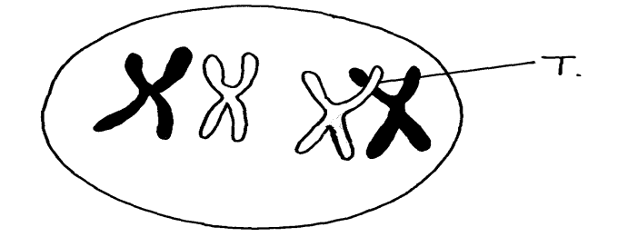

Name the part labeled T. (1mk)

(i) State the biological importance of the part labeled T. (1mk)
(ii) Identify the type of cell division in which this phenomenon occurs. (1mk)

4. The diagram below represents a human foetus in a uterus

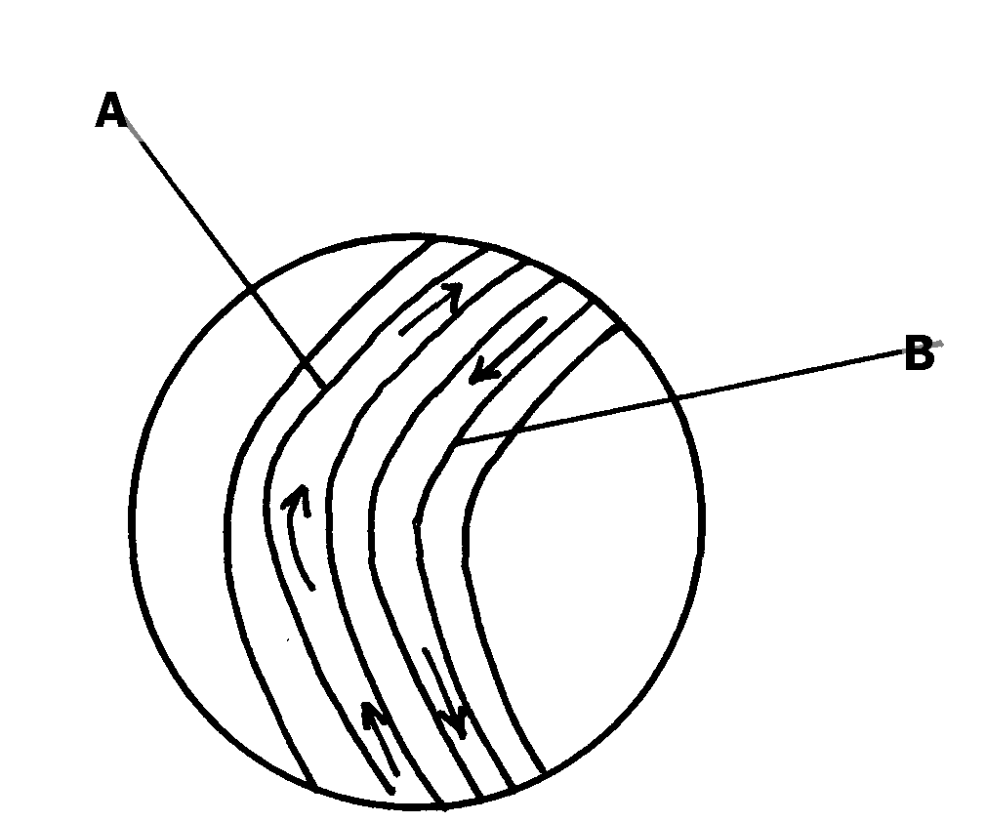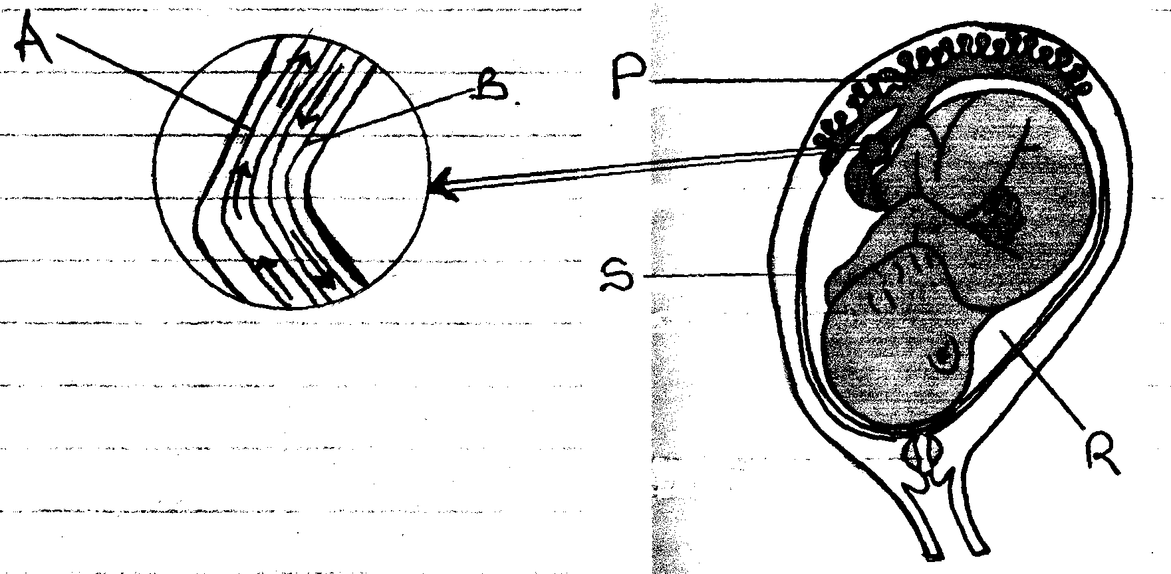
S
PO
BO
RO

(a) Name the part labeled S (1mk)
(b) (i) Name the blood vessels labeled A and B (1mk)
A

B
(ii) State one difference in composition of blood found in vessels A and B (1mk)

(c) State the role of the part labeled P (1mk)

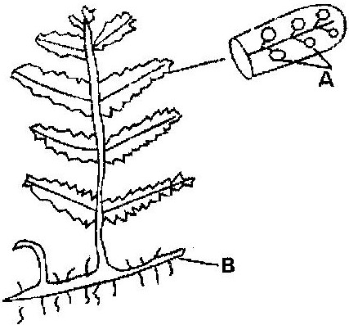
5. The diagram below represents a fern

Name
(a) Parts labeled A and B ( 2mks)
A
B
(b) The division which the plant belongs ( 1mk)

An organism with an exoskeleton, segmented body, two pairs of legs per segment, a pair of eyes and a pair of eyes and a pair of short antennae belongs to the phylum (1mk)

6. Below is a diagram of an organelle that is involved in aerobic respiration.
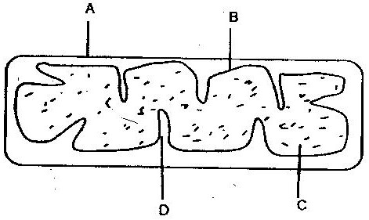

a) Name the organelle (1mk)

b) Name the parts labeled A, B, and C. (3mks)
A

B

C

c) What is the purpose of the folding labeled D? (1mk)

d) Give the chemical compound which is formed in the organelle and
forms the immediate source of energy (1mk)

7. The figure represents a feeding relationship in an ecosystem
Grasshopper
Grass
Guinea fowls
Termites
Gazelles
Leopards
Vulture

Write down the food chain in which the Guinea Fowls are secondary consumers (1mk)

(b) What would be the short term effects on the ecosystem if lions invaded the area (1mk)

(c) Name the organism through which energy from the sun enters the food web (1mk)

8.(a)Name the class in the phylum arthropoda which has the largest number of individuals ( 1mk)

(b) Give two reasons why the organisms named in the class above has the largest population
(2mks)

9.(a) The specific name of Irish potato is solanumTuberrasum
(i) Identify two errors that have been made when writing the name (2mks)

(ii) What is the species name of Irish potato? (1mk)

An ecologist came across a plant with the following characteristics, green in colour, non- flowering, compound leaves and sori on the underside of the leaflets. State the probable division of the plan ( 1mk)
10.The number and distribution of stomata on three different leaves are shown in
the table below
Leaf | Number of stomata
 | Upper epidermis | Lower Epidermis
A  B  C | 300  150  02 | 0  200  13

(a)Suggest the possible habitat of the plants from which the leaves were obtained. ( 3mks)
Leaf Habitat
A ____________________
B ____________________
C ____________________
(b) State the modification found in the stomata of leaf C (1mk)

11.The following is a simplified drawing of nitrogen cycle.
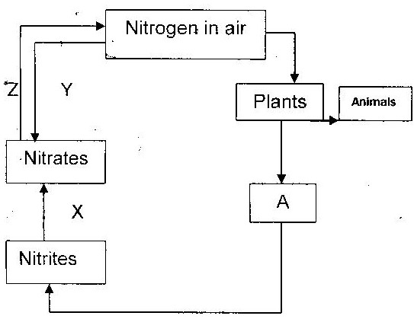

(a) Identify the compound named A ( ½ mk)
(b) Name the processes (1 ½ mks)
X _________________
Y _________________
Z _________________

12.The diagram below represents a stage during cell division
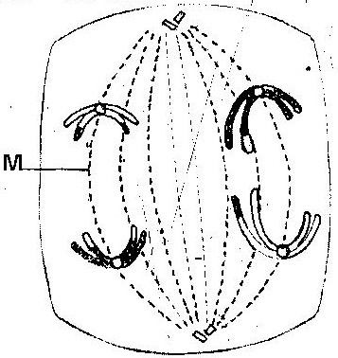

(a) (i) Identify the stage of cell division ( 1mk)

(ii) Give two reasons for your answer (a) (i) above ( 2mks)

(b) Name the structure labeled M ( 1mk)

13. Explain 3 ways through which xerophytes are adapted to their habitat. (3mks)

