**NAME____________________________ADMISSION NO.________CLASS______**

**231/1**

**BIOLOGY (Theory)**

**DECEMBER 2021**

**2 Hours**

**KENYA CERTIFICATE OF SECONDARY EDUCATION**

**FORM FOUR BIOLOGY PAPER 1**

Instructions to Candidates

* Write your Name and admission Number in the Spaces Provided.
* Sign and write date of examination in the spaces provided.
* You should check the question paper to ascertain that all the pages are printed as indicated and that no questions are missing.

***Answer all the questions in the spaces provided.***

1.State two features of leaves which enable a plant to reduce the loss of water. (2mk)

2.a) State the Phylum where all members have open circulatory system. (1mk)

b) Explain two advantages of closed circulatory system over open circulatory system. (2mk)

3. a) Under which of the following magnifications would one see a larger part of the specimen X 40 or X500? Give a reason. (2 Marks)

(b) State how magnification is worked out in a light microscope. (1 Mark)

4.Name two components of blood that are not present in glomerular filtrate. (2mks)

5.The following is an equation representing a type of respiration

C6H12O6 2C3H6O3 + Energy

1. Identify the type of respiration. (1mk)

b) Suggest one industrial application of the process named in (a) above. (1mk)

6a) What is meant by the term binomial nomenclature. (1mk)

b) A dog is called Canis familiairis. Name the taxonomic unit represented by canis.(1mk)

7.Give two functions of the exoskeleton in arthropods. (2mks)

8. The colour of tips of hair in Shepherd dog is controlled by a gene with three alleles B for Black, R for red and C for copper. A cross between pure breeding red and copper hair tips produce offsprings with scarlet hair tips. Crossing pure breeding red and black hair tips yields all red offsprings. A cross between pure breeds of copper and black produce offsprings that are all copper.

a) Comment on the inheritance of the three alleles B, R and C. (2 marks)

b) A dog breeder wishes to know the genotype of a dog with red hair tips. State and explain the cross needed to determine the dog’s genotype. (2 marks)

9. What is the importance of seed dispersal? (3mks)

10. State two adaptations of guard cells to its function. (2Marks)

11. Describe the censor mechanism of seed dispersal. (2mks)

12. Explain “struggle for existence” and “survival of the fittest” as they apply to natural

Selection. (4mks)

Struggle for existence

Survival of the fittest:-

13. (a) Define the following term

Incomplete metamorphosis. (1mk)

(b) State one function of each of the following hormones (2mks)

(i) Juvenile hormone.

(ii) Ecdysone.

14. a) Name the organelle where the cell wall components are synthesized. (1mk)

b) State two roles of cell wall to a plant. (2mks)

15. The diagram below represents a section through the mammalian ear.



a) Name the structures labelled R and T. (2 mark)

b) State how the structures Q and S are adapted to their functions. (2 mark)

16. The diagram below represents some gaseous exchange structures in humans

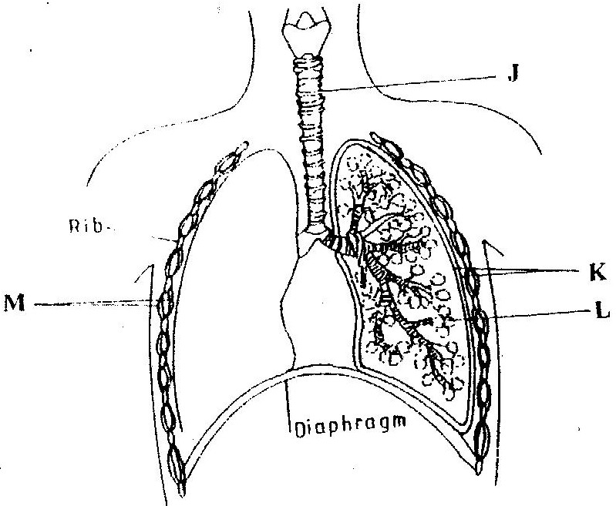

(a) Name the structures labeled K ( 1 marks)

(b) state two way in which the structure labeled J is suited to its function? (2 marks)

(c) Name the process by which inhaled air moves from the structure labeled **L** into

blood capillaries ( 1 mark)

(d) Give the scientific name of the organism that causes tuberculosis in humans

(1 mark)

17. The diagram below represents the anterior view of a certain vertebra.

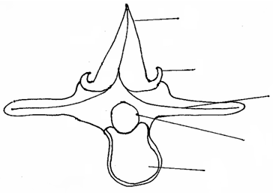

**A**

**B**

**C**

**D**

**E**

(a) With a reason, identify the type of vertebra shown above. (1mks)

b) Name the parts labeled.

(i) A (1mk)

(ii) D (1mk)

c) State the function of part E. (1mk)

18. State THREE adaptations of a leaf to gaseous exchange. (3 marks)

19. What is the importance of the pollen tube in fertilization in plants? (1 marks)

20.The following are events suggested by the theory of natural selection.

1. Reproduction of organism with favorable variation
2. The emergence of new species
3. Variation between individuals
4. A struggle for existence
5. The survival to the fittest
6. Who postulated the theory of natural selection? (1 mark)
7. What is meant by natural selection? (1 mark)
8. Arrange in an order that best illustrate the sequence of events leading to evolution by natural selection (1 mark)

21.The diagram below shows a vertical section through human brain.

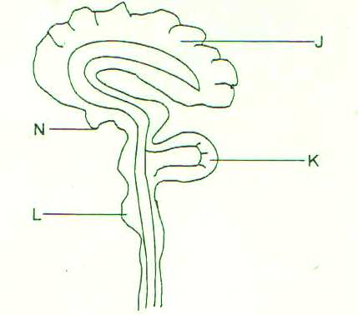

1. Name the part labeled K (1 mark)
2. State why the part labeled J is large and highly folded. (1 mark)
3. Give a letter on the diagram which:
4. Serve as endocrine gland (1 mark)
5. Control breathing, swallowing and blood circulation (1 mark)

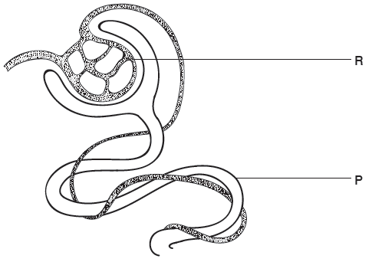**22.** The diagram below shows part of a nephron from the human kidney.

1. (i) Name the structure labelled **R**. (1 mark)

(ii) Name the process carried out at **P**  (1 mark)

1. The hormone ADH affects water reabsorption from the nephron.
2. Which part of the brain releases ADH? (1 mark)

(ii) Name a part of the nephron where water is reabsorbed. (1 mark)

23.The figure below illustrates a food web in a certain ecosystem.

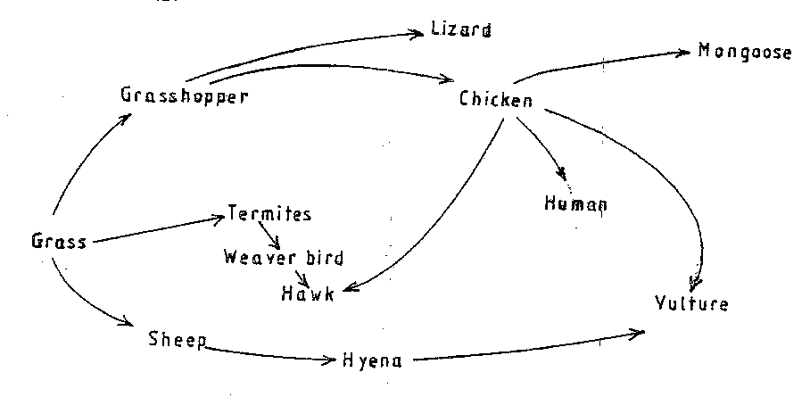

From the food web:

1. Draw the shortest food chain; (1mk)
2. identify the organisms with the highest
3. Number of predators (1mk)

(ii) Biomass (1mk)

24.The diagram below represents a certain organism collected by a student at the sea shore.

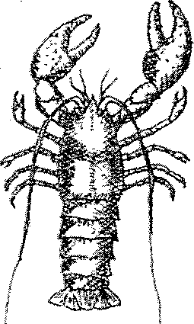

(a) Name the class to which the organism belongs. (1mk)

(b) Give three reasons for your answer in (a) above. (3mks) -

25.In an experiment, disinfection soaked bean seeds were put in a vacuum flask which was then fitted with a thermometer as shown in the diagram below.

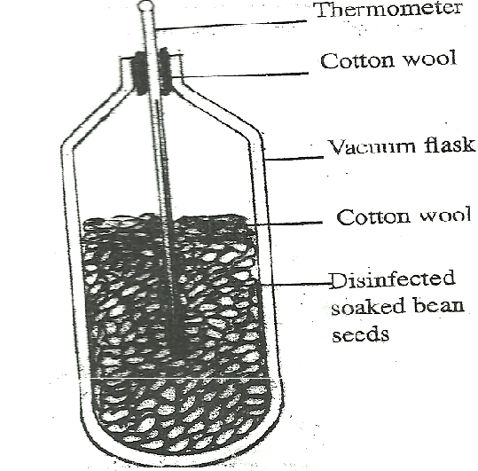

The temperature readings were taken every morning for three consecutive days.

1. Which process was being investigated? (1 mark)
2. i) what were the expected results? (1 mark)

ii) Account for the answer in (b) (i) above? (2 marks)

26. The diagram below shows a specialized plant cell

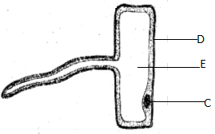

(a) i) name the cell (1mk)

ii) name the cell parts labeled D and E (2mk)

b) state the functions of the part labelled C (1mk)