NAME....................................................................... ADM NO..........
DATE............................. SIGN.............................................
231/3
Biology paper 3
(Practical)
1 ¾ HRS
DEC 2021.

Kenya Certificate of Secondary Education 2021

231/3
Biology paper 3
(Practical)
TIME: 1 ¾ HRS

INSTRUCTIONS TO CANDIDATES
- Write your name and index number in the spaces provided at the top of this page.
- Answer all the questions in the spaces provided.
For examiner’s use only

Question | Maximum score | Candidate’s score
1 | 13
2 | 15
3 | 12
Total score | 40

- You are provided with powder Q and powder R. Measure 10ml of distilled water and put it in a boiling tube. Put powder Q in the boiling tube, shake and make a solution. Label it solution Q. Measure 10ml of distilled water and put it in another boiling tube. Put powder R in the boiling tube, shake and make a solution. Label it solution R.

- Using the reagents provided carryout food tests on the two solutions to determine the food present in the two solutions. ( 8mks)

Solution | Food | Procedure | Observation | Conclusion
Q
R

b (i). Which of the two food substances should be included in a diet to protect a child suffering from kwashiorkor? (1mk)

ii). Give a reason for your answer in b (i) above. (1mk)

C (i) Name two enzymes in the human body which digest the food substances found in the powder. (2mks)

ii) State the organ from which each enzyme you have stated in c (i) acts. (2mks)

- Observe the three photographs carefully and answer the questions that follow
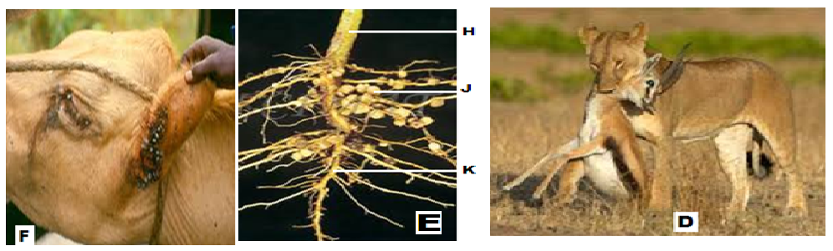
- Identify the structures labeled H, J, and K (3mks)

- Suggest the group of plant from which the root is obtained (1mk)

- Explain the relationship found at point J (4mks)

- Explain how the relationship benefits a farmer. (2mks)

- State one difference between the relationships in photographs D and F. (1mk)

- Construct one food chain from the organisms in photograph D (1mk)

- State two disadvantages of the relationship shown in photograph F (2mks )

- The photographs below show a certain physiological process.

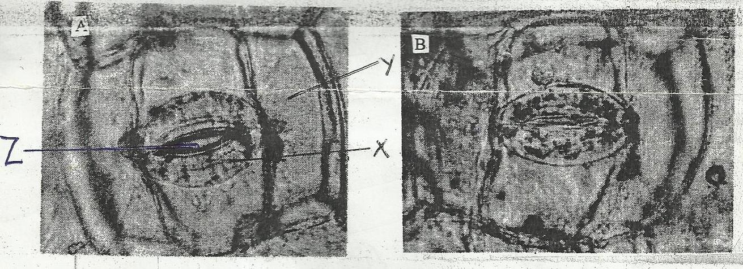
A
B
Z
X
Y

- Name the physiological process shown by the photographs. (1Mark)

- Name cells X and Y. (2Marks)
X
Y
- How is cell X adapted to function? (2Marks)

- i) Name two substances that passes through part Z. (2Marks)

ii) Describe the significance of the process shown by figure A. (2Marks)

- State three theories that explain the appearance of figure A and B. (3Marks)

