NAME: ………………………………………. ADM NO: ………….. CLASS: …...
231 BIOLOGY
FORM FOUR
MID TERM 2
(NOVEMBER, 2021)
TIME: 1³/₄ HOURS

Instructions to candidates.
1. Write your Name, Class and Admission Number in the spaces provided above.
2. This paper consists of 15 questions.
3. All answers should be written in the spaces provided.
- Name the stage in meiosis where chromosome number is reduced by a half? (1 mark)
…………………………………………………………………………………………

- Some herbaceous stems have very little strengthening tissue yet still remain upright. Suggest how they are able to do this. (1 marks )
………………………………………………………………………………………………………………………………………………………………………………………………………………………………………………………………………………………
- In a bony fish, water flows along the gill lamellae in a direction opposite that of the flow of blood. Explain the importance of this. (2 marks )
……………………………………………………………………………………………………………………………………………………………………………………………………………………………………………………………………………………………………………………………………………………………………………………
- (i)What is the basic unit of a DNA molecule (1 mark)
…………………………………………………………………………………………..

(ii)Name the chemical components of the unit named in (1) above (3 marks)
………………………………………………………………………………………………………………………………………………………………………………………………………………………………………………………………………………………
(iii) Name one type of disorder that arises due to chromosomal mutation in human beings (1 mark)
…………………………………………………………………………………………….
- Explain four adaptations of blood capillaries to their function (4 marks)
……………………………………………………………………………………………………………………………………………………………………………………………………………………………………………………………………………………………………………………………………………………………………………………
- State three roles of auxins in plants (3 marks)
………………………………………………………………………………………………………………………………………………………………………………………………………………………………………………………………………………………
- Name the organelles that are involved in the following
- Formation of ATP. (1 mark)
……………………………………………………………………………………………
(b)Fixation of carbon (IV)oxide, to form glucose. (1 mark)
……………………………………………………………………………………………
- The spread of acaricide - resistant ticks in Kenyan farmland is an example of natural selection in action. Explain this phenomenon. (3 marks)
………………………………………………………………………………………………………………………………………………………………………………………………………………………………………………………………………………………………………………………………………………………………………………………………………………………………………………………………………………………………………………………………………………………………………………
- (a) Explain the term basal metabolic rate (1 mark)
…………………………………………………………………………………………………………………………………………………………………………………………
(b) List three differences between aerobic respiration and photosynthesis (3 marks)
………………………………………………………………………………………………………………………………………………………………………………………………………………………………………………………………………………………………………………………………………………………………………………………………………………………………………………………………………………………………………………………………………………………………………………
- What is the significance of diffusion in pollination? (1 mark)
…………………………………………………………………………………………………………………………………………………………………………………………
(b) Is diffusion an energy driven process? Explain. (2 marks)
………………………………………………………………………………………………………………………………………………………………………………………………………………………………………………………………………………………
- Imagine you are sitting outside in the shade of a tree reading a newspaper and you look up to a distance sunlit aero plane flying in the air. Describe the sequence of events in that take place in the eye structures from reading the newspaper to viewing the plane (4 marks)
………………………………………………………………………………………………………………………………………………………………………………………………………………………………………………………………………………………………………………………………………………………………………………………………………………………………………………………………………………………………………………………………………………………………………………
- The figure below shows the changes in blood levels of hormones that take place during the menstrual cycle in human female.
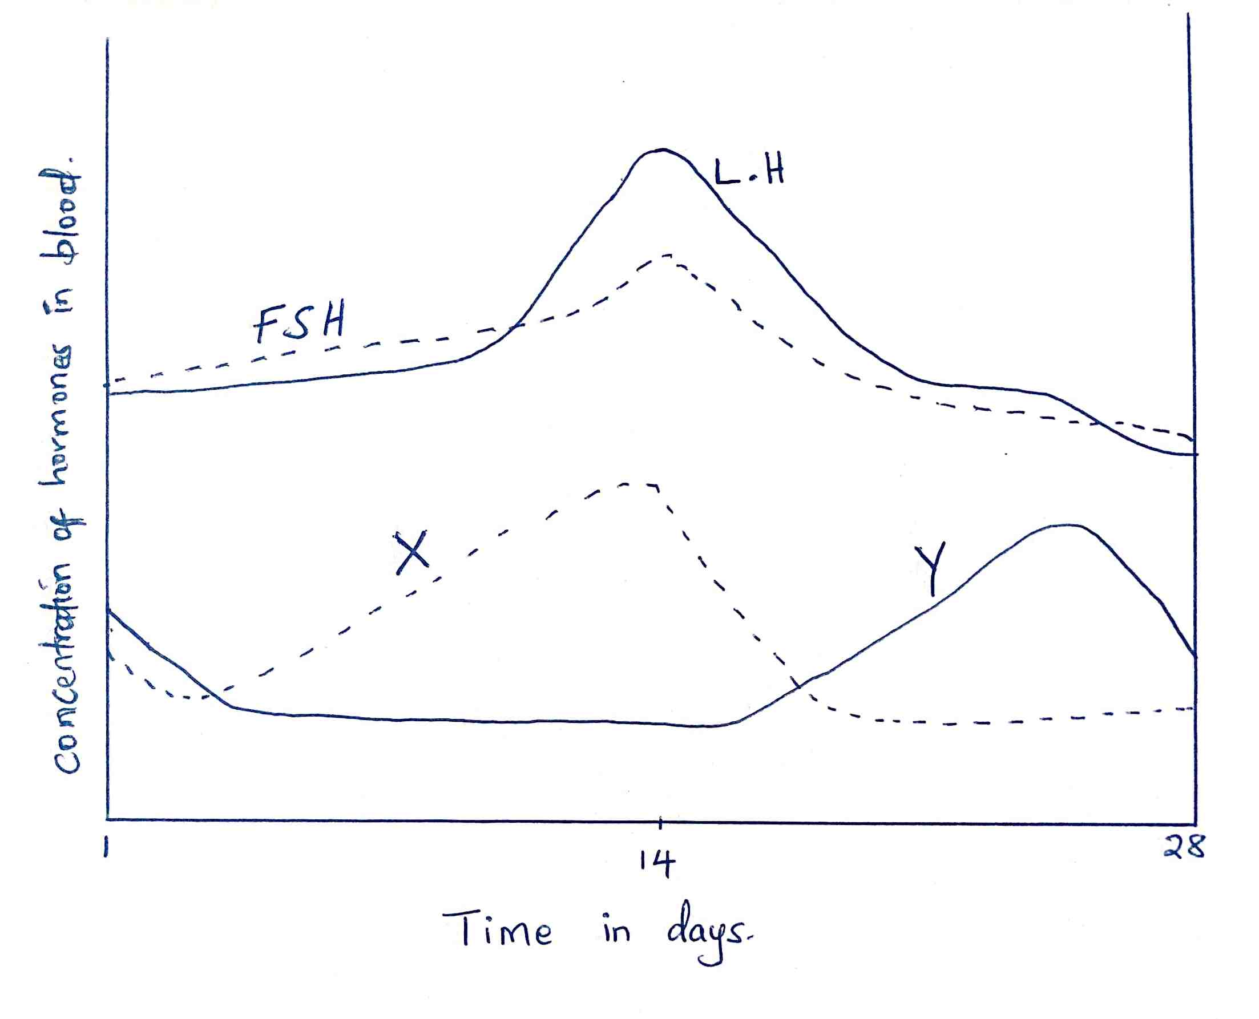

a) Name the hormones whose concentrations are represented by curves X and Y (2 marks)
…………………………………………………………………………………………………………………………………………………………………………………………
b) State two effects of the hormone X during the menstrual cycle (2 marks)
………………………………………………………………………………………………………………………………………………………………………………………………………………………………………………………………………………………
c) Explain the role of FSH in female reproduction (2 marks)
………………………………………………………………………………………………………………………………………………………………………………………………………………………………………………………………………………………
d) What is the role of a high concentration of luteinizing hormone? (1 mark)
…………………………………………………………………………………………………………………………………………………………………………………………
e) State the fertile period during the menstrual cycle (1 mark)
…………………………………………………………………………………………
- Arachnids and crustaceans belong to the same phylum.
a) Name the phylum (1 mark)
…………………………………………………………………………………………
b) State two characteristics that make them to be classified in the phylum you stated in (a) above (2 marks)
………………………………………………………………………………………………………………………………………………………………………………………………………………………………………………………………………………………

c) Give one structural feature that can be used to differentiate crustaceans and arachnids (1 mark)
…………………………………………………………………………………………………………………………………………………………………………………………
- In a certain experiment the field of view of the microscope was determined as 4 mm. If 16 cells were found to span across the diameter of the field of view of the microscope.
a) Calculate the size of one cell in micrometers (2 marks)

b) If 100 epidermal cells were viewed under magnification x 150, how many cells will be observed at magnification x 450 using the same slide? (2 marks)

- a) Guard cells are specialized epidermal cells. State two structural features which suit them to their functions (2 marks)
…………………………………………………………………………………………………………………………………………………………………………………………
b) Apart from gaseous exchange; give one other function of the stomata (1 mark)
…………………………………………………………………………………………………………………………………………………………………………………………

