NAME_____________________________ADMISSION NO.__________CLASS________

231
BIOLOGY (Theory)
DECEMBER 2021
2$\frac{1}{2}$ Hours
KENYA CERTIFICATE OF SECONDARY EDUCATION
FORM ONE BIOLOGY PAPER
Instructions to Candidates
- Write your Name and admission Number in the Spaces Provided.
- Sign and write date of examination in the spaces provided.
- This paper consists of three sections A, B and C.
- Answer all the questions in Sections A, B and C in the spaces provided.
- You should check the question paper to ascertain that all the pages are printed as indicated and that no questions are missing.
SECTION A
1.State the use of the Pooter in the study of living organisms (1 mark)

2.When are two organisms considered to belong to the same species (1 mark)

3. Define the following term
- Entomology [1 mk]

- Genetics [1 mk]

4. The scientific names of three animals leopard, wolf and lion in the family carnivora are; Panthera pardus, Canis lupus and Panthera leo respectively.
a) Why are scientific names given in Latin? (1 mark)

b) What does Canis refer to? (1 mark)

c) Giving a reason, state the organisms that are MOST closely related. (1 mark)

5. State the specific sites in which the following reactions occur: (2mks)
(i) Light stage.

(ii) Dark stage.

6. State two functions of cell membrane (2mks)

7(a) Explain the term cell specialization. (1mk)

(b) State how each of the cells listed below is specialized to carry out its function;
(i) Palisade cell. (1mk)

(ii) A sperm cell. (1mk)

8. Give one structural and one functional difference between smooth endoplasmic reticulum and rough endoplasmic reticulum (2 mks)
RER SER

9.Name the parts of a light microscope which perform each of the following functions.
i. Controlling the amount of light entering the specimen. (lmk)

ii. Magnifies the object. (1mk)

iii. Used for focusing image under low power. (lmk)

10. The diagram below shows a type of epithelial tissue.
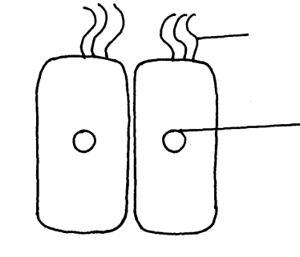
M
N

- Name the parts labelled M and N. (2mks)

b. State function of structures labelled M. (lmk)

c. Name one part of the body where M can be found. (lmk)

11. Give two functions of a cell membrane. (2mks)

12. (a) What is the formula for calculating linear magnification using a light microscope. (1mk)

b) State two functions of centrioles (2mks)

13.(a)Name two raw materials for the dark stage process of photosynthesis. (2 marks)

- The set up shows an experiment to investigate photosynthesis.
Aquatic plants
Gas collected
At the start
After the experiment
Water containing sodium hydrogen carbonate

(i) What gas was collected in the test tube? (1 mark)

(ii)What was the role of sodium hydrogen carbonate in the experiment? (2 marks)

14.a) The diagram below represents a cell organelle.
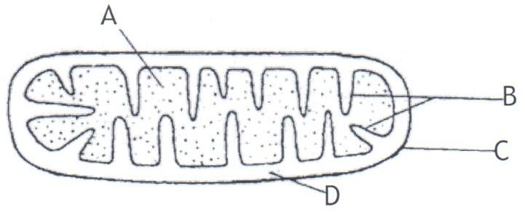
    - Identify the organelle. (1mk)

    - Name the part labelled B. (1mk)

    - State the function of the part labelled A. (1mk)

b) State the functions of the following parts of light microscope
(i)Condenser (1mk)

(ii)Diaphragm (1mk)

15. State the characteristics of living things that is being demonstrated by plants
producing carbon (IV) oxide during daytime (1 mark)

16. Why is it necessary to expand biology to include the study of non-living things? (1 mark)

17.Give one importance of each of the following processes in living organisms. (3 mks)
(a) Locomotion:

(b) Excretion:

(c) Irritability:

18. Give a reason for the following.
- A mature plant cell does not collapse even after losing water. (2mks)

- Explain what would happen to red blood cells if they are placed in a concentrated salt solution.

19.Distinguish between plasmolysis and Haemolysis. (2mks)

20. A student collected a bone from the school garden. The bone was measuring 45 cm. He drew the bone in his book and his diagram was 9 cm long.
Calculate the magnification of his drawing. (2 marks)

21. Name the tissue that carry out the following functions in mammals.
a) Binds and supports various organs in the body. (1 mark)

b) Transport oxygen throughout the body. (1 mark)

c) Contract and relax to bring about movement. (1 mark

SECTION B
22.a) Define the term cell physiology (1mk)

b) Two pieces of leaf petioles were cut as shown in the diagram below, then each piece
placed in solution of different concentration.
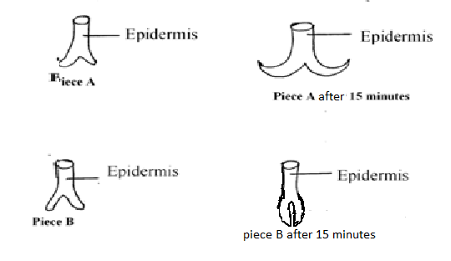
i)What physiological process was being investigated in this experiment? (1mk)

ii)Suggest the type of solution piece B was placed (1mk)

iii) Explain the appearance of piece A after 15 minutes (3mks)

24. (a) Name two types of slides: (2 mks)

- When estimating the size of an onion epidermal cell, a transparent ruler was placed on the field of view of a light microscope and the number of mm marks counted as shown below.
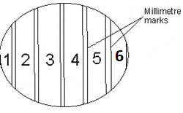
The transparent ruler was then measured and replaced with a section of an onion epidermis on the field of view as shown below.
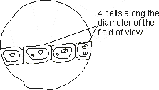
- Using the information provided above, calculate the average size of an onion epidermal cell
(3mks)

(ii) State one limitation of the method above for illustrating cell size (1mk)

(c) Explain why, (i) Adrop of water was placed on the epidermis before a coverslip was placed on top. (1mk)

- A sharp surgical blade was used when cutting the epidermal sections: (1mk)

25.The diagram below shows an experiment to investigate the diffusion of substances through a membrane.
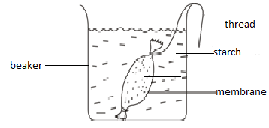
- Account for the observations made at the end of the experiment.4mks)

- State two uses of osmosis in plants.(2mks)

- Name two body regions in man where active transport occurs.(2mks)

26. A health plant was kept in the dark for 48 hrs .Then one of its leaves (x) was enclosed in a glass flask as down below .The whole plant was then returned to light
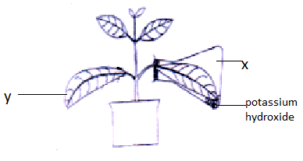
- After 48 hrs the leaves were tested for starch. What observations do you expect?(2marks)

- i) What conclusions can you draw from this observation (1mark )

ii) Explain your conclusion in b (i) above (2marks)

- Why was the plant kept in the dark for 48 hrs (1mark)

SECTION C

27.a) Define the following terms (3mk)
- Photosynthesis

- Chemosynthesis

- Nutrition

b) How is the structure of leaf adapted to the photosynthetic function? (8mks)

c) Describe the light stage of photosynthesis (9mks)

