NAME_____________________________ADMISSION NO.__________CLASS________

231
BIOLOGY (Theory)
DECEMBER 2021
2$\frac{1}{2}$ Hours
KENYA CERTIFICATE OF SECONDARY EDUCATION
FORM TWO BIOLOGY PAPER
Instructions to Candidates
- Write your Name and admission Number in the Spaces Provided.
- Sign and write date of examination in the spaces provided.
- This paper consists of three sections A, B and C.
- Answer all the questions in Sections A, B and C in the spaces provided.
- You should check the question paper to ascertain that all the pages are printed as indicated and that no questions are missing.
SECTION A

- (a) Biologically, what is a cell? (1 mk)

b] Define the following term
- Entomology (1 mk)

- Genetics (1 mk)

- State the characteristics of life that is demonstrated when seeds produce heat during germination (1 mark)

- State three structural differences between arteries and veins. (3 mks)
Arteries | veins

- State two factors that denature enzymes. (2mks)

- Name two major branches of Biology. (2mks)

- (a) Name the organelles that perform each of the following functions in a cell.
- Synthesis of proteins (1mk)

- Transport cell secretions (1mk)

- Destroy old and worn out organelles or even the entire cell. (1mk)

- Package and transport glycoproteins. (1mk)

(b) Using a light microscope, a student counted 55 cells across a field of view whose diameter was 6000μm. Calculate the average length of the cells. Show your working. (3 marks)

(c) Why is it recommended to keep the stage of the microscope dry. (1 mark)

- State the functions of the following apparatus.
    - Bait trap (1mk)

    - Pooter (1mk)

- In which two structural ways in which organelles chloroplast and mitochondria similar.(2mks)

- State two functions of centrioles. (2mks)

- What is the effect of extreme temperatures on proteins? (2mks)

- Study the reaction below and answer the questions that follow.
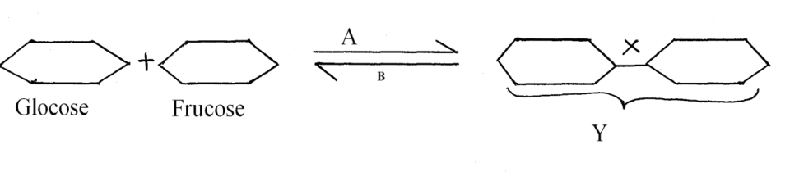
i) State the biological process that takes place represented by A (1mk)

ii) What Biological process is represented by B (1mk)

iii) State the product Y (1mk)

iv) State the bond represented by X (1mk)

- The diagram below show how food bolus moves along the human oesophagus and the intestines.
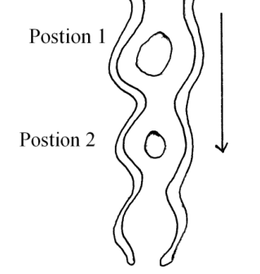
a) Identify the process illustrated above (1mk)

b) Briefly state how the movement of the bolus from position 1 to position 2 is achieved. (2mks)

- State two reasons why the stomach wall cannot be digested by the proteolytic enzymes. (2 marks)

- (a) Define the term balanced diet. (2marks)

(b) State the importance of roughage in a diet. (1mark)

15. State ONE role played by the following substance in digestion.
(i) Hydrochloric acid (2mks)

(ii) Bile salts (2mks)

16. State the role of the following chemicals in a test for non-reducing sugar.
(i) Hydrochloric acid (1mk)

(ii) Sodium hydrogen carbonate (1mk)

17. (a) Why is blood group AB described as universal recipient? (2mks)

(b) Suggest why blood does not clot in blood vessels of a healthy person. (lmk)
- State three ways in which the vessels that link arterioles with venules are suited to carrying out their functions. (3marks)

19. Below are diagrams of specialised cells in mammals
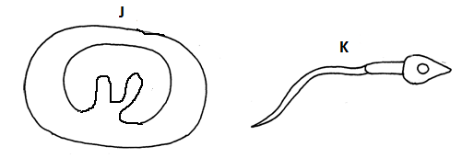
(a) Identify each of the cells (2mks)
(i) J. ...........................................................................................................

(ii) K ...........................................................................................................

(b) Explain how cell specialization has enabled cell K to be effective in its functions (2mks)

20. Some students set-up the experiment shown below to investigate a certain physiological process in plants. After one hour, they placed cobalt chloride paper on the leaf surface.

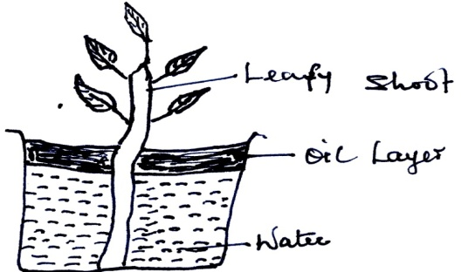

a) What process was being investigated? (1mk)

b) State the role of the oil layer in the experiment (1mk)

c) Suggest one precautionary measure that the students were supposed to observe during the preparation and setting up of the experiment (1mk)

d) Suggest changes observed on the cobalt chloride paper after one hour. (1mk)

21. Explain why water logged soil does not support plant growth. (3mks)

Section B

- The diagram below shows part of plant tissue.
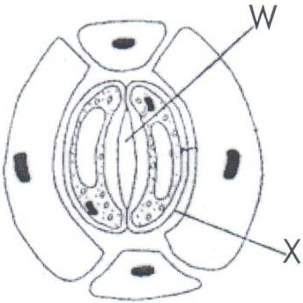

    - Name the cell labelled X and part labelled W. (2mks)

    - State two adaptations of cell labelled X to its functions. (2mks)

- The number of stomata on the lower and upper surface of two leaves form plant X and Y were counted under the field of view of a light microscope. The results were show below.
 | Number of stomata
Leaf | Upper surface | Lower surface
X | 4 | 12
Y | 20 | 23

- Which of the leaves would be expected to have lower rate of transpiration (1mk)

(b) Give a reason for your answer in [a] above (1mk)

- An experiment was set up as show below.
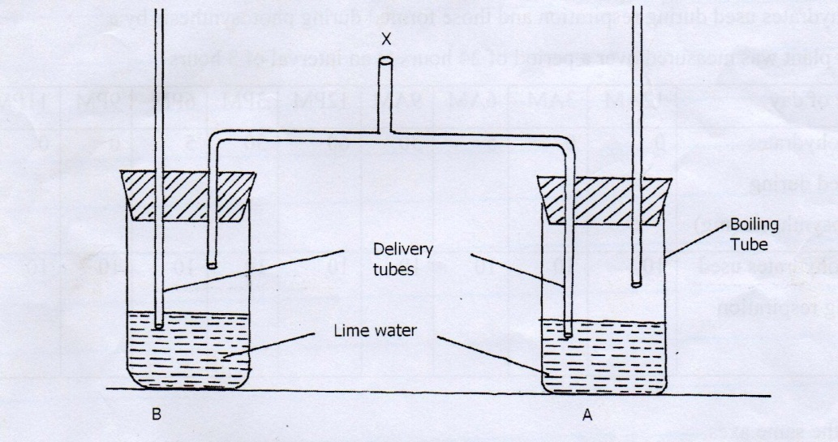
- A student blew air in and out through point X. Using arrows indicate how air gets in and out of the set up (2mks)
(b) (i) In which of the tube would lime water turn milky first. (1mk)

ii) Give a reason. (1mk)

25. (a) Name the type of circulatory system found in members of the class insecta . (1mk)

(b) Name the blood vessels that transport blood from:
(i) Small intestines to the liver (1mk)

(ii) Lungs to the heart (1mk)

(c) The diagram below shows gaseous exchange in tissues
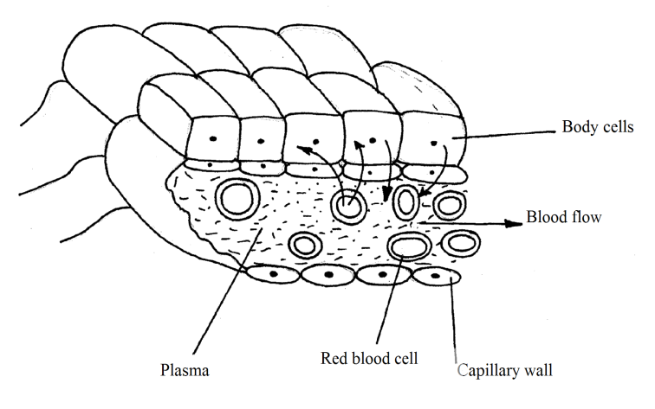
(i) Name the gas that diffuses
(I) To the body cells (1mk)

(II) From the body cells (1mk)

(ii) Which compound dissociates to release the gas named in (a)(i) above (1mk)

(d) What is tissue fluid? (2mks)

- Describe the opening of the stomata using the potassium ion theory (10mks)

- (a) Name the respiratory surface in human beings. (1mk)

- Describe exhalation mechanism in human being. (9mks)

