**MID TERM TWO 2021 EXAM**

**CHEMISTRY FORM THREE.**

**TIME:2 HRS**

**NAME…………………………………… CLASS……….. ADM NO………….**

1. A student separated liquid P (B.P 78°C) and liquid Q (B.P 100°C) wring the apparatus shown below.



(i) Name the apparatus labelled

(a) M (1 mark)

  (b) R (1 mark)

  (ii) State one function of the glass bead in apparatus labelled R (1 mark)

(iii) What is the reading on the thermometer when the first jar drops of the distillate appeared in the beaker.(1 mark)

  (iv) Which of the liquids remains in the flask.(1 mark)

2. Name a method that can be used to extract the following:-

 (i) Common salt from a salt solution.(1 mark)

(ii) Paraffin from crude oil.(1 mark)

3. A compound of carbon, hydrogen and oxygen contain 54.55% carbon, 9.09% and remaining 36.36% oxygen. If its relative molecular mass is 88, determine its molecular formula(C=12.0, H =1.0, O= 16.0) [4mark]

4.Sodium nitrate(V)can also be used to prepare nitric(V)acid. State two reasons why potassium nitrate(V) is preferred over Sodium nitrate(V). (2marks)

5. The atomic number of an element A is 11 and that of B to 8.

(a) Write down a possible formula of compounded formed between A and B(1mark)

  (b) Draw a dot (•) and cross (×) diagram to show bonding in compound farmed. (2 marks)

 6**.** (a) Below is a paper chromatogram of pure substances W, X and Y



   a) The mixture K contains substances W and X only. Indicate on the diagram the chromatogram of K.(2 marks)

  (b) State one application of chromatography.(1 mark)

7. Moist hydrogen sulphide gas was passed through a tube containing wet sulphur (IV) oxide gas as shown below.



  (a) State the observation (s) made.(1 mark)

  (b) Write an equation for the reaction above.(1 mark)

  (c) Giving a reason, which substance undergoes reduction above.(1 mark)

8.  Study the set up below and use it to answer the questions that follow.



   (a) What observations are made in the boiling tube. Explain.(1 mark)

  (b) Write an equation of reaction occurring in the boiling tube.(1 mark)

 9. When excess dilute hydrochloric acid was added to sodium sulphate, 960cm³ of sulphuric (IV) oxide gas was produced. Calculate the mass of sodium sulphite that was used. (Molar mass of sodium sulphite = 126g) and molar gas volume at rtp is 24dm³.(3 marks)

10. The table below shows atomic and ionic radii of some elements represented by letters U, V, W, X (*Not the actual symbols*) Study it and answer the questions that follow.

|  |  |  |
| --- | --- | --- |
| Element | Atomic Radius (nm) | Ionic radius (nm) |
| U | 0.174 | 0.099 |
| V | 0.203 | 0.133 |
| W | 0.099 | 0.181 |
| X | 0.136 | 0.065 |

(a) Classify element X as a metal or non-metal. Explain. (1 mark)

  (b) Which of the elements is the strongest reducing agent? (1 mark)

(c) Which element forms an anion.(1 mark)

11.**(**a) State Graham’s law of diffusion.(1 mark)

(b) 400cm3 of gas D diffuses from porous plug in 50 seconds while 600cm3 of oxygen diffuses from the same porous plant in 30 seconds. Calculate the relative molecular mass of gas. (O = 16)(3 marks)

12.The flow chart below shows the industrial preparation of ammonia and process used in the manufacture of ammonium compounds. Study it and answer the questions that follow.



  (a) Give the name of the:

(i) Process in step 1(1 mark)

  (ii) Reaction that takes place in step 5 (1 mark)

(b) (i) State **one** other source of hydrogen gas apart from natural gas. (1 mark)

  (ii) Explain why it is necessary to compress nitrogen and hydrogen in this process.(2 marks)

 (c) (i) Write an equation for the reaction which takes place in step 2(1 mark)

  (ii) Name the catalyst and the reagents used in step 3.

  a) Catalyst (1 mark)

b) Reagents (1 mark)

  (d) Name compound Z1(1 mark)

  (e) Give one commercial use of compound Z2(1 mark)

13. What property of concentrated sulphuric (VI) acid is displayed in the following reactions.

(a) Concentrated sulphuric (VI) acid taking water from gases leaving them dry.(1 mark)

(b) Concentred sulphuric acid takes water from blue crystals or hydrated copper (II) sulphate, leaving white anhydrous copper (II) sulphate.(1 mark)

(c) Hot concentrated sulphuric (VI) acid reacts with copper turnings forming copper (II) sulphate sulphur (IV) oxide and water.(1 mark)

 14. The diagram below shows a set-up that was used to prepare and collect sulphur (IV) oxide gas. Study it and answer the questions that follows.

  (a) (i) Name substance R.(1 mark)

  (ii) Name apparatus M.(1 mark)

(iii) Write a balanced equation for the reaction between R and Sodium sulphite. (1 mark)

  (iv) Why is sulphur (IV) oxide not collected by over water methods.(1 mark)

  (v) (i) Identify substance K.(1 mark)

  (ii) What is the function of substance K. (1 mark)

15. The diagram below represents pipes used in the Frasch pump for the extraction of sulphur.



Which substances pass through tubes

 1 (1 mark)

2 (1 mark)

3 (1 mark)

16. Dry ammonia gas was passed over hot zinc oxide as shown in the diagram below

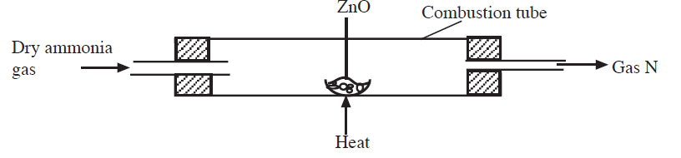

a)Identify gas N.(1mark)

b)Stateobservationmadeinthecombustiontube.(2marks)

c)Namethereagentsrequiredtoproduceammoniagas(2marks)

17. The flow chart below shows properties of two allotropes of element Q.

Above960C

Allotrope B

Burning in air

AllotropeD

Below960C

Burning inair

Product P

i)Identifytheallotropes:

D (1mk)

B (1mk)

ii)NameelementQ(1mk)

iii)Write a chemical equation for the reaction forming product P.(1mk)

iv)What term is given to the temperature of 960C shown above?(*1mark)

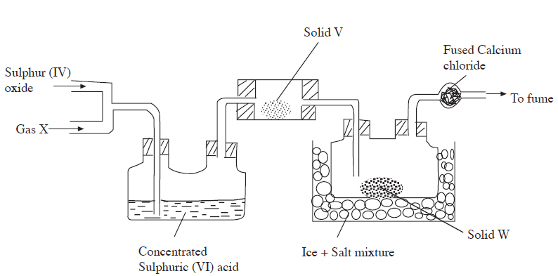

18.

(i) Name substance: X and Y( 2 mks)

(ii)What is the role of the following substances ?

a)Solid V(1 mk)

b)Fused calcium chloride(1mk)

c) Salt in the Ice + salt mixture(1mk)

iii)Explainwhythefumechamberisused?(1mk)

iv)Write an equation for the reaction that took place in the combustion tube.(1mk)

19. Starting with zinc metal, describe how a solid sample of zinc hydroxide can prepared.(3 marks)

20. The substances and apparatus below were used to test the presence of nitrate in substance D.



      (a) Identify substance D (1 mark)

(b) What are the components of the brown ring.(1 mark)

**20.** Nitrogen does not support combustion yet burning magnesium introduced into a gas jar of nitrogen continues to burn, forming a white solid. Explain.(1 mark)

(a) Write an equation for the reaction forming the white solid.(1 mark)

  (b) State two uses of nitrogen.(1 mark)

21. Study the flow chart below and answer the questions that follow.



Identify

  (a) Solution K.(1 mark)

(b) Solid L(1 mark)

c) gas M ( 1 mk)

22. Study the scheme below and answer the questions that follow.



Explain the observations made in

  (i) Step 1 (1 mark)

(ii) Step 2 (1 mark)

(iii) Step 3 (1 mark)

23. Study the diagram below and use it to answer the questions that follow.



(a) Identify electrodes.(2 marks)

(b) Name the product formed at the anode.(1 mark)

24. The flow diagram below is a summary of the industrial manufacture of sulphuric (VI) acid.

 (i) Write an equation for the reaction in the burner.(1 mark)

(ii) Why is it important to pass gas T and air through cleaners?(1 mark)

(iii) Identify

  (a) Gas U (½ mark)

(b) Liquid K(½ mark)

(c) Liquid L(½ mark)

(iv) Write equation for the reaction taking place in the catalytic chamber (1 mark)

(v) Name the most suitable catalyst that can be used in the catalytic chamber. (1 mark)

(vi) Give the name of the product formed in the absorption tower.(1 mark)

(vii) Write equation for the reaction taking place in the dilution chamber. (1 mark)

(viii) Name the main pollutant in this process and state how it is taken care of.(1½ marks)

 ix) Give one use of sulphuric (VI) acid.(1 mark)