**MID TERM TWO EXAMS**

**CHEMISTRY FORM THREE.**

**MARKING SCHEME 2021**

1. A student separated liquid P (B.P 78°C) and liquid Q (B.P 100°C) wring the apparatus shown below.



(i) Name the apparatus labelled

(a) M (1 mark)

**liebig condenser**

  (b) R (1 mark)

**Fractionating column**

  (ii) State one function of the glass bead in apparatus labelled R (1 mark)

**To increase surface area for condensation**

(iii) What is the reading on the thermometer when the first jar drops of the distillate appeared in the beaker.(1 mark)

**78**

  (iv) Which of the liquids remains in the flask.(1 mark)

**water**

2. Name a method that can be used to extract the following:-

 (i) Common salt from a salt solution.(1 mark)

**evaporation**

(ii) Paraffin from crude oil.(1 mark)

**Fractional distillation**

3. A compound of carbon, hydrogen and oxygen contain 54.55% carbon, 9.09% and remaining 36.36% oxygen. If its relative molecular mass is 88, determine its molecular formula(C=12.0, H =1.0, O= 16.0) [4mark]

|  |  |  |  |
| --- | --- | --- | --- |
| Element | Carbon | Hydrogen | Oxygen |
| Symbol | C | H | O |
| Moles present = % composition  Molar mass | 54.55  12 | 9.09  1 | 36.36  16 |
| Divide by the smallest value | 4.5458  2.2725 | 9.09  2.2725 | 2.2725  2.2725 |
| Mole ratios | 2 | 4 | 1 |

Empirical formula is **C2H4O**

The molecular formula is thus determined :

**n**  = Relative formular mass = 88 = 2

Relative empirical formula 44

The molecular formula is (C2H4O ) x 2 = **C4H8O2**.

4.Sodium nitrate(V)can also be used to prepare nitric(V)acid. State two reasons why potassium nitrate(V) is preferred over Sodium nitrate(V). (2marks)

**(i) Potassium nitrate(V) is more volatile than sodium nitrate(V) and therefore readily displaced from the less volatile concentrated sulphuric(VI)acid**

**(ii) Sodium nitrate(V) is hygroscopic and thus absorb water . Concentrated sulphuric(VI)acid dissolves in water. The dissolution is a highly exothermic process**

5. The atomic number of an element A is 11 and that of B to 8.

(a) Write down a possible formula of compounded formed between A and B(1mark)**A2B**

  (b) Draw a dot (•) and cross (×) diagram to show bonding in compound farmed. (2 marks)



 6**.** (a) Below is a paper chromatogram of pure substances W, X and Y



   a) The mixture K contains substances W and X only. Indicate on the diagram the chromatogram of K.(2 marks)



  (b) State one application of chromatography.(1 mark)

**Testing of illegal drugs in urine**

7. Moist hydrogen sulphide gas was passed through a tube containing wet sulphur (IV) oxide gas as shown below.



  (a) State the observation (s) made.(1 mark)

**Yellow deposit formed**

  (b) Write an equation for the reaction above.(1 mark)



  (c) Giving a reason, which substance undergoes reduction above.(1 mark)

**Sulphur (IV) oxide gas is reduced since it accepts electrons from hydrogen sulphide**

8.  Study the set up below and use it to answer the questions that follow.



   (a) What observations are made in the boiling tube. Explain.(1 mark)

**Red residue cooled to a yellow residue**

**Brown fumes produced**

***✓½***

  (b) Write an equation of reaction occurring in the boiling tube.(1 mark)



 9. When excess dilute hydrochloric acid was added to sodium sulphate, 960cm³ of sulphuric (IV) oxide gas was produced. Calculate the mass of sodium sulphite that was used. (Molar mass of sodium sulphite = 126g) and molar gas volume at rtp is 24dm³.(3 marks)



**1 mole Mole**



**Mole ratio 1 : 1 🗸*½***

**Moles of Na2SO3 = 0.04 ü*½***

**RMM of Na2SO3 = 126**

**Mass of Na2SO3 = 0.04 × 126 ✓*½***

**= 5.04 g ✓**

10. The table below shows atomic and ionic radii of some elements represented by letters U, V, W, X (*Not the actual symbols*) Study it and answer the questions that follow.

|  |  |  |
| --- | --- | --- |
| Element | Atomic Radius (nm) | Ionic radius (nm) |
| U | 0.174 | 0.099 |
| V | 0.203 | 0.133 |
| W | 0.099 | 0.181 |
| X | 0.136 | 0.065 |

(a) Classify element X as a metal or non-metal. Explain. (1 mark)

**Its a metal½ since atomic radius is greater🗸½ than ionic radius**

  (b) Which of the elements is the strongest reducing agent? (1 mark)

**V**

(c) Which element forms an anion.(1 mark)

**W**

11.**(**a) State Graham’s law of diffusion.(1 mark)

**The rate of diffusion of a gas is inversely proportional to the square root of its density provided the initial conditions remain constant**

(b) 400cm3 of gas D diffuses from porous plug in 50 seconds while 600cm3 of oxygen diffuses from the same porous plant in 30 seconds. Calculate the relative molecular mass of gas. (O = 16)(3 marks)



12.The flow chart below shows the industrial preparation of ammonia and process used in the manufacture of ammonium compounds. Study it and answer the questions that follow.



  (a) Give the name of the:

(i) Process in step 1(1 mark)

**Fractional distillation**

  (ii) Reaction that takes place in step 5 (1 mark)

**neutralization**

(b) (i) State **one** other source of hydrogen gas apart from natural gas. (1 mark)

**Cracking of long chain alkanes**

   (ii) Explain why it is necessary to compress nitrogen and hydrogen in this process. (2 marks)

**High pressure brings the molecules closer/increasing the concentration of gas**

**molecules/the pressure shifts the equilibrium the right; Hence the yield of ammonia increases**

  (c) (i) Write an equation for the reaction which takes place in step 2(1 mark)

**NH3(g) + CH3COOH(aq)  CH3CHOONH4**

  (ii) Name the catalyst and the reagents used in step 3.

  a) Catalyst- **Platinum rhodium /platinum** (1 mark)

b) Reagents **Water and oxygen** (1 mark)

  (d) Name compound Z1(1 mark)

**Ammonium nitrate; rej Formula**

  (e) Give one commercial use of compound Z2 (1 mark)

**as fertilizer; rej manufacture of fertilizer;✓1**

13. What property of concentrated sulphuric (VI) acid is displayed in the following reactions.

(a) Concentrated sulphuric (VI) acid taking water from gases leaving them dry.(1 mark)

**It is hygroscopic**

(b) Concentred sulphuric acid takes water from blue crystals or hydrated copper (II) sulphate, leaving white anhydrous copper (II) sulphate.(1 mark)

**Dehydrating property**

(c) Hot concentrated sulphuric (VI) acid reacts with copper turnings forming copper (II) sulphate sulphur (IV) oxide and water.(1 mark)

**Oxidising property**

 14. The diagram below shows a set-up that was used to prepare and collect sulphur (IV) oxide gas. Study it and answer the questions that follows.

  (a) (i) Name substance R.(1 mark)

**dilute hydrochloric acid**.

  (ii) Name apparatus M.(1 mark)

**dropping funnel**

 (iii) Write a balanced equation for the reaction between R and Sodium sulphite. (1 mark)

  (iv) Why is sulphur (IV) oxide not collected by over water methods.(1 mark)

**It is soluble in water**

  (v) (i) Identify substance K.(1 mark)

**Concentrated sulphuric (VI) acid**

  (ii) What is the function of substance K. (1 mark)

**To dry sulphur (IV) oxide gas**

15. The diagram below represents pipes used in the Frasch pump for the extraction of sulphur.



Which substances pass through tubes

 1 **Compressed hot air in** ✓1

2 - **Molten froth of sulphur water mixture out**

3- **superheated water-in ✓1**

(1 mark)

(1 mark)

(1 mark)

16. Dry ammonia gas was passed over hot zinc oxide as shown in the diagram below

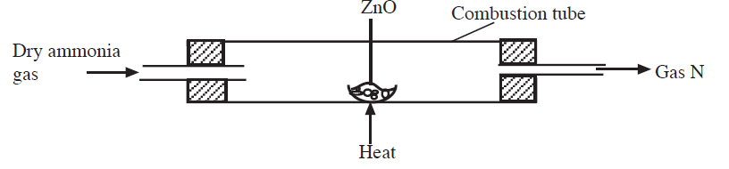

a) Identify gas N.(1mark)

**nitrogen gas**

b) State observation made in the combustion tube.(2marks)

**color of zinc oxide changes from yellow to gey**

**colourless liquid formed on cooler parts of the testtube**

c) Name the reagents required to produce ammonia gas(2marks)

**ammonium chloride and calcium hydroxide**

17. The flow chart below shows properties of two allotropes of element Q.

Above 960C

Allotrope B

Burning in air

Allotrope D

Below 960C

Burning in air

Product P

i) Identify the allotropes:

D **rhombic** (1mk)

B **monoclinic** (1mk)

ii) Name element Q(1mk)

**sulphur**

iii) Write a chemical equation for the reaction forming product P.(1mk)

**s+02-------so2**

iv) What term is given to the temperature of 960C shown above?(*1mark)

**transitional temperature**

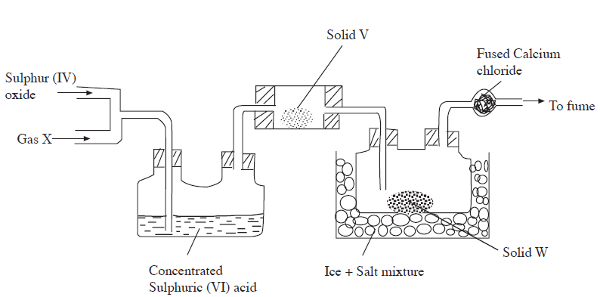

18.

(i) Name substance: X and V( 2 mks)

**X; oxygen**

**V;vanadium (v) OXIDE**

(ii)What is the role of the following substances ?

a) Solid V(1 mk)

**act as a catalyst**

b)Fused calcium chloride(1mk)

**prevent entry of moisture into the flask**

c) Salt in the Ice + salt mixture(1mk)

**salt act as an impurity to lower melting point of ice**

iii) Explain why the fume chamber is used?(1mk)

**to absorb excess poisonous sulphur (V) oxide**

iv) Write an equation for the reaction that took place in the combustion tube.(1mk)

**S02+02------🡪SO3**

19. Starting with zinc metal, describe how a solid sample of zinc hydroxide can prepared.(3 marks)

**To nitric acid add excess zinc metal, filter to remove excess zinc. Add sodium hydroxide to zinc nitrate solution.**

**A precipitation reaction will occur where zinc hydroxide will be precipitated out. Filter to obtain zinc hydroxide as the residue and dry it between filter paper.**

20. The substances and apparatus below were used to test the presence of nitrate in substance D.



      (a) Identify substance D (1 mark)

**Concentrated sulphuric acid**

(b) What are the components of the brown ring.(1 mark)

**Iron (II) sulphate-nitrogen (II) oxide complex**

**20.** Nitrogen does not support combustion yet burning magnesium introduced into a gas jar of nitrogen continues to burn, forming a white solid. Explain.(1 mark)

**Burning magnesium produce a lot of heat capable of breaking triple bond holding nitrogen atoms together**

(a) Write an equation for the reaction forming the white solid.(1 mark)

**Mg + N2________>Mg3N2**

  (b) State two uses of nitrogen.(1 mark)

**Haber process**

**Manufacture of nitrogenous fertiliser**

21. Study the flow chart below and answer the questions that follow.



Identify

  (a) Solution K.(1 mark)

**Nitric acid**

(b) Solid L(1 mark)

**PbO**

c) gas M ( 1 mk)

**Oxygen gas**

22. Study the scheme below and answer the questions that follow.



Explain the observations made in

  (i) Step 1 (1 mark)

**Low viscosity and flows easily**

(ii) Step 2 (1 mark)

**Liquid sulphur becomes very viscous**

(iii) Step 3 (1 mark)

**Turns black and flows easily**

23. Study the diagram below and use it to answer the questions that follow.



(a) Identify electrodes.(2 marks)

**A; anode**

**B; cathode**

(b) Name the product formed at the anode.(1 mark)

**Bromine gas**

24. Th ane flow diagram below is a summary of the industrial manufacture of sulphuric (VI) acid.



 (i) Write an equation for the reaction in the burner.(1 mark)

**S + 02_______>SO2**

(ii) Why is it important to pass gas T and air through cleaners?(1 mark)

**To remove dust which might reduce efficiency of catalyst**

(iii) Identify

  (a) Gas U (½ mark)

**SO3**

(b) Liquid K(½ mark)

**water**

(c) Liquid L(½ mark)

**Sulphuric acid**

(iv) Write equation for the reaction taking place in the catalytic chamber (1 mark)

**SO2 + O2_________> SO3**

(v) Name the most suitable catalyst that can be used in the catalytic chamber. (1 mark)

**Vanadium(V)oxide**

(vi) Give the name of the product formed in the absorption tower.(1 mark)

**oleum**

(vii) Write equation for the reaction taking place in the dilution chamber. (1 mark) **H2S2O7 +H2O_______>2H2SO4**

(viii) Name the main pollutant in this process and state how it is taken care of.(1½ marks) **SO2, is passed through a chimney lined with calcium hydroxide**

 ix) Give one use of sulphuric (VI) acid.(1 mark)

**manufacture of fertiser, manufacture of plastics, manufacture of detergents**