NAME:………………………………………………………….CLASS:……ADM NO:………

MID TERM EXAMINATION
CHEMISTRY
FORM 3
TERM 2 – 2021
TIME:

INSTRUCTIONS.
Answer all the questions in the spaces provided.

- Fractional distillation of liquid air usually produces nitrogen and oxygen as the major products.
- Name one substance that is used to remove carbon (IV) oxide from the air before it is changed into liquid. (1mk)

- Describe how nitrogen gas is obtained from the liquid air. (boiling points, nitrogen = 196ºC, oxygen = -183ºC) (2mks)

- The set up in the figure below can be used to prepare nitrogen (II) oxide. Use it to answer the questions that follow.

- Name substance A. (1mk)

- When the gas jar containing nitrogen (II) oxide is exposed to air, a brown colour is observed. Explain. (1mk)

- Write an equation for the reaction which accured in the flask. (1mk)

- Carbon (IV) oxide is present in soft drink. State two roles of carbon (IV) oxide in soft drinks. (2mks)

b. Explain the observation made when a bottle containing a soft drink is opened. (1mk)

- Calculate the mass of Zinc oxide that will just neutralize dilute nitric (V) acid containing 12.6g of nitric (V) acid in water. (Zn=65., O=16.0, H=1.0, N=14.0) (3mks)

- When compound N is heated, a red-brow gas is evolved and a yellow residue is left on cooling. Name:
- Compound N (1mk)

- The red-brown gas. (1mk)

- Write the equation for the decomposition of compound N. (1mk)

- Calculate the volume of oxygen that would be obtained when 21.25g of sodium nitrate is decomposed at stp. (1 mole of a gas occupied 22.4dm³ at stp; N=14, Na=23, O=16) (3mks)

- In the extraction of sulphur by the Frasch process, water at a temperature of 170ºC is pumped into the sulphur deposits.
- State the role of the water. (1mk)

- State how a temperature of 170ºC is achieved. (1mk)

- When coloured flower petals are dropped into a gas jar containing sulphur(IV) oxide gas, they are bleached. Explain. (2mks)

b. Write the equations for the reactions that occur in (a) above. (2mks)

- State and explain the observations made when a burning piece of magnesium ribbon is placed in a gas jar of nitrogen gas. (3mks)

- When cabon(IV) oxide is passed through calcium hydroxide solution for a short time, a white precipitate is formed, but when passed through sodium hydroxide no precipitate is formed. Explain. (3mks)

- In a compound of magnesium and nitrogen, 54g of magnesium combine with 21g of nitrogen. Determine the empirical formula of the compound. (mg=24, N=14) (3mks)

- A volume of 120cm³ of nitrogen gas diffused through a membrane in 40 seconds, how long will 240cm³ of carbon (IV) oxide take to diffuse through the same membrane? (N=14, C=12, O=16) (3mks)

- The following set-up is used to prepare nitric (V) acid in the laboratory

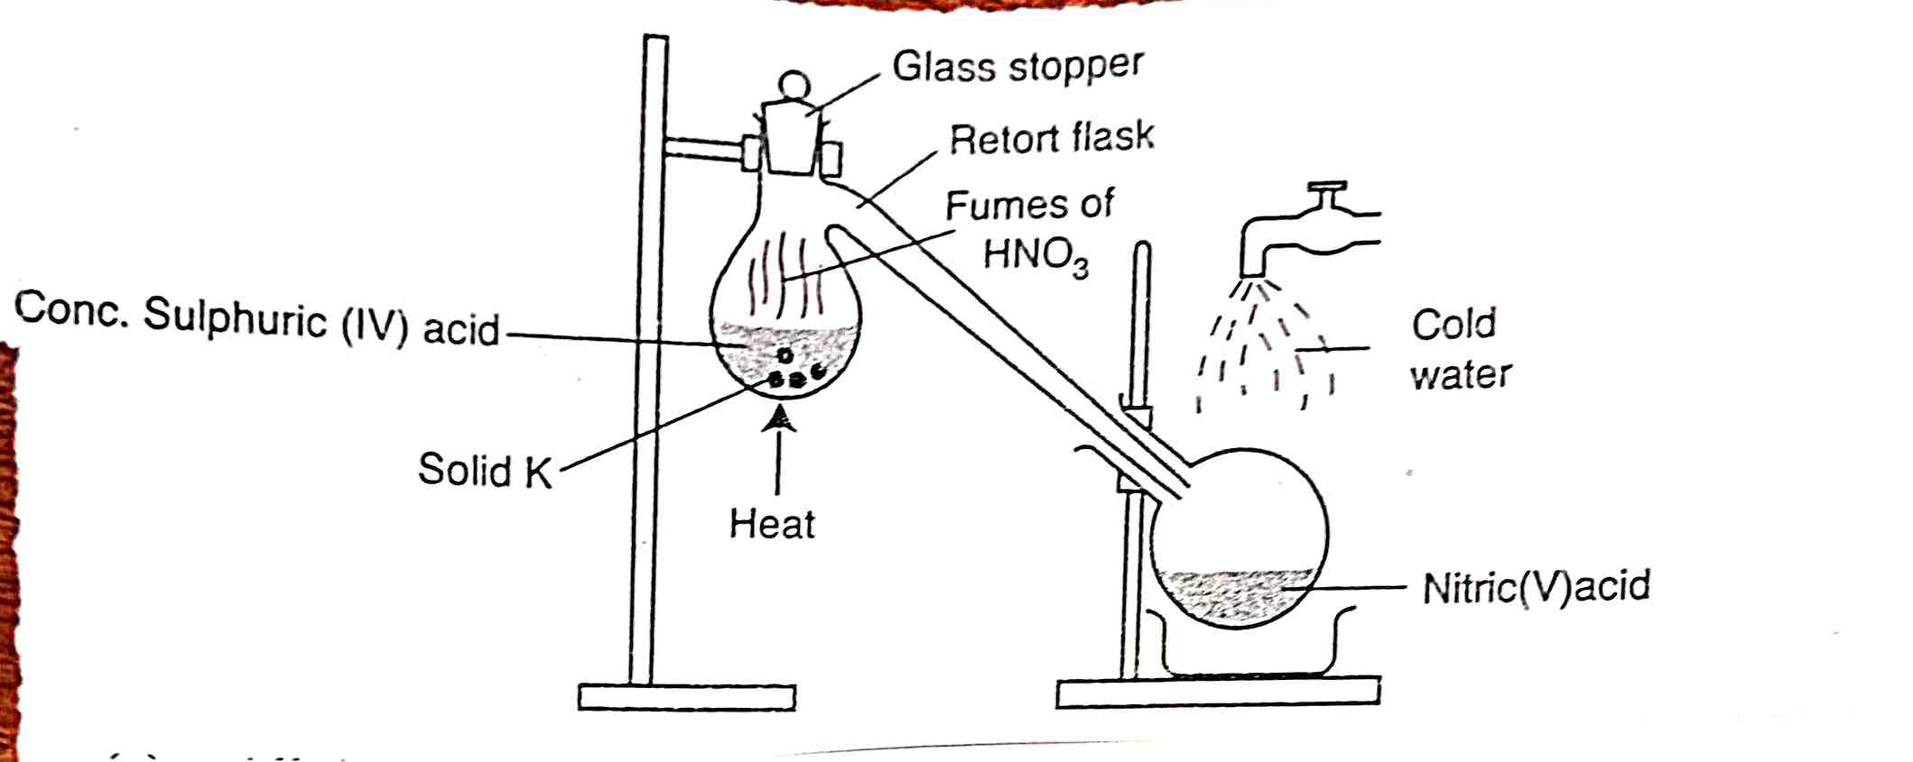

- All the apparatus used during preparation of nitric (V) acid are made of glass. Give a reason. (1mk)

- Name solid K. (1mk)

- State one use of nitric (V) acid. (1mk)

- Study the flow chart below and answer the questions that follow.

Yellow substance Y
Z
Green solution
Solution P pH=5
Heat
O₂
Acidified
K₂Cr₂O₇

- Identify:
- Z (1mk)

- M (1mk)
- In the contact process, during the production on sulphur (VI) oxide, a catalyst is used. Give two reasons why vanadium (V) oxide is preferred to platinum. (2mks)

- Aqueous ammonia was added to copper (II) sulphate solution dropwise until in excess.
- What observations were made? (2mks)

- Write down the ionic equations representing the observation mentioned in (a) above. (2mks)

- In the laboratory ammonia gas is prepared by the reaction between calcium hydroxide and ammonium chloride.
- Write the equation for the reaction which produces ammonia. (1mk)

- State the drying agent used to dry ammonia. (1mk)

- State the raw materials used in the manufacture of ammonia in the Haber process. (1mk)

