Name:………………………………………………..Class:……..…AdmNo:…….
FORM 1 CHEMISTRY 2021
END OF TERM 2 EXAMINATION
DECEMBER 2021
2 HOURS
ANSWER ALL QUESTIONS IN THE SPACES PROVIDED
1.The diagram below is a set up for the laboratory preparation of dry oxygen gas.
Sodium peroxide
Liquid X
Liquid Y

- Name:
- Liquid Y (1 Mark)

- Liquid X (1 Mark)

- Write a word equation for the reaction that took place in the flask. (1mark)

- State two uses of oxygen gas (2mks)

2. Study the figure below and answer questions that follow.

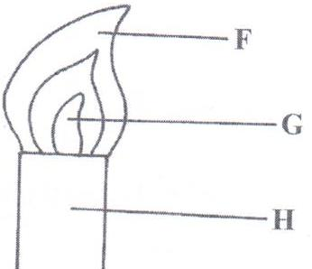

- Name the type of flame shown and give a reason. (2mks)

(b)Name the parts labelled F and G. (2mks)

(c) State the conditions under which the above flame is produced? (1mk)

(d) State the three differences between the two flames of a Bunsen burner (3Mks)

3. State the best method to separate the following mixtures (5Mks)
(a) Components of crude oil

(b) benzoic acid and sodium chloride

(c) Oil from sunflower seeds

(d) Iron filings and sulphur

(e) Coloured pigment from grass

4. Draw and state one use of the following apparatus.(10mks)
(a) Deflagrating spoon

(b)Conical flask

c) Round bottomed flask

- Mortar and pestle

- Evaporating dish

5. Mugure a form one student was stung by a wasp in the laboratory, the technician applied sodium hydroxide on her. Explain why this was done. (2mks)

6. State three roles of chemistry as a subject to the society (3mks)

7. Complete the table below(8mks)
element | symbol | element | Symbol
sodium |  |  | Hg
 | K | copper
sulphur |  |  | C
iron |  | hydrogen
8.(a) Define the term mixture (1mks)

(b) Name five types of mixtures (5Mks)

9.(a) Define the following terms (2mks)
(i) Drug

(iI)Drug abuse
(b) Name three commonly abused drugs (3mks)

(c) State two effects of drug abuse to the consumer (2mks)
10. During Olympics, urine sample of five short distance runners were taken and tested for the presence of two illegal steroids by paper chromatography. Methanol was used as the solvent. A chromatogram from the test appeared as shown below. Study the chromatogram and answer the questions that follow.

KEY
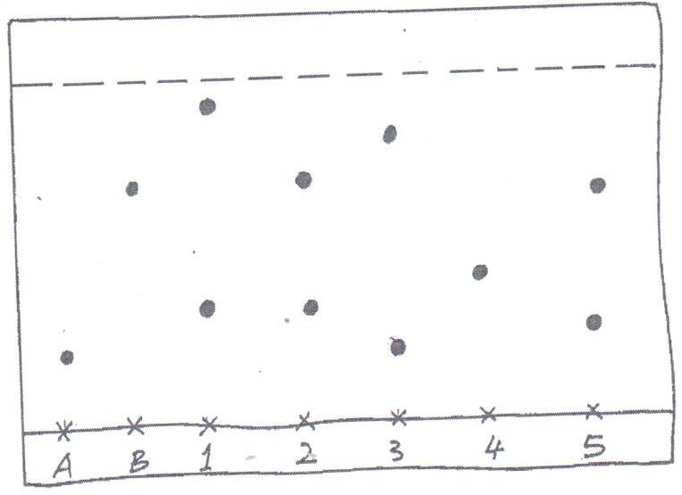
SPOT A – STEROID A
SPOT B – STEROID B
SPOT 1 – ATHLETE 1
SPOT 2 – ATHLETE 2
SPOT 3 – ATHLETE 3
SPOT 4 – ATHLETE 4

x x x x x x x
A B 1 2 3 4 5

  - Which of the two steroids is most likely to be more soluble in methanol? Give a reason. (1mk)

  - Identify the athletes that tested positive for the illegal steroids. (2mks)

  - On the diagram, indicate the solvent front. (1mk

11. The diagram below shows parts of a Bunsen burner.
A
B
C

- Name the parts labelled A , B (1 mark)

- Give one use of the part labelled B (1 mark)

12. Hydrated copper (II) sulphate exists as blue crystals while anhydrous copper (II) sulphate is a white powder. Describe a laboratory experiment that can be used to show that the action of heat on hydrated copper (II) sulphate is a reversible reaction (3 marks)

13.(a) Melting point of naphthalene is 80⁰C. When camphor is added to a sample of naphthalene, the melting point changes to 79.8⁰C. Explain (2mks)

- What is effect of adding magnesium sulphate to the boiling point of distilled water? (1mk

14.(a) A patient was given tablets with prescription 2 x 3 on the envelope. Clearly outline how the patient should take the tablets.
(1 mark)

- Two samples of equal volumes of water were put in 250cm³ beaker and heated for 10 minutes. Sample 1 registered a higher temperature than sample 2.

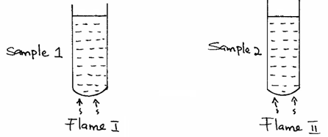

State the conditions under which flame I is produced in Bunsen burner. (1 mark)

15. The apparatus below was used to separate a mixture of liquid A and B.
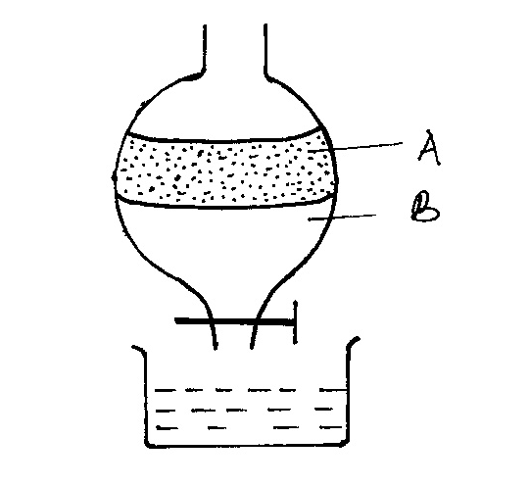

- State two properties of the liquids that make it possible to separate them using such apparatus. (2 marks)

16. The table below shows PH values of solutions A, B, C and D.
Solution | PH
A | 3.0
B | 13.0
C | 8.5
D | 7.0
E | 5.5

(a) Identify a solution which is
(i) Strongly acidic. (1 mk)

(ii) Strongly basic. (1mk)

- Distilled water (1mk)

- Lemon juice (1mk)

(b) Which of solutions would react with lead (II) oxide? Explain. (2 marks)

17.In an experiment a certain volume of air was passed repeatedly from syringe over heated zinc powder as shown in the diagram below.
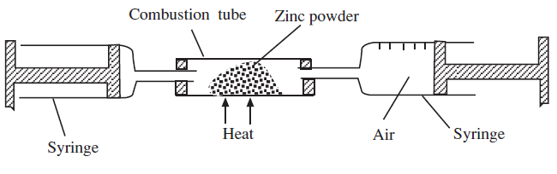

The experiment was repeated using excess magnesium powder. In which one of the two experiments was the change in volume of air greatest. Give reasons. (3mks)

18 (a) what is the chemical name for rust. (1mk)

- State the conditions necessary for rusting. (1mk)

(c) List three methods of preventing rusting. (3mks)

19. Complete the word equations for the following reactions; (3mks)
(a) sodium carbonate + hydrochloric acid =

(b) Zinc + sulphuric acid =

(c) potassium hydroxide + nitric acid =
20. Define the following terms and give an example of each (8mks)
(a) An atom

(b) Molecule

(c) Element

(d) Compound

21. Give three differences between permanent and temporary changes. (3mks)
TEMPORARY CHANGE | PERMANENT CHANGE

22. State two laboratory rules to observe when preparing a poisonous gas. (2mks)

……………………………THE END……………………………..

