CHEMISTRY
FORM 2
MARKING SCHEME

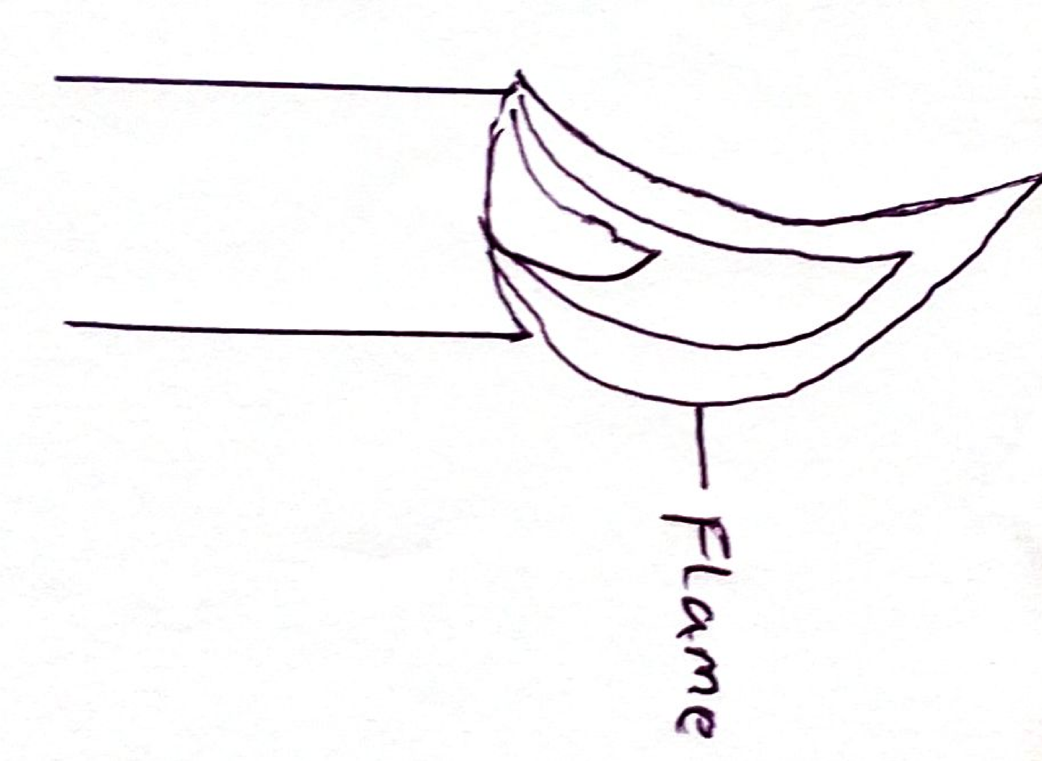
- The figure below shows a frame obtained from a Bunsen burner.

- Name the type of a frame. (1mks)

Luminous paper

- State one shortcoming of using this flame in heating substances in the laboratory. (1mk)

It forms a soot on the apparatus during heating

- It is always advisable to leave the burner with the air hole closed when it is lit bit not in use. Explain. (2mks)

The flame is bright yellow and big, hence can easily be seen to avoid accident.

- An element ²⁴R
¹²
- To which chemical family does it belong? (1mk)

Alkaline earth metals.

- Write the electron arrangement of the atom (1mk)

2.8.2
- Draw the structure of its Ion. (1mk)

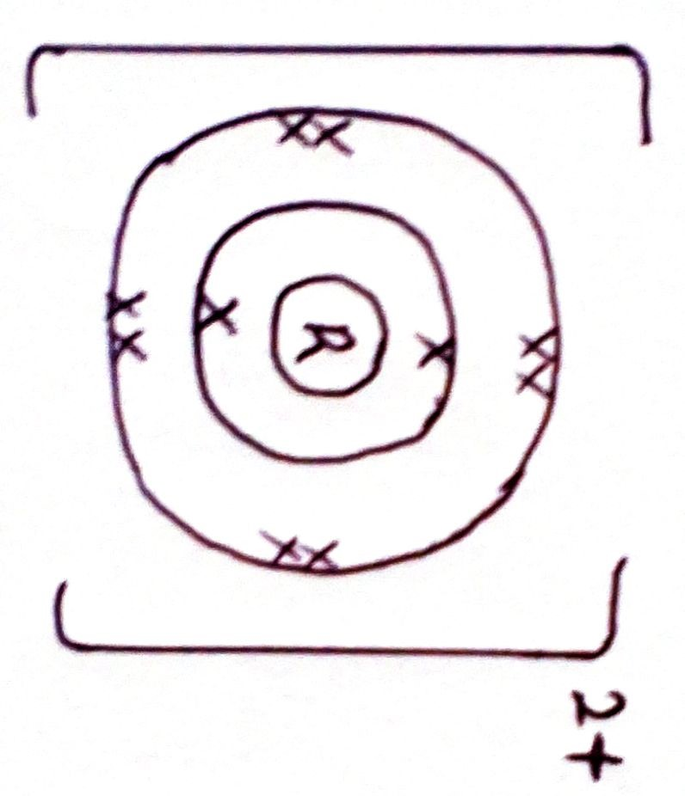

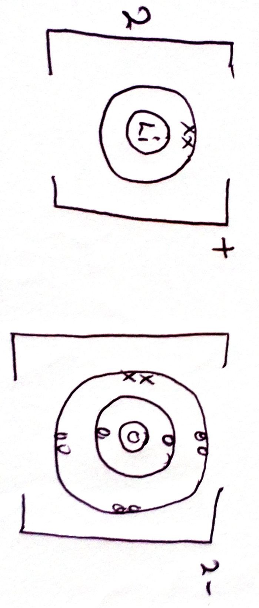
- Use dot (.) and cross (x) to show the bonding in Lithium Oxide. (2mks)

- Excess magnesium ribbon was burnt in air to form a white solid mixture. Write two equations to show the formation of the white solid mixtures. (2mks)

2Mg _{(s)} + O_{2 (g)} 2MgO_{(s)}

3Mg_{(s)} + N_{2(g)} Mg₃N_{2 (s})

- State two laboratory rules that should be followed to avoid contamination and wastage of chemicals (2mks)
Label all containers carrying chemicals.
Turn off water and gas taps when not in use.
Use
Always work on a clean bench.

- State two application of chromatography. (2mks)
- In sports to identify banned substances
- To test purity of drugs in Pharmacy
- Identify contaminants in food and drunks
- Identify harmful substances in cosmetics.

- A student planned some hydrogen peroxide in a test tube then added a small amount of manganese (IV) Oxide - . A glowing splint was then brought near the mouth of the tube.
- State the observation made on the glowing splint. (1mk)

It relight a glowing splint.

- What is the role of the Manganese (IV) Oxide (1mk)
Serves as a catalyst.

- Give two use of the gas produced. (2mks)

- Breathing aid by patients with respiratory problems
- Ox hydrogen flame is used in welding and cutting metals
- Mixed with hilum for deep sea diving and mountain climbing.

- Define the flowing terms as used in salts
- Deliquescence (1mk)
It is the process in which salts when being exposed in atmosphere absorb water and forms a solutions.

- Hygroscopic. (1mk)

These rare salts when exposed in the atmosphere they absorb water but does not dissolve to form solutions.

- Hygroscopy. (1mk)
This is the process in which when some of the slats exposed in the atmosphere absorb water but does not form solutions.

- Complete the following equation on effect of heat on Nitrates and carbonates. (4mks)
NaNO₃ _{(s)} NaNO_{2 (s) +} O₂

Zn (NO₃)₂ ZnO ₊ 4NO₂ ₊ O2

Ag NO₃ _{(s}) Ag + NO₂ +O₂

CaCO_{3(s)} CaO _{(s)} + CO_{2 (g)}

- Explain why graphite is a non-metal made up of element carbon and yet conducts electric current. (2mks)
In graphite the carbon uses 3 – outermost electrons to bond to form graphite while one remain for delocalization.

- Explain why lead (ii) bromide does not conduct electric current in solid state but contact in molten state. (1mk)

In molten state the lead (ii) bromide has mobile Ions that contact electric current.

- A certain element Y has atomic number 15 and mass number of 31.
- Calculate this number of Neutrons in the element. (1mk)
31-15= 16 neutrons

