MID- TERM EXAM-2021
FORM 2 Marking scheme

1. | NO |  | STD | LOG |  | M1  M1  M1  A1
 | 72.56  0.64  1.845  2.390 |  | 7.256X10¹  6.4X10⁻¹  1.845X10⁰  2.390×10⁰ | 1 .8607  $\overline{1}$ .8062
1.6669
0.2660×2
0.5320
1.1349×$1/3$
0.3783

2. | X+X+2+X+4=219  3X=213  X=71  71,73,75 |  |  |  |  | M1  M1  A1
3. | - 100000x77.24  Ksh. 7724000  - $\frac{7724000}{122.24}$  =63171.669 sterling pound |  |  |  |  | M1  A1  M1  A1
4. | $\frac{1}{3}$X3.142X25X12  =314.2cm²  314.2= 3.142X$\frac{4}{3}$r³  r³=75  r=4.217cm  S.A =4x3.142x4.142²  =223.52cm² |  |  |  |  | M1  M1  M1  A1
5. | $\frac{12X240}{\begin{aligned}60\end{aligned}}$  =42 |  |  |  |  | M1  A1
6. | 6x²-13x+6=0  -9,-4  6x²-4x-9x+6=0  2x(3x-2)-3(3x-2)=0  X=$\frac{3}{2}$ or x=$\frac{2}{3}$ |  |  |  |  |  | M1  M1  A1
7. | 4X$\frac{1}{\sqrt{2}}$ X $\frac{\sqrt{3}}{2}$  $\frac{2\sqrt{3}}{\sqrt{2}}$ |  |  |  |  |  | M1  A1
8. | NO | STD |  |  | LOG | M1  M1  A1
 | 11.45  Sin38.3  7.096 | 1.145x10¹  7.096x10⁰ |  |  | 1.0588  $\overline{1}$ .7922
 |  |  |  |  | 0.8510
9. | 185.1=9x0.5Xa²sin40  $\frac{185.1}{4.5sin40}$ =a²  575.93=a²  A=8cm |  |  |  |  | M1  M1  A1
10. | 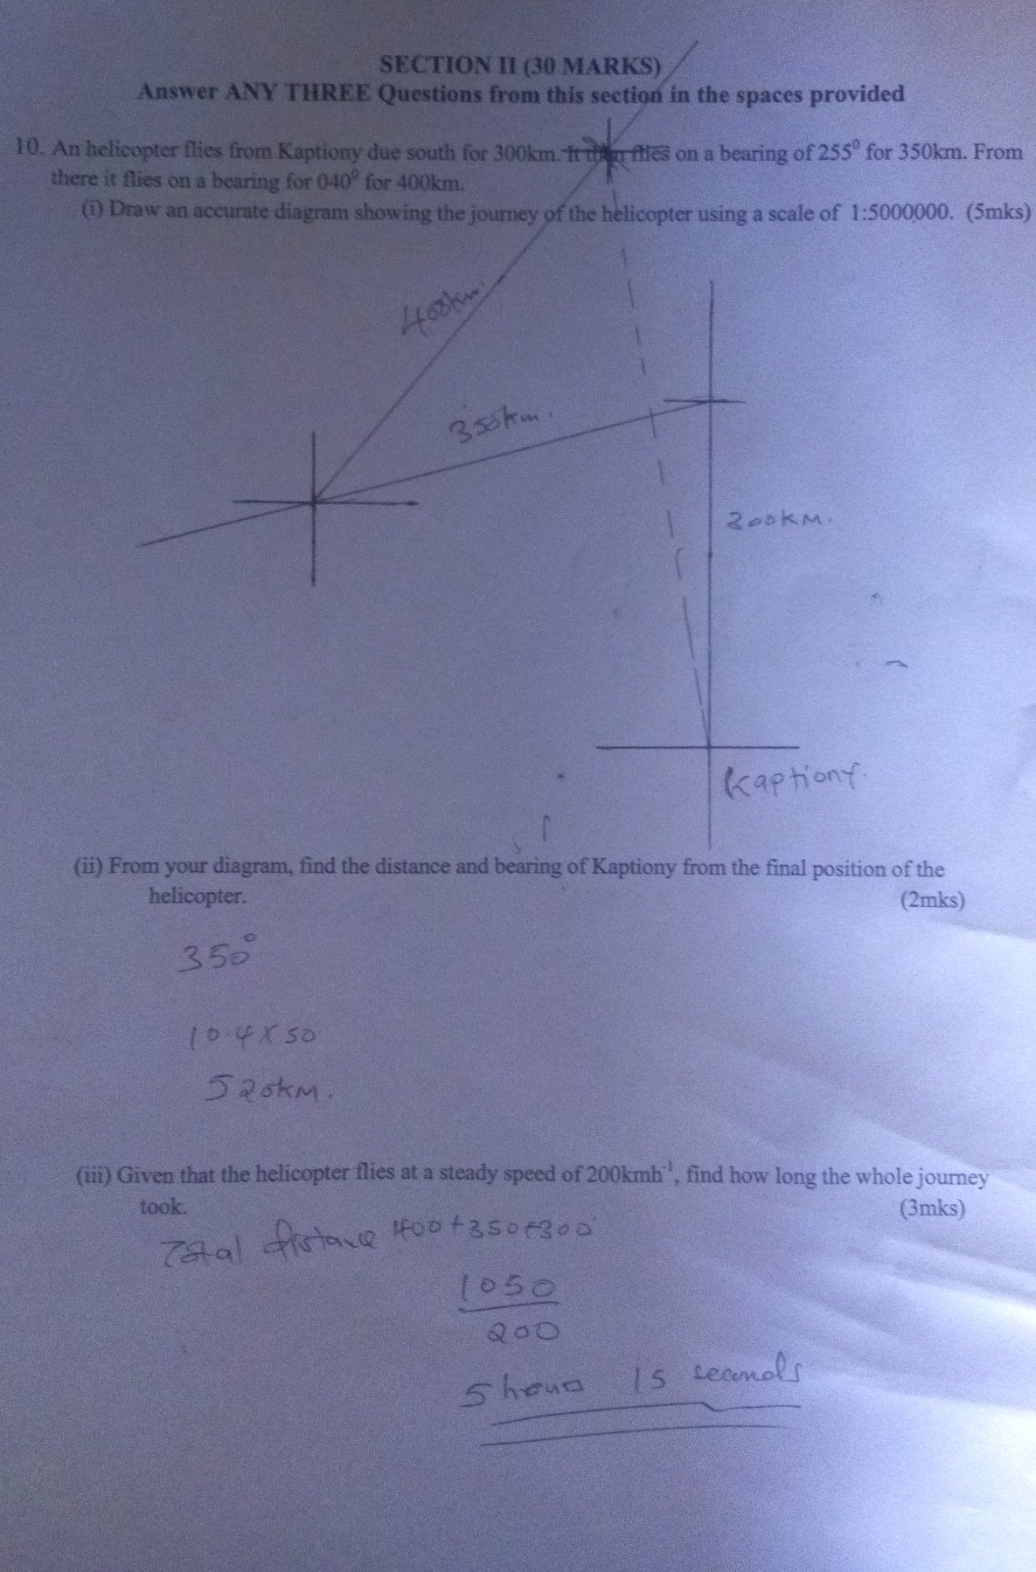  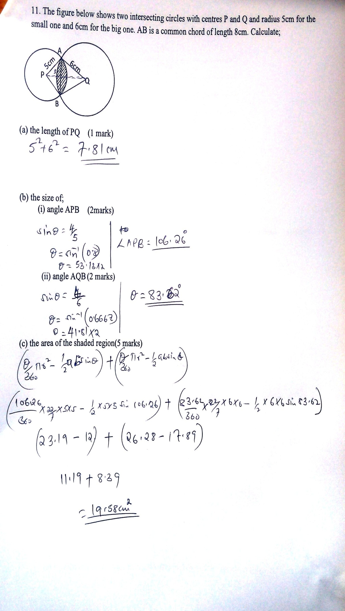
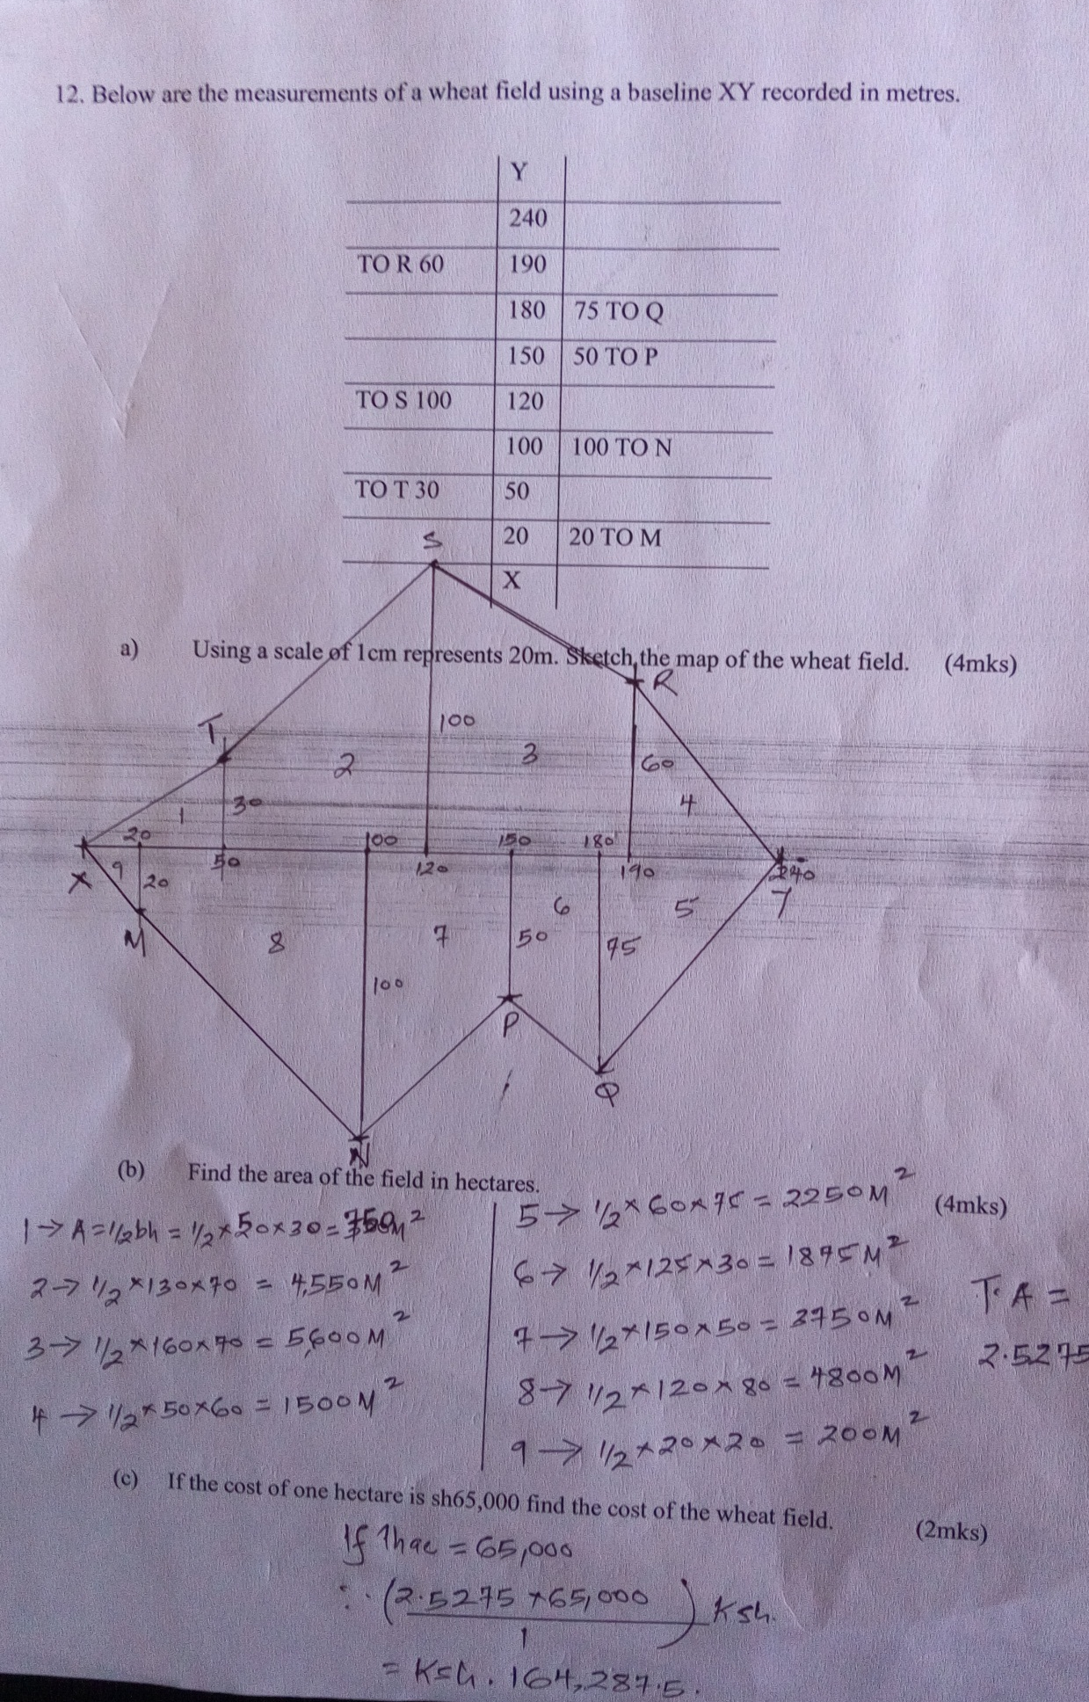

13.
