MID- TERM EXAM-2021
FORM 3 Marking scheme

1. | 5.246 x log 0.2349  0.06364 ½  = 5.246 x ‾1.3708  0..6364 ½  =-(5.246 x 0.6292  0.063664 ^{½}  No Log  5.246 0.7198  0.6292 ‾1.7988  0.5186 0. 5186 -  0.06364 ½ ½ x ‾2.8038 ‾1.4019  1.1167  10⁻¹ x 1.309  = -0.1309 | M1  M1  M1  A1 | for – 0.6292  All logs including 0.06364^{½}  ✓ attempt to add and subtract
 |  | 04
2. | $$\begin{aligned}t^{2}=\frac{4m^{2}}{n^{2}}\left(\frac{4m^{2}}{3k}\right) \\ t^{2}=\frac{4m^{2}l−4m^{2}A}{3n^{2}k} \\ 3n^{2}t^{2}k=4m^{2}l−4m^{2}A \\ 4m^{2}A=4m^{2}l−3n^{2}t^{2}k \\ A=\frac{4m^{2}l−3n^{2}t^{2}k}{4m^{2}}\end{aligned}$$ | M1  M1  A1
 |  | 03
3. | $$\begin{aligned}\text{let} x=4\text{.}\text{37272} \\ \text{10}x=\text{43}\text{.}\text{72} \\ \text{100}x=\text{437}\text{.}2 \\ \text{1000}x=\text{4372}\text{.}\text{72} \\ \text{1000}x−\text{10}x=\text{4372}\text{.}\text{72}−\text{43}\text{.}\text{72} \\ \text{990}x=\text{4329} \\ x\frac{\text{4329}}{\text{990}}=\frac{\text{481}}{\text{110}}\end{aligned}$$ | M1  A1
 |  | 02
4. | $$\begin{aligned}Q=\left(\begin{matrix}6 \\ 3\end{matrix}\right); \begin{matrix}R \\ \text{\sim }\end{matrix}=\left(\begin{matrix}−4 \\ 2\end{matrix}\right);\begin{matrix}U \\ \text{\sim }\end{matrix}=\left(\begin{matrix}8 \\ −4\end{matrix}\right) \\ S\vec{Q}T \\ \begin{matrix}T \\ \text{\sim }\end{matrix}\vec{R}U \\ \text{Object} + \text{Translation} \text{vector} = \text{image} \text{vector} \\ T=\left(\begin{matrix}8 \\ −4\end{matrix}\right)−\left(\begin{matrix}−4 \\ 2\end{matrix}\right)=\left(\begin{matrix}\text{12} \\ −9\end{matrix}\right) \\ \begin{matrix}S \\ \text{\sim }\end{matrix}=\left(\begin{matrix}\text{12} \\ −6\end{matrix}\right)−\left(\begin{matrix}6 \\ 3\end{matrix}\right)=\left(\begin{matrix}6 \\ −9\end{matrix}\right) \\ \text{co}−\text{ordinator} \text{of} S = \left(6,−9\right)\end{aligned}$$ | B1  B1  B1 | Column vector for T  Column vector for S  Co- ordinate
 |  | 03
5. | $$\begin{aligned}\frac{3\left(3−\sqrt{5}\right)+3\sqrt{5}\left(3+\sqrt{5}\right)}{9−5} \\ =\frac{9−3\sqrt{5}+9\sqrt{5}+\text{15}}{4} \\ =\frac{\text{24}+6\sqrt{5}}{4} \\ =6+\frac{3}{2}\sqrt{5} \\ ∴ a=6 \text{and} b=\frac{2}{3}\end{aligned}$$ | M1  M1  A1
 |  | 04
6. | $$\begin{aligned}\frac{\text{30}}{\text{360}}×\frac{\text{22}}{7}×r^{2}−\frac{1}{2} r^{2} \text{sin} {\text{30}}^{0}=5\text{.}\text{25} \\ \frac{1}{\text{42}}r^{2}−\frac{1}{4}r^{2}=5\text{.}\text{25} \\ \frac{1}{\text{84}}r^{2}=\text{441} \\ r=±\text{21}\text{cm} \\ r=\text{21}\text{cm}\end{aligned}$$ | M1  B1  A1
 |  | 03
7. | AB = $\begin{aligned}\left(4 | \right)\left(−7 | \right) \\ \end{aligned}$  AB = 2i – 12j + Ok  $$\left|\text{AB}\right| = \begin{aligned}\sqrt{2^{2} + (−\text{12})^{2} + 0^{2}}\end{aligned}$$  = $\sqrt{4 +\text{144}}$  ₌ 148  = 12.17 | M1  M1  A1
 |  | 03
8. | $$\begin{aligned}4\left(5−x\right)−6x=0 \\ \text{20}−4x−6x=0 \\ \text{10}x=\text{20} \\ x=2\end{aligned}$$ | M1  A1
 |  | 02
9. | $$\begin{aligned}\text{FE}×\text{ED}=\text{GE}×\text{EB} \\ 7\text{.}8x=4\text{.}1×6\text{.}9 \\ 7\text{.}8x=\text{28}\text{.}\text{29} \\ x=3\text{.}\text{627} \\ =\text{253}\text{.}\text{4224} \text{cm} \\ {\text{BC}}^{2}=\text{CD}×\text{CF} \\ y^{2}=\text{11}\text{.}2×\text{22}\text{.}\text{627} \\ \text{253}\text{.}\text{4224} \\ y=\sqrt{\text{253}\text{.}\text{4224}}=\text{15}\text{.}\text{92}\text{cm}\end{aligned}$$ | M1  B1  M1  A1
 |  | 04
10. | $$\begin{aligned}A=\left[\begin{matrix}2 & 1 \\ 3 & 4\end{matrix}\right] \\ \left[\begin{matrix}2 & 1 \\ 3 & 4\end{matrix}\right] \left[\begin{matrix}2 & 1 \\ 3 & 4\end{matrix}\right] = \left[\begin{matrix}2 & 1 \\ 3 & 4\end{matrix}\right] + B \\ \left[\begin{matrix}7 & 6 \\ \text{18} & \text{19}\end{matrix}\right] = \left[\begin{matrix}2 & 1 \\ 3 & 4\end{matrix}\right] + B \\ B= \left[\begin{matrix}7 & 6 \\ \text{18} & \text{19}\end{matrix}\right] − \left[\begin{matrix}2 & 1 \\ 3 & 4\end{matrix}\right] \\ B=\left[\begin{matrix}5 & 5 \\ \text{15} & \text{15}\end{matrix}\right]\end{aligned}$$ | M1  M1  B1 | r
 |  | 03

11.a) | $$\begin{aligned}p±t \text{and} p×t^{2} \\ ∴p=\text{mt}+{\text{nt}}^{2} \\ \text{45}=\text{20}m+\text{400}n \\ \text{60}=\text{24}m+\text{576}n \\ 9=4m+\text{80}n\text{.}\text{.}\text{.}\text{.}\text{.}\text{.}\text{.}(i)×2 \\ 5=2m+\text{48}n\text{.}\text{.}\text{.}\text{.}\text{.}\text{.}\text{.}(\text{ii})×4 \\ \text{18}=8m+\text{160}n \\ \text{20}=8m+\text{192}n− \\ \overline{−2= −\text{32}n }\end{aligned}$$  $$\begin{aligned}n=\frac{2}{\text{32}}=\frac{1}{\text{16}} \\ \text{and} m=5−\left(\text{48}×\frac{1}{\text{16}}\right)\frac{1}{2}=\frac{7}{2} \\ \text{hence} p=\frac{7}{2}t+\frac{1}{\text{16}}t^{2}\end{aligned}$$ | M1  B1
b) | $$p=\left(\frac{7}{2}×\text{32}\right)+\left(\frac{1}{\text{16}}×\text{32}×\text{32}\right)=\text{112}+\text{64}=\text{176}$$ | M1  A1
 |  | 04
12. | $$\begin{aligned}A=P{\left(1+\frac{r}{\text{100}}\right)}^{n} \\ A=\text{20000}{\left(1+\frac{8}{\text{100}}\right)}^{4} \\ = \text{27},\text{210} \\ I = \text{27210} − \text{20},\text{000} \\ = \text{Sh}\text{.}7,\text{210}\end{aligned}$$  $$−3\underset{\text{\sim }}{i}2j−2\underset{\text{\sim }}{k}$$ | M1  M1  A1 | Or alternative  allow 27209.78  allow 7209.78
 |  | 3
13. | 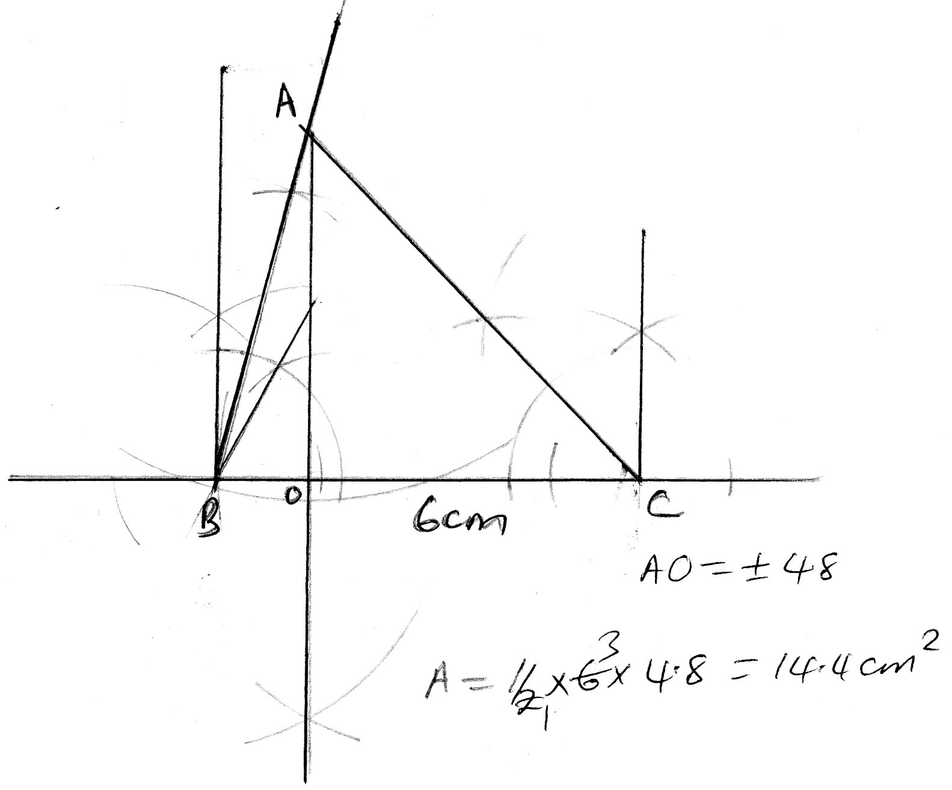 | M1  A1  M1  A1 | ΔABC  Perpendicular  Area
 |  | 04
14. | Men hours days  5 8 3  12 5 x  $$\begin{aligned}x=\frac{5×8×3}{\text{12}×5} \\ =2 \text{days}\end{aligned}$$ | M1  A1
 |  | 04
15. | Area Scale Factor = Determinant of the matrix  = x-12  6=+3x-12  X= -6 or 3  X=3 | M1  A1  B1
 |  | 03
16. | $$\begin{aligned}\text{men}=\frac{7}{9}×\text{45}=\text{35} \\ \text{women}=\frac{2}{9}×\text{45}=\text{10} \\ \text{let} \text{the} \text{additional} \text{number} \text{of} \text{women} \text{be} x \\ \frac{\text{35}}{\text{10}+x}=\frac{5}{4} \\ \text{50}+5x=\text{140} \\ 5x=\text{90} \\ x=\text{18} \text{women}\end{aligned}$$ | B1  M1  A1
 |  | 03
17.a)  b)  c)  d) | $$\begin{aligned}\text{IF}=\text{38000}+\text{14000}+\text{8500} \\ +\text{3300}\text{.} \\ =\text{Ksh}\text{.} \text{63},\text{800}\text{pm} \\ \text{IF} =\left(\frac{\text{63800}x\text{12}}{\text{20}}\right)=K\oint{\text{38280}}\end{aligned}$$  1st 6000x2=12000  2nd6000x3 =18000  3rd6000x4 =24000  4th6000x5 =30000  5th 6000x6=36000  6th 6000x7=42000  7th 2280x8 1842  Tax due =Ksh.180,240pa  Less relief 18,000  Tax payable 162,240  PAYE = 13,520  Total deduction  =13520+320+1000+2000+5000+500  =Ksh.22,340  38280-22340  =Ksh.15,940 | M₁  A₁  M₁  M₁  M₁  A₁  M₁  A₁  A₁  10 | For the 1st 3slabs  For 18,240  Process of - relief  CAO  addition
18.a) | a) i) Reflection in the line PR or ER B1  ii) Enlargement centre E B1  Scale factor -1 B1  iii) Rotation about point R B1  Through 90⁰ B1  clockwise B1 Accept -90 or 270  b) i) R - S B1 - quarter tum B2  C - A B1 + quarter turn 32  ii) R’ - Q B1  C’ - E B1 10
19.a)  b) | 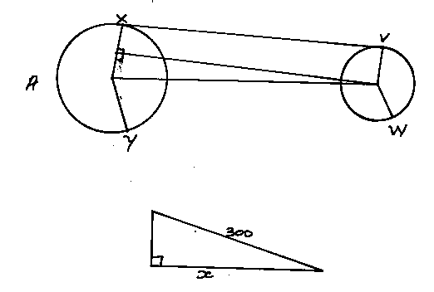 | M1  A1
 | a) length XV = 300 cm 70⁰ M₁  = 281.9cm A₁  b) Arc length VBW =  $\begin{aligned}\frac{\text{140}}{\text{360}}x2πr \\ \end{aligned}$$\begin{aligned}=\frac{{\text{140}}^{0}}{\text{360}}x2x\frac{\text{22}}{7}x\text{180} \\ =\text{439}\text{.}\text{88}\text{cm} \end{aligned}$  c) Length XAY  $\begin{aligned}C=\frac{θ}{\text{360}}2πr =\frac{\text{220}}{\text{360}}x2x\frac{\text{22}}{7}x\text{180} \\ = \text{691}\text{.}\text{24} \end{aligned}$  d) Length of the conveyor belt  =691.2+439+(2x281.9)  =1694.88 | M1  M1  A1  M1  M1  A1  M1  A1

20.a) | 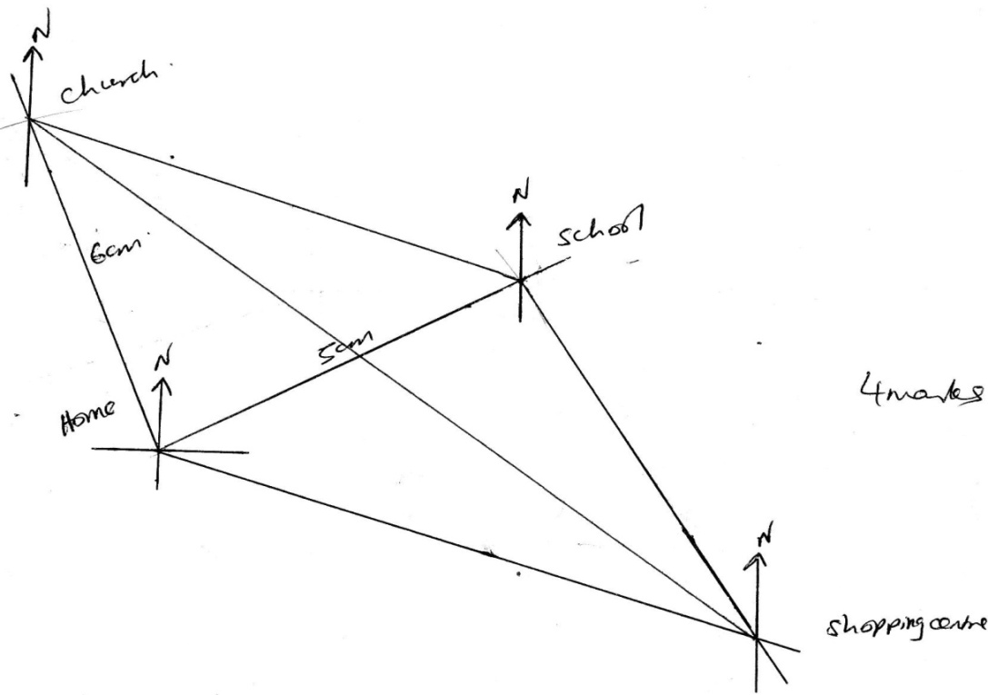 | B1  B1  B1  B1
b) | i)  ii)  iii)  bearing= 310º1º  - 7.5  Bearing =110º1º | B1  B1  B1  B1  B1  B1
 |  | 10

21. | (a) $P α \frac{V}{\sqrt{R}} P = K\frac{V}{\sqrt{R}}$  $\text{180} = K\frac{9}{\sqrt{\text{25}}} K = \frac{\text{180} × 5}{9}$  K = 100  $\text{180} = \frac{\text{100}V}{\sqrt{R}}$  $P = \frac{\text{100} × 6}{\sqrt{\text{26}}} = \text{117}\text{.}\text{67}$  (b) $P = \frac{\text{100}V}{\sqrt{R}} \text{360} = \frac{\text{100}V}{\sqrt{0\text{.}\text{64}}}$  $\text{360} = \frac{\text{100}V}{0\text{.}8}$  $\frac{\text{360} × 0\text{.}8}{\text{100}} = V$  V = 2.88  (c) V = 116% R = 75%  $P = \frac{\text{100} × 1\text{.}\text{16}}{\sqrt{0\text{.}\text{75}}}$  P = 133.945 – After change  133.945 – 100  = 33.945% | M1  M1  A1  M1  M1  A1  B1  M1  M1  A1
22.a)  b)
  x | -30 | 0 | 30 | 60 | 90 | 120 | 150 | 180 | 210 | 240 | 270
  Sin (x – 30) |  |  | 0.87 |  |  | 0.5 | 0.00 |  | 0.87 | -1.00
  Cos (x – 15) |  | 0.97 |  | 0.71 |  | -0.26 | -0.71
22.a)  b) | 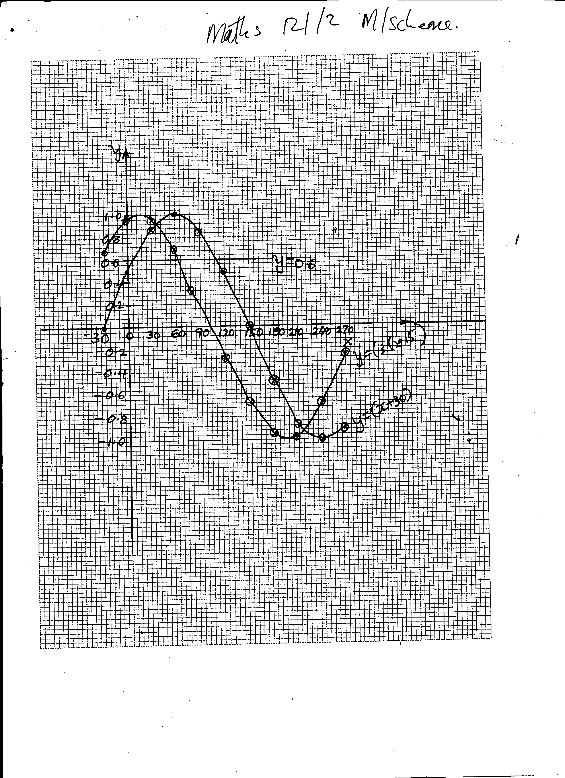
22.a)  b) | i) cos (x – 15)- sin (x – 30) = 0  cos (x – 15 ) = sin(x + 30)  x = 36 ±2 or x = 216±2  ii) co-ordinates of the turning point of y = cos (x – 15) on the negative section  (198;-1)  iii) Cos (x – 15 ) = 0.6  iv) X-15 = 66⁰
23.a)  b)  c) | 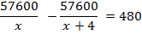  X²+4x=480=0  X²+24x-20x-480=0  X(x+24)-20(x+24)=0  (x+24)(x-20)=0  X=20  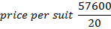  =sh 2880  % profit  =25% | B1  B1  M1  M1  M1  M1  A1  M1  A1  M1  A1  10
24. | $$\begin{aligned}S=\frac{A}{2}\left\{2a+\left(n−1\right)\right.d\left.\right\} \\ a=2, n=8 \text{and} S=\text{156},d \\ \frac{8}{2}\left\{2×2+\left(8−1\right)d\right\}=\text{156} \\ 4\left(4+7d\right)=\text{156} \\ \text{16}+\text{28}d=\text{156} \\ ⇒\text{28}d=\text{156}−\text{16} \\ \text{28}d=\text{140} \\ d=5\end{aligned}$$
 | $$\begin{aligned}\frac{n}{2}\left\{2×2+\left(n−1\right)\right.5=\text{416} \\ \frac{n}{2}\left(4+5n−5\right)=\text{416} \\ 4n+5n^{2}−5n=\text{416}×2⇒4n−5n+5n^{2}=\text{832} \\ 5n^{2}−n−\text{832}=0 \\ n=n\frac{1±\sqrt{\left(1\right)}−4×5−\text{832}}{\text{10}}=\frac{1±\text{129}}{\text{129}} \\ n=\frac{1±\text{129}}{\text{10}}=\frac{\text{130}}{\text{10}}=\text{13} \\ n=\frac{1−\text{129}}{\text{10}}=\frac{−\text{128}}{\text{10}}=n=\text{12}\text{.}8 \\ \text{ignore} n=\text{12}\text{.}8 \\ ∴n=\text{13}\end{aligned}$$
 | $$\begin{aligned}∴a+2d,a+4d,a+7d \\ \frac{a+4d}{a+2d}=\frac{a+7d}{a+4d} \\ \left(a+4d\right) \left(a+4d\right)=\left(a+2d\right) \left(a+7d\right) \\ a^{2}+4\text{ad}+4\text{ad}+1{\text{bd}}^{2}=a^{2}+2\text{ad}+\text{14}d^{2} \\ 8\text{ad}+\text{16}d^{2}=9\text{ad} \\ \text{16}d^{2}=9\text{ad}−8\text{ad} \\ \frac{\text{16}d^{2}}{9}=\frac{\text{ad}}{d} \\ a=\text{16}d \\ \text{but} d=3 \\ ⇒a=\text{16}×3 \\ \text{48} \\ r=\frac{a+4d}{a+2d}=\frac{\text{48}×4×3}{\text{48}+\left(2×3\right)}=\frac{\text{60}}{\text{54}}=\frac{\text{10}}{9} \\ \text{Sn}=\frac{a\left(r^{n}−1\right)}{r−1} \\ \frac{\text{48}\left(\frac{\text{10}}{9}\right)−1}{\frac{\text{10}}{9}−1} \\ \text{683}\text{.}\text{067}\end{aligned}$$

