NAME: ……………………………………….… ADM NO ………………………….
CLASS: ………………………….……. DATE…………………………………….…….
MIDTERM EXAM
TERM II 2021
PHYSICS FORM 3 TIME: 1hr 30min

Answer all the questions in this section in the spaces provided

1. The diagram below shows a pulley system, a mass of 10kg is raised 2m by an effort of 80N.
- Calculate the distance moved by effort. 2mks
____________________________________________________________________________________________________________________________________________________________________________________________________________________________________________________________________________________________________________________________________________
- How much potential energy does the load gain? 2mks
____________________________________________________________________________________________________________________________________________________________________________________________________________________________________________________________________________________________________________________________________________
- How much work is done by the effort? 2mrks
_____________________________________________________________________________________________________________________________________________________________________________________________________________________________________________________________________________________________________________________________________________
- What is the efficiency of these pulleys? 2mrks
_______________________________________________________________________________________________________________________________________________________________________________________________________________________________________________________________________________________________________________________________________________________________________________________________________________________________
v). The efficiency of a pulley system is always less than 100%. State two reasons. (2 marks)

2.(a) State the principle of conservation of Linear momentum. (1mk)

(b).Calculate the recoil velocity of a gun of mass 0.4kg which fires a bullet of mass 0.090kg at a velocity of 600m/s. (3mks)

3. (i) Statetwo factors which affect frictional force of a body. (2mrks)

(ii).Suggest anytwo ways in which friction can be minimized. (2mks)

(iii).State two advantages of friction. (2mks)

4.A trolley of mass 0.5kg moving with a velocity of 1.2ms⁻¹collides in elastically with a second trolley of mass 1.5kg moving in the same direction with a velocity of 0.2ms⁻¹.
(a) What is an inelastic collision? (2mk)

(b) Determine the velocity of the trolleys after collision. (2mks)

(c). Define the following terms as used in refraction

i. Total internal reflection (1mrks)

ii. Critical angle ( 1mrks)

d). State the two law of fraction of light. (2mks)

5. (a) Differentiate the following terms, (1maks)
- Distance and displacement
………………………………………………………………………………………………………………………………………………………………………………………………………………………………………………………………………………………………………………
- Speed and velocity (1 marks)
………………………………………………………………………………………………………………………………………………………………………………………………………………………………………………………………………………………………………………
- Acceleration and deceleration. (1 marks)
………………………………………………………………………………………………………………………………………………………………………………………………………………………………………………………………………………………………………………
. (b).An object at rest is dropped from a height of 80m.
(i) Sketch a velocity-time graph for the object. (2marks)

(ii) Determine how long it takes to reach the ground (3 marks)

(iii) Determine the velocity as it hits the ground. (3marks)

6. (a) (i) State the basic law of electrostatics. (1mark

(b) The figure below shows an arrangement which may be used to charge a capacitor of capacitance 50µF and then to connect it to a capacitor of capacitance 20µF.
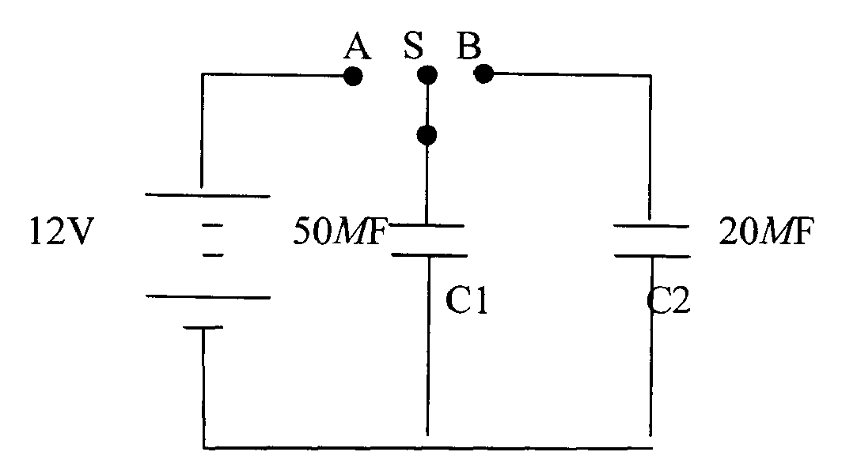

The switch S is first placed at position A, so that the capacitor C, is connected to the 12V dc supply.
Calculate the charge stored in the capacitor. (3marks)
…………………………………………………………………………………….…………………..…………
…………………………………………………………………………………….…………………..…………
…………………………………………………………………………………….…………………..…………

7. a). Studythe figure below and use it to answer the questions below it.

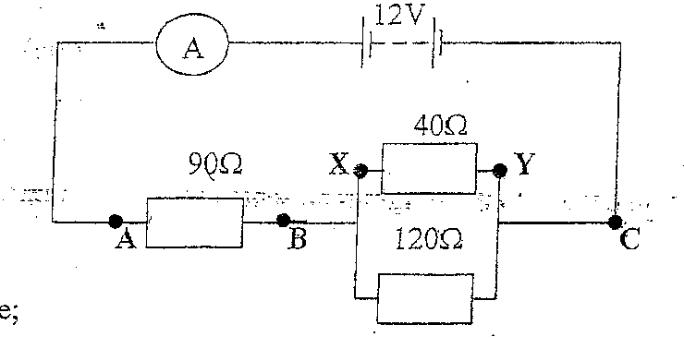

Determine the:
i) Current flowing through the ammeter. (3marks)
------------------------------------------------------------------------------------------------------------------------------------------------------------------------------------------------------------------------------------------------------------------------------------------------------------------------------------------------------------------------------------------------------------------------------------------------------------------------------------------------------------------------------------------------------------------------------------------------------------------------------------------------------------------------
ii) potential difference between X and Y (2marks)
------------------------------------------------------------------------------------------------------------------------------------------------------------------------------------------------------------------------------------------------------------------------------------------------------------------------------------------------------------------------------------------------------------------------------------------------------------------------------------------------------------------------------------------------------------
b). State two factors that affect electrical resistance of a conductor. (2marks)
------------------------------------------------------------------------------------------------------------------------------------------------------------------------------------------------------------------------------------------------------------------------------------------------------------------------------------------------------------------------------------------------------------------------------------------------

