MARKING SCHEME
231 BIOLOGY
FORM FOUR
MID TERM 2

- Name the stage in meiosis where chromosome number is reduced by a half? (1 mark)
Anaphase 1
- Some herbaceous stems have very little strengthening tissue yet still remain upright. Suggest how they are able to do this. (1 marks )
Herbaceous plants have parenchyma tissues; when the tissues are turgid, they provide mechanical support
- In a bony fish, water flows along the gill lamellae in a direction opposite that of the flow of blood. Explain the importance of this. (2 marks )
Ensures that as blood gets progressively oxygenated ,it meets water that is progressively richer in oxygen ; therefore there is continuous diffusion of oxygen from water into the blood ; blood that leaves the gills has almost the same concentration of oxygen as the water that enters the gills
- (i)What is the basic unit of a DNA molecule (1 mark)
Nucleotide
(ii)Name the chemical components of the unit named in (1) above (3 marks)
A 5- carbon sugar (Deoxyribose ) ;
Phosphate group;
Organic nitrogenous base
(iii) Name one type of disorder that arises due to chromosomal mutation in human beings (1 mark)
Down’s syndrome, Klinefelter’s syndrome, Turner’s syndrome (Mark the first)
- Explain four adaptations of blood capillaries to their function (4 marks)
Their walls are made up of an endothelium only which allows part of blood to move into the intercellular space;
Are numerous thus creating a large surface area for exchange of materials;
Have narrow lumens that maintain high blood pressure;
Have sphincter muscles at the arteriole end which enables regulation of blood flow
- State three roles of auxins in plants (3 marks)
Stimulate cell division, elongation and differentiation;
Responsible for tropisms;
Stimulates growth of adventitious roots;
Stimulates pathenocarpy;
Stimulates apical dominance;
Callus tissue formation;
In presence of cytokinins it initiates cell division at the cambium
- Name the organelles that are involved in the following
- Formation of ATP. (1 mark)
Mitochondria
(b)Fixation of carbon (IV) oxide, to form glucose. (1 mark)
Chloroplasts
- The spread of acaricide - resistant ticks in Kenyan farmland is an example of natural selection in action. Explain this phenomenon. (3 marks)

Tick population has different strains ; some strains have a gene that makes them neutralize the effects of the acaricide ; this gives them a selective advantage which enables them to survive ; reproduce and transmit the gene to their offspring ; over time the population of this resistant strain has increased and spread across the Kenyan farmlands ; ( O.W.T.T.E.)
- (a) Explain the term basal metabolic rate (1 mark)
A basal metabolic rate is the minimum amount of energy that an organism requires at rest to maintain life processes
(b) List three differences between aerobic respiration and photosynthesis (3 marks)
Aerobic Respiration | Photosynthesis
Takes place in both plant and animal cells | Takes place only in plant cells with chlorophyll ;
Continues both in presence and absence of light | Takes place only in presence of light ;
Uses oxygen | Releases oxygen ;
Releases carbon (iv) oxide and water | Uses carbon (iv) oxide and water ;
Takes place in mitochondria | Takes place in chloroplast ;
Leads to breakdown of complex organic food molecules into simple inorganic compounds | Leads to synthesis of complex organic molecules from simple inorganic compounds ;
Releases energy | Stores energy in chemical bonds of complex organic molecules ;

- What is the significance of diffusion in pollination? (1 mark)
The insects that carry out pollination are attracted by the smell from the flowers , this may lead to pollination
(b) Is diffusion an energy driven process? Explain. (2 marks)
No; it is a passive process where particles move along a diffusion gradient
- Imagine you are sitting outside in the shade of a tree reading a newspaper and you look up to a distance sunlit aero plane flying in the air. Describe the sequence of events in that take place in the eye structures from reading the newspaper to viewing the plane (4 marks)
Ciliary muscles relax increasing the tension of ligaments,
Lens decrease curvature /lens becomes thinner, light rays from a far object are less refracted and hence focused on the retina.
Radial muscles of iris relax ,circular muscles contract, Pupil size constricts to reduce amount of light entering the eye.
(O.W.T.T.E)

- The figure below shows the changes in blood levels of hormones that take place during the menstrual cycle in human female.
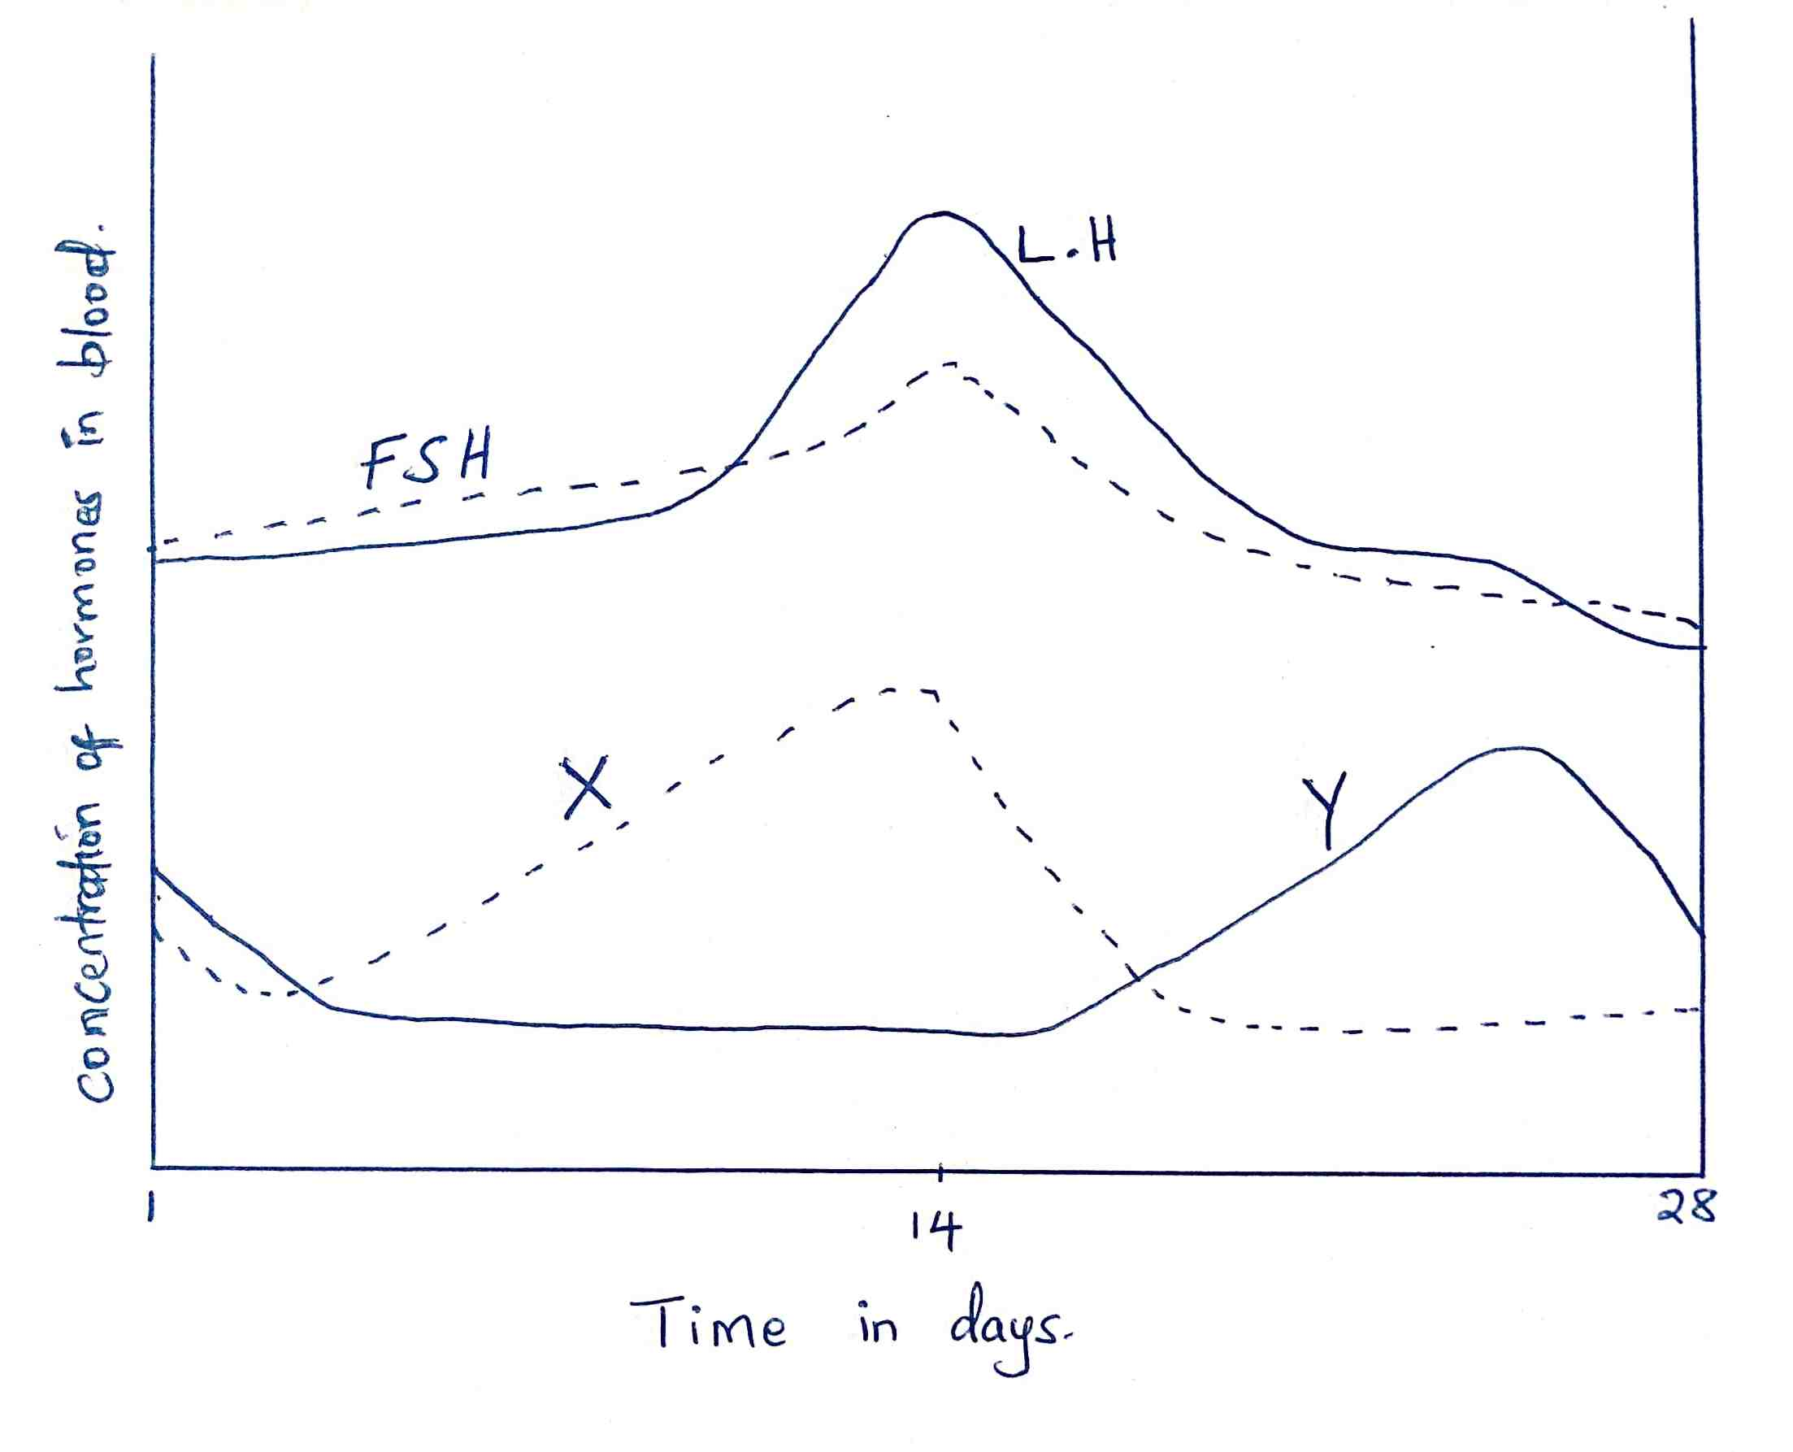

a) Name the hormones whose concentrations are represented by curves X and Y (2 marks)
X – oestrogen
Y – progesterone
b) State two effects of the hormone X during the menstrual cycle (2 marks)
Repair and healing of endometrium ;
Stimulates pituitary glands to secret LH
c) Explain the role of FSH in female reproduction (2 marks)
FSH causes development of Graafian follicles ;
Stimulates the cells on the wall of the Graafian follicle to secret oestrogen
d) What is the role of a high concentration of luteinizing hormone? (1 mark)
Triggers ovulation; ( 1 mk )
e) State the fertile period during the menstrual cycle (1 mark)
12th to 16th day after the onset of menstruation
- Arachnids and crustaceans belong to the same phylum.
a) Name the phylum (1 mark)
Arthropoda ; rej. If A is small
b) State two characteristics that make them to be classified in the phylum you stated in (a) above (2 marks)
Have jointed appendages ;
Have exoskeleton made of chitin;
Have segmented body
c) Give one structural feature that can be used to differentiate crustaceans and arachnids (1 mark)
Crustaceans have two pairs of antennae while arachnids have none
- In a certain experiment the field of view of the microscope was determined as 4 mm. 16 cells were found to span across the diameter of the field of view of the microscope.
a) Calculate the size of one cell in micrometers (2 marks)
Field of view diameter = 4 mm
Number of cells found = 16
Cell size = Diameter of field of view
Number of cells
= ( 4 x 1000 ) micrometers
16 cells
=250 micrometers
b) If 100 epidermal cells were viewed under magnification x 150, how many cells will be observed at magnification x 450 using the same slide? (2 marks)
^{150 x 100}/₄₅₀ = 33 cells
15. a) Guard cells are specialized epidermal cells. State two structural features which suit them to their functions (2 marks)
Inner thick wall and outer thin wall which result into unequal expansion causing opening and closing of stomata;
Presence of many chloroplasts for photosynthesis;
Curved / bean shape
b) Apart from gaseous exchange; give one other function of the stomata (1 mark)
Permits escape / loss of water vapor from the leaf by transpiration

