NAME:……………………………………………………… CLASS: …………………..
DATE: ………………………………………………………. ADM NO: ……………………….

Kenya Certificate of Secondary Education
FORM 4

MATHEMATICS
PAPER- JUNE/JULY
TIME: 2 ½ HOURS

INSTRUCTIONS TO CANDIDATES

1. Write your name and index number in the spaces provided at the top of this page.
2. This paper consists of two sections: Section l and Section II
3. Answer all questions in section l and any five questions from Section II.
4. Show all the steps in your calculations, giving your answers at each stage in the spaces below each question.
5. Marks may be given for correct working even if the answer is wrong.
6. Non- programmable silent electronic calculators and KNEC Mathematical tables may be used.

FOR EXAMINER’S USE ONLY
SECTION I
1 | 2 | 3 | 4 | 5 | 6 | 7 | 8 | 9 | 10 | 11 | 12 | 13 | 14 | 15 | 16 | TOTAL

SECTION II GRAND TOTAL

17 | 18 | 19 | 20 | 21 | 22 | 23 | 24 | TOTAL

This paper consists of 16 printed pages. Candidates should check the question paper to ascertain that all pages are printed as indicated and that no questions are missing.
- Use logarithms to evaluate. (3mks)

- A quantity y varies partly as x² and partly as x. When y = 6, x = 1 when y = 30, x = 3. Find y when x = - 3. (3mks)

- Point T is the mid-point of a straight line AB. Given the position vectors of A and T are i-j + k and 2 i+ 1 ½ k respectively, find the position vector of B in terms of i, j and k. (3mks)

- The points with coordinates (5, 5) and (-3, 1) are the ends of a diameter of a circle centre A.
Determine:
(a) The coordinates of A (1mk)

(b)The equation of the circle, expressing it in form x² + y² + ax + by + c = 0 Where a, b, and c are constants (2mks)

- Giving reasons, find the angle marked b, given that EF is parallel to AC (2mks)
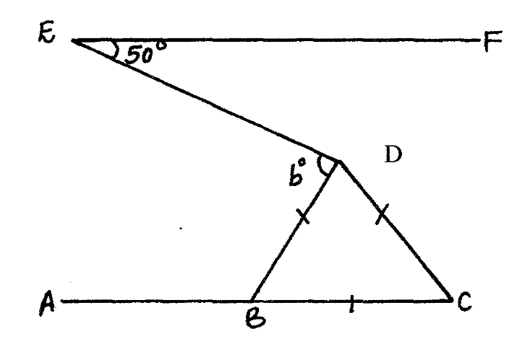

- Solve the equation 4 sin (x +30⁰) = 2 for 0 < x < 360⁰ (3mks)

- Pipe A empties a full tank in 8 hours, pipe B empties in 6 hours and pipe C empties in 3 hours. If all the three pipes are open for 30 minutes and then pipe A closed, How long will it take to empty a full tank. (3 mks)

- Simplify the expression: (3mks)

- Two trains T₁ and T₂, traveling in opposite directions on parallel tracks are just beginning to pass one another. Train T₁ is 72 metres long and is traveling at 108km/hr.T₂ is 78 metres long and traveling at 72km/hr. Find the time in seconds the two take to completely pass oneanother. (4mks)

- By using the substitution y = 2^{x}, solve the equation. (3mks)
- x 2^{2x+1}– 3 x 2^{x} – 34 = 0

- A circle centre o, has the equation x² + y² = 4
The area of the circle in the first quadrant is divided into 5 vertical strips each of width 0.4cm.
- Use the equation of the circle to complete the table below for values of y correct 2 decimal places. (1 mk)

X | 0 | 0.4 | 0.8 | 1.2 | 1.6 | 2.0
Y | 2.00 |  |  | 1.60 |  | 0

b)Use the trapezium rule to estimate the area of the circle. (2mks)

- Find the positive number m for which (3mks)
$\int_{1}^{m}{4x^{2}}dx=80$

- The length of a triangle is (3x + 1) cm. Its width is 3cm shorter than its length. Given that the area of rectangle is 28cm². Find its length. (3 marks)

- Write down the inequalities that satisfy the unshaded region R shown in the figure below. (4 mks)

- Given that point A(2,4) and B(8, -4), find the equation of the perpendicular bisector of line AB. (3 marks)

- Make P the subject (2 marks)

SECTION II (50 MARKS)
Answer ANY FIVE Questions from this section in the spaces provided
- A tailor is required to make two types of skirts. Type A and type B. The total number of skirtsmust not exceed 500. Skirts of type B must not be less than skirts of type A. The tailor must make at least 200 skirts of type A. Let x represent the number of skirts of type A and Y represent the number of skirts of type B.
a) Write down the inequalities that describe the given conditions above. (3marks)

b) On the grid provided, draw the three inequalities and shade the unwanted regions.(3marks)

c) Profits were as follows
Type A, Kshs. 900 per skirt
Type B, Kshs. 700 per skirt
Determine the maximum possible profits (4 marks)

- Construct a triangle PQT such that PQ = 10 cm QR = 9 cm and RP = 8 cm.
i) Construct the locus of the point x such that QX = XR and mark with the letter X the point where this locus meets QR.

- Construct the locus of the point X such that QX = XR and mark with the letter X the point where this locus meets QR

- Construct the locus of the point Y such that PY= 6cm and mark with the letter Y, the point where the locus meets PR.

- By Shading the unwanted regions show the area bounded by the three loci by theletter T such that QT, PT 6 cm, < PRT< QRT
Label the region required by the letter T. ( 10mks)

- The diagram below shows a straight line intersecting the curve y = (x-1)² + 4.
at the points P and Q. The line also cuts x-axis at (7,0) and y axis at (0,7)
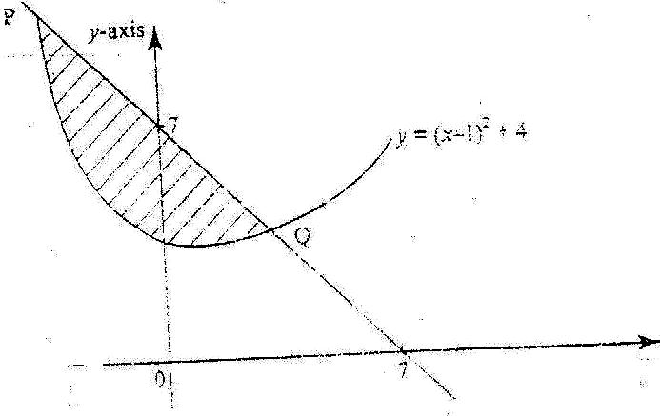

a) Find the equation of the straight line in the form y = mx +c. (3mks)

b) Find the coordinates of P and Q. (2mks)

c) Calculate the area of the shaded region. (5mks)

- In the figure below, P, Q, R and S are points on the circle centre O. PRT and USTV are straight lines. Line UV is a tangent to the circle at S. ∠RST = 50⁰ and ∠RTV = 150^{0.}
- Calculate the size of;
i) Angle ORS (2 marks)

ii) Angle USP (1 mark)

iii) Angle PQR (2 marks)

- Given that RT = 7cm and ST = 9cm, calculate to 3 significant figures;
i) The length of line PR. (2 marks)

ii) The radius of the circle. (3 marks)

21. The probability of passing K.C.P.E depends on performance in the school mock examination. If the candidate passes in mock, the probability of passing K.C.P.E is ⁴/_{5.} If the candidate fails in mock, the probability of passing K.C.P.E is ³/_{5.}If the candidate passes K.C.P.E, the probability of getting employed is ¹/_{3,} the probability of passing mock is ²/_{3.}
a). Draw a well labelled tree diagram to represent the above information. (2mks)

b) Use your tree diagram in (a) above to find the probability that she
i) Passes KCPE exams (2mks)

ii) Gets employed (2mks)

iii) Passes KCPE and gets employed (2mks)

iv) Passes mock and gets employed (2mks)

22. a) The first term of an arithmetic progression (AP) is 2.The sum of the first 8 terms of AP is 256.
i) Find the common difference of AP (2mks)

- Given that the sum of the first n terms of the AP 416. Find n (2mks)

b) The 3rd, 5th, and 8th terms of another AP forms the first three terms of a GeometricProgression (GP).If the common difference of the AP is 3.
Find
- The first term of GP (4mks)

- The sum of the first 9 terms of the GP to 4 s.f (2mks)

23. A company employee earns a monthly basic salary of Kshs. 25,000 and is also given a taxable allowance amounting to Kshs. 10,480. Using the rate of taxation below
Monthly taxable income (Kshs) Rate in Kshs / pound
1 – 4350 2
4351 – 8900 3
8901 – 13455 4
13451 – 18005 5
18006 and above 6
- Calculate the employees taxable income (2mks)

- If the employee is entitled to a personal tax relief of Kshs. 800 per month, determine the net tax (5mks)

- If the employee was given 40% increase in his income, calculate the percentage increase in his income tax (3mks)

- In the figure below (not drawn to scale), AB = 11cm, BC=8cm, AD=3cm, AC=5cm and angle DAC is a right angle.
5 cm
11 cm
3 cm
8cm
D
C
B
A

Correct to 1 decimal place, calculate:
- The length DC. (2mks)

- The size of angle ADC. (2mks)

- The size of angle ACB. (3mks)

- The area of the quadrilateral ABCD. (3mks)

