GEOGRAPHY MARKING SCHEME
FORM 3
TERM 2 – 2021
TIME: 1 HR 25 MINUTES

INSTRUCTIONS.
Answer all the questions in the spaces provided.

- The diagram below represents a barchan. Use it to answer questions. (a)

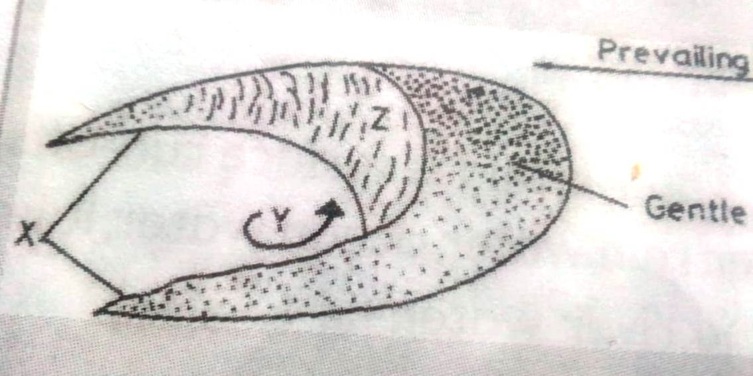

- Name:
- The feature marked X. (1mk)
- Horns
- The air current marked y. (1mk)
- Eddy current
- The slope marked Z. (1mk)
- Steep leeward slope
- State three ways in which wind transports the Lord. (3mks)
- Suspension
- Surface creep
- Saltation
- Name two types of submerged highland coasts. (2mks)
- Ria coasts
- Longitudinal coasts
- Flord coast

b. Differentiate between an ocean and a sea. (2mks)
- An ocean is an extensive mass of saline water occupying a large basin between continents while a sea is a large body of saline water on the continental margin.
- State two factors which determine the size of a lake. (2mks)
- The total annual rainfall of the drainage basin.
- The size of the depression in which the lake forms or the barrier behind which water collects to form a lake.
- The diagram below shows a waterfall. Name the feature marked X,Y and Z. (3mks)

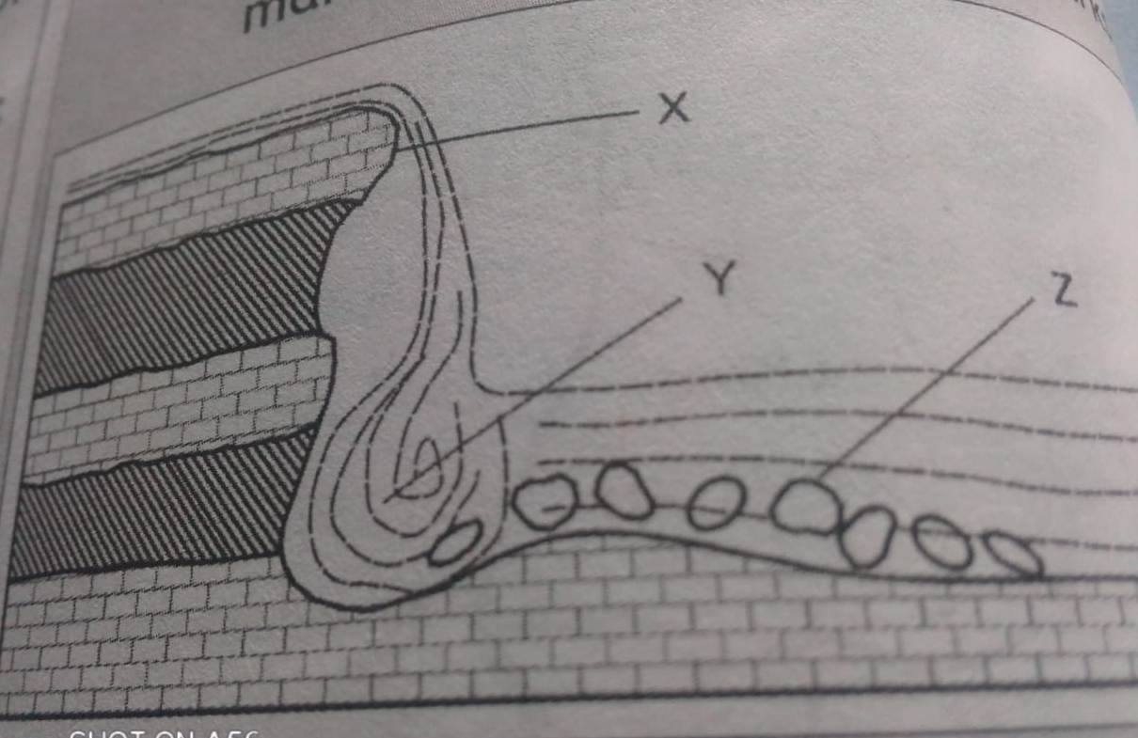

X- Resistant rock
Y- Plunge pool
Z- boulders

- State four factors that influence weathering. (4mks)
- Nature of the rock
- Degree of steepness of the land
- Structure of the rocks
- Climate of the area.
- The table below shows the value of live births of country Y in the year 2020. Use these data to present the information using a simple pie-chart. (8mks)
Province | No. of live births.
Kataba | 2800
Fataka | 3600
Kipani | 4020
Gamboni | 6200
Total | 16620

Kataba = 2800 x 360º= 60.6º
16620

Fataka = 3600 x 360º= 77.9º
16620
Kipani = 4020 x 36⁰= 87º
16620
Gamboni = 6200 x 360º=134.2º
16620

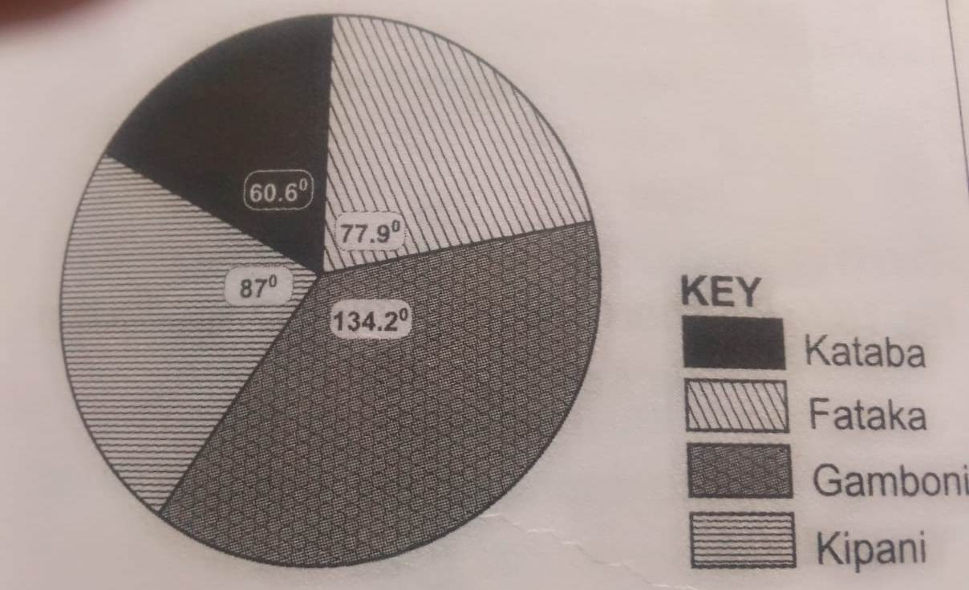

- Differentiate between planted and secondary vegetation. (2mks)
- Planted vegetation refers to the vegetation planted or grown deliberately by human being while secondary vegetation refers to the vegetation that has regenerated itself naturally after the original vegetation has been cut down.

ii. State four characteristics of coniferous forest. (4mks)
- The trees have a conical shape.
- The trees have thick backs.
- The trees have hard needle shaped leaves.
- Trees take longtime to mature due to extreme cold.
- The tree are ever green.
- Trees are tall and light in weight.
- Trees are found in pure stand.

b. Differentiate between weather and climate. (2mks)
- Weather refers to the day to day atmosphere conditions of a place over a short period of time while climate refers to a weather condition of a place over a long period of time usually 30-35 years.

ii. What is climate change? (2mks)
- Climate change is the process by which new atmospheric conditions especially of temperature and rainfall are established in a place hence changing its climate state.

c. Name four extrusive volcanic features. (4mks)
- Shield volcanoes
- Composite volcanoes
- Crater and caldera
- Hot springs and geysers.

- Name two types of open cost mining. (2mks)
- Stripping
- Hill slope boring

ii. Name three types of igneous rocks. (3mks)
- Intrusive igneous rocks
- Extrusive igneous rocks
- Hypabysal igneous rocks.

b. You have planned to carry out a field study on the weather experienced in the locality of your school. State two importance of the reconnaissance visit. (2mks)
- To familiarize the researcher with the route to study.
- Help decide on methods of data collection.
- Help identify the possible problems and probable solution cost of study can be estimated and planned for.

ii. List two theories that explain the origin of the solar system. (2mks)
- Nebula cloud theory
- Passing star theory.

