NAME:………………………………………………………….CLASS:……ADM NO:………

MID TERM EXAMINATION
GEOGRAPHY
FORM 3
TERM 2 – 2021
TIME: 1 HR 25 MINUTES

INSTRUCTIONS.
Answer all the questions in the spaces provided.

- The diagram below represents a barchan. Use it to answer questions. (a)

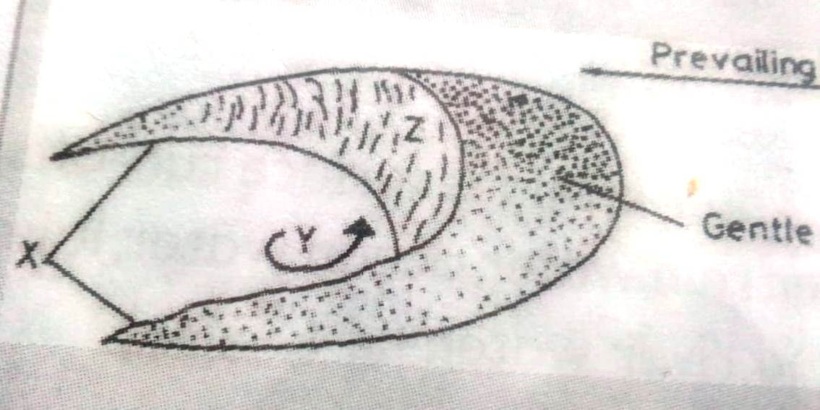

- Name:
- The feature marked X. (1mk)

- The air current marked y. (1mk)

- The slope marked Z. (1mk)

- State three ways in which wind transports the Lord. (3mks)

- Name two types of submerged highland coasts. (2mks)

b. Differentiate between an ocean and a sea. (2mks)

- State two factors which determine the size of a lake. (2mks)

- The diagram below shows a waterfall. Name the feature marked X,Y and Z. (3mks)

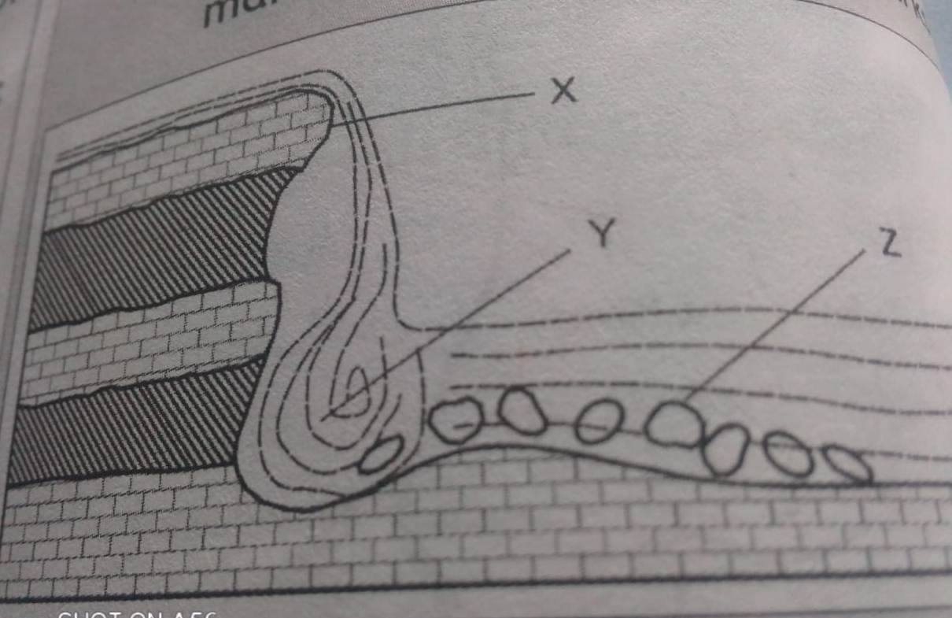

- State four factors that influence weathering. (4mks)

- The table below shows the value of live births of country Y in the year 2020. Use these data to present the information using a simple pie-chart. (8mks)
Province | No. of live births.
Kataba | 2800
Fataka | 3600
Kipani | 4020
Gamboni | 6200
Total | 16620

- Differentiate between planted and secondary vegetation. (2mks)

ii. State four characteristics of coniferous forest. (4mks)

b. Differentiate between weather and climate. (2mks)

ii. What is climate change? (2mks)

c. Name four extrusive volcanic features. (4mks)

- Name two types of open cost mining. (2mks)

ii. Name three types of igneous rocks. (3mks)

b. You have planned to carry out a field study on the weather experienced in the locality of your school. State two importance of the reconnaissance visit. (2mks)

ii. List two theories that explain the origin of the solar system. (2mks)

