FORM FOUR GEOGRAPHY

MARKING SCHEME

1. Study the graph below and use it to answer the question (a) and (b).
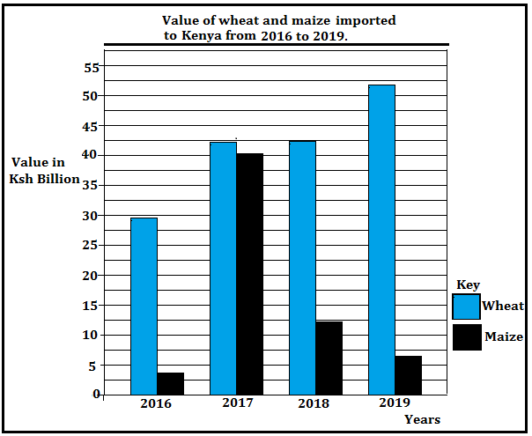
(a) (i) Identify the type of graph drawn above. (1 mark)
Comparative bar graph.
(ii) Give the trend of the imports represented on the graph (2 marks)
- The value of wheat imports had been increasing over the four years.
- Value of maize imports increased sharply in 2017 then declined in the following years.
- Year 2019 had the highest value of wheat imports.
- The difference in value of wheat and maize imports was smallest in year 2017.
- 2016 had the lowest value of maize imports.
(b) State three problems facing maize farmers in Kenya. (3 marks)
- The crop is attacked by pests i.e. weevils/birds/aphids/army worms/stalk-borer lowering yields and quality
- The crop is attacked by diseases such as maize lethal Necrosis and white leaf blight thus lowering yields and quality.
- The crop is affected by fluctuations in market prices, reducing income to the farmer.
- Some maize growing areas have poor /impassable roads, during the rainy seasons which affect the production/delivery of the harvest.
- Inadequate rainfall/drought at times leads to crop failure.
- High cost of farm inputs prices which reduce farmers’ income.
- Delayed payments to farmers reduce their morale.
- Poor storage facilities /silos thus the produce is destroyed by the weevils.

2. (a) Name two fishing nations within the North East Pacific fishing ground. (2 marks)
- Canada
- United States of America.
(b) Give three measures taken to address the problem of overfishing in Kenya. (3 marks)
- Fishing is restricted to specific seasons to allow for breeding and maturing of fish
- Enforcing the use of standardized nets to prevent catching of immature fish/fingerlings
- Licensing fishermen to control their number and to ensure that there is no over-fishing.
- Patrolling the Kenyan waters at the coast to prevent foreign fishing vessels.
- Fish farming is being encouraged to that there is sufficient supply of fish from other sources other than the natural fisheries
- Restocking of over-fished waters by introducing fingerlings from hatcheries.
3. State three disadvantages of petroleum as a source of energy. (3 marks)
- Crude oil is bulky to transport.
- Burning petroleum products pollutes the environment.
- Petroleum products are highly inflammable thus deadly if improperly handled.
- Oil exploration is very expensive.
- Petroleum is an exhaustible source of energy.
4. (a) Distinguish between balance of trade and balance of payments. (2 marks)
Balance of trade is the difference in value between a country’s visible exports and its visible imports whereas balance of payments is the difference in value between a country’s total exports (visible and invisible) and its total imports (visible and invisible).
(b) State three objectives of forming Common Market for Eastern and Southern Africa. (COMESA) (3 marks)
- To create a common market for goods produced within member states.
- To promote transport and communication between member states.
- To reduce unnecessary competition amongst member states.
- To eliminate taxes on goods produced within member states.
- To establish a common bank that would assist in investment, economic and social development.
- To enable the member states to increase the use of their raw materials.
- To facilitate good relations, peace, political stability and high standards of living
5. (a) Give three natural environmental hazards. (3 marks)
- Volcanic eruptions
- Windstorms
- Earthquakes
- Pests and diseases
- Lightning
- Floods
- Land slides
(b) State three causes of water pollution in Kenya. (3 marks)
- Discharge of toxic industrial effluent in water bodies.
- Poisonous farm /agrochemicals that are drained into rivers through surface runoff.
- Animal waste from abattoirs and farm houses which are discharged in water bodies.
- Soil erosion due to human activities which pollutes rivers and lakes.
- Rotting garbage which is washed into rivers thus polluting the water.
- Discharge of raw sewage into water bodies such as rivers, lakes and the sea.
- Oil spills from oil rigs, tankers, water vessels and underwater pipelines.

6.. (a) (i) Apart from a census, give two other primary sources of population data (2 marks)
- Sample surveys
- Registration of persons
(ii) State three reasons why a census is important to Kenya (3 marks)
- A census provides information on the trends of mortality and fertility
- Information obtained helps governments to plan for the provision of basic facilities such as schools hospitals and food
- It helps in the creation of new administrative units such as counties, constituencies or wards
- It shows the composition of population in terms of age sex and regional distribution
- Total population assists the government to know if there are adequate resources
- A population census enables the estimation of population growth to determine literacy level.
(b) Explain three causes of a reduced fertility rate in Kenya (6 marks)
- Increased rate of use of birth control measures among many productive females which lowers the number of children.

- More girls are attending school up to tertiary levels thus delaying in getting married which contributes to a lower fertility rate.
- Increased number of women mainly in urban centres opting to remain single thus opting to have very few children
- Modern career opportunities may delay young women from getting children as some employers avoid women who keep on going on maternity leave.
- Hard economic times in urban centres and the high cost of child upkeep have forced many people to limit the number of children which lowers the fertility rate.

7. (a) Define the term urbanization. (2 marks)
Urbanization is the process through which people are transformed from the traditional agricultural lifestyle to a modern commercial lifestyle.
(b) The diagram below shows the functional zones of an ideal urban centre.
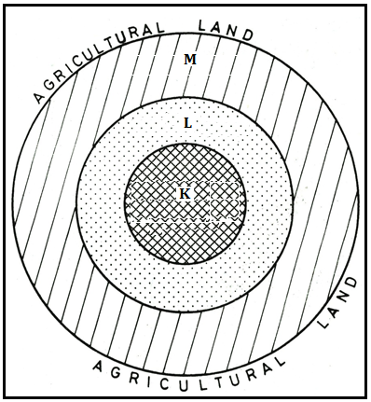
(i) Identify the zones marked L and M. (2 marks)
L – Industrial zone/area
M – Residential zone/area
(ii) Sate four characteristics of the zone marked K. (4 marks)
- Has many tall buildings / sky crappers.
- Has very high land/rental value.
- Has very limited space.
- Has vertical extension of buildings to maximize on land use
- It is the centre of traffic focus.
- Has limited surface parking space.
- Has traffic jams during rush hours.
- Underground parking space is common.
- Traffic flow is constant and slow
- Has high population density during the day and low at night.

(c) Explain how Lake Victoria has contributed to the growth of Kisumu. (6 marks)
- Being a lake port, Kisumu handles goods across the Lake Victoria to neighbouring countries such as Uganda and Tanzania thus facilitating regional trade.
- Kisumu’s location on the shores of Lake Victoria ensures a reliable source of water for domestic and industrial use.
- Fishing activities in Lake Victoria and the establishment of fish processing industries has attracted many people contributing to the growth of the Lakeside City.
- Lake Victoria attracts many tourists who visit Kisumu thus increased income to the local residents.

THIS IS THE LAST PRINTED PAGE.

