NAME……………………………………………………………................CLASS………ADM………….
FORM FOUR
GEOGRAPHY
MID TERM 2, 2021 EXAM.
DURATION: 1HR 15MIN
Instructions: Answer all the questions in the foolscaps provided

1. Study the graph below and use it to answer the question (a) and (b).
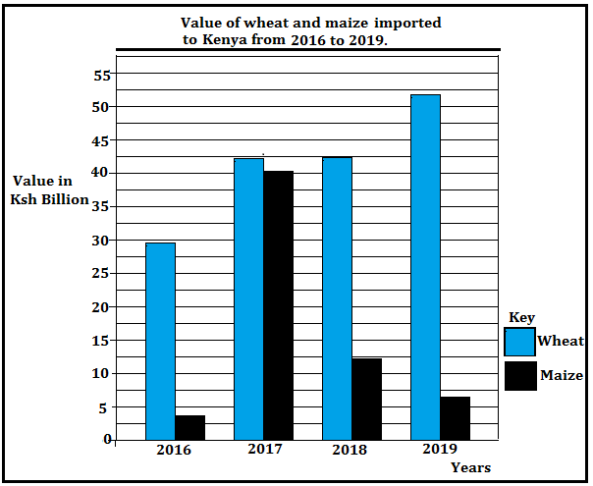
(a) (i) Identify the type of graph drawn above. (1 mark)
(ii) Give the trend of the imports represented on the graph (2 marks)
(b) State three problems facing maize farmers in Kenya. (3 marks)
2. (a) Name two fishing nations within the North East Pacific fishing ground. (2 marks)
(b) Give three measures taken to address the problem of overfishing in Kenya. (3 marks)
3. State three disadvantages of petroleum as a source of energy. (3 marks)
4. (a) Distinguish between balance of trade and balance of payments. (2 marks)
(b) State three objectives of forming Common Market for Eastern and Southern Africa. (COMESA) (3 marks)
5. (a) Give three natural environmental hazards. (3 marks)
(b) State three causes of water pollution in Kenya. (3 marks)
6.. (a) (i) Apart from a census, give two other primary sources of population data (2 marks)
(ii) State three reasons why a census is important to Kenya (3 marks)
(b) Explain three causes of a reduced fertility rate in Kenya (6 marks)

7. (a) Define the term urbanization. (2 marks)
(b) The diagram below shows the functional zones of an ideal urban centre.
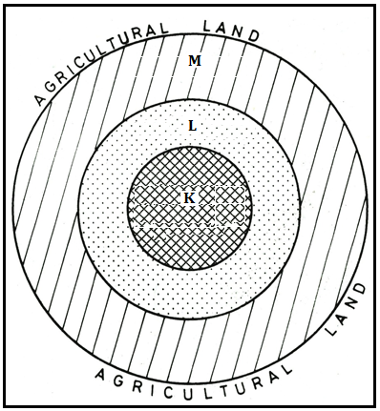
(i) Identify the zones marked L and M. (2 marks)
(ii) Sate four characteristics of the zone marked K. (4 marks)
(c) Explain how Lake Victoria has contributed to the growth of Kisumu. (6 marks)

THIS IS THE LAST PRINTED PAGE.

