NAME: ADM NO:

DATE: SIGN:

312/1
GEOGRAPHY
FORM 2
END OF TERM II EXAM (2021)
TIME: 2 HRS

Instructions
- Answer all questions on the spaces provided
- Answer should be written in English

- Identify the term that describe the following statement (4mks)
 | Statement | Term
 | Study of the rock materials
 | study of weather and climate
 | study of soil
 | study of population
- Identify four ways a form two student would benefit from studying geography (4mks)
…………………………………………………………………………………………………………………………………………………………
…………………………………………………………………………………………………………………………………………………………
………………………………………………………………………………………………………………………………………………………
…………………………………………………………………………………………………………………………………………………………
3) Classify the following clouds as either high, middle or low clouds (use a tick) (3mks)
 | Types of clouds | High | Middle | Low
i) | Cumulus
ii) | Cirros
iii) | Stratus
4) Name four instruments kept in a Stevenson screen (4mks)
…………………………………………………………………………………………………………………………………………………………
…………………………………………………………………………………………………………………………………………………………
……………………………………………………………………………………………………………………………………………..…………
…………………………………………………………………………………………………………………………………………………………
5)a) Differentiate between magnetic North and true North (2mks)
…………………………………………………………………………………………………………………………………………………………
…………………………………………………………………………………………………………………………………………………………
……………………………………………………………………………………………………………………………………………..…………
b) Identity four factors that should be considered when preparing a questionnaire (4mks)
…………………………………………………………………………………………………………………………………………………………
…………………………………………………………………………………………………………………………………………………………
……………………………………………………………………………………………………………………………………………..…………
…………………………………………………………………………………………………………………………………………………………
6) State four methods of recording statistical Data (4mks)
…………………………………………………………………………………………………………………………………………………………
…………………………………………………………………………………………………………………………………………………………
……………………………………………………………………………………………………………………………………………..…………
…………………………………………………………………………………………………………………………………………………………
7)a)i) Define the term map (2mks)
…………………………………………………………………………………………………………………………………………………………
…………………………………………………………………………………………………………………………………………………………
ii) Give three characteristics of sketch map (3mks)
…………………………………………………………………………………………………………………………………………………………
…………………………………………………………………………………………………………………………………………………………
……………………………………………………………………………………………………………………………………………..…………
b) Convert the following statement scale into representative fraction (RF scale)
i) 1 cm rep 1km (2mks)
…………………………………………………………………………………………………………………………………………………………
…………………………………………………………………………………………………………………………………………………………
……………………………………………………………………………………………………………………………………………..…………
ii) 1cm rep 200m (2mks)
…………………………………………………………………………………………………………………………………………………………
…………………………………………………………………………………………………………………………………………………………
……………………………………………………………………………………………………………………………………………..…………
iii) 1cm rep 0.05km (2mks)
…………………………………………………………………………………………………………………………………………………………
…………………………………………………………………………………………………………………………………………………………
……………………………………………………………………………………………………………………………………………..…………
c) Outline three methods used to measure distance on a curved line (3mks)
…………………………………………………………………………………………………………………………………………………………
…………………………………………………………………………………………………………………………………………………………
……………………………………………………………………………………………………………………………………………..…………
8)a) Name the two type of Earth Movement that occur within the earth’s crust (2mks)
…………………………………………………………………………………………………………………………………………………………
…………………………………………………………………………………………………………………………………………………………
…………………………………………………………………………………………………………………………………………………………

b) Explain four evidence put forward to proof continental draft theory (8mks)
…………………………………………………………………………………………………………………………………………………………
…………………………………………………………………………………………………………………………………………………………
……………………………………………………………………………………………………………………………………………..…………
…………………………………………………………………………………………………………………………………………………………
…………………………………………………………………………………………………………………………………………………………
…………………………………………………………………………………………………………………………………………………………
……………………………………………………………………………………………………………………………………………..…………
…………………………………………………………………………………………………………………………………………………………
…………………………………………………………………………………………………………………………………………………………
…………………………………………………………………………………………………………………………………………………………
……………………………………………………………………………………………………………………………………………..…………
…………………………………………………………………………………………………………………………………………………………
…………………………………………………………………………………………………………………………………………………………
c) Name one fold mountain in
i) Asia ……………………………………………………………………… (1mk)
ii) North America ……………………………………………………………………… (1mk)
iii) South America ……………………………………………………………………. (1mk)
d)i) Apart from fold mountain name three other features resulting from folding (3mks)
…………………………………………………………………………………………………………………………………………………………
…………………………………………………………………………………………………………………………………………………………
……………………………………………………………………………………………………………………………………………..…………
9) The diagram below represent feature produced by faulting. Use it to answer the questions that follows.
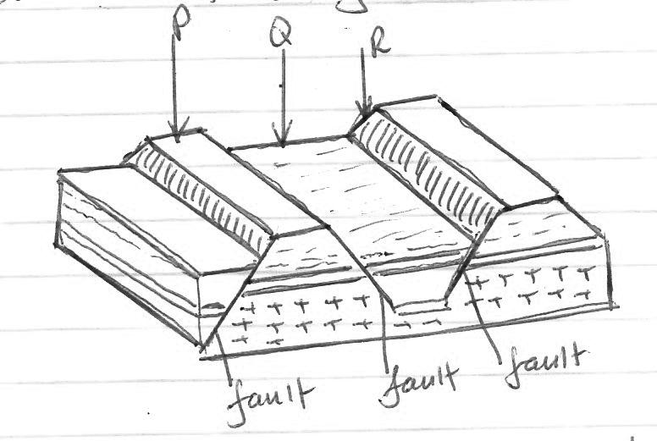

- Name the features marks (3mks)
P ……………………………………………..
Q …………………………………………….
R…………………………………………….
- Differentiates between a normal fault and a reverse fault (2mks)
…………………………………………………………………………………………………………………………………………………………
…………………………………………………………………………………………………………………………………………………………
……………………………………………………………………………………………………………………………………………..…………
c) State four uses of rocks (4mks)
…………………………………………………………………………………………………………………………………………………………
…………………………………………………………………………………………………………………………………………………………
……………………………………………………………………………………………………………………………………………..…………
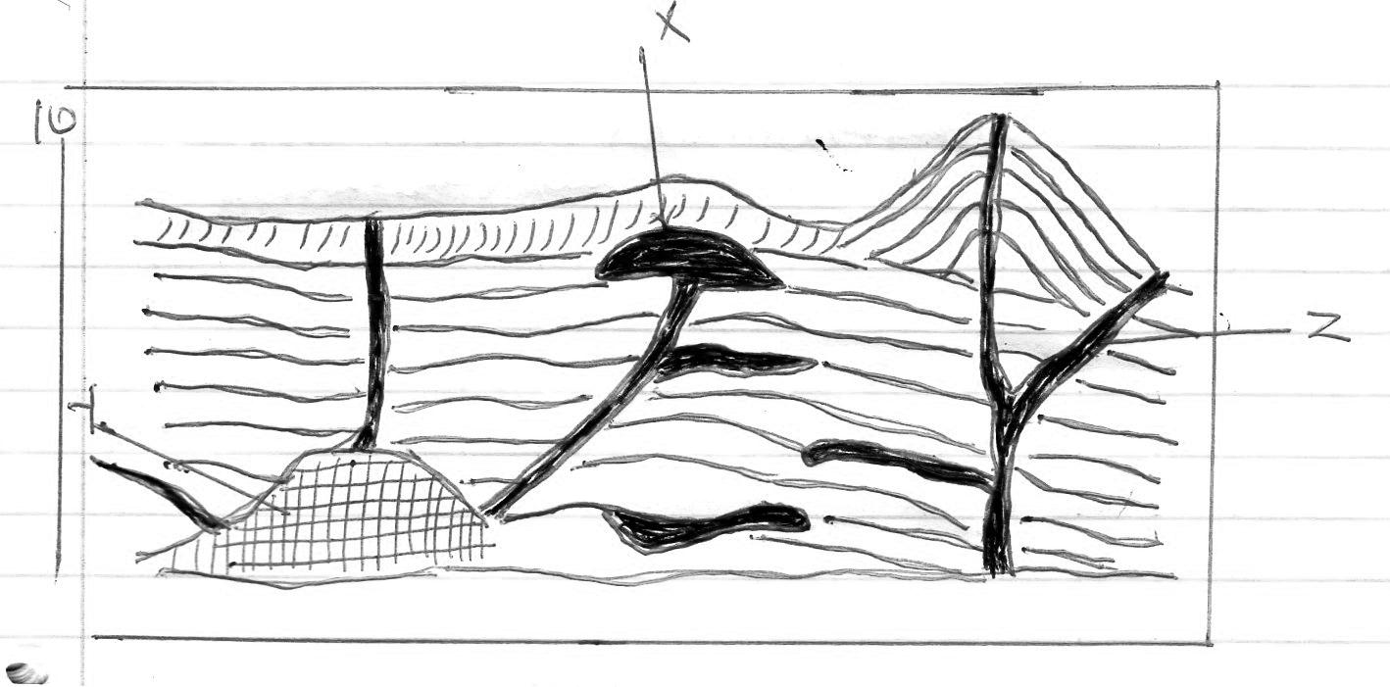
…………………………………………………………………………………………………………………………………………………………

a)i) name the features marked X, Y, and Z (3mks)
X …………………………………………………….
Y ……………………………………………………..
Z ………………………………………………………….
ii) Explain how a parasitic cone is formed (4mks)
…………………………………………………………………………………………………………………………………………………………
…………………………………………………………………………………………………………………………………………………………
……………………………………………………………………………………………………………………………………………..……………………………………………………………………………………………………………………………………………………………………
b) Give six characteristics of a composite cone (6mks)
…………………………………………………………………………………………………………………………………………………………
…………………………………………………………………………………………………………………………………………………………
……………………………………………………………………………………………………………………………………………..……………………………………………………………………………………………………………………………………………………………………
…………………………………………………………………………………………………………………………………………………………
……………………………………………………………………………………………………………………………………………..…………
c) Explain four ways in which volcanic mountain positively influence human activities (8mks)
…………………………………………………………………………………………………………………………………………………………
…………………………………………………………………………………………………………………………………………………………
……………………………………………………………………………………………………………………………………………..…………
…………………………………………………………………………………………………………………………………………………………
…………………………………………………………………………………………………………………………………………………………
……………………………………………………………………………………………………………………………………………..…………
…………………………………………………………………………………………………………………………………………………………
…………………………………………………………………………………………………………………………………………………………
……………………………………………………………………………………………………………………………………………..…………
d) You intend to carry out a field study of a volcanic landscape
i) State four reasons why it is necessary to conduct a reconnaissance of the area of the
study (4mks)
…………………………………………………………………………………………………………………………………………………………
…………………………………………………………………………………………………………………………………………………………
……………………………………………………………………………………………………………………………………………..…………
…………………………………………………………………………………………………………………………………………………………
ii) During your field study state why you would need the following item.
i) Geological hammer (2mks)
…………………………………………………………………………………………………………………………………………………………
…………………………………………………………………………………………………………………………………………………………
……………………………………………………………………………………………………………………………………………..…………
ii) A polythene bag (2mks)
…………………………………………………………………………………………………………………………………………………………
…………………………………………………………………………………………………………………………………………………………
……………………………………………………………………………………………………………………………………………..…………
11)a) Give four causes of earthquakes (4mks)
…………………………………………………………………………………………………………………………………………………………
…………………………………………………………………………………………………………………………………………………………
……………………………………………………………………………………………………………………………………………..…………
…………………………………………………………………………………………………………………………………………………………
b) Name three types of earth quakes (3mks)
…………………………………………………………………………………………………………………………………………………………
…………………………………………………………………………………………………………………………………………………………
……………………………………………………………………………………………………………………………………………..…………
c) State the five ways in which earth crust is affected by earthquake (5mks)
…………………………………………………………………………………………………………………………………………………………
…………………………………………………………………………………………………………………………………………………………
……………………………………………………………………………………………………………………………………………..…………
…………………………………………………………………………………………………………………………………………………………
…………………………………………………………………………………………………………………………………………………………
…………………………………………………………………………………………………………………………………………………………
……………………………………………………………………………………………………………………………………………..…………
…………………………………………………………………………………………………………………………………………………………

12)a) What is a photograph? (2mks)
…………………………………………………………………………………………………………………………………………………………
…………………………………………………………………………………………………………………………………………………………
b) List three types of ground photographs (3mks)
…………………………………………………………………………………………………………………………………………………………
…………………………………………………………………………………………………………………………………………………………
……………………………………………………………………………………………………………………………………………..…………
c) Name three ways in which a photograph can be subdivided horizontally (3mks)
…………………………………………………………………………………………………………………………………………………………
…………………………………………………………………………………………………………………………………………………………
……………………………………………………………………………………………………………………………………………..………

