NAME: ADM NO:

DATE: SIGN:

312/1
GEOGRAPHY PP1
FORM 3
END OF TERM II EXAM (2019)
TIME: 2 ¾ HRS

Instructions
- This paper has section A and B. Answer all the questions in section A.
- In section B, answer questions 6 and any other two questions.
- Answers should be written in the answer booklet provided.
- Provided your answers in English
- Follow the instructions as provided.

SECTION A
Answer all questions in this section
1)a) What are natural leaves? (2mks)
…………………………………………………………………………………………………………………………………………………………
…………………………………………………………………………………………………………………………………………………………
………………………………………………………………………………………………………………………………………………………..
b) List three conditions necessary for the formation of a delta (3mks)
…………………………………………………………………………………………………………………………………………………………
…………………………………………………………………………………………………………………………………………………………
………………………………………………………………………………………………………………………………………………………..
2)a) What is a lake? (2mks)
…………………………………………………………………………………………………………………………………………………………
…………………………………………………………………………………………………………………………………………………………
………………………………………………………………………………………………………………………………………………………..
b) State any three ways through which lakes are formed (3mks)
…………………………………………………………………………………………………………………………………………………………
…………………………………………………………………………………………………………………………………………………………
………………………………………………………………………………………………………………………………………………………..
3)a) What is climate? (2mks)
…………………………………………………………………………………………………………………………………………………………
…………………………………………………………………………………………………………………………………………………………
………………………………………………………………………………………………………………………………………………………..
b) Explain three effects of climate change on the physical environment (3mks)
…………………………………………………………………………………………………………………………………………………………
…………………………………………………………………………………………………………………………………………………………
………………………………………………………………………………………………………………………………………………………..
4)a) Name one active volcano in Kenya (1mk)
…………………………………………………………………………………………………………………………………………………………
…………………………………………………………………………………………………………………………………………………………
b) Describe how a geyser is formed? (4mks)
…………………………………………………………………………………………………………………………………………………………
…………………………………………………………………………………………………………………………………………………………
………………………………………………………………………………………………………………………………………………………..
…………………………………………………………………………………………………………………………………………………………
…………………………………………………………………………………………………………………………………………………………
5)a) Name the two types of deltas (2mks)
…………………………………………………………………………………………………………………………………………………………
…………………………………………………………………………………………………………………………………………………………
………………………………………………………………………………………………………………………………………………………..
b) Name the three parts of a wave (3mks)
…………………………………………………………………………………………………………………………………………………………
…………………………………………………………………………………………………………………………………………………………
………………………………………………………………………………………………………………………………………………………..
SECTION B
Answer questions 6, and any other two
- Study the map of Taita hills (sheet 189/4) provided and answer the following questions
a)i) Give the four figure grid reference of the Mwatunge hilltop (2mks)
…………………………………………………………………………………………………………………………………………………………
…………………………………………………………………………………………………………………………………………………………
………………………………………………………………………………………………………………………………………………………..
ii) What was the magnetic variation of the map? (2mks)
…………………………………………………………………………………………………………………………………………………………
…………………………………………………………………………………………………………………………………………………………
………………………………………………………………………………………………………………………………………………………..
iii) What is the general direction of Mwatate Wundanyi C104 all weather road-bound surface (2mks)
…………………………………………………………………………………………………………………………………………………………
…………………………………………………………………………………………………………………………………………………………
………………………………………………………………………………………………………………………………………………………..
b)i) Name three physical features found along the Northing 22 from 330220 to 370220 (3mks)
…………………………………………………………………………………………………………………………………………………………
…………………………………………………………………………………………………………………………………………………………
………………………………………………………………………………………………………………………………………………………..
iii) Draw a rectangle 16cm by 12cm to represent the area enclosed by the Eastings 24 and 40 and Northings 20 and 30 (1mk)

- On the rectangle, mark and name the following:
- Mganga Hill (1mk)
- A rock outcrop (1mk)
- All weather road, bound surface (1mk)
- Ronge forest (1mk)
c) Citing evidence from the map, explain three factors that may have favoured the establishment of Taita Sisal Estates in the Southern parts of the area covered by the map (5mks)
…………………………………………………………………………………………………………………………………………………………
…………………………………………………………………………………………………………………………………………………………
………………………………………………………………………………………………………………………………………………………..
…………………………………………………………………………………………………………………………………………………………
…………………………………………………………………………………………………………………………………………………………
………………………………………………………………………………………………………………………………………………………..
…………………………………………………………………………………………………………………………………………………………
…………………………………………………………………………………………………………………………………………………………
………………………………………………………………………………………………………………………………………………………..
d) Describe the distribution of settlements in the area covered by the map (5mks)
…………………………………………………………………………………………………………………………………………………………
…………………………………………………………………………………………………………………………………………………………
………………………………………………………………………………………………………………………………………………………..
…………………………………………………………………………………………………………………………………………………………
…………………………………………………………………………………………………………………………………………………………
………………………………………………………………………………………………………………………………………………………..
…………………………………………………………………………………………………………………………………………………………
…………………………………………………………………………………………………………………………………………………………
………………………………………………………………………………………………………………………………………………………..
7)a) Identify two types of high level clouds (2mks)
…………………………………………………………………………………………………………………………………………………………
…………………………………………………………………………………………………………………………………………………………
………………………………………………………………………………………………………………………………………………………..
ii) Name two types of clouds that give rise to rainfall in the tropical regions (2mks)
…………………………………………………………………………………………………………………………………………………………
…………………………………………………………………………………………………………………………………………………………
………………………………………………………………………………………………………………………………………………………..
b)i) Give two factors that influence relative humidity (2mks)
…………………………………………………………………………………………………………………………………………………………
…………………………………………………………………………………………………………………………………………………………
………………………………………………………………………………………………………………………………………………………..

ii) Outline the steps followed when measured humidity using a hygrometer (4mks)
…………………………………………………………………………………………………………………………………………………………
…………………………………………………………………………………………………………………………………………………………
………………………………………………………………………………………………………………………………………………………..
…………………………………………………………………………………………………………………………………………………………
…………………………………………………………………………………………………………………………………………………………
c)i) Draw a diagram of the earth and on it label the North Pole and South Pole (3mks)
…………………………………………………………………………………………………………………………………………………………
…………………………………………………………………………………………………………………………………………………………
………………………………………………………………………………………………………………………………………………………..
ii) Explain two reasons why the intensity of the insolation is higher at the equator than at the two poles (4mks)
…………………………………………………………………………………………………………………………………………………………
…………………………………………………………………………………………………………………………………………………………
………………………………………………………………………………………………………………………………………………………..
…………………………………………………………………………………………………………………………………………………………
…………………………………………………………………………………………………………………………………………………………
d)i) Draw a map of Africa, and on it label the following currents (3mks)
- Mozambique (1mk)
- Benguela (1mk)
- Guinea (1mk)

ii) State two effects of a warm ocean current on the adjacent coastlands (2mks)
…………………………………………………………………………………………………………………………………………………………
…………………………………………………………………………………………………………………………………………………………
………………………………………………………………………………………………………………………………………………………..
8)a)i) Name two features that result from horizontal earth movements (2mks)
…………………………………………………………………………………………………………………………………………………………
…………………………………………………………………………………………………………………………………………………………
………………………………………………………………………………………………………………………………………………………..
ii) Give three causes of horizontal earth movements (3mks)
…………………………………………………………………………………………………………………………………………………………
…………………………………………………………………………………………………………………………………………………………
………………………………………………………………………………………………………………………………………………………..
b)i) List any two large plates (2mks)
…………………………………………………………………………………………………………………………………………………………
…………………………………………………………………………………………………………………………………………………………
………………………………………………………………………………………………………………………………………………………..
ii) What is subduction? (2mks)
…………………………………………………………………………………………………………………………………………………………
…………………………………………………………………………………………………………………………………………………………
………………………………………………………………………………………………………………………………………………………..
c)i) Explain the formation of the fold mountains according to the plate tectonic theory (4mks)
…………………………………………………………………………………………………………………………………………………………
…………………………………………………………………………………………………………………………………………………………
………………………………………………………………………………………………………………………………………………………..
…………………………………………………………………………………………………………………………………………………………
…………………………………………………………………………………………………………………………………………………………
ii) Name three fold mountains each from a separate continent (3mks)
…………………………………………………………………………………………………………………………………………………………
…………………………………………………………………………………………………………………………………………………………
………………………………………………………………………………………………………………………………………………………..
d)i) A part from fold mountains, mention three resultant features due to folding (3mks)
…………………………………………………………………………………………………………………………………………………………
…………………………………………………………………………………………………………………………………………………………
………………………………………………………………………………………………………………………………………………………..
ii) Explain three significance of folding to the physical environment (6mks)
…………………………………………………………………………………………………………………………………………………………
…………………………………………………………………………………………………………………………………………………………
………………………………………………………………………………………………………………………………………………………..
…………………………………………………………………………………………………………………………………………………………
…………………………………………………………………………………………………………………………………………………………
………………………………………………………………………………………………………………………………………………………..
…………………………………………………………………………………………………………………………………………………………
…………………………………………………………………………………………………………………………………………………………
………………………………………………………………………………………………………………………………………………………..
9)a)i) What is an arid area? (2mks)
…………………………………………………………………………………………………………………………………………………………
…………………………………………………………………………………………………………………………………………………………
………………………………………………………………………………………………………………………………………………………..
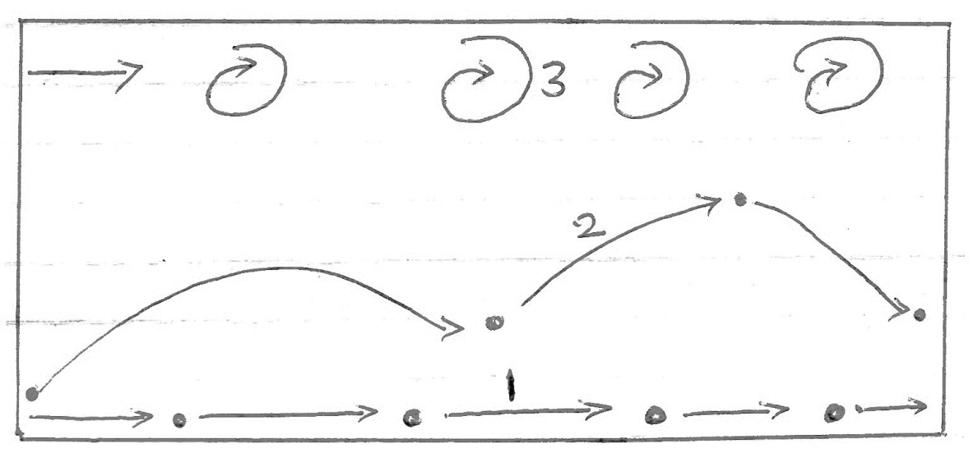
ii) The diagram below shows ways through which wind transport its load

Name the three ways labeled 1, 2 and 3 (3mks)
…………………………………………………………………………………………………………………………………………………………
…………………………………………………………………………………………………………………………………………………………
………………………………………………………………………………………………………………………………………………………..
b)i) Apart from Barchans, identify two types of sand dunes (2mks)
…………………………………………………………………………………………………………………………………………………………
…………………………………………………………………………………………………………………………………………………………
………………………………………………………………………………………………………………………………………………………..
ii) Name five features of a Barchan (5mks)
…………………………………………………………………………………………………………………………………………………………
…………………………………………………………………………………………………………………………………………………………
………………………………………………………………………………………………………………………………………………………..
…………………………………………………………………………………………………………………………………………………………
…………………………………………………………………………………………………………………………………………………………
………………………………………………………………………………………………………………………………………………………..
…………………………………………………………………………………………………………………………………………………………
…………………………………………………………………………………………………………………………………………………………
………………………………………………………………………………………………………………………………………………………..

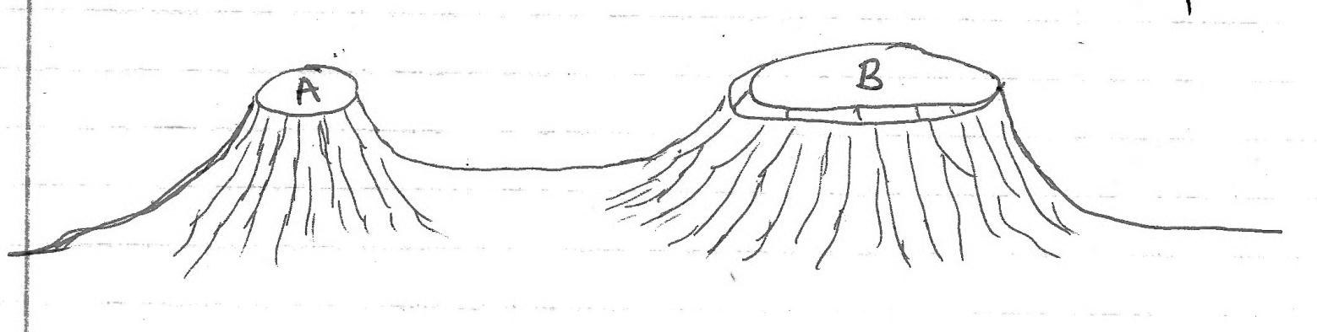
c) Study the diagrams below and answer the questions that follow below:

i) Name the two desert erosive features labeled A and B above (2mks)
…………………………………………………………………………………………………………………………………………………………
…………………………………………………………………………………………………………………………………………………………
………………………………………………………………………………………………………………………………………………………..
ii) Name three counties in Kenya where the named features in C (i) above can be found (3mks)
…………………………………………………………………………………………………………………………………………………………
…………………………………………………………………………………………………………………………………………………………
………………………………………………………………………………………………………………………………………………………..
iii) Explain any four negative significance of desert features to human activities (8mks)
…………………………………………………………………………………………………………………………………………………………
…………………………………………………………………………………………………………………………………………………………
………………………………………………………………………………………………………………………………………………………..
…………………………………………………………………………………………………………………………………………………………
…………………………………………………………………………………………………………………………………………………………
………………………………………………………………………………………………………………………………………………………..
…………………………………………………………………………………………………………………………………………………………
…………………………………………………………………………………………………………………………………………………………
………………………………………………………………………………………………………………………………………………………..
…………………………………………………………………………………………………………………………………………………………
…………………………………………………………………………………………………………………………………………………………
………………………………………………………………………………………………………………………………………………………..
…………………………………………………………………………………………………………………………………………………………
…………………………………………………………………………………………………………………………………………………………
………………………………………………………………………………………………………………………………………………………..
10) i) Apart from weathering, name any two process that sculpture the Earth surface (2mks)
…………………………………………………………………………………………………………………………………………………………
…………………………………………………………………………………………………………………………………………………………
………………………………………………………………………………………………………………………………………………………..
ii) What is mechanical weathering? (2mks)
…………………………………………………………………………………………………………………………………………………………
…………………………………………………………………………………………………………………………………………………………
………………………………………………………………………………………………………………………………………………………..
b)i) Explain the carbonation process of weathering (6mks)
…………………………………………………………………………………………………………………………………………………………
…………………………………………………………………………………………………………………………………………………………
………………………………………………………………………………………………………………………………………………………..
…………………………………………………………………………………………………………………………………………………………
…………………………………………………………………………………………………………………………………………………………
………………………………………………………………………………………………………………………………………………………..
…………………………………………………………………………………………………………………………………………………………
…………………………………………………………………………………………………………………………………………………………
………………………………………………………………………………………………………………………………………………………..

ii) Identify any three biological factors that influence weathering (3mks)
…………………………………………………………………………………………………………………………………………………………
…………………………………………………………………………………………………………………………………………………………
………………………………………………………………………………………………………………………………………………………..
c) You are planning to carry out a field study in a rocky landscape around the school
i) Name three relevant tools that you would require for the field study (3mks)
…………………………………………………………………………………………………………………………………………………………
…………………………………………………………………………………………………………………………………………………………
………………………………………………………………………………………………………………………………………………………..
ii) Identify three methods that you would use to collect data (3mks)
…………………………………………………………………………………………………………………………………………………………
…………………………………………………………………………………………………………………………………………………………
………………………………………………………………………………………………………………………………………………………..
iii) Explain any three problems likely to be encountered during the field study (6mks)
…………………………………………………………………………………………………………………………………………………………
…………………………………………………………………………………………………………………………………………………………
………………………………………………………………………………………………………………………………………………………..
…………………………………………………………………………………………………………………………………………………………
…………………………………………………………………………………………………………………………………………………………
………………………………………………………………………………………………………………………………………………………..
…………………………………………………………………………………………………………………………………………………………
…………………………………………………………………………………………………………………………………………………………
………………………………………………………………………………………………………………………………………………………..

