NAME: ADM No:
CLASS: SIGN:
232/2
PHYSICS FORM 4
PAPER 2
END TERM 2 YEAR 2021
TIME 2 HRS

INSTRUCTIONS
i) Answer All questions in the spaces provided.
ii) Use the following CONSTANTS where applicable.
iii) All working must be clearly shown for numerical questions.
iv) Candidates should check to ascertain that all questions are printed as indicated in the table below.
Constants
i) Density of water = 1g/cm³ or 1000kg/m³.
ii) Gravitational acceleration = 10m/s².

SECTION A (25 MARKS)
- A ray is incident on two mirrors inclined at 60⁰ as shown in the diagram below. (3mks)
40⁰
60⁰
Mirror B
Mirror A

Determine the angle of reflection on mirror A, hence trace the path of the ray as it leaves mirror B.

- a) The coils P and S are connected as shown below. P is connected to a battery, rheostat and a switch K. S is connected to a galvanometer G.
K
P
G
S

State the behavior of the pointer on G in the following cases;
- When K is switched on (closed) (1mk)

II) When K is opened. (1mk)

b) A transformer has 200 turns in the primary coil and 1000 turns in the secondary coil. If the transformer is 100% efficient and the current in the secondary coil is 0.15A, determine the current in the primary coil. (3mks)
- Figure below shows a simple experiment using a permanent magnet and two metal bars A and B
Put close to the iron filings.
S
N
A
B
A
B
After

During attraction

State with a reason which bar is made from a soft magnetic material. (2mks)

- The diagram below shows a ray of light xy traveling through a glass block of critical 42⁰ to point A
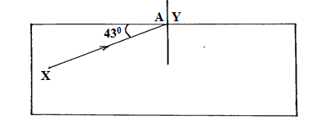
- Calculate the refractive index of the glass block. (3mks)

- On the same diagram, draw the path of the ray as it travels past point A. (1mks)

- The photoelectrons liberated from an illuminated metal surface constitute a photoelectric current. What is the effect of decreasing the intensity of illumination on the magnitude of the photoelectric current? (1mk)

- Figure below shows a battery of e.m.f 3.0v connected in series will two capacitors.
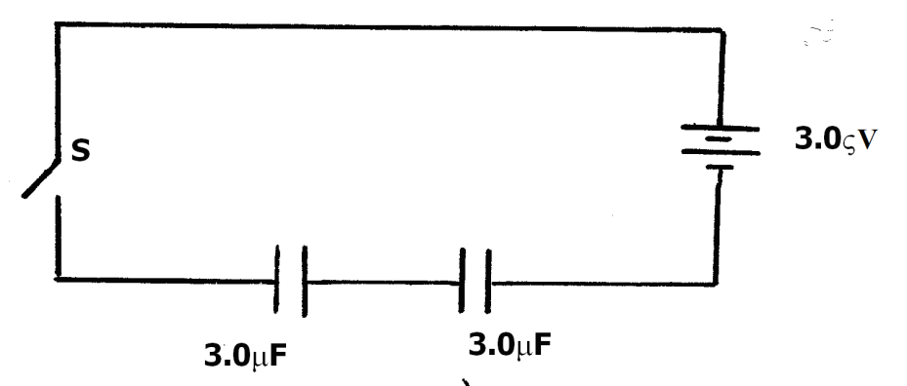
Determine the energy stored in the combined capacitors when the switch is closed. (3mks)

- The figure below shows a meter rule in equilibrium with the magnet and weight W. The Soft iron core is fixed to the bench.
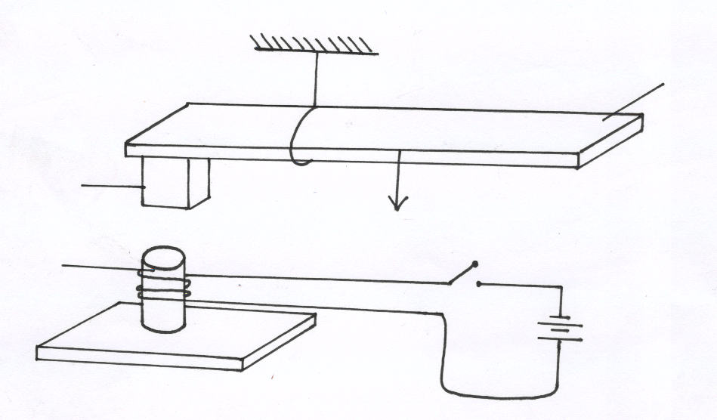
Metre rule
s
Magnet
Soft Iron core
Fixed on bench
N
Bench top
W

State and explain the effect on the meter rule when the switch S is closed (2mks)

- State how polarization is reduced in a dry cell. (1mk)

- State two differences between the cathode ray tube (CRT) of a T.V and the cathode ray oscilloscope (CRO). (2mks)

- Distinguish between a P-type and a N-type extrinsic semiconductors. (2mks)

SECTION B (55 MARKS)
- (a) Students set up a mass attached to a spring such that when it oscillates it taps on water surface in a wide shallow tank as in figure 11 below.
Spring
Mass
800m
B
Water
Direction of
oscillation
Fig. 11

The students measured time for 20 oscillations and found that the mass takes 36 seconds.
Determine:
- The periodic time of the mass (2mks)

(ii) The frequency of the waves produced on the water surface (2mk)

(iii) The speed of the waves if the students counted four ripples between the mass and
end B of the tank (3mks)
(b) State any two factors that would increase the speed of sound in air (2mks)

(c) An echo sounder of a ship received the reflected waves from a sea bed after 0.20s.
(i) Determine the depth of the sea bed if the velocity of sound in water is 1450m/s (2mks)

(ii) When the ship above passes over a sunken reef, the echo sounder receives an echo after 0.16s. Determine the height of the sunken reef (2mks)

- (a) The diagram below shows an X-ray tube drawn by a student. Use it to answer the questions which follow.
Heating
Voltage
R
S
Evacuated
P
EHT

- State with reason the material used for the part labeled R. (2mks)

(ii) Why is the tube evacuated (1mk)

(iii) How can the wavelength of the X-rays emitted from this tube be reduced (1mk)

(b) X-rays are emitted when a tube operates at 3 x 10² V and a current of 0.01 A is passing through it (take e = 1.6 x 10⁻¹⁹C, Me = 9 x 10⁻³¹kg). Calculate;
(i) The velocity of the electron on hitting the target. (3mks)

(ii) The minimum wavelength of the X-rays emitted (3mks)

C (i) State one properties of X-rays (1mk)

(ii) Sate one uses of X-rays (1mk)

- a) Differentiate between a nuclear fusion and nuclear fission. (2mks)

b) The equation below represents a nuclear reaction.
218
84
P_{o}
218
85
A
+
q
p
Y

i) Determine the values of p and q. (2mks)
p………………………………..………………………..

q…………………………………..……………………..

ii) Identify Y…………………………………………………………....……. (1mk)
- The figure below represents deflection of various radiations from a radioactive source S placed in electric field between two plates X and Y.
M
S
Y
+
X
-
P

Identify the radiations marked with letters M and P. (2mks) M…………………………………………………………………………………
P……………………………………………………………………………………
- A sample of radioactive substance initially has 8x10²⁵ particles. The half life of the sample is 98 seconds. Determine the number of particles that will have decayed after 294 seconds. (3mks)

14. a) State Ohm’s Law. (1mk)

b) The figure below shows a circuit that can be used to verify Ohm’s law
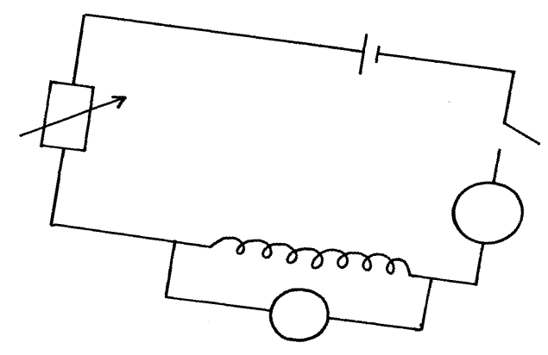
S
A
nichrome wire
Rheostart
Ammeter

V

Explain briefly how the setup can be used to verify ohm’s law (3mks)
- The graph below was obtained from experiment to determine the effective resistance of two resistors connected in parallel. If the value of one resistor is 50 ohms. determine the value of the other resistor.
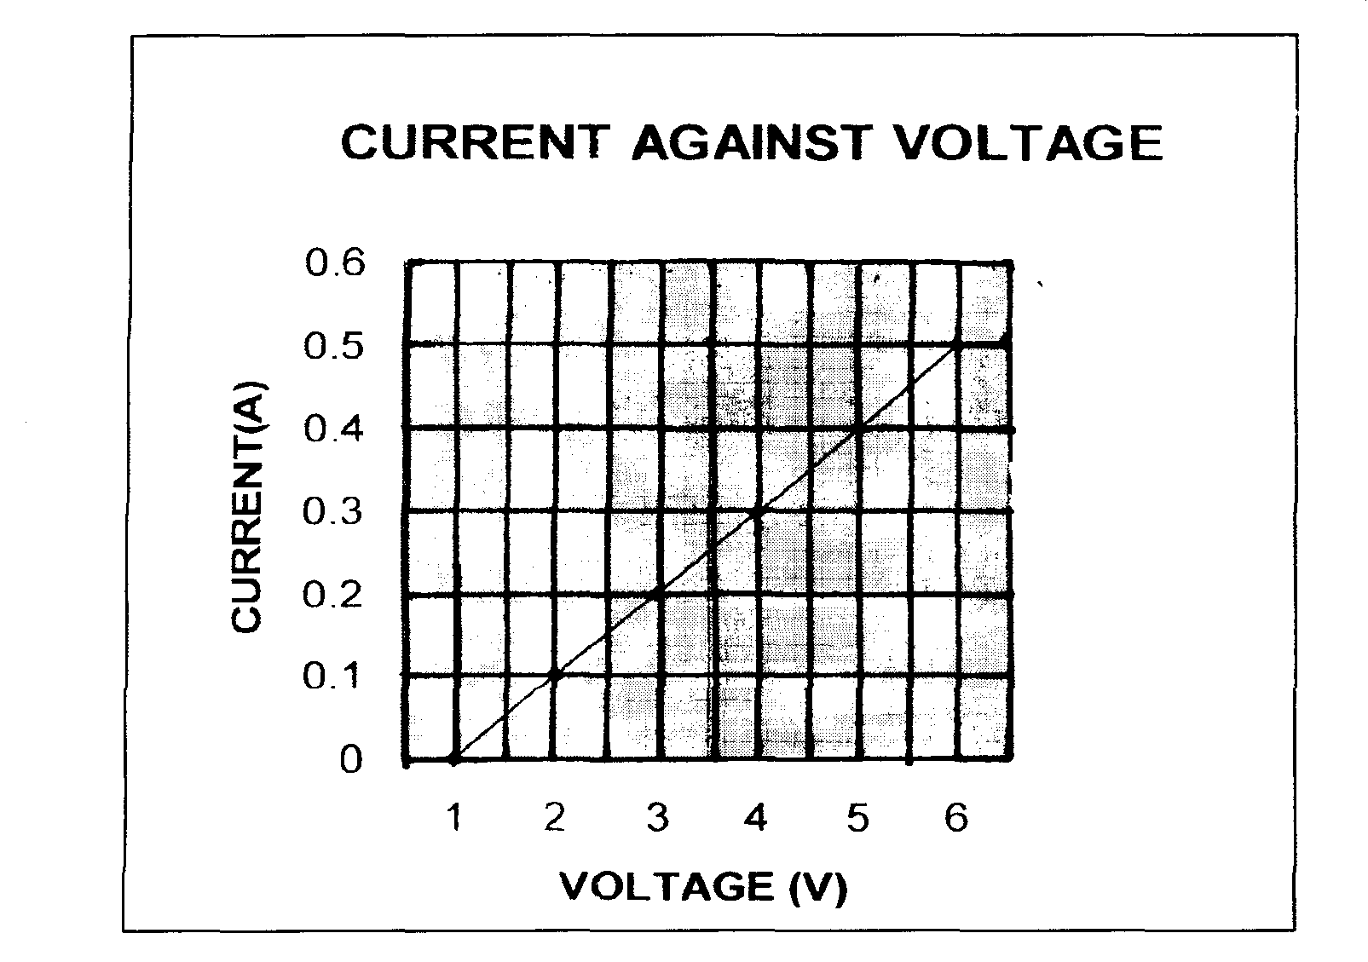

From the graph, determine
- effective resistance of the two resistors (2mk)

- the value of the other resistor (3mks)

- (a) An object O stands on the principal axis of a concave mirror as shown in figure 9 below.
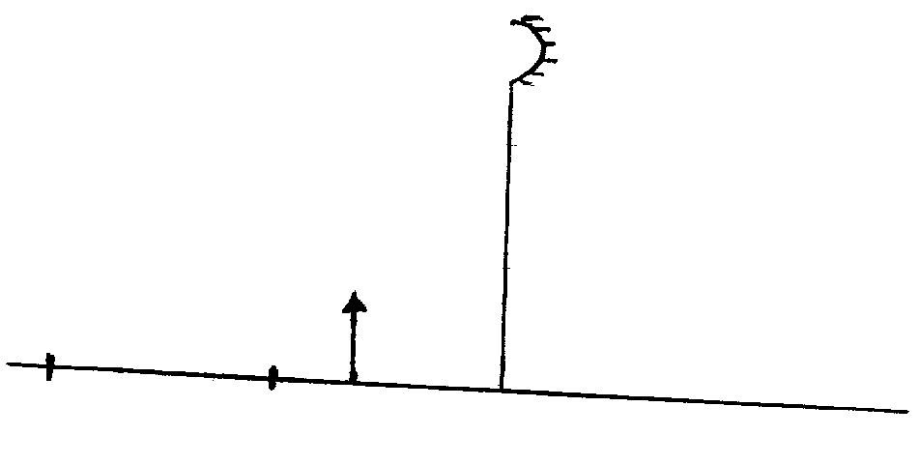
C
F
O
Fig. 9

(i) By drawing suitable rays, show the position of the image (3mks)
(ii) Determine the magnification of the image formed (2mks)
(b) In an experiment to determine the focal length of a converging lens, a group of form four students collected some data and used the results to plot the graph shown in figure below.

Using the graph above, determine:
(i) The object position when the image position is 45 cm (2mks)

(ii) Slope of the graph. (2mks)

(iii) The focal length of the lens given m = $\frac{v}{f}$ - 1

