NAME: ADM No:
CLASS: SIGN:
232
PHYSICS FORM 2
END TERM 2 YEAR 2021
TIME 2 HRS
INSTRUCTIONS
i) Answer All questions in the spaces provided.
ii) Use the following CONSTANTS where applicable.
iii) All working must be clearly shown for numerical questions.
iv) Candidates should check to ascertain that all questions and pages are available.
Constants
i) Density of water = 1g/cm3 or 1000kg/m³.
ii) Gravitational acceleration = 10m/s².

SECTION A (50MARKS)
- 50 drops of a liquid were released from a burette which was originally reading 22cm³ to give a new reading of 56cm³. Calculate the volume of each drop. (2mks)

- (a) State two factors that affect surface tension. (2mks)

(b) Figure 3 below shows a funnel dipped into a liquid soap solution.

Fig 3

Explain what happens to the soap bubble when the funnel is removed. (1mk)

- State one defect of a simple cell and how it can be minimized. (2mrks)

- State the property of light associated with formation of shadows (1mk)

- (i) State the basic law of electrostatics. (1mk)
ii) List down four uses of electroscope. (4mk)

(iii) In testing for the sign of charge on a body, state and explain the behavior of a
positively charged electroscope when negatively charged body is brought closer to the cap of the electroscope. (2mks)

- a) Define electric current. (1mk)

b) A current of 0.25A is flowing through a lamp. Find the time it will takes for 75C of charge to pass through the lamp. (3mks)

- a) State the principle of transmission of pressure. (1mk)

b) In the figure below piston A has area of 12.25cm² while piston B has an area of 196cm². If a force of 11N is exerted on piston A, calculate the force exerted on piston B. (3mks)
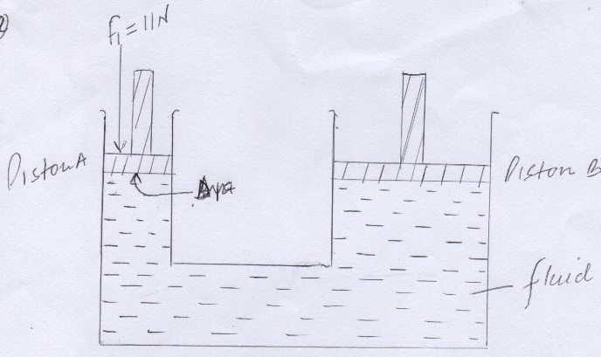

- a) The figure below show a microscope M focused on smoke particles inside a glass container.
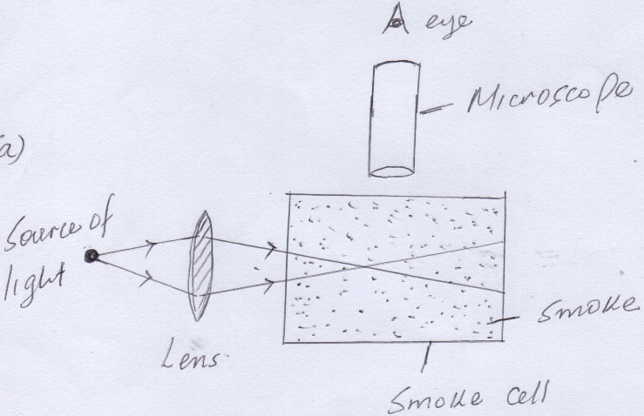
- Explain what is observed. (2mks)

- What change is observed to the movement of smoke particles when temperature is increased. (1mk)

- State three differences between alcohol and mercury as thermometric liquid (3mks)

- a) Differentiate between scalar and vector quantity. Give one example of each. (4mks)

b) Two forces 6N and 8N acts on a body at right angle. Draw the two forces acting on the body and find the resultant force diagrammatically. (4mks)

- In a vacuum flask the walls enclosing the vacuum are silvered on the inside. State the reason for this. (1mk)

- Explain how physics is related to the following subject.
- Mathematics (1mk)

- History (1mk)

- The diagram below shows three glass tubes A, B and C of different diameters dipped in water. The level of water in A is indicated.
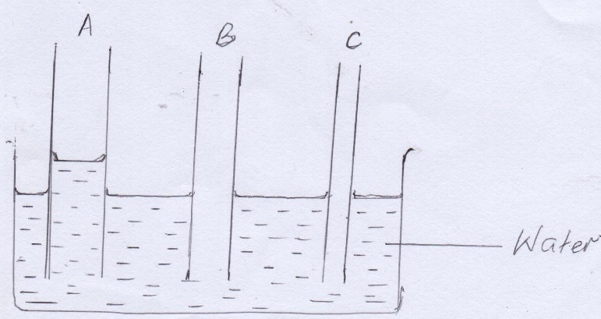
- Mark the appropriate levels of water in B and C. (2mks)
- Explain your observations. (2mks)

- The diagram below shows a plane mirror, an eye and an object.

eye
complete the ray diagram to show the position of the image. (3mks)
- A form one student conducted experiment in the laboratory.
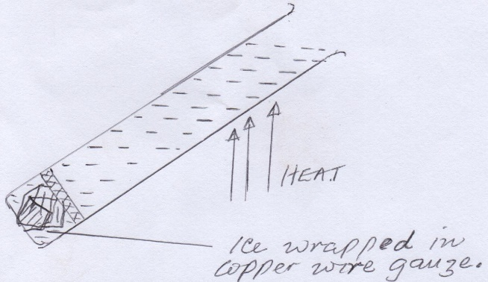
water was heated as shown until it started boiling at the top.
- What is the purpose of the wire gauze? (1mk)

- What was observed on the ice. (1mk)

- What was the aim of the experiment? (1mk)

- A uniform mixture consists of 30cm³ of water and 40cm³ of ethanol. If the densities of water and ethanol are 1g/cm³ and 0.85g/cm³respectively. Determine the density of the mixture. (4mks)

SECTION B (50 MARKS)
- State the basic law of magnetism. (1 mark)

- The figure below shows how magnets are stored in pairs with keepers at the ends.
S
N
A
B
Bar magnets
Keeper
Keeper

Identify pole A…………………. and B…………………….. (2 marks)
c) Explain why soft iron keepers are suitable for storing magnets (2mks)

d) Figure below shows a current carrying conductor. Indicate the direction of current in the conductor hence the magnetic field pattern. (2mks)
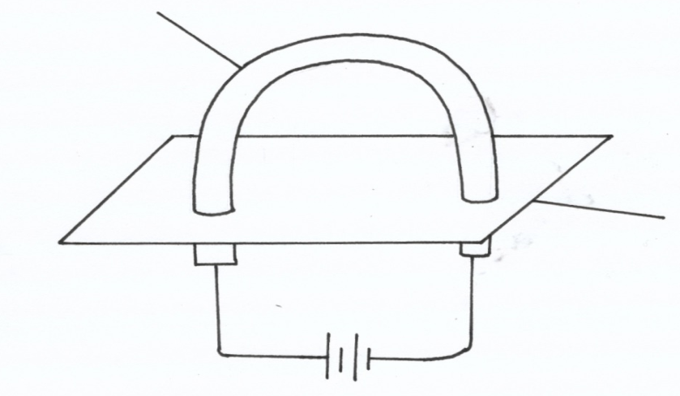
Conductor

Cardboard
- Figure below shows a conductor carrying current placed in the magnetic field of two magnets. Complete the diagram by showing the field pattern and the direction of force F that acts on the conductor (2mks)

- State 3 factors that affect the strength of electromagnet. (3mks)

- (a) (i) Define the term center of gravity of a body. (1mk)

(ii) Locate the C.o.g. of the cylinder shown below. (1mk)

- State two factors affecting stability of the body. (2mks)

- The figure below shows a boy and a girl on playground seesaw. The seesaw has a mass of 30kg and is pivoted at its centre. Their mother has to hold the girl’s end in order to keep the seesaw level. The boy’s mass is 50kg and the girl’s mass is 30kg. All the distances are shown on the diagram.
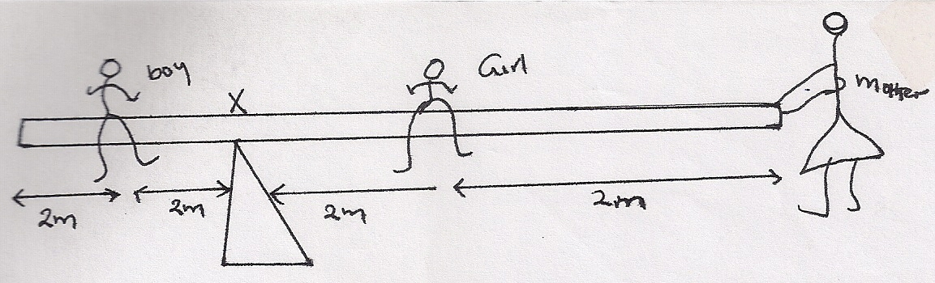
Calculate:
- The turning effect of the boy’s weight about point x. (1mk)

- The turning effect of the girl’s weight about x. (1mk)

- The force their mother must apply on the end of the seesaw in order to keep it level. (2mks)

- The total downward force in the central support of the seesaw. (2mks)

- a) State Hookes law. (1mk)

b) i) A rubber chord of elastic constant 200N/m support an object of mass 400g. the object is then pulled down by an extra force of 1.6N. calculate the total extension of the rubber (3mks)

- Two springs of elastic constant 400N/m are arranged in series and a load of 500g is suspended from the combination at the lower end. Find the extension of the combination. (3mks)

- Sketch a graph of force against extension for material that obeys Hookes law. (2mks).

- a i) Distinguish between concave and convex mirrors. (2mks)

- State one application of each of the following.
- Convex mirror (1mk)

- Parabolic mirror (1mk)

b) An object O is placed in front of a concave mirror as shown in the figure below.
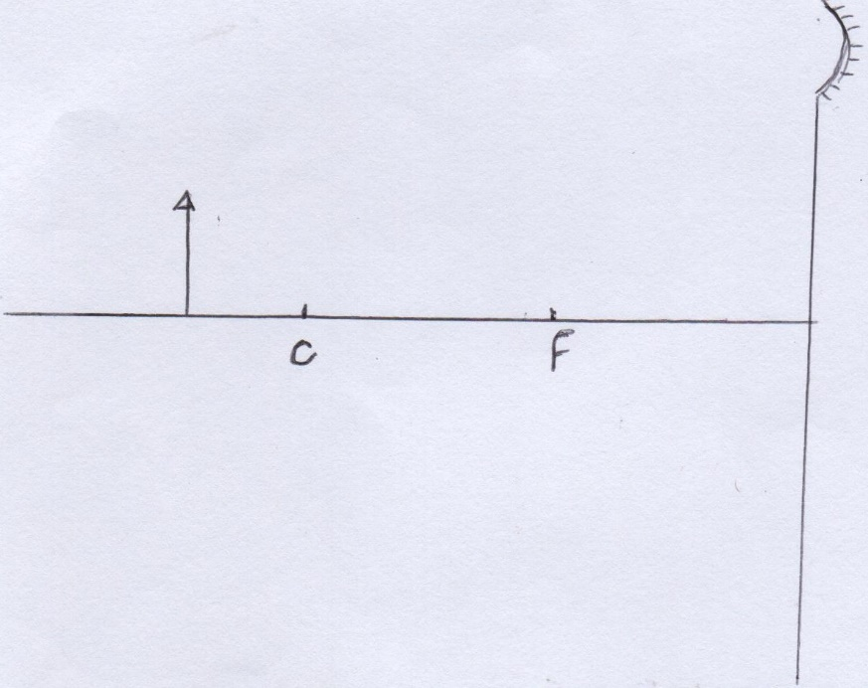
- Complete the diagram to show the position of the image. (3mks)
- State two properties of the image formed. (2mks)

- An object is placed 30cm from a concave mirror of focal length 20cm. calculate the position of the image. (3mks)

- In an experiment to estimate the size of an oil molecule, an oil drop of diameter 0.05cm spreads
over water to form a circular path whose diameter is 15cm.
Determine:
(i) Volume of the drop. (2mrks)

(ii) Area of the patch (2mrks)

(iii) Size of the oil molecule (2mrks)

