NAME: ADM No:
CLASS: SIGN:
232
PYSICS FORM 3
END TERM 2 YEAR 2021
TIME 2 HRS
INSTRUCTIONS
i) Answer All questions in the spaces provided.
ii) Use the following CONSTANTS where applicable.
iii) All working must be clearly shown for numerical questions.
iv) Candidates should check to ascertain that all questions and pages are available.
Constants
i) Density of water = 1g/cm3 or 1000kg/m³.
ii) Gravitational acceleration = 10m/s².

SECTION A (50 MARKS)
- A spherical ball bearing of mass 0.0024 kg is held between the anvil and spindle of a micrometer screw gauge. The reading on the gauge when the jaws are closed without anything in between is 0.11mm. Use this information and the position of the scale in the figure below to answer the questions (a) and (b) below:
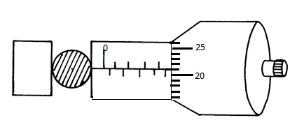
- What is the diameter of the ball bearing? ( 1 mk)

- Find the density of the ball bearing correct to 3 significant figures (3 mks)

- Figure 2 shows two identical thermometers. Thermometer A has a blackened bulb while
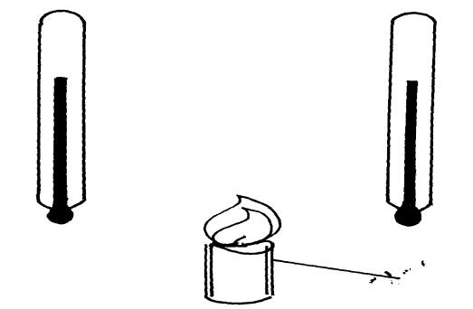thermometer B has a silvery bulb. A candle is placed equidistant between the two thermometers
Candle
B
A

Fig. 2

State with a reason the observations made after some time. (2 mk)

- A density bottle weighs 23.5 g when empty and 63.1g when partly filled with soil. When water is added to the soil to completely fill the bottle, the new weight was 98.1g. If the weight of the bottle when filled with water only is 73.5g, calculate the density of the soil. (3mks)

- A boat sends a sound signal in the middle of Lake Victoria and an echo is heard after 6 seconds. Determine;
i) The depth of the lake. (2mks)

ii) The frequency of the signal stated in (i) above. (2mks)
(Take speed of sound in water = 1440ms⁻¹, wavelength = 0.4m)

- The graph in the figure below shows the relationship between the attractive forces of an electromagnet and the magnetizing current. Give reasons for the shape of the graph by domain theory. (2mrks)
Magnetizing Current (A)
Fig 2
Attractive force N

- An opaque object is placed before a light source as shown in figure 2 below.

Source of light opaque body
screen
Draw rays in the diagram to show how the shadow is formed. (2mks)
- Explain why an electric kettle with shinny outer surface is more efficient than one with a dull outer surface. (2mks)

- The stability of a body can be increased by increasing the base area and lowering its center of gravity. State one way of lowering its center of gravity. (1mk)

- Name one force that determines the shape of a liquid drop on a solid surface (1mk)

- Using the idea of particles, differentiate between solid and liquid in terms of intermolecular distance. (2mks)

- Two immiscible liquid water and liquid L are put in a U tube as shown below.
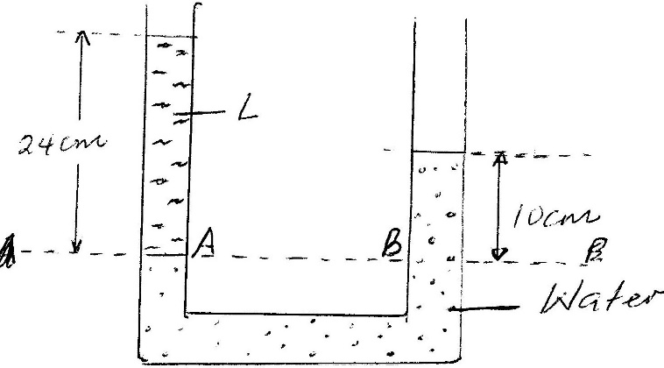
- Use the diagram to find;
- Pressure at B (2mks)

- Pressure at A. (1mk)

- Density of liquid L. (2mks)

- Draw the magnetic field pattern around the two parallel conductors shown below. (2mks)
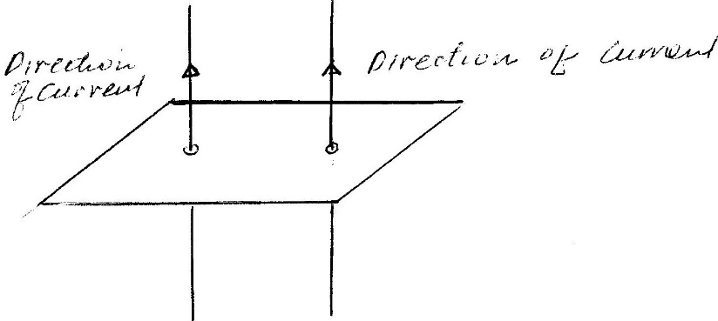
- Water flows at a velocity of 48cm/s in a drainage pipe with non-uniform cross sectional area at a point where the radius of the pipe is 2.1cm. calculate the diameter of the pipe in a section in which the velocity becomes 32cm/s. (3mks)

- The figure below shows a graph of displacement against time for a wave.
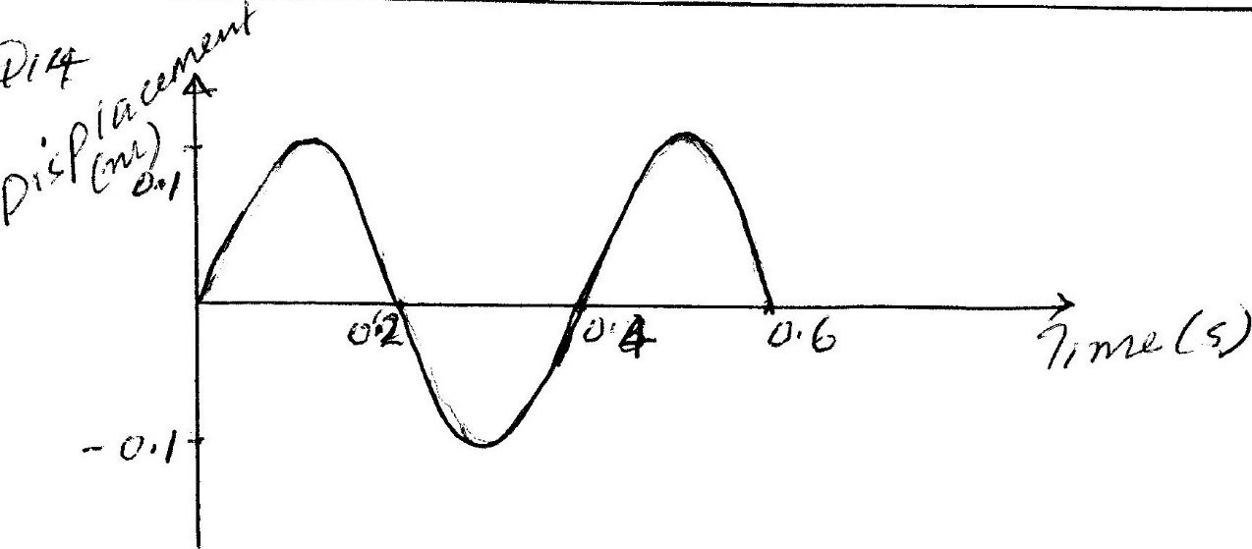
Determine;
- Periodic time (1mk)

- Frequency (2mks)

- Amplitude (1mk)

- a) State the principle of the moments. (1mk)

b) The figure below shows a uniform bar of length 6m in equilibrium under the action of two forces 40N and F.
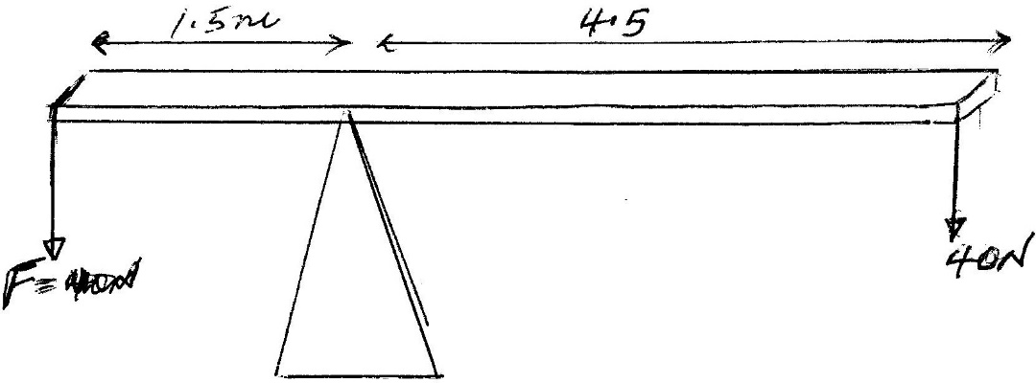
If the weight of the bar is 20N Calculate the force F (3mks)

- The figure below represents a step in charging a material A by induction.
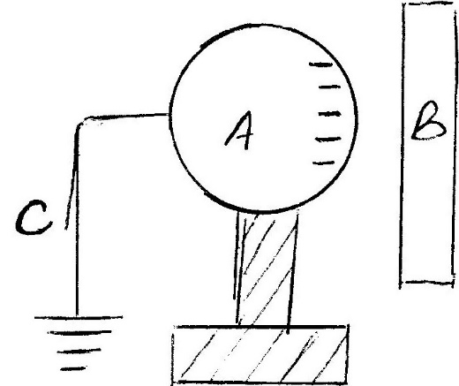
- What is charge on B. (1mk)

- Explain what happens at C (1mk)
- A form one student has the following apparatus two cells, a switch, connecting wires and two bulbs. Draw a possible circuit diagram for the arrangement that will allow the two bulbs to light simultaneously. (2mks)

- (a) Define diffraction with respect to waves. (1 mark)

(b) In the diagram below the size of the aperture at the barrier is 10cm while the distance
Wave front
Barrier
between two consecutive wave fronts is 3cm. If the waves are moving towards the barrier, draw the wave fronts as they appear after passing through the aperture. (2 marks)

- The figure below (drawn to scale) shows the image I, formed by a convex mirror. F is the virtual principal focus of the mirror.

I
F

Using ray diagrams locate the position of the object and draw the object. (2 marks)
SECTION B (50 MARKS)
- (a) Distinguish between elastic and inelastic collision (1mk)

(b) A ball X of mass 0.1kg moving with a velocity of 6m/s collides directly with a ball Y of mass 0.2kg at rest. X bounces back with a velocity of 2m/s in the opposite direction after collision.
Determine: -
(i) The velocity of Y after collision (3mks)

(ii) The kinetic energy of Y after collision (2mks)

- Figure 6 below shows a tape made from a ticker tape timer running at 50Hz.
A
B
C
D
E
5cm
Fig. 6
15cm

Find.
(i) The time taken for one tick interval (1mk)

(ii) The velocity between points AB and DE (2mks)

(iii) The acceleration of the body over the interval AE. (3mks)

- a) List two effects of force. (2mks)

b) Define mechanical advantage and velocity ratio of a machine. (2mk)

c) A man uses an inclined plane to lift 100kg load through a vertical distance of 8m. The inclined plan makes an angle of 30⁰ with the horizontal. If the efficiency of the machine is 80%, calculate;
i) The velocity ratio of the machine. (1mk)

ii) The effort needed to move the load up the inclined plane at a constant velocity. (2mks)

- A force of 20N acts on the suspended block of wood of mass 1kg for 1.2 seconds shown below.
Fig.8
1kg
F= 20N

Assuming the air resistance is negligible, how high will the block rise as it swings (3mrks)

- a) i) State Ohms law (1mk)

ii). Give one example of ohmic conductor and non ohmic conductor. (2mks)

b). The figure below shows a circuit with an ammeter reading 1.5A.
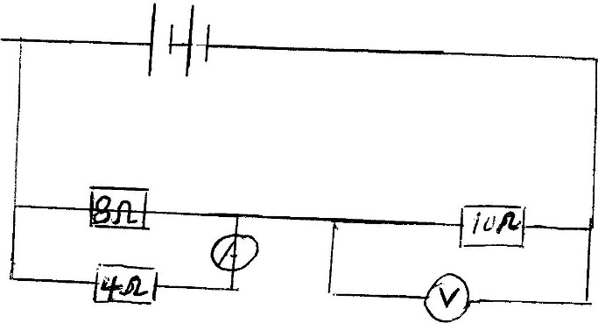
Determine;
- Potential difference across the 4-ohm resistor. (2mks)

- The current through 10-ohm resistor. (2mks)

- Voltmeter reading (2mks)

- An electric heater has a resistance of 100 ohms and is connected to a 240 v mains. Determine;
- Current flowing in the heater. (2mks)

- Power rating of the heater (2mks)

- State Snell’s law. (1mk)

- A coin is placed beneath a transparent block of thickness 10cm and refractive index 1.56. Calculate the vertical displacement of the coin. (3mks)

- The speed of green light in a prism is 1.94 × 10⁸m/s.
  - Determine the refractive index of the prism material.
(Speed of light in air = 3.0 × 10⁸m/s). (2mks)

(ii) Determine the critical angle of the prism material. (2mks

(d) State one advantages of using optical fiber in communication. (1mks)

- a) Define velocity. (1mk)

b) Below shows a displacement – time graph.

B
Displacement (m)
Velocity
(m/s)
0.6
Time (s)

A

O Time (s)
Describe the motion of the body between points:

OA…………………………………………………………………………… ( 1 mk)
AB……………………………………………………………………………..( 1 mk)

c). An object dropped from a height, h, attains a velocity of 6m/s just before hitting the ground. Find h. (3mks)

