NAME:………………………………………………………….CLASS:……ADM NO:………
MID TERM EXAMINATION
MATHEMATICS
FORM 2
TERM 2 – 2021
TIME:

INSTRUCTIONS.
Answer all the questions in the spaces provided.

- Evaluate: (3mks)
⁵/₆ of (4¹/₃ – 3 ⁵/₆)
⁵/₁₂ x ^{3/}₂₅ + 1⁵/₉ ÷ 2 ¹/₃

- A Kenyan company received US dollars which it converted into Kenya Shillings in a commercial bank. The bank buys and sells foreign currencies. Using the table below:
 | Buying in (Kshs) | Selling in (Kshs)
1 sterling pound | 125.78 | 126.64
1 US dollar | 75.66 | 75.86

- If the company received Ksh 15,132,000, calculate the amount received in US Dollars. (2mks)

- The company exchanged the above Kenya Shillings into sterling pounds to buy a car in Britain. Calculate the cost of the car to the nearest sterling pound. (2mks)

- The object shown below is reflected in the line x=-1, followed by a reflection in the line y=0, draw the two images after the two reflections. (3mks)

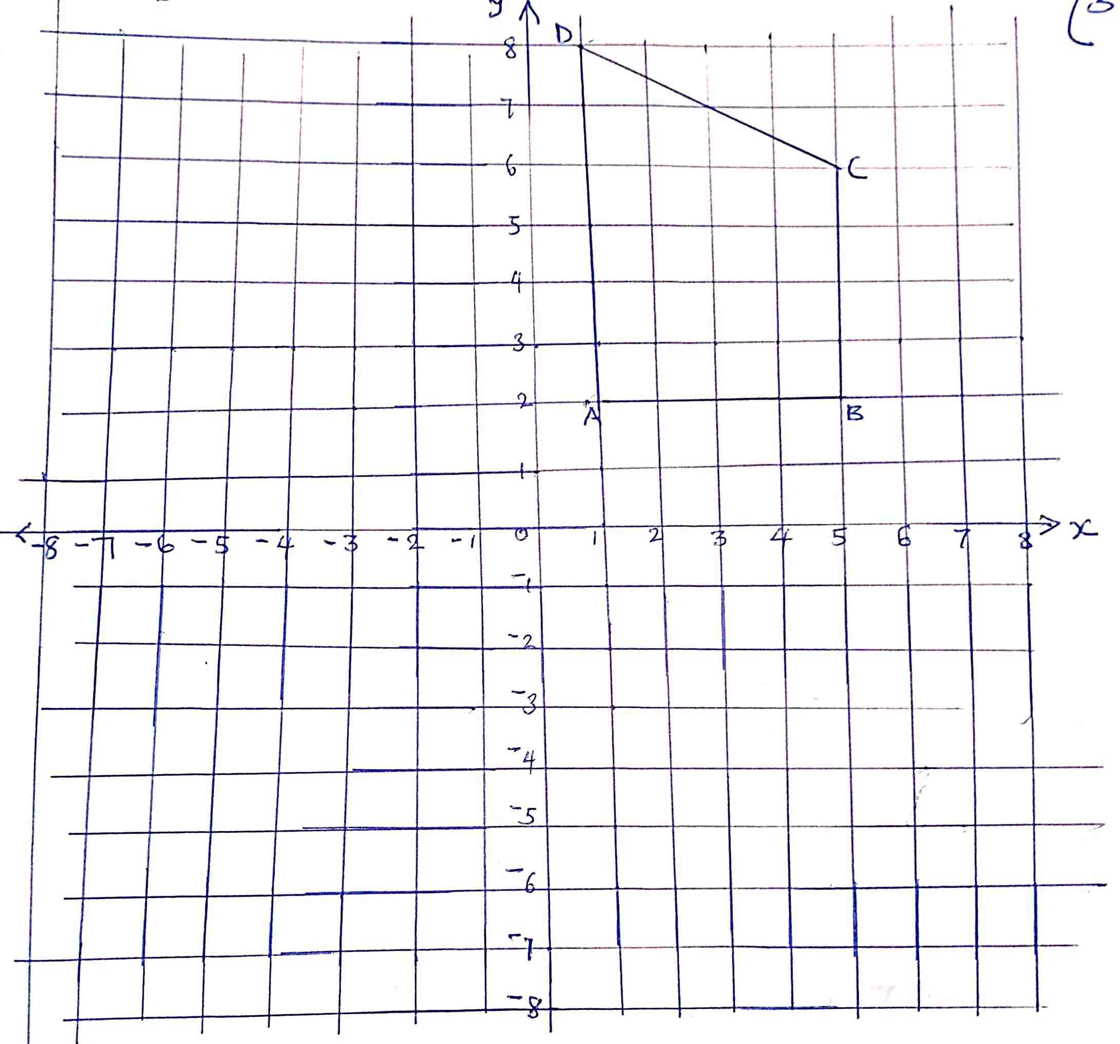

- A hawk is perched on a tree at a height of 15M above the ground. It spots a chick on the ground at an angle of depression of 25º, calculate the distance of the chick from the base of the tree. (3mks)

- The figure below shows a regular hexagon, the distance from the centre O of the hexagon to any vertex is 5cm.
D
B
A
F
E
O
5cm

C

- Calculate the size, of the exterior angle of the polygon (1mk)

- Find the area of the hexagon giving your answer correct to 4 s.f. (2mks)

- If 2^{x+y}=16 and 4^{2x-y}= ¼, find the values of x and y. (5mks)

- A straight line L1 has a gradient – ½ and passes through the point P(-1,-3). Another line L2 passes through P and is perpendicular to L1. Find:
- The equation of L1. (1mk)

- The equation of L2. (2mks)

- The scale of a map is 1:50,000. On the map, a coffee plantation coverts an area of 20cm². Find the area of the plantation in hectares. (2mks)

- The volume of water in a measuring cylinder is 200cm³. When a cube is immersed into the water, the cylinder reading is 543cm³. Find
- The volume of the cube. (1mks)

- The length of the side of the cube. (2mks)

- The figure shown below represents rectangle ABCD which measures 12cm by 9cm. if the shaded area is 68cm², find the values of x. (3mks)
B
c
D
A
9 cm
X

