TRIAL EXAMINATIONS 2021
Kenya Certificate of Secondary Education (KCSE)

231/2 - BIOLOGY - Paper 2
(THEORY)

Dec. 2021 – 2 hours

Name: ………………………………..…….......… Index No: ……….……………
Stream: ……………… Candidate’s Signature: …….……....Date:…..…………...

Instructions to candidates
- Write your name and admission number in the spaces provided above.
- Sign and write the date of the examination in the spaces provided above
- This paper consists of two sections; A and B.
- Answer all questions in section A in the spaces provided.
- In section B answer question 6 (compulsory) and either and either 7 and 8 in the spaces provided after question 8.
- This paper consists of 11 printed pages.
- Candidates should check the question paper to ascertain that all the pages are printed as indicated and that no questions are missing.
- Candidates should answer the questions in English.
For Examiner’s Use Only
Section | Question | Maximum Score | Candidate’s Score
A | 1 | 8
 | 2 | 8
 | 3 | 8
 | 4 | 8
 | 5 | 8
B | 6 | 20
 |  | 20
 | Total Score | 80

SECTION A (40 MARKS)
Answer all questions in this section in the spaces provided
- The figure below represents structures located in plant leaves. Use them to answer the questions that follow.
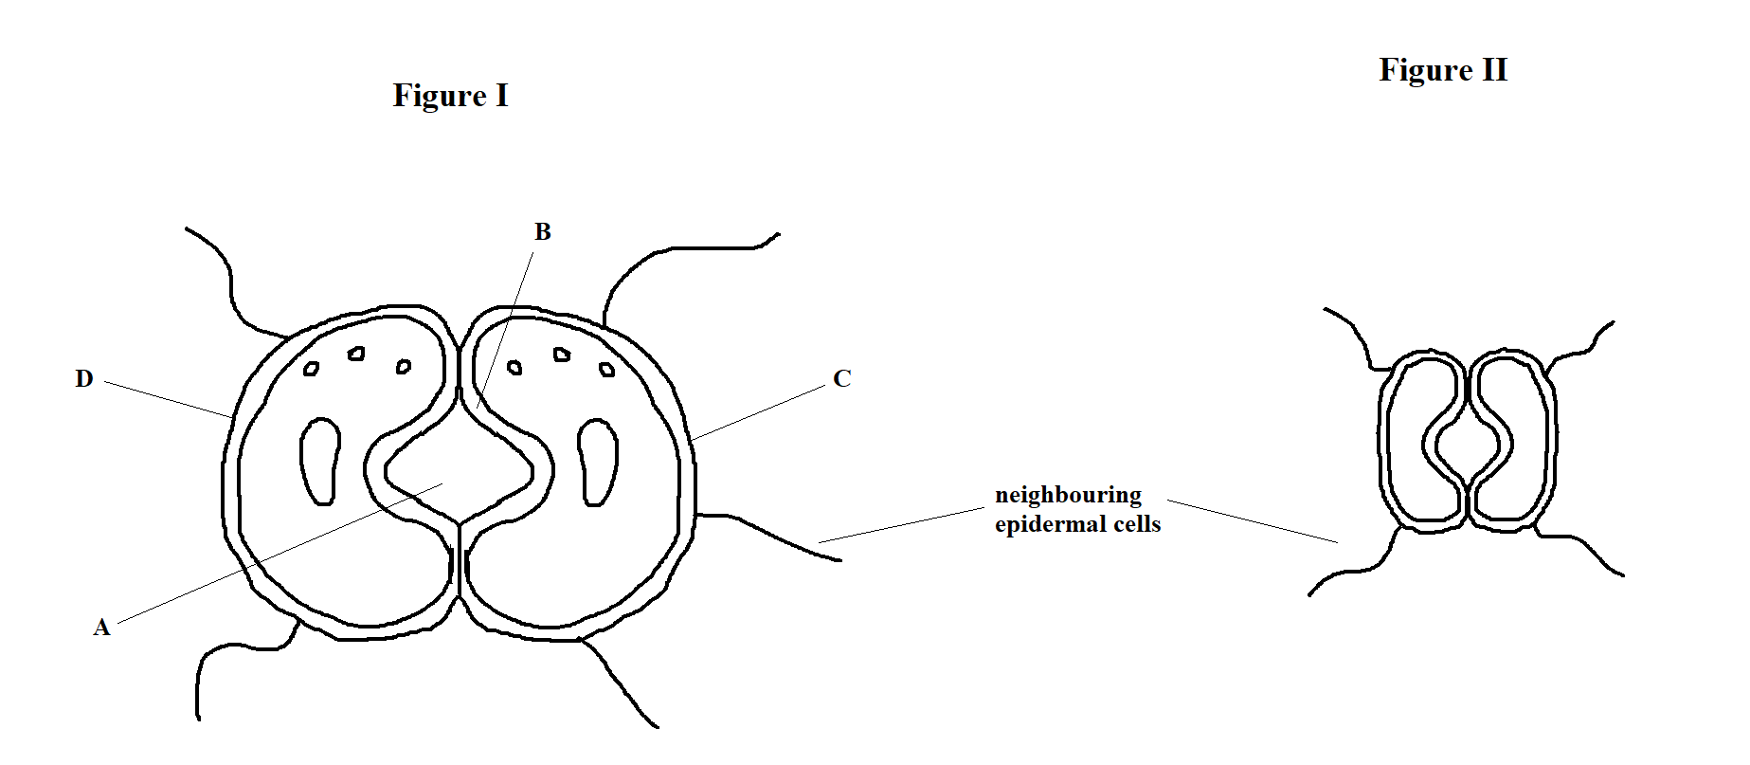
- How is the structure, labelled D, adapted to its function? (2 marks)
…………………………………………………………………………………………………..
…………………………………………………………………………………………………..
- Name the parts labelled (2 marks)
A ……………………………………………………………………………………………….
B ……………………………………………………………………………………………….
- Using photosynthesis theory, briefly explain how the part marked A in the Figure II changes to part marked A in the Figure I. (4 marks)
…………………………………………………………………………………………………..
…………………………………………………………………………………………………..
…………………………………………………………………………………………………..
…………………………………………………………………………………………………..
- In an experiment, black mice were crossed with brown mice. All the offspring had patches of black and brown in equal proportion. Using letter B to represent the gene for black colour, and b to represent the gene for brown colour:
- Work out the phenotypic ratio of F2 generation (5 marks)

- What is genetic engineering? (1 mark)
…………………………………………………………………………………………………..
…………………………………………………………………………………………………..
- Explain why drosophila melanogaster is suitable for use in genetic experiment. (2 marks)
…………………………………………………………………………………………………..
…………………………………………………………………………………………………..
…………………………………………………………………………………………………..
- Study the electron micrograph below, and answer the questions that follow.
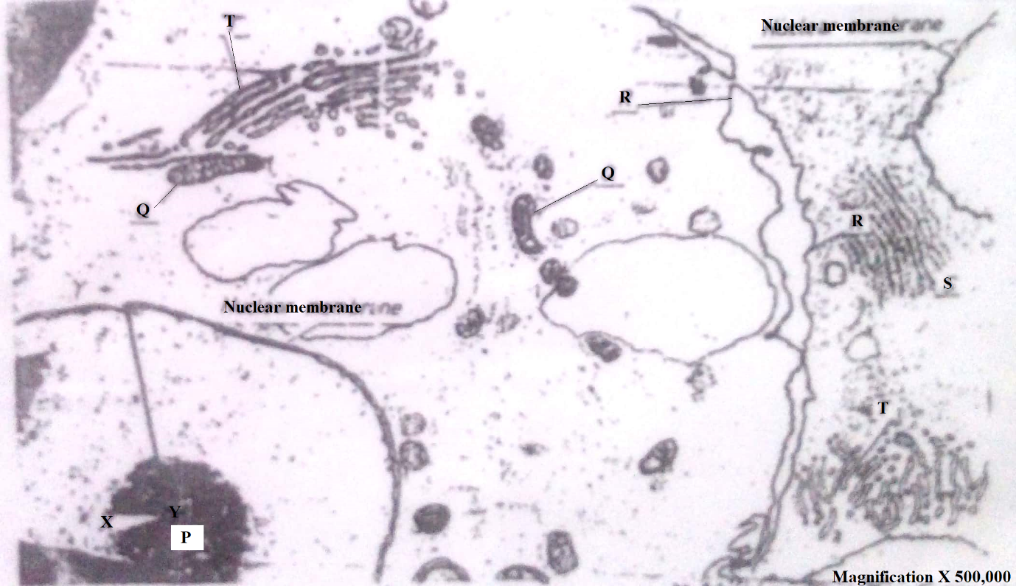
- With reasons, identify whether this is a plant of animal cell (3 marks)
- Identity ………………………………………………………………………………….
- Reasons
…………………………………………………………………………………………..
…………………………………………………………………………………………..
- Calculate the diameter labelled X – Y in micrometres (2 marks)
…………………………………………………………………………………………………..
…………………………………………………………………………………………………..
What is the function of the structure labelled T? (2 marks)
…………………………………………………………………………………………………..
…………………………………………………………………………………………………..
- State one significance of the structure labelled R (1 mark)
…………………………………………………………………………………………………..
…………………………………………………………………………………………………..
- The diagram below represents the apparatus that can be used to investigate an aspect of gaseous exchange in man.
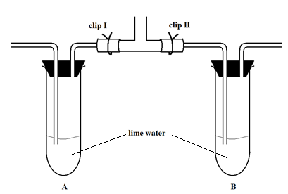
A person placed his mouth at tube M and breathed in and out several times through the tube.
- State the purpose of clip I and II in the experiment. (2 marks)
Clip I …………………………………………………………………………………………..
…………………………………………………………………………………………………
Clip II ………………………………………………………………………………………….
………………………………………………………………………………………………….
- Account for the expected results in the experiment above (4 marks)
…………………………………………………………………………………………………
…………………………………………………………………………………………………
…………………………………………………………………………………………………
…………………………………………………………………………………………………
- Explain two advantages of breathing through the nose rather than through the mouth. (2 marks)
…………………………………………………………………………………………………..
…………………………………………………………………………………………………..
…………………………………………………………………………………………………..
…………………………………………………………………………………………………..

- A certain response was exhibited by a certain plant on a stem of a maize plant.
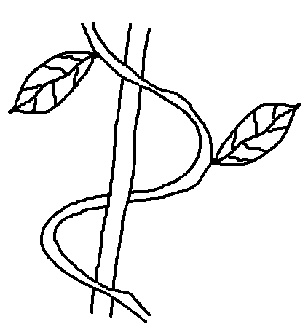

- Name the type of response exhibited above. (1 mark)
…………………………………………………………………………………………..
- Explain how the response named in a) (i) above occurs. (2 marks)
…………………………………………………………………………………………..
………………………………………………………………………………………….
…………………………………………………………………………………………
…………………………………………………………………………………………
- What is the importance of tactic responses to microscopic plants (1 mark)
………………………………………………………………………………………………….
………………………………………………………………………………………………….
- State four applications of plant hormones in agriculture. (4 marks)
…………………………………………………………………………………………………..
…………………………………………………………………………………………………..
…………………………………………………………………………………………………..
…………………………………………………………………………………………………..

SECTION B (40 MARKS)
Answer question 6 (compulsory) and either question 7 and 8 in the spaces provided after question 8
- A culture of bacteria was taken at intervals in order to estimate the number of bacteria in the population. The data is as provided in the table below.
Time in hours | 0 | 5 | 15 | 20 | 25 | 30 | 35 | 40 | 45
Number of living cells (millions) | 10 | 20 | 1000 | 1000 | 1000 | 800 | 400 | 250 | 50

- On the grid provided, draw a graph of the number of living cells against time (6 marks)

- Account for the shape of the graph below:
- 0 – 5 hours (2 marks)
………………………………………………………………………………………….
………………………………………………………………………………………….
………………………………………………………………………………………….
- 5 – 15 hours (2 marks)
………………………………………………………………………………………….
………………………………………………………………………………………….
………………………………………………………………………………………….
- 15 – 25 hours (2 marks)
………………………………………………………………………………………….
………………………………………………………………………………………….
………………………………………………………………………………………….
- When was the population of bacteria 750 million? (2 marks)
…………………………………………………………………………………………………..
…………………………………………………………………………………………………..
- Give two reasons for the trend between 25 – 45 hours (2 marks)
…………………………………………………………………………………………………..
…………………………………………………………………………………………………..
…………………………………………………………………………………………………..
- Suggest what would happen to the population of bacteria if the temperature was lowered to 0ºC after incubating for 12 hours. (1 mark)
…………………………………………………………………………………………………..
…………………………………………………………………………………………………..
- Give a reason for your answer in e) (i) above (1 mark)
…………………………………………………………………………………………………..
…………………………………………………………………………………………………..
- To obtain the observed results, state two variables that were kept constant during the investigation. (2 marks)
…………………………………………………………………………………………………..
…………………………………………………………………………………………………..
- Describe the menstrual cycle (20 marks)

- How does excretion take place in plants? (4 marks)

- Describe the role of human skin in homoeostasis. (16 marks)

…………………………………………………………………………………………………………
…………………………………………………………………………………………………………
…………………………………………………………………………………………………………
…………………………………………………………………………………………………………
…………………………………………………………………………………………………………
…………………………………………………………………………………………………………
…………………………………………………………………………………………………………
…………………………………………………………………………………………………………
…………………………………………………………………………………………………………
…………………………………………………………………………………………………………
…………………………………………………………………………………………………………
…………………………………………………………………………………………………………
…………………………………………………………………………………………………………
…………………………………………………………………………………………………………..
…………………………………………………………………………………………………………..
…………………………………………………………………………………………………………..
…………………………………………………………………………………………………………..
…………………………………………………………………………………………………………..
…………………………………………………………………………………………………………..
…………………………………………………………………………………………………………..
…………………………………………………………………………………………………………..
…………………………………………………………………………………………………………..
…………………………………………………………………………………………………………..
…………………………………………………………………………………………………………..
…………………………………………………………………………………………………………..
…………………………………………………………………………………………………………..
…………………………………………………………………………………………………………..
…………………………………………………………………………………………………………..
…………………………………………………………………………………………………………..
…………………………………………………………………………………………………………..
…………………………………………………………………………………………………………..
…………………………………………………………………………………………………………..
…………………………………………………………………………………………………………..
…………………………………………………………………………………………………………..
…………………………………………………………………………………………………………..
…………………………………………………………………………………………………………..
…………………………………………………………………………………………………………..
…………………………………………………………………………………………………………..
…………………………………………………………………………………………………………..
…………………………………………………………………………………………………………..
…………………………………………………………………………………………………………..
…………………………………………………………………………………………………………..
…………………………………………………………………………………………………………..
…………………………………………………………………………………………………………..
…………………………………………………………………………………………………………..
…………………………………………………………………………………………………………..
…………………………………………………………………………………………………………..
…………………………………………………………………………………………………………..
…………………………………………………………………………………………………………..
…………………………………………………………………………………………………………..
…………………………………………………………………………………………………………..
…………………………………………………………………………………………………………..
…………………………………………………………………………………………………………..
…………………………………………………………………………………………………………..
…………………………………………………………………………………………………………..
…………………………………………………………………………………………………………..
…………………………………………………………………………………………………………..
…………………………………………………………………………………………………………..
…………………………………………………………………………………………………………..
…………………………………………………………………………………………………………..
…………………………………………………………………………………………………………..
…………………………………………………………………………………………………………..
…………………………………………………………………………………………………………..
…………………………………………………………………………………………………………..
…………………………………………………………………………………………………………..
…………………………………………………………………………………………………………..
…………………………………………………………………………………………………………..
…………………………………………………………………………………………………………..
…………………………………………………………………………………………………………..
…………………………………………………………………………………………………………..
…………………………………………………………………………………………………………..
…………………………………………………………………………………………………………..
…………………………………………………………………………………………………………..
…………………………………………………………………………………………………………..
…………………………………………………………………………………………………………..
…………………………………………………………………………………………………………..
…………………………………………………………………………………………………………..
…………………………………………………………………………………………………………..
…………………………………………………………………………………………………………..
…………………………………………………………………………………………………………..
…………………………………………………………………………………………………………..

…………………………………………………………………………………………………………..
…………………………………………………………………………………………………………..
…………………………………………………………………………………………………………..
…………………………………………………………………………………………………………..
…………………………………………………………………………………………………………..
…………………………………………………………………………………………………………..
…………………………………………………………………………………………………………..
…………………………………………………………………………………………………………..
…………………………………………………………………………………………………………..
…………………………………………………………………………………………………………..
…………………………………………………………………………………………………………..
…………………………………………………………………………………………………………..
…………………………………………………………………………………………………………..
…………………………………………………………………………………………………………..
…………………………………………………………………………………………………………..
…………………………………………………………………………………………………………..
…………………………………………………………………………………………………………..
…………………………………………………………………………………………………………..
…………………………………………………………………………………………………………..
…………………………………………………………………………………………………………..
…………………………………………………………………………………………………………..
…………………………………………………………………………………………………………..
…………………………………………………………………………………………………………..
…………………………………………………………………………………………………………..
…………………………………………………………………………………………………………..
…………………………………………………………………………………………………………..
…………………………………………………………………………………………………………..
…………………………………………………………………………………………………………..
…………………………………………………………………………………………………………..

