**TRIAL EXAMINATIONS 2021**

**Kenya Certificate of Secondary Education (KCSE)**

**232/2 - PHYSICS - Paper 2**

**(Theory)**

**Nov/Dec. 2021 – 2 Hours**

**Name: …………………………………..… Index No: ……….…...Stream …………..**

**Candidate’s** **Signature**: ..……………………….…. **Date**:……………………………..

**INSTRUCTIONS TO CANDIDATES:-**

1. *Write your name, Admission number and class in the spaces provided above.*
2. *This paper consists of* ***two*** *sections:* ***A*** *and* ***B***
3. *Answer* ***all*** *the questions in section* ***A*** *and* ***B*** *in the spaces provided*
4. ***All*** *working* ***must*** *be clearly shown.*
5. *Mathematical tables and electronic calculators may be used*
6. ***This paper consists of 12 printed pages. Candidates should check to ascertain that all pages are printed as indicated and that no questions are missing.***
7. ***Candidates should answer the questions in English****.*

**For Examiner’s Use Only:**

|  |  |  |  |
| --- | --- | --- | --- |
| **Section** | **Question** | **Maximum**  **Score** | **Candidate’s**  **Score** |
| **A** | **1 – 12** | **25** |  |
|  | **13** | **9** |  |
|  | **14** | **11** |  |
| **B** | **15** | **13** |  |
|  | **16** | **10** |  |
|  | **17** | **12** |  |
| **Total Score** | | **80** |  |

**SECTION A (25 MARKS)***Answer all the questions*

1. Figure 1 shows a ray of light incident on a mirror at an angle of 500. Another mirror is placed at an angle of 500 to the first one as shown.



**fig 1**

500

500

500

500

By completing the ray diagram determine the angle of reflection on the second mirror (3 marks)

1. State how the speed of sound in air is affected by increase in humidity (1 mark)

………………………………………………………………………………………………………………………………………………………………………………………………………………

1. What is dispersion of light? (1 mark)

………………………………………………………………………………………………………………………………………………………………………………………………………………

1. In the circuit diagram in fig2, determine the potential difference across the 6Ω resistor (2 marks)

**6 V**

**fig 2**

**12Ω**

**6Ω**

**36Ω**

1. The diagram below shows the variation of $\frac{1}{V}$ and $\frac{1}{U}$ in an experiment used to determine the focal length of a lens

0.3

0.2

(cm-1)

0.1

0

0.1 0.2 0.3 0.4 0.5

(cm-1)

Use the graph to determine the focal length of the lens (3 marks)

………………………………………………………………………………………………………………………………………………………………………………………………………………………………………………………………………………………………………………………………………………………………………………………………………………………………

1. A consumer has the following appliances operating in his house for the duration indicated in a day

* Four 75W , 240V bulbs for 45minutes
* One 1000W, 240Vrefrigerator for 8 hours
* One 3kW, 240V heated for 2 hours

Assuming the power consumption per day remains the same, calculate the cost of electricity consumed in 30 days if 1 unit costs sh. 1.50 (3 marks)

………………………………………………………………………………………………………………………………………………………………………………………………………………………………………………………………………………………………………………………

1. Fig 3 shows a horseshoe magnet whose poles are labeled and two other magnets near it. Iron nails are attracted to the lower ends of magnets as shown.

Identify the poles marked **X** and **Y** (2 marks)

Horseshoe magnet

**X**

**N**

**S**

**Y**



**Fig 3**

Nails

X………………………………………………………………………………………….

Y…………………………………………………………………………………………

1. Transformer in fig 4 is used to operate a 9V a.c. shaving machine. Determine the number of turns in the primary coil. (1 mark)

**fig 4**

9V

**240VV**

60 turns

1. Give a reason why alpha practices in a cloud chamber cause short, straight, and thick tracks. (1 mark)

………………………………………………………………………………………………………………………………………………………………………………………………………………

1. (a) State the reason why the current produced by a simple cell falls rapidly when the cell is being used (1 mark)

………………………………………………………………………………………………………………………………………………………………………………………………………………

(b) Give **two** advantages of lead acid accumulator over alkaline accumulators (2 marks)

………………………………………………………………………………………………………………………………………………………………………………………………………………………………………………………………………………………………………

1. Light travels through a glass of refractive index 1.50with a speed of **v**. calculate the valve of **v** (speed of light in air = (3.0x108ms-1) (2 marks)

………………………………………………………………………………………………………………………………………………………………………………………………………………………………………………………………………………………………………………………………………………………………………………………………………………………………………………………………………………………………………………………………………

1. State and explain the purpose of the split ring commutator in the working principle of a d.c motor (2 marks)

………………………………………………………………………………………………………………………………………………………………………………………………………………………………………………………………………………………………………………………

**SECTION B** (55 MARKS)

*Answer* ***all*** *the questions in this section in the spaces provided.*

1. In a compound microscope, the focal length of the objective lens **O** is 3.0cm and that of the eye piece **lens E** is 4.0cm. they are placed 15cm apart and an object **OB** is placed 4.0cm from the objective lens as shown in figure 5.

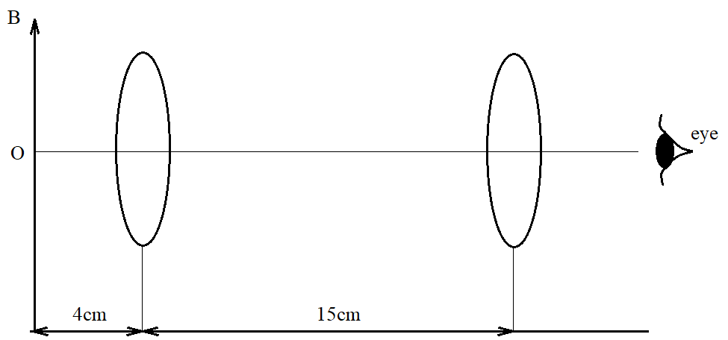

**Fig 5 (not to scale)**

1. From $\frac{1}{f}$ = $\frac{1}{u}$ + $\frac{1}{V},$ find the position of the final image for each lens (4 marks)

………………………………………………………………………………………………………………………………………………………………………………………………………………………………………………………………………………………………………………………………………………………………………………………………………………………………

1. Calculate the magnification produced by the arrangement of these lenses (3 marks)

………………………………………………………………………………………………………………………………………………………………………………………………………………………………………………………………………………………………………………………

1. Calculate the size of final image viewed by the eye, if the size of the object **OB** is 1.0mm (2 marks)

……………………………………………………………………………………………………………………………………………………………………………………………………………………

1. A uniform resistance wire **AB** has length 50cm and diameter 0.36mm. The resistivity of the metal of wire is 5.1 x 10-17Ωm
2. Calculate the resistance of the wire **AB** (2 marks)

………………………………………………………………………………………………………………………………………………………………………………………………………………………………………………………………………………………………………………………

1. The wire **AB** is connected in series with a power supply **E** and a resistance **R** as shown in figure 6

E

R

B

M

A

2.5 Ω

C N D

The electromotive force (emf) of **E** is 6.0v and its internal resistance is negligible. The resistance of **R** is 2.5Ω.A second uniform wire **CD** is connected across the terminals of **E**. The wire **CD** has length 100cm, diameter 0.18mm and is made of the same metal as wire **AB**. Calculate the current supplied by **E**. (4 marks)

………………………………………………………………………………………………………………………………………………………………………………………………………………………………………………………………………………………………………………………………………………………………………………………………………………………………

1. Define doping as used in electronics (1 mark)

………………………………………………………………………………………………………………………………………………………………………………………………………………

1. Differentiate between a p-type and n-type semiconductors in terms of charge carriers. (2 marks)

………………………………………………………………………………………………………………………………………………………………………………………………………………

1. Explain what happens to the depletion layer when a diode is reverse biased. (2 marks)

………………………………………………………………………………………………………………………………………………………………………………………………………………

1. (a) When a highly positively charged rod is gradually brought from a high position towards the cap of a negatively charged electroscope, it is observed that the gold leaf collapses initially and then finally diverges.
2. Explain why the gold leaf collapses initially (2 marks)

………………………………………………………………………………………………………………………………………………………………………………………………………………

1. Explain why the gold leaf diverges finally (2 marks)

………………………………………………………………………………………………………………………………………………………………………………………………………………

(b) Figure 7 shows a circuit that can be used to charge and discharge a capacitor.

K

**L**

**R**

R

**C**

1. State what would be observed on the following when the switch is closed at **K**.
2. The millimeter. (1 mark)

………………………………………………………………………………………………………

1. The voltmeter (1 mark)

………………………………………………………………………………………………………

1. Explain how the capacitor **C** gets charged (2 marks)

………………………………………………………………………………………………………………………………………………………………………………………………………………

1. State the purpose of resistor **R** (1 mark)

………………………………………………………………………………………………………………………………………………………………………………………………………………

1. On the axes provided, sketch the graph of voltage(v) against time (t) when the switch is then closed at L. (1 mark)

**Voltage**

**(V)**

Time (t)

(c) **Figure 8** shows a circuit where a battery of e.m.f12v, switches **A** and **B**, two capacitors C1 = 9µf and C2 =7µF and a voltmeter are connected

-

A

+

B

12 V

7µ

9µ

Switch **A** is closed while switch **B** remains open. After some time, Switch **A** is opened, and switch **B** closed. Determine the final reading of voltmeter. (3 marks)

………………………………………………………………………………………………………………………………………………………………………………………………………………………………………………………………………………………………………………………

1. (a)What is meant by radioactivity (1 mark)

………………………………………………………………………………………………………

1. Below is a nuclear reaction

m

$γ$ (gamma)

$${}_{90}^{232}{X }{}_{88}^{228}{Y }{}_{B}^{A}Z$$

1. Identify radiation **m** (1 mark)

………………………………………………………………………………………………

1. Determine the values of **A** and **B** (2 marks)

………………………………………………………………………………………………………………………………………………………………………………………………

(c ) **Figure 9** shows a Geiger miller (G.M. ) tube cathode

+

Mica Window

**Cathode (Metal cylinder)**

* **High**

**potential**

Argon gas at low

pressure + Anode

hydrogen vapour

1. Give the reason why mica window is made thin (1 mark)

………………………………………………………………………………………………………………………………………………………………………………………………

1. Explain how radiation entering the tube through the window is detected by the tube. (4 marks)

………………………………………………………………………………………………………………………………………………………………………………………………………………………………………………………………………………………………………………………………………………………………………………………………

1. **Figure 10** below shows the path of a ray of yellow light through a glass prism. The speed of yellow light in the prism is 1.88x108m/s

**Fig 10**

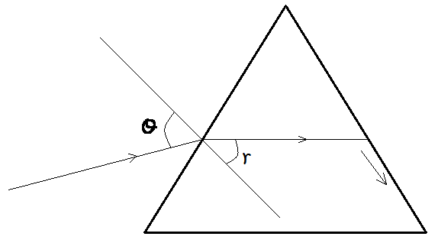

1. Determine the refractive index of the prism material for the light (speed of light in vacuum c = 3.0 x108m/s) (3 marks)

………………………………………………………………………………………………………………………………………………………………………………………………………………………………………………………………………………………………………………………

1. Show **on the figure** the critical angle **c** and determine its value. (4 marks)

………………………………………………………………………………………………………………………………………………………………………………………………………………………………………………………………………………………………………………………

1. Given that r = 21.20, determine the angle θ (3 marks)

………………………………………………………………………………………………………………………………………………………………………………………………………………………………………………………………………………………………………………………………………………………………………………………………………………………………

1. On the same figure, sketch the path of the light after striking the prism if the prism was replaced by another of similar shape but lower refractive index. (Use dotted line for your answer) (2 marks)