**KITUTU CENTRAL JOINT EXAMINATION**

***Kenya Certificate of Secondary Education***

**443/1 - AGRICULTURE - Paper 1**

**(THEORY)**

**December 2021 - 2 hours**

Name…………………………………………Index No…………. Adm. No……………

Candidates Signature……………………Class……………..Date…………………….

**Instructions to students**

*(a) Write your name and index number in the spaces provided at the top of this page.*

*(b) Sign and write the date of the examination in the spaces provided.*

*(c) This paper consists of three sections:* ***A****,* ***B*** *and* ***C****.*

*(d) Answer all questions in sections* ***A*** *and* ***B.***

*(e) Answer any two questions in section* ***C.***

*(f) All answers should be written in the spaces provided.*

***(h) This paper consists of 13 pages.***

***(g) Candidate should check the question paper to ascertain that all pages are printed asindicated and that no questions are missing.***

***(i) Candidate should answer the questions in English.***

***j) The photographs must be coloured.***

**For Examiner’s Use Only**

|  |  |  |  |
| --- | --- | --- | --- |
| **SECTION** | **QUESTIONS** | **MAXIMUM SCORE** | **CANDIDATES SCORE** |
| **A** | 1 − 19 | 30 |  |
| **B** | 20− 23 | 20 |  |
| **C** |  | 20 |  |
|  | 20 |
|  | **TOTAL SCORE** | **90** |  |

**SECTION A- (30 MARKS)**

**Answer all questions in the spaces provided**

1. State the **three** forms in which horticulture is practiced in Kenya (11/2 marks)

**……………………………………………………………………………………………………………………………………………………………………………………………………………………………………………………………………………………………………………………………………………………………………………………………………………………………….**

2. Identify **two** ways in which agriculture support agro based industries (1 mark)

**………………………………………………………………………………………………………………………………………………………………………………………………………………**

3. List down **three** biotic factors that influence agriculture negatively (11/2marks)

**………………………………………………………………………………………………………………………………………………………………………………………………………………………………………………………………………………………………………………………………………………………………………………………………………………………………**

4. Name any **three** crops that can be propagated by use of suckers (11/2marks)

**………………………………………………………………………………………………………………………………………………………………………………………………………………………………………………………………………………………………………………………………………………………………………………………………………………………………**

5. Outline **four** roles of trees in soil conservation (2 marks)

**………………………………………………………………………………………………………………………………………………………………………………………………………………………………………………………………………………………………………………………………………………………………………………………………………………………………………………………………………………………………………………………………………**

6. Identify **two** examples of intensive farming systems practiced in crop production (1 mark)

**………………………………………………………………………………………………………………………………………………………………………………………………………………**

7. Outline **four** ways in which living organisms contribute to soil formation (2 marks)

**………………………………………………………………………………………………………………………………………………………………………………………………………………………………………………………………………………………………………………………………………………………………………………………………………………………………**

8. Give **four** reasons that may necessitate sub soiling to be carried out on a piece of land (2 marks)

**………………………………………………………………………………………………………………………………………………………………………………………………………………………………………………………………………………………………………………………………………………………………………………………………………………………………………………………………………………………………………………………………………**

9. Name any **four** physical methods of water treatment (2 marks)

**……………………………………………………………………………………………………………………………………………………………………………………………………………………………………………………………………………………………………………………………………………………………………………………………………………………………………………………………………………………………………………………………………….**

10. Give **three** reasons why green manure is not commonly used. (11/2marks)

**………………………………………………………………………………………………………………………………………………………………………………………………………………………………………………………………………………………………………………………………………………………………………………………………………………………………………………………………………………………………………………………………………**

11. Name **two** types of labour records that can be kept by a large scale plantation farmer. (1 mark)

**………………………………………………………………………………………………………………………………………………………………………………………………………………**

12. Outline **four** areas that should be avoided when collecting a soil sample for testing (2 marks)

**………………………………………………………………………………………………………………………………………………………………………………………………………………………………………………………………………………………………………………………………………………………………………………………………………………………………………………………………………………………………………………………………………**

13. Differentiate between a seed bed and a seedling bed (1 mark)

**………………………………………………………………………………………………………………………………………………………………………………………………………………………………………………………………………………………………………………………**

14. Name **three** field practices that are used to support weak stemmed crops (11/2marks)

**………………………………………………………………………………………………………………………………………………………………………………………………………………………………………………………………………………………………………………………………………………………………………………………………………………………………**

15. Give **four** reasons that would make a farmer chose a jembe during land preparation over a disc plough (2 marks)

**………………………………………………………………………………………………………………………………………………………………………………………………………………………………………………………………………………………………………………………………………………………………………………………………………………………………………………………………………………………………………………………………………**

16. Give a reason why use of organic manure is discouraged in carrot production (1 mark)

**……………………………………………………………………………………………………………………………………………………………………………………………………………….**

17. Outline **four** advantages of zero grazing as a system of grazing (2marks)

**…………………………………………………………………………………………………………………………………………………………………………………………………………………………………………………………………………………………………………………………………………………………………………………………………………………………….…**

18. Identify **four** sources of credit facilities where one can get capital to carry out crop production

(2 marks)

**……………………………………………………………………………………………………………………………………………………………………………………………………………………………………………………………………………………………………………………………………………………………………………………………………………………………………………………………………………………………………………………………………….**

19. Name any **three** fertilizer elements (11/2 marks)

**……………………………………………………………………………………………………………………………………………………………………………………………………………………………………………………………………………………………………………………………………………………………………………………………………………………………….**

**SECTION B (20 MARKS)**

***Answer all questions in this section.***

20. Illustrated below is method of grafting in citrus trees. Study it and answer the questions that follows:

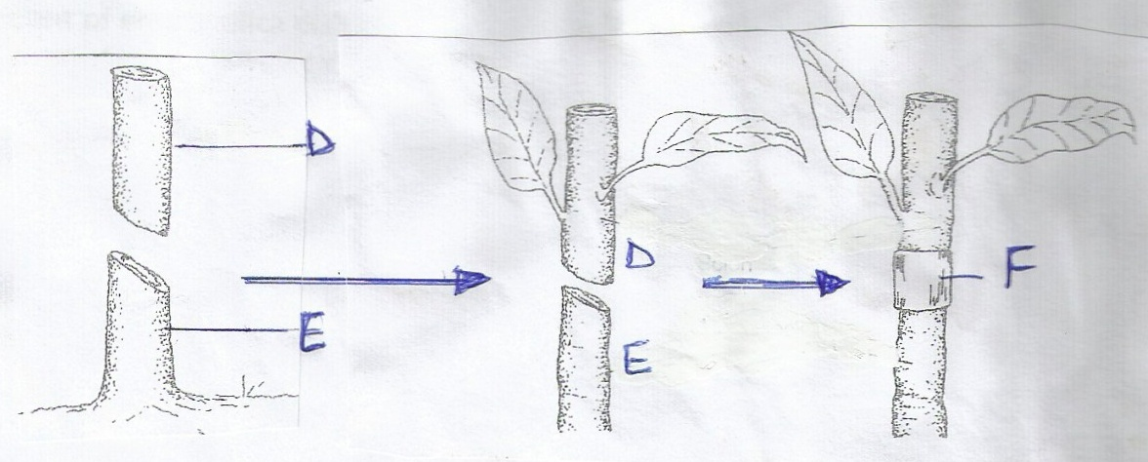

1. Identify the method ( 1 mark)

**………………………………………………………………………………………………………………………………………………………………………………………………**

(b) What name is given to the part labelled **D……………………………………**(1mark)

(c) Give **two** characteristic of the part labelled E that makes it suitable for use in grafting.

(2marks)

**……………………………………………………………………………………………….…………………………………………………………….………………………………………………………………………………………………………………………………….**

(d) Name the appropriate materials for wrapping round the union at point **F**. (1mark)

**………………………………………………………………………………………………………………………………………………………………………………………………**

21. The photograph below shows a type of erosion caused by runoff water. Study the photograph carefully and then answer the questions that follow

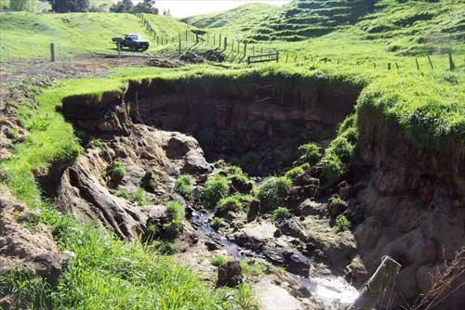

(a)Identify the type of erosion shown in the photograph (1 mark)

**………………………………………………………………………………………………………………………………………………………………………………………………**

(b)State **three** measures which could be taken to reverse the effect caused by the erosion shown in the photograph (3 marks)

**………………………………………………………………………………………………………………………………………………………………………………………………………………………………………………………………………………………………………………………………………………………………………………………………**

22. The diagrams show three crops labeled **A, B, C** suffering from deficiency of a certain nutrient.

**A**

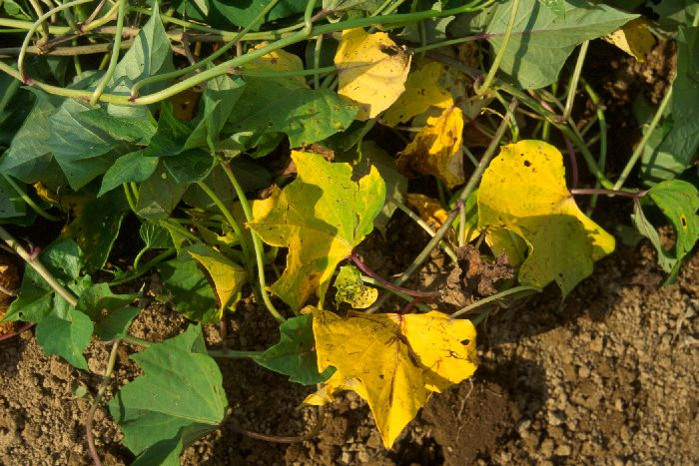

**B C**

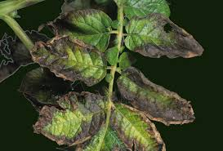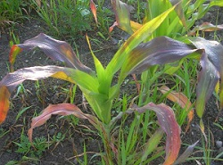

1. Name the nutrient deficiency in each of the three crops (3 marks)

**A……………………………………………………………………………………**

**B……………………………………………………………………………………**

**C……………………………………………………………………………………**

1. Name the chemical fertilizer which might correct the deficiency when added to the soil

in each case. (3 marks)

**…………………………………………………………………………………………………………………………………………………………………………………………………………………………………………………………………………………………………………………………………………………………………………**

1. Maize requires 120kg/ha of phosphorus pentoxide (P2O5). How much of the compound

fertilizer 20:20:10 would be applied to 0.4 hectare of land to achieve this rate (1½ marks)

**…………………………………………………………………………………………………………………………………………………………………………………………………………………………………………………………………………………………………………………………………………………………………………**

23. The table below shows weekly demand for rice in am market

Price (ksh) Quantity demanded (kgs)

10 250

9 350

8 550

7 600

6 700

5 1000

4 1500

Calculate the elasticity of demand (Ed) for rice when the price falls from Kshs. 10 to Kshs. 9 per Kg. (show your working) (2 ½ marks)

**………………………………………………………………………………………………………………………………………………………………………………………………………………………………………………………………………………………………………………………………………………………………………………………………………………………………………………………………………………………………………………………………………………………………………………………………………………………………………………………………………………………………………………………………………………………………………………………………………………………………………………………………………………………………………………………………………………………………………………………………………………………………………………………………………………**

**SECTION C – 40 MARKS)**

***Answer any two questions and answer them in the spaces provided after question 26***

24 a) Describe harvesting of pyrethrum under the following subheading

i) Method and procedure (3 marks)

ii) Precautions (3 marks)

b) State **five** characteristics of nitrogenous fertilizers (4 marks)

c) Explain **five** factors to consider when designing a crop rotation programme. (10 marks)

25. a) Discuss the various cultural practices carried by farmers to control pests (10marks)

b) Discuss the production of dry beans under the following headings

Varieties (2 marks)

Section of planting materials (3 marks)

Postharvest practices of dry beans (5 marks)

26. a) A farmer has 30 hectares of arable land, 20 hectares of which is planted with maize and

10hectares with grass hay. He wishes to replace 10 hectares of maize with Irish potatoes next year. The fertilizer rate will have to be increased from 2 bags per hectare for maize to 4 bags per hectare for potatoes. As a result of the change extra 40 men days of casual labour per hectare will be necessary at the rate of Kshs.100 per man a day. The average yield per hectare of maize is 35bags and for potatoes 120bags.The price paid is Kshs.1, 000 per bag of maize and Kshs.600 per bag of potatoes. Maize seeds cost Kshs.750 per hectare and potatoes cost Kshs.800 per hectare. Fertilizer costs are Kshs. 650 per hectare.

i) Draw up a partial budget and advice the farmer accordingly. (9 marks)

ii) Name the other type of budget that can be prepared by a farm manager (1 mark)

b) Discuss the various problems associated with land fragmentation (6 marks)

c) Explain **four** environmental factors that affect the effectives of herbicides (4 marks)

**…………………………………………………………………………………………………………………………………………………………………………………………………………………………………………………………………………………………………………………………………………………………………………………………………………………………………………………………………………………………………………….…………………………………………………………………………………………………………………………………………………………………………………………………………………………………………………………………………………………………………………………………………………………………………………………………………………………………………………………………………………………………………….…………………………………………………………………………………………………………………………………………………………………………………………………………………………………………………………………………………………………………………………………………………………………………………………………………………………………………………………………………………………………………….…………………………………………………………………………………………………………………………………………………………………………………………………………………………………………………………………………………………………………………………………………………………………………………………………………………………………………………………………………………………………………….**

**………………………………………………………………………………………………….**

**…………………………………………………………………………………………………………………………………………………………………………………………………………………………………………………………………………………………………………………………………………………………………………………………………………………………………………………………………………………………………………….…………………………………………………………………………………………………………………………………………………………………………………………………………………………………………………………………………………………………………………………………………………………………………………………………………………………………………………………………………………………………………….…………………………………………………………………………………………………………………………………………………………………………………………………………………………………………………………………………………………………………………………………………………………………………………………………………………………………………………………………………………………………………….…………………………………………………………………………………………………………………………………………………………………………………………………………………………………………………………………………………………………………………………………………………………………………………………………………………………………………………………………………………………………………….**

**………………………………………………………………………………………………….**

**…………………………………………………………………………………………………………………………………………………………………………………………………………………………………………………………………………………………………………………………………………………………………………………………………………………………………………………………………………………………………………….…………………………………………………………………………………………………………………………………………………………………………………………………………………………………………………………………………………………………………………………………………………………………………………………………………………………………………………………………………………………………………….…………………………………………………………………………………………………………………………………………………………………………………………………………………………………………………………………………………………………………………………………………………………………………………………………………………………………………………………………………………………………………….…………………………………………………………………………………………………………………………………………………………………………………………………………………………………………………………………………………………………………………………………………………………………………………………………………………………………………………………………………………………………………….**

**………………………………………………………………………………………………………………………………………………………………………………………………………………………………………………………………………………………………………………………………………………………………………………………………………….………………………………………………………………………………………………………………………………………………………………………………………………………………………………………………………………………………………………………………………………………………………………………………………………………….**

***THIS IS THE LAST PRINTED PAGE.***