KITUTU CENTRAL JOINT EXAMANITION
Kenya Certificate of Secondary Education

FORM 4, TERM 2, 2021

443/2 AGRICULTURE Paper 2

DECEMBER 2021 – Time: 2Hours

Name: ……………………………………….....…… Adm No: ……….……
Class: …………Candidate’s Signature: …….……….Date: …..……../12/2021.

INSTRUCTIONS TO CANDIDATES
- Write your name and Adm. Number in the spaces provided above.
- Sign and write the date of examination in the spaces provided above.
- This paper consists of THREE sections A, B and C.
- Answer All the Question in section A and B and TWO questions in section C.
- This paper consists of 11 printed pages.
- Candidates should check the question paper to ascertain that all the pages are printed as
indicated and that no questions are missing.

FOR EXAMINER’S USE ONLY

SECTIONS | QUESTIONS | MAXIMUM SCORE | CANDIDATES SCORE
A | 1-18 | 30
B | 19-23 | 20
C |  | 40
 |  | 40
TTOAL |  | 90
SECTION A (30 MARKS)
Answer all the questions in this section in the spaces provided.

1. State four reasons for maintaining farm tools. (2 marks)
………………………………………………………………………………………………………………………………………………………………………………………………………………………………………………………………………………………………
………………………………………………………………………………………………………………………………………………………………………………………………
2. What is a zoonotic disease? (1 mark)
………………………………………………………………………………………………………………………………………………………………………………………………………………………………………………………………………………………………
3. Explain two uses of a sprayer to a farmer. (2 marks)
………………………………………………………………………………………………………………………………………………………………………………………………………………………………………………………………………………………………
4. State four constructional features necessary in a fish pond. (2 marks)
………………………………………………………………………………………………………………………………………………………………………………………………………………………………………………………………………………………………………………………………………………………………………………………………………………………………………………………………………………………………
5. Write down types of lubrication systems used in tractor. (1 mark)
………………………………………………………………………………………………………………………………………………………………………………………………………………………………………………………………………………………………
6. Give two signs that would indicate a cow has died of anthrax (1 mark)
………………………………………………………………………………………………………………………………………………………………………………………………………………………………………………………………………………………………

7. State TWO ways in which digestion of food in pigs differs from that in ruminants. (1mark)
………………………………………………………………………………………………………………………………………………………………………………………………………………………………………………………………………………………………

8. The dressed weight of a beef animal is 450kg and its kill out percentage is 75. Calculate its live weight. (2 marks)
………………………………………………………………………………………………………………………………………………………………………………………………………………………………………………………………………………………………
9. State two advantages of wind power in the farm. (2 marks)
………………………………………………………………………………………………………………………………………………………………………………………………………………………………………………………………………………………………
10. Outline four reasons why indigenous cattle breeds are more suited to semi-arid areas of Kenya than exotic breeds (2 marks)

………………………………………………………………………………………………………………………………………………………………………………………………………………………………………………………………………………………………………………………………………………………………………………………………
11. Name the organism that causes the following disease. (½ mark)
(a) East Coast Fever
………………………………………………………………………………………………………………………………………………………………………………
(b) Fowl typhoid (½ mark)
………………………………………………………………………………………………………………………………………………………………………………

12. State two functions of calcium element in dairy cows. (2 marks)
………………………………………………………………………………………………………………………………………………………………………………………………………………………………………………………………………………………………

13. Distinguish between isolation and quarantine as used in livestock management. (1 mark)
………………………………………………………………………………………………………………………………………………………………………………………………………………………………………………………………………………………………
14. (a) What is a predilection site of a parasite. (1 mark)
………………………………………………………………………………………………………………………………………………………………………………………………………………………………………………………………………
(b) Name two reasons on a cow where blue ticks are likely to be found.(2 marks)
………………………………………………………………………………………………………………………………………………………………………………………………………………………………………………………………………
15. State two disadvantages of using hurricane lamps or lanterns as providers of heat in a
brooder. (2 marks)
………………………………………………………………………………………………………………………………………………………………………………………………………………………………………………………………………………………………
16. Name the part in each of the following animals where cellulose is digested. (2 marks)
(a) Poultry
………………………………………………………………………………………………………………………………………………………………………………
(b) Goats
………………………………………………………………………………………………………………………………………………………………………………

17. Name two appropriate tools for trimming hooves in livestock. (2 marks)
………………………………………………………………………………………………………………………………………………………………………………………………………………………………………………………………………………………………
18. State two characteristics of a good acaricides. (1 mark)
………………………………………………………………………………………………………………………………………………………………………………………………

SECTION B (20 MARKS)
Answer all the questions in this section in the spaces provided.

19. Study the diagram drawn below and answer the questions that follow.
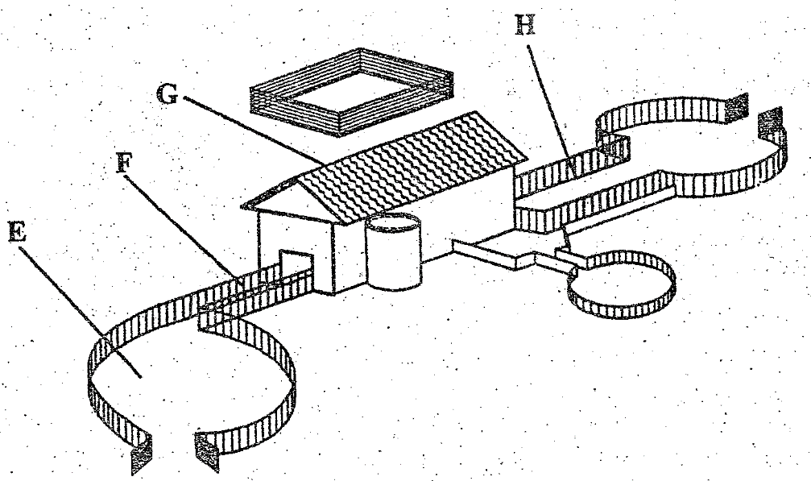
(i) Name the parts labeled E and F. (1 mark)
E…………………………………………………………………………………….
F ……………………………………………………………………………………
(ii) State two importance of part G. (2 marks)
………………………………………………………………………………………………………………………………………………………………………………………………………………………………………………………………………………………………………………………………………………………………
(iii) Give two reasons for holding animals for a short period in part H after dipping. (2 marks)
………………………………………………………………………………………………………………………………………………………………………………………………………………………………………………………………………

(iv) Outline three precautionary measures to be taken before dipping to ensure effective dipping. (3 marks)

………………………………………………………………………………………………………………………………………………………………………………………………………………………………………………………………………………………………………………………………………………………………
………………………………………………………………………………………………………………………………………………………………………………

20. Below is a type of beehive.
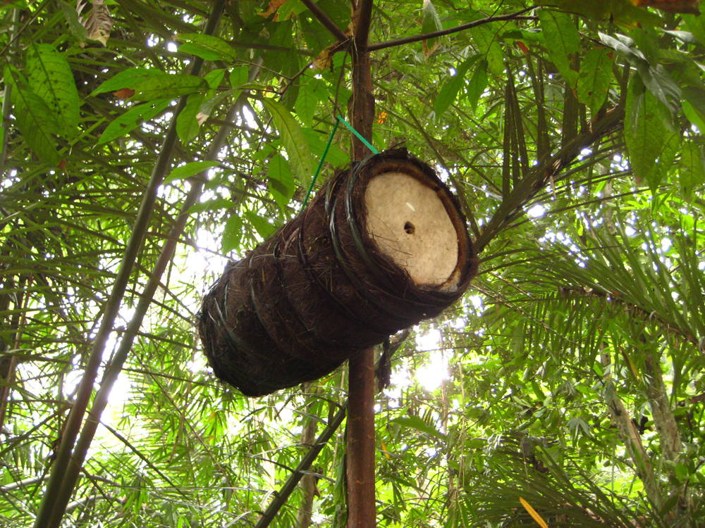

- Name the type of beehive. (1 mark)
………………………………………………………………………………………………………………………………………………………………………………………………

b) State two advantages of using the Kenya Top Bar Hive (KTBH) over the type of beehive
named in (i) above. (2 marks)
………………………………………………………………………………………………………………………………………………………………………………………………
………………………………………………………………………………………………………………………………………………………………………………………………
c) State three factors to consider when siting an apiary. (3 marks)
…………………………………………………………………………………………………………………………………………………………………………………………………………………………………………………………………………………………………………………………………………………………………………………………………………………………………………………………………………………………………………..
- Name two diseases that attack bees. (1 mark)
………………………………………………………………………………………………………………………………………………………………………………………………………………………………………………………………………………………………………

21. The diagram below is an illustration of an egg. Study it carefully and answer the questions that follow.
L
M
H
J
I
K

- Name the parts labelled I, J, K and M. (2 marks)
………………………………………………………………………………………………………………………………………………………………………………………………………………………………………………………………………………………………………………………………………………………………
- Give two qualities of the part labelled H that would be considered when selecting
eggs for incubation. (2 marks)
………………………………………………………………………………………………………………………………………………………………………………………………………………………………………………………………………………………………………………………………………………………………
- What is the function of the part labelled L (1 mark)
………………………………………………………………………………………………………………………………………………………………………………

SECTION C (40 marks)
Answer any two questions from this section in the spaces provided after question 26.

22. a) Describe calf scours under the following subheadings.
- Causative agent. (1 mark)
- Predisposing causes (4 marks)
- Symptoms of attack (5 marks)
- Control measures (6 marks)
- State the factors to consider when selecting site for a fish pond. (4 marks)

23. a) State four components of tractor fuel system and function of each. (8 marks)
b) State any seven maintenance practices carried out on a tractor. (7 marks)
c) i) Give two advantages of tractor hire services. (2 marks)
ii) State the three ways in which implements are attached to the tractor. (3 marks)

24. a) Explain the requirements of an ideal calf pen. (5 marks)
b) State six disadvantages of live fence in the farm. (6 marks)
c) Describe the various control measures of diseases in livestock in the farm. (9 marks)

………………………………………………………………………………………………………………………………………………………………………………………………………………………………………………………………………………………………………………………………………………………………………………………………………………………………………………………………………………………………………………………………………………………………………………………………………………………………………………………………………………………………………………………………………………………………………………………………………………………………………………………………………………………………………………………………………………………………………………………………………………………………………………………………………………………………………………………………………………………………………………………………………………………………………………………………………………………………………………………………………………………………………………………………………………………………………………………………………………………………………………………………………………………………………………………………………………………………………………………………………………………………………………………………………………………………………………………………………………………………………………………………………………………………………………………………………………………………………………………………………………………………………………………………………………………………………………………………………………………………………………………………………………………………………………………………………………………………………………………………………………………………………………………………………………………………………………………………………………………………………………………………………………………………………………………………………………………………………………………………………………………………………………………………………………………………………………………………………………………………………………………………………………………………………………………………………………………………………………………………………………………………………………………………………………………………………………………………………
………………………………………………………………………………………………………………………………………………………………………………………………………………………………………………………………………………………………………………………
………………………………………………………………………………………………………………………………………………………………………………………………………………
………………………………………………………………………………………………………………………………………………………………………………………………………………………………………………………………………………………………………………………………………………………………………………………………………………………………………………………………………………………………………………………………………………………………………………………………………………………………………………………………………………………………………………………………………………………………………………………………………………………………………………………………………………………………………………………………………………………………………………………………………………………………………………………………………………………………………………………………………………………………………………………………………………………………………………………………………………………………………………………………………………………………………………………………………………………………………………………………………………………………………………………………………………………………………………………………………………………………………………………………………………………………………………………………………………………………………………………………………………………………………………………………………………………………………………………………………………………………………………………………………………………………………………………………………………………………………………………………………………………………………………………………………………………………………………………………………………………………………………………………………………………………………………………………………………………………………………………………………………………………………………………………………………………………………………………………………………………………………………………………………………………………………………………………………………………………………………………………………………………………………………………………………………………………………………………………………………………………………………………………………………………………………………………………………………………………………………………………………
………………………………………………………………………………………………………………………………………………………………………………………………………………………………………………………………………………………………………………………
………………………………………………………………………………………………………………………………………………………………………………………………………………
………………………………………………………………………………………………………………………………………………………………………………………………………………
………………………………………………………………………………………………………………………………………………………………………………………………………………………………………………………………………………………………………………………………………………………………………………………………………………………………………………………………………………………………………………………………………………………………………………………………………………………………………………………………………………………………………………………………………………………

