**KITUTU CENTRAL JOINT EXAMINATION**

***Kenya Certificate of Secondary Education***

**Form 4, Term 2, 2021**

**231/1 BIOLOGY Paper 1**

**December 2021 – TIME: 2 Hours**

**Name**: ………………………………………….....…… **Adm** **No**: ……….……

**Class**: ………………**Candidate’s** **Signature**: ………... **Date**: …..…/09/2021.

**INSTRUCTIONS TO CANDIDATES**

1. Write your name and Admn. No. in the spaces above

2. Sign and write the date of examination in the space provided above.

3. This paper consists of 11 printed pages.

4. Candidates should check the question paper to ascertain that all the pages are printed as indicated and **no questions are missing**

5. Answer all the questions

**FOR EXAMINER’S USE ONLY**

|  |  |  |
| --- | --- | --- |
| **Question** | **Maximum**  **Score** | **Candidate’s**  **Score** |
| 1-33 | 80 |  |

**© END OF TERM TWO EXAMINATION**

**231/1**

**Biology Paper 1**

**THEORY**

1. State **two** functions of a mammalian ear. (2 marks)

**………………………………………………………………………………………………**

**………………………………………………………………………………………………**

**………………………………………………………………………………………………**

2**.** State **two** physiological changes that occur in the body to lower carbon (iv) oxide level back to normal after vigorous exercise (2 marks)

**………………………………………………………………………………………………**

**………………………………………………………………………………………………**

**………………………………………………………………………………………………**

3. Explain why it is advisable to wipe off any water on the microscope stage during carrying out microscopic procedures (1mark)

**………………………………………………………………………………………………**

**………………………………………………………………………………………………**

4. Name the plant hormone whose effects are described below:

1. In high concentration causes closing of stomata (1 mark)

**………………………………………………………………………………………………………………………………………………………………………………**

1. Induces parthenocarpy (1 mark)

**………………………………………………………………………………………………………………………………………………………………………………**

1. Inhibits development of the side branches from lateral buds (1mark)

**………………………………………………………………………………………………………………………………………………………………………………**

5. The diagram shown below represents a male reproductive system.

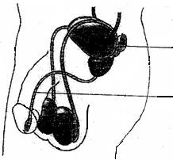X

Y

(i) Name the structure labelled **X**…………………………………............(1mark)

(ii) Name **one** substances that pass through structure labelled **Y**……….. (1mark)

6. (a) Give one external feature that distinguishes an earthworm from a round worm .(1 mark

**………………………………………………………………………………………………………………………………………………………………………………………………………………………………………………………………**

(b) Name the phylum to which each belongs

Earthworm **…………………………………………………………………..(**1mark)

Roundworm **……………………………………………………………….…**(1mark)

7. (a) State the roles of light in plant nutrition. (2marks)

**………………………………………………………………………………………………………………………………………………………………………………………………………………………………………………………………**

(b) Give a reason why glucose formed at the end of photosynthesis is converted at once into

starch. (1mark)

**………………………………………………………………………………………………………………………………………………………………………………………………………………………………………………………………**

8. The diagram below shows a plant supportive tissue

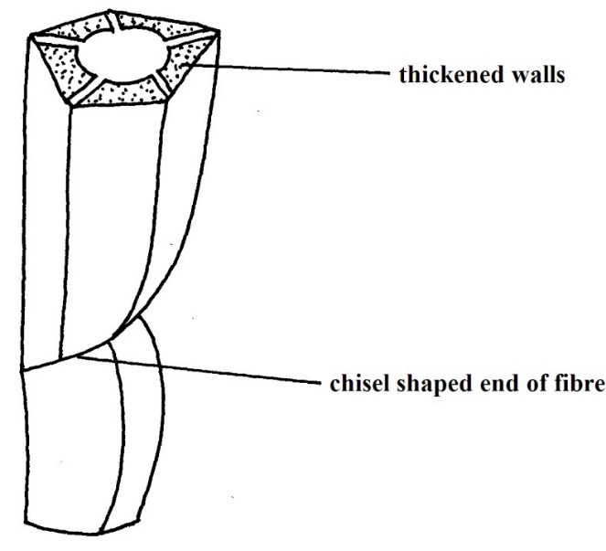

(a) Identify the tissue (1mark)

**……………………………………………………………………………………………………………………………………………………………………………………………………**

(b) State two similarities between tissue named in 9(a) above and one conducting water in dicotyledonous plant. (2marks)

**………………………………………………………………………………………………………………………………………………………………………………………………………………………………………………………………………………………………………**

9. The photograph below shows a type of saprophytic fungi. State its benefit in the natural habitat? (1 mark)

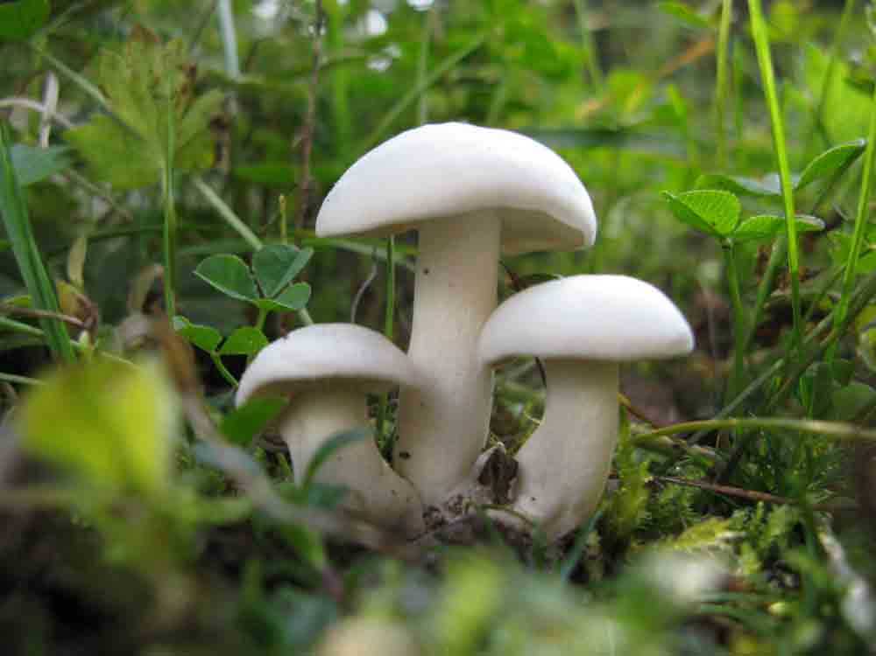

……………………………………………………………………………………………………………………………………………………………………………………………………………………………………………………………………………………………………………………………………………..

10. A certain organelle was observed in a cell, and a diagram drawn, as shown below.

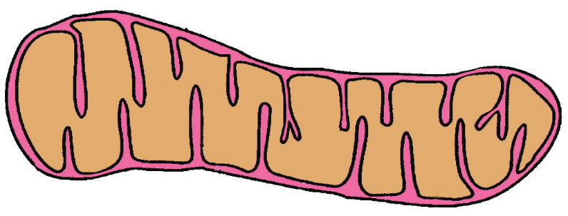

(a) State the function of the organelle. (1 mark)

**……………………………………………………………………………………………………………………………………………………………………………………………………**

(b) Name two plant cells with a very large numbers of such organelles. (2 marks)

**………………………………………………………………………………………………………………………………………………………………………………………………………………………………………………………………………………………………………**

11. (a) Define the term osmosis. (1 mark)

**............................................................................................................................................................................................................................................................................................................................................................................................................**

(b) Describe the role of diffusion in plants reproduction. (2 marks)

**............................................................................................................................................................................................................................................................................................................................................................................................................**

12. The figure below shows a kidney nephron. Study it and answer the questions that follow.

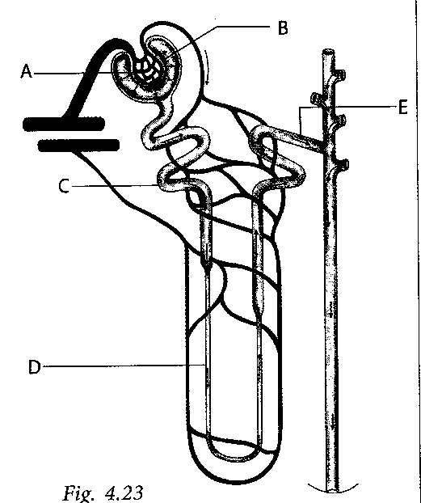

a) Name the parts labelled A, C, D (3 marks)

**A……………………………………………………………………………………..**

**C……………………………………………………………………………………..**

**D……………………………………………………………………………………..**

b) State **two** adaptations of the part labelled C to its functions (2 marks)

**………………………………………………………………………………………………………………………………………………………………………………………………………………………………………………………………………………………………………………………………………………………………**

13. Study the diagrams below of organisms P, R and S.

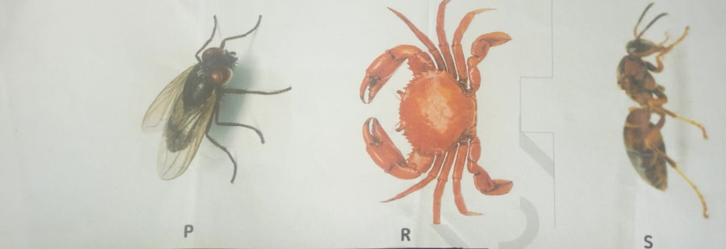

Construct a dichotomous key that would be used to identify them. (2 marks)

**………………………………………………………………………………………………………………………………………………………………………………………………………………………………………………………………………………………………………………………………………………………………………………………………**

14. (a) What is cell specialization? (1 mark)

………………………………………………………………………………………………………………………………………………………………………………………………………………………………………………………………………

(b) State two adaptations of a neuron to its function. (2 marks)

………………………………………………………………………………………………………………………………………………………………………………………………………………………………………………………………………………………………………………………………………………………………

15. During a class experiment green grams’ plants were germinated in two trays containing soil. Tray A contained soil that had been mixed with nitrogenous fertilizer while in tray B the fertilizer had not been added. One week after germination the seedlings were uprooted, their roots washed and their root nodules counted.

(a) What was the aim of the above experiment? (1 mark)

**……………………………………………………………………………………………………………………………..……………………………………………….……………………..……………………………………………………………….**

(b) Account for the observation made when the root nodules of the two sets of

plants were counted. (2 marks)

**…………………………………………………………………………………………………………………………….………………………………………………..…………………………………………………………………………….………...………………………………………………………………………………………**

16. Competition is an instinct in all organisms for their survival. Identify the type competition shown in the photo below. (1 mark)

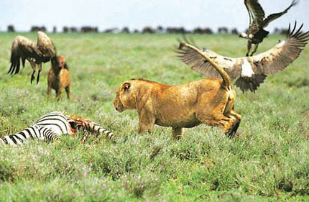

**…………………………………….………………………………………………..…………………………………………………………………………….………...………………**

17. Name the **two** products of dark reaction of photosynthesis in plants. (2 marks)

**………………………………………………………………………………………………….…………………………………………………………………………………………...………………………………………………………………………………………………**

18. Name **two** sites of respiration in a cell. (2 marks) **………………………………………………………………………………………………………………………………………………………………………………………………………………………………………………………………………………………………**

19. (i) What is blood transfusion? (1 mark)

**………………………………………………………………………………………………………………………………………………………………………………**

1. A person whose blood group is A died shortly after receiving blood from a person

of blood group B. Explain the cause of death. (2 marks)

**………………………………………………………………………………………………………………………………………………………………………………………………………………………………………………………………………**

20. (a) Differentiate between sickle-cell anaemia and sickle- cell trait. (2 marks)

**………………………………………………………………………………………………………………………………………………………………………………………………………………………………………………………………………**

1. Name the type of gene mutation that brings about the sickle cell anaemia.

(1 mark)

**…………………………………………………………………………………………….. ……………………………………………………………………………….**

21. Give **one** example in each case of the following:

* 1. a fixed joint: (1 mark)

**………………………………………………………………………………………………………………………………………………………………………………**

(b) a ball and socket joint: (1 mark) **……………………………………………………………………………………………………………………………………………………………………………...**

22. List **two** isolation mechanisms which could lead to speciation. (2 marks) **…………………………………………………………………………………………………………………………………………………………………………………………………… ………………………………………………………………………………………...**

23. Name **two** characteristic features used to distinguish a mammal from other vertebrates?

(2 marks)

**……………………………………………………………………………………………………………………………………………………………………………………………………………………………………………………………………………………….**

24. (a) Which component of the diet is largely responsible for causing tooth decay?

(1 mark)

**………………………………………………………………………………………………………………………………………………………………………………**

1. Explain how the component you have named in (a) above causes the tooth decay.

(2 marks)

**……………………………………………………………………………………………………………………………………………………………………………………………................................................................................................................**

25. List the causative agent of the following sexually transmitted infections (STIs):

1. Gonorrhoea. (1 mark) **……………………………………………………………………………………… ………………………………………………………………………………………**
2. Syphilis (1 mark) **………………………………………………………………………………………………………………………………………………………………………………**

26. Name the **two** types of chemical compounds which combine to form a lipid. (2 marks) **………………………………………………………………………………………………………………………………………………………………………………………………**

27. Name the processes by which the following enter the root hair cell.

(a) Oxygen. (1 mark) **………………………………………………………………………………………………………………………………………………………………………………**

(b) Water. (1 mark) **………………………………………………………………………………………………………………………………………………………………………………**

28. Give **two** structural differences between mature white blood cells and red blood cells.

(2 marks)

**………………………………………………………………………………………………………………………………………………………………………………………………………………………………………………………………………………………………**

29. Give **two** examples of genetic engineering that are intended to improve crop plants.

(2 marks)

**………………………………………………………………………………………………………………………………………………………………………………………………………………………………………………………………………………………………**

30. Give **two** characteristics of Cardiac muscles. (2 marks) **………………………………………………………………………………………………………………………………………………………………………………………………………………………………………………………………………………………………**

31. Alveoli are well-ventilated to provide efficient gas exchange.

(i) State the name of the muscles that cause the ribs to move during ventilation. (1 mark)

**………………………………………………………………………………………………………………………………………………………………………………………………………………………………………………………………………**

(ii) During inspiration the pressure and volume in the thorax changes. State these changes. (1 mark)

pressure **....................................................................................................................................** volume **....................................................................................................................................**

32. The figure below shows a group of male students. They are all the same age.



(i)The students show continuous variation in some of their

characteristics. State **three** characteristics in which these students show continuous variation. (3 marks)

**………………………………………………………………………………………………………………………………………………………………………………………………………………………………………………………………………………………………………………………………………………………………**

(ii)State **one** example of discontinuous variation. (1 mark)

**………………………………………………………………………………………………………………………………………………………………………………**

33.(i) **What** is gene mutation? (1mark)

**………………………………………………………………………………………………………………………………………………………………………………**

(ii) **State** **two** disorders in human beings caused by gene mutations. (2 marks)

**………………………………………………………………………………………………………………………………………………………………………………………………………………………………………………………………………**

**(iii) What** name is given to the factors in the environment that encourage or speed up

mutation? (1 mark)

**………………………………………………………………………………………………………………………………………………………………………………**