**KITUTU CENTRAL JOINT EXAMINATION**

***Kenya Certificate of Secondary Education***

**FORM 4, TERM 2, 2021**

**231/1 BIOLOGY Paper 2**

**DECEMBER 2021 – TIME: 2 Hours**

**Name: ……………………………….......Adm No: ………….……..**

**Class: ……Candidate’s Signature: ……..…..Date: /12/2021…….….**

**INSTRUCTIONS TO CANDIDATES**

* Write your **Name** and Index **Number** in the spaces provided above.
* **Sign** and write the **date** of examination in the spaces provided above.
* This paper consists of **TWO** sections: **A** and **B.**
* Answer **ALL** the questions in section **A** in the spaces provided after each question
* In Section **B**, answer question **6 (compulsory**) in the spaces provided and either question **7** or **8** in the spaces provided after question **8**.
* Answers must be written in English only.

**FOR EXAMINER’S USE ONLY**

|  |  |  |  |
| --- | --- | --- | --- |
| **Section** | **Question** | **Maximum**  **Score** | **Candidate’s Score** |
| A | 1 | 8 |  |
| 2 | 8 |  |
| 3 | 8 |  |
| 4 | 8 |  |
| 5 | 8 |  |
| 6 | 8 |  |
| B | 7 | 20 |  |
| 8 | 20 |  |
| **Total Score** | | |  |

*This paper consists of* ***12*** *printed pages.*

*Candidates should check the question paper to ensure that all the pages are printed as indicated and no question is missing.*

**SECTION A (40 MARKS)**

***Answer ALL Questions***

**1. a)** Fig 1 shows a flower that reproduces using wind-pollination.

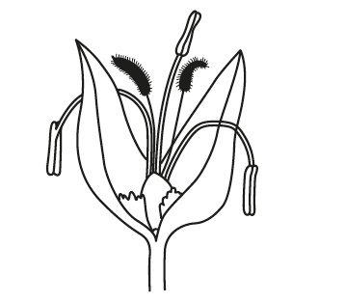

State **two** ways in which the flower in Fig. 1 is adapted for wind-pollination. (2 marks)

………………………………………………………………………………………

……………….……………………………………………………………………...

………………………………………………………………………………………

**b)** Fig. 1.2 shows two photomicrographs of pollen.



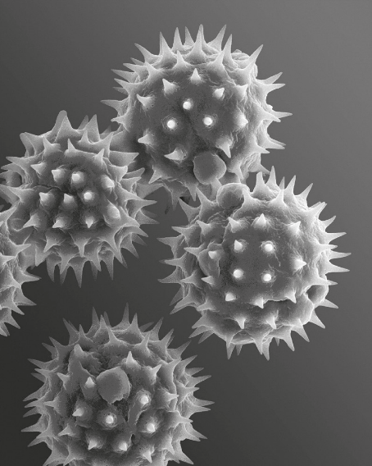

Magnification × 1250 Magnification × 2000

Pollen from an insect-pollinated flower Pollen from a wind-pollinated flower

Explain, using your knowledge and the information in Fig. 1.2, how pollen from

an insect-pollinated flower is different to pollen from a wind-pollinated flower.

(3 marks)

**........................................................................................................................................................................................................................................................................................................................................................................................................................................................................................................................................................................................................................................................................................................................................................................................................................**

**(d)** Sexual reproduction in plants results in seeds being formed.

State **three** conditions needed for the germination of seeds. (3 marks)

**....................................................................................................................................................................................................................................................................................................................................................................................................................................................................................................................................................................................................................................................................................**

2. Malaria is a disease caused by a parasite that is transmitted from one person to another by a vector.

(a)Name the vector of the parasite that causes malaria. (1 mark)

**........................................................................................................................................................................................................................................................................**

(b) (i)Spread of the vector may be controlled by using an insecticide.

State **two** other ways of controlling the spread of the vector. (2 marks)

**................................................................................................................................................................................................................................................................................................................................................................................................................................................................................................**

(ii)Resistance to the insecticide can appear in the vector population.

Describe how the process of natural selection may bring about resistance of the vector to insecticide. (4 marks)

**................................................................................................................................................................................................................................................................................................................................................................................................................................................................................................................................................................................................................................................................................................................................................**

3. Two herbivore mammalian species were introduced into an ecosystem at the same time and in equal numbers. The graph below represents their populations during the first seven years. Study the graph and answer the questions that follow:

**Species A**

**Species B**

1. (i) Which species has better competition ability? (1mark)

**………………………………………………………………………………………………………………………………………………………………**

1. Give a reason for your answer in (a)(i) above. (1 mark)

**………………………………………………………………………………………………………………………………………………………………**

1. Account for the shape of the curve of species A between:
2. One year and three years. (2 marks)

**………………………………………………………………………………………………………………………………………………………………………………………………………………………………………………**

1. three years and seven years. (2 marks)

**………………………………………………………………………………………………………………………………………………………………………………………………………………………………………………**

1. Name the type of interaction that exists between the two species of Paramecia in

the ecosystem. (1 mark)

**…………………………………………………………………………………………………………………………………………………………………….**

1. Why is it that gazelles and buffaloes do occupy same ecosystem? (1 mark)

**………………………………………………………………………………………………………………………………………………………………………………**

4. Below is a photograph obtained from the pelvic region of a human being, and showing some bones of the vertebral column. Examine it.

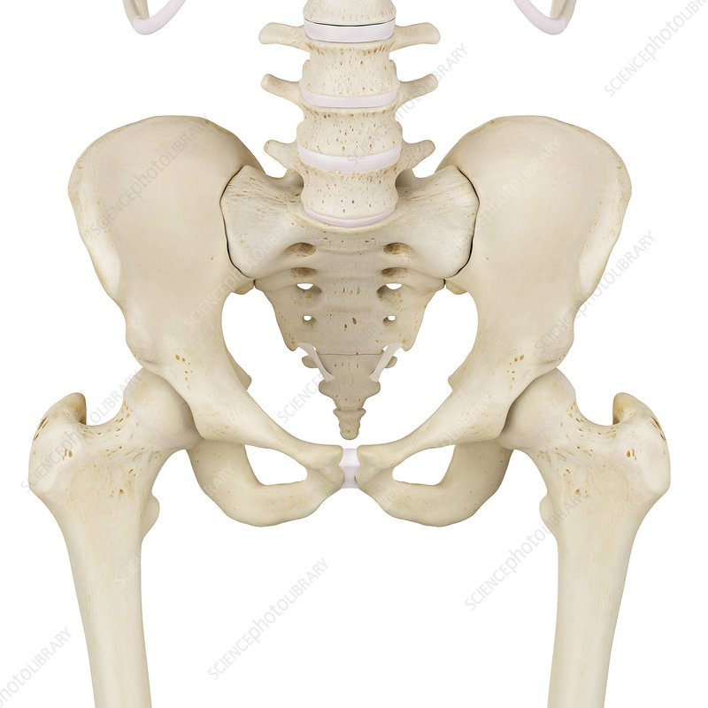

**1**

**2**

**3**

(a) **Name** the bones labelled 1, 2 and 3 on the photograph (3 marks)   
 **1: ……………………………………………………………………………**

**2: ………………………………………………………………………........**

**3: ………………………………………………………………….………..**

(b) **Indicate** on the above diagram the position of pubis symphysis. (1mark)

(c) Using observable features only, **state** how bone I as adapted to its functions.

(4marks)

**………………………………………………………………………………………………………………………………………………………………………………………………………………………………………………………………………………………………………………………………………………………………………………………………………………………………………………………………………………………………………………………………………………**

5.The brain is one component of the nervous system.

(a)State **two** other components of the nervous system. (2 marks)

**………………………………………………………………………………………………………………………………………………………………………………………………………………………………………………………………………………………………………………………………………………………………………………………………………………**

(b)The figurebelow shows the human brain.

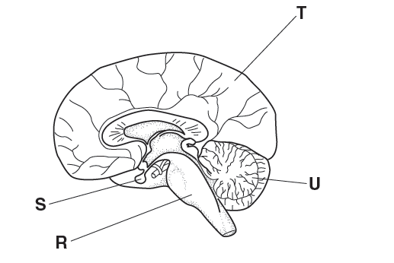

Name and explain the functions of parts **R**, **S**, **T** and **U**, labelled in Fig. 8.1, in terms of coordinating and regulating bodily functions. (6 marks)

**…………………………………………………………………………………………………………………………………………………………………………………………………………………………………………………………………………………………………………………………………………………………………………………………………………………………………………………………………………………………………………………………………………………………………………………………………………………………………………………………………………………………………………………………………………………………………………………………………………………………………………………………………………………………………………………………………………………………………………………………………………………………………………………………………………………………………………………………………………………………………………………………………………………………………………………………………………………………………………………………………………………………………………………..**

**SECTION B (40 MARKS)**

***Answer question 6 (compulsory) and either question 7 or 8 in the spaces provided after question 8.***

6. In an experiment to investigate the action of salivary amylase on starch, equal amounts of amylase was added to equal amounts of starch in different tubes. The test tubes were placed at different temperatures. The table below shows the time taken for the enzymes to digest starch.

|  |  |  |  |  |  |  |  |  |
| --- | --- | --- | --- | --- | --- | --- | --- | --- |
| Time (min) | 45 | 27.5 | 15 | 05 | 1.5 | 1 | 8 | 35 |
| Temperature (0C) | 0 | 20 | 20 | 30 | 35 | 38 | 40 | 45 |

1. On the grid provided, plot a graph of time in minutes against temperature. (5 marks)
2. What is the optimum temperature of the enzyme? (1 mark)

**………………………………………………………………………………………………………………………………………………………………………………………………………………………………………………………………………………………………………………**

1. Account for the time taken to digest starch at:

i) 50C (2 marks)

**………………………………………………………………………………………………………………………………………………………………………………………………………………………………………………………………………………………………………………………………………………………………………………………………………………………………………………**

ii) 450C (2 marks)

**………………………………………………………………………………………………………………………………………………………………………………………………………………………………………………………………………..……………………………………………………………………………………………………………………………………………………………………**

1. Other than temperature, name **two** factors that influence the rate of enzyme activity. (2 marks)

**………………………………………………………………………………………………………………………………………………………………………………………………………………………………………………………………………..……………………………………………………………………………………………………………………………………………………………………………**

1. What is the rate of enzyme action at 150C? Work out using the graph drawn. (3 marks)

**………………………………………………………………………………………………………………………………………………………………………………………………………………………………………………………………………..……………………………………………………………………………………………………………………………………………………………………………………………………………………………………………………………………………………………………………………………………………………**

1. Salivary amylase continues to digest starch to maltose in the food bolus from the mouth

down the oesophagus but stops in the stomach. Explain this observation. (2 marks)

**………………………………………………………………………………………………………………………………………………………………………………………………………………………………………………………………………..……………………………………….………………………………………………………………………………………………………………………………………………….**

1. Name the secretions received in the duodenum from the pancreas to facilitate the process of

digestion. (1 mark)

**………………………………………………………………………………………………………………………………………………………………………………………………………………………………………………………………………..……………………………………….………………………………………………………………………………………………………………………………………………….**

1. During a scientific research on a rat, hydrochloric acid was carefully introduced in the pancreatic duct to mix with the secretion before it was received in the duodenum. It was discovered that no digestion took place in the duodenum. Explain. (2 marks)

**………………………………………………………………………………………………………………………………………………………………………………………………………………………………………………………………………..……………………………………….………………………………………………………………………………………………………………………………………………….………………………………………………………………………………………………………………………………………………………**

1. a) What is pollution (1 mark)

b) Give examples of pollutants that can cause

1. Air pollution (3 marks)
2. Soil pollution (3 marks)
3. Water pollution (3 marks)

c) Using specific examples, outline the effects of environmental pollution

(10 marks)

8. a) Describe the mechanism of gaseous exchange in;

1. a bony fish (6 marks)
2. a green plant (6 marks)

b) List down the characteristic features of meristematic cells in a plant. (4 marks)

c) Explain the effect of unidirectional light on growth in a seedling. (4 marks)

**……………………………………………………………………………………………………………………………………………………………………………………………………………………………………………………………………………………………………………………………………………………………………………………………………………………………………………………………………**

**……………………………………………………………………………………………………………………………………………………………………………………………………………………………………………………………………………………………………………………………………………………………………………………………………………………………………………………………………**

**……………………………………………………………………………………………………………………………………………………………………………………………………………………………………………………………………………………………………………………………………………………………………………………………………………………………………………………………………**

**……………………………………………………………………………………………………………………………………………………………………………………………………………………………………………………………………………………………………………………………………………………………………………………………………………………………………………………………………**

**……………………………………………………………………………………………………………………………………………………………………………………………………………………………………………………………………………………………………………………………………………………………………………………………………………………………………………………………………**

**……………………………………………………………………………………………………………………………………………………………………………………………………………………………………………………………………………………………………………………………………………………………………………………………………………………………………………………………………**

**……………………………………………………………………………………………………………………………………………………………………………………………………………………………………………………………………………………………………………………………………………………………………………………………………………………………………………………………………**

**……………………………………………………………………………………………………………………………………………………………………………………………………………………………………………………………………………………………………………………………………………………………………………………………………………………………………………………………………**

**……………………………………………………………………………………………………………………………………………………………………………………………………………………………………………………………………………………………………………………………………………………………………………………………………………………………………………………………………**

**……………………………………………………………………………………………………………………………………………………………………………………………………………………………………………………………………………………………………………………………………………………………………………………………………………………………………………………………………**

**……………………………………………………………………………………………………………………………………………………………………………………………………………………………………………………………………………………………………………………………………………………………………………………………………………………………………………………………………**

**……………………………………………………………………………………………………………………………………………………………………………………………………………………………………………………………………………………………………………………………………………………………………………………………………………………………………………………………………**

**……………………………………………………………………………………………………………………………………………………………………………………………………………………………………………………………………………………………………………………………………………………………………………………………………………………………………………………………………**

**……………………………………………………………………………………………………………………………………………………………………………………………………………………………………………………………………………………………………………………………………………………………………………………………………………………………………………………………………**

**……………………………………………………………………………………………………………………………………………………………………………………………………………………………………………………………………………………………………………………………………………………………………………………………………………………………………………………………………**

**……………………………………………………………………………………………………………………………………………………………………………………………………………………………………………………………………………………………………………………………………………………………………………………………………………………………………………………………………**

**……………………………………………………………………………………………………………………………………………………………………………………………………………………………………………………………………………………………………………………………………………………………………………………………………………………………………………………………………**

**……………………………………………………………………………………………………………………………………………………………………………………………………………………………………………………………………………………………………………………………………………………………………………………………………………………………………………………………………**

**……………………………………………………………………………………………………………………………………………………………………………………………………………………………………………………………………………………………………………………………………………………………………………………………………………………………………………………………………**

**……………………………………………………………………………………………………………………………………………………………………………………………………………………………………………………………………………………………………………………………………………………………………………………………………………………………………………………………………**

**……………………………………………………………………………………………………………………………………………………………………………………**