KITUTU CENTRAL JOINT EXAMINATION
Kenya Certificate of Secondary Education (KCSE)

FORM 4, TERM 2, DECEMBER 2021

231/3 BIOLOGY PAPER 3
(Practical)
TIME: 1 ¾ Hours

Name: …………………………………………..................... Index No………………………….

Signature……………………………….…………………. Date: ……………………………

Instructions to Candidates
- Write your Name and Index Number in the spaces provided above.
- Sign and write the date of examination in the spaces provided above.
- Answer all the questions in this paper.
- You are supposed to spend the first 15 minutes of the 1 ¾ hours allowed for this paper reading the whole paper carefully before commencing your work.
- Answers must be written in the spaces provided on the question paper.
- Additional pages must not be inserted.
- Candidates may be penalized for recording irrelevant information and for incorrect spelling especially of technical terms.
- Answers must be written in English only.
For Examiner’s use only
Question | Maximum score | Candidate’s  score
1 | 15
2 | 14
3 | 11
Total | 40

This paper consists of 7 printed pages. Candidates should check the question paper to ensure that all the pages are printed as indicated and no question is missing.

1. You are provided with cooking oil, liquids L and K and an Irish potato.

- Label two test tubes A and B. Place 2cm3 of water into each test tube. Add 8
drops of the cooking oil into each test tube. To the test tube labelled A, add 8 drops of liquid L. Shake both test tubes. Allow to stand for 2 minutes.
i) Record your observations. (2marks)
Test tube A
………………………………………………………………………………………………………………………………………………………………………………………………………………………………………………
Test tube B
………………………………………………………………………………………………………………………………………………………………………………………………………………………………………………
ii) Name the process that has taken place in test tube A. (1mark)
………………………………………………………………………………………………………………………………………………………………………………………………………………………………………………
iii) State the significance of the process named in (a) (ii) above. (1mark)
………………………………………………………………………………………………………………………………………………………………………………………………………………………………………………
iv) Name;
The digestive juice in humans that has the same effect on oil as liquid L.
(1mark)
………………………………………………………………………………………………………………………………………………………………
The region of the alimentary canal into which the juice named in (a) (iv) above is secreted. (1mark)
………………………………………………………………………………………………………………………………………………………………

(b) Label one test tube C.
Place 2cm³of liquid K into the test tube. Add a drop of iodine solution into the test tube.
(i) Record your observation (1mark)
………………………………………………………………………………………………………………………………………………………………

(ii) Suggest the identity of K (1mark)
………………………………………………………………………………………………………………………………………………………………
(c) Cut out a cube whose sides are about 2cm from the Irish potato provided. Crush
the cube to obtain a paste. Place the paste into the test tube labelled C containing K and iodine solution from (b) above. Leave the set up for at least 30 minutes.
i) Record your observations. (1mark)
………………………………………………………………………………………………………………………………………………………………
ii) Account for the results in (c) (i) above. (3marks)
………………………………………………………………………………………………………………………………………………………………
………………………………………………………………………………………………………………………………………………………………
(d) (i) Cut out another cube whose sides are 1cm from the Irish potato provided.
Crush the cube to obtain a paste. Use the paste to carry out food test with Benedict`s solution and record the results. (1mark)
………………………………………………………………………………………………………………………………………………………………
(ii) Account for the results in (d) (i) above. (2marks)
………………………………………………………………………………………………………………………………………………………………
………………………………………………………………………………………………………………………………………………………………

2. Below are sections of a dicotyledonous plant organs labeled X and Y.
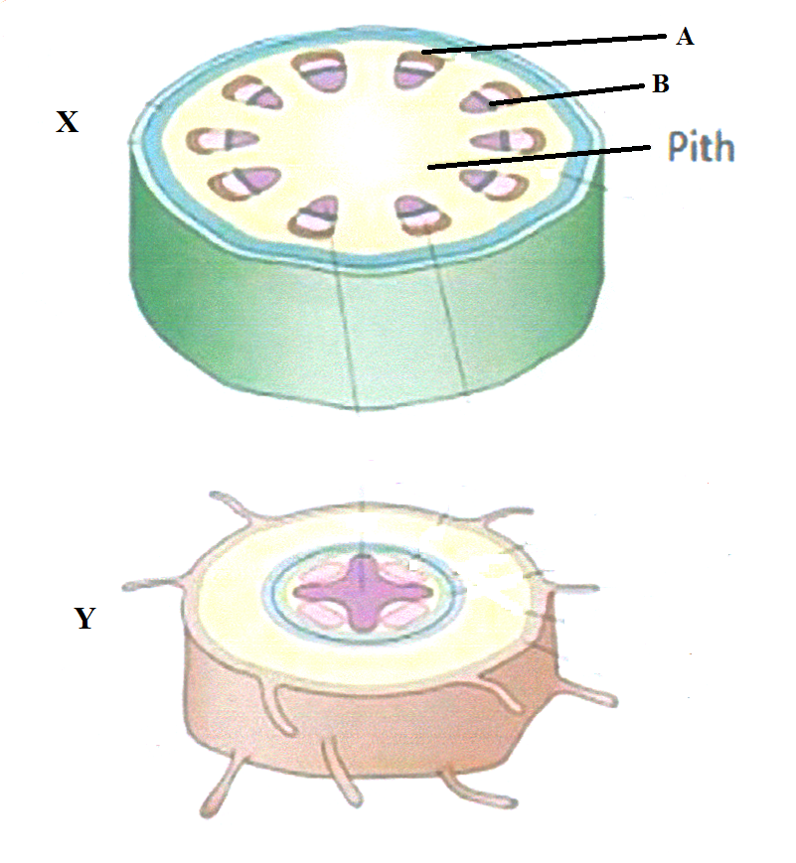
D
E

(a) Give three observable differences between the sections. (3 marks)
………………………………………………………………………………………………………………………………………………………………………………………………………………………………………………………………………………………………………………………………………………………………………………………………………………………………………………………
(b) Identify and state the functions of the parts labeled D and E. (4 marks)
D ……………………………………………………………………………………
Function……………………………………………………………………………………………………………………………………………………………………………………………………………………………………………………………
E ……………………………………………………………………………………
Function……………………………………………………………………………………………………………………………………………………………………………………………………………………………………………………………
(d) How would section X compare with that of a monocotyledonous plant? (3 marks)
………………………………………………………………………………………………………………………………………………………………………………………………………………………………………………………………………………………………………………………………………………………………………………………………………………………………………………………
- Study the photographs P and W below and answer the questions that follow.
PHOTOGRAPH P
PHOTOGRAPH R
M
N
J
K
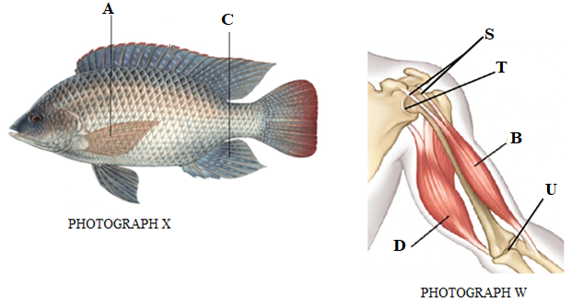
- Name the parts labeled M, N and S in photographs P and R. (3 marks)
M……………………………………………………………………………………
N…………………………………………………………………………………….
S…………………………………………………………………………………….
- Name the structures that enable the following during movement of fish.
(2 marks)
- Prevents rolling …………………………………………………………………….
- Prevents pitching …………………………………………………………………...
- i) Calculate the tail power of the organism in photograph P. (3 marks)
…………………………………………………………………...…………………………………………………………………...…………………………………………………………………...…………………………………………………………………...................................................................................
ii) State the significance of high tail power. (1 mark)
…………………………………………………………………...…………………………………………………………………...…………………………
- State one functional difference between the joints labeled T and U in photograph W. (1 mark)
…………………………………………………………………...…………………………………………………………………...…………………………………………
- i) Explain what happens to muscles J and K as the arm is straightened? (1 mark)
…………………………………………………………………...…………………………………………………………………...…………………………
ii) State three differences between the muscles in photograph R and those found in the walls of the alimentary canal. (3 marks)
…………………………………………………………………...…………………………………………………………………...…………………………………………………………………...…………………………………………………………………...................................................................................

