NAME……………………………………………INDEX NO……………………………
CANDIDATE’S SIGN………………………….DATE……………………………….

231/2
BIOLOGY
PAPER 2
THEORY
OCT/NOVEMBER
TIME: 2 HOURS

Kenya Certificate of Secondary Education (K.C.S.E)

231/2
BIOLOGY
PAPER 2
THEORY
TIME: 2 HOURS

INSTRUCTIONS TO CANDIDATES.
1) Write your name and index number in the spaces provided above.
2) Sign and write the date of examination in the spaces provided above.
3) This paper consists of section A and B.
4) Answer ALL questions in section A in the spaces provided.
5) In section B answer questions 6 (compulsory) and either question 7 or 8 in the spaces provided after question 8.

FOR EXAMINERS’ USE ONLY.
SECTION | QUESTIONS | MAXIMUM SCORE | CANDIDATES SCORE
A | 1 | 8
 | 2 | 8
 | 3 | 8
 | 4 | 8
 | 5 | 8
B | 6 | 20
 | 7 | 20
 | 8 | 20
 | TOTAL | 80

This paper consists of 9 printed pages.
Candidates should check the question paper to ascertain that all pages are printed as indicated and no questions are missing.
SECTION A (40MARKS)
Answer all questions in this section in the spaces provided.
1 The diagram below shows a set up to investigate a factor necessary for germination.

a) Name the factor under investigation. (1mk)
………………………………………………………………………………………………….………………………………………………………………………………………………….. b) State the role of pyrogallic acid in the set up. (1mk)
…………………………………………………………………………………………………..…………………………………………………………………………………………………..
c) Which type of respiration is taking place in the beans? (1mk)
…………………………………………………………………………………………………..………………………………………………………………………………………………….
d) Write a word equation for the process named in (c) above. (1mk)
…………………………………………………………………………………………………..………………………………………………………………………………………………….
e) Explain why plants can only carry out the above respiration process for a short while. (1mk)
…………………………………………………………………………………………………..………………………………………………………………………………………………….
f) State other three factors necessary for germination. (3mks)
…………………………………………………………………………………………………..………………………………………………………………………………………………….
…………………………………………………………………………………………………..………………………………………………………………………………………………….
…………………………………………………………………………………………………..………………………………………………………………………………………………….

2 a) Birds have beaks which are structurally modified to different modes of feeding.

    - What is the name given to such structures in evolution? (1 mark)
............................................................................................................................................................................................................................................................................................................................................
    - What is the name given to the evolution of beaks of birds? (1 mark)
............................................................................................................................................................................................................................................................................................................................................
  - (i) What is meant by “vestigial structures”?(1 mark)
............................................................................................................................................................................................................................................................................................................................................
- Name two vestigial structures present in man. (1 mark)
............................................................................................................................................................................................................................................................................................................................................
  - Bacteria tend to develop resistance to antibiotics after they have been subjected to them for a long period of time. Explain. (2 marks)
............................................................................................................................................................................................................................................................................................................................................
......................................................................................................................................................................
  - Explain continental drift as an evidence of evolution. (2 marks)
............................................................................................................................................................................................................................................................................................................................................
............................................................................................................................................................

3 a) What is internal fertilization ? ...................................................................................................................................................................................................................................................................................... (1mk)
b) Suggest two disadvantages of internal fertilization in most mammals. ........................................................................................................................................................................................................................................................................................................................ (2mks)
c) State two roles of placenta in mammals.
........................................................................................................................................................................................................................................................................................................................ (2mks)

d) Mention one role played by each of the following hormones in human menstrual cycle.
i) Oestrogen .....................................................................................................................................................
ii) Luteinizing hormone ..................................................................................................................................................
iii )Follicle stimulating hormone .....................................................................................................................................................
(3mks)
4. Below is a cell obtained from a living organisms. Study it and answer the questions that follow
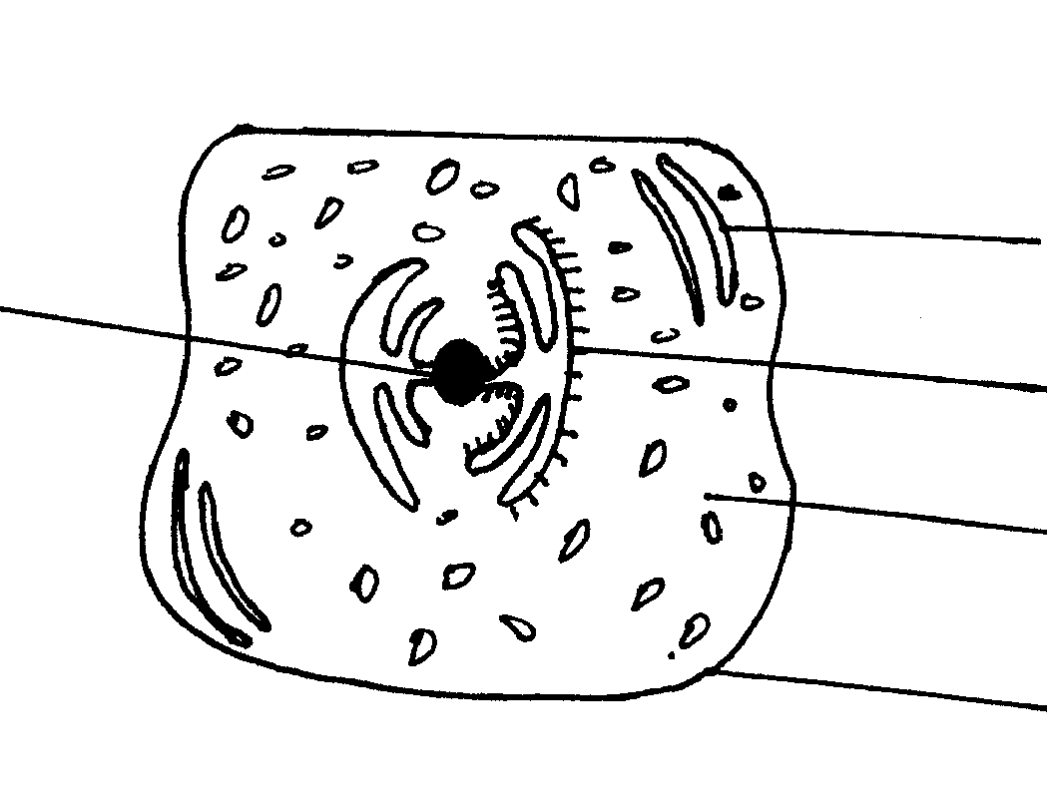
A
E
C
B
D

(a) From which kingdom of organism was the cell obtained?
…………………………………………………………………………………………………..………
……………………………………………………………………………………………………....…. ( 1mk)

(b) Give two reasons for your answer in 4 (a) above
(i)……………………………………………………………………………………………………
(ii)…………………………………………………………………………………………………… (2mks)
(c) On the diagram identify parts A,B and C.
(3mks)
(d) State the role of parts D and E.
D:……………………………………………………………………………………………………
E:…………………………………………………………………………………………………… (2mks)
5 a) What is meant by the term linked genes? (1mk)
………………………………………………………………………………………………………………………………………………………………………………………………………………………………………………………………………………
b). Haemophilia is a genetic condition transmitted through a recessive gene linked to X chromosome. The normal gene may be represented by X^{H}.

- What is the genotype of a haemophilic female?
…………………………………………………………………………………………………………………………………………………………… (1mk)
- A woman who is a carrier for the haemophilia gene marries a normal man. Work out the phenotypic ratio for their offspring. (4mk)

- Haemophilia is more common in males than in females. Explain this phenomenon.
………………………………………………………………………………………………………………………………………………………………………………………………………………………………………………………………………………………………………………………………………………………………………………………………… (2mks)

SECTION B (40 MARKS)
Answer question 6 (compulsory) and either question 7 or 8 in the spaces provided after question 8
6. The table below shows how the quantities of sweat and urine vary with external temperature.
External temperature | Urine cm³/hr | Sweat cm³/hr
0 | 100 | 5
5 | 90 | 6
10 | 80 | 10
15 | 70 | 20
20 | 60 | 30
25 | 50 | 60
30 | 40 | 120
35 | 30 | 200

(a) On the same axis plot graphs of the quantities of urine and sweat produced against the external temperature. (7mks)

(b) At what temperature are the amounts of sweat and urine produced equal? …………………………………………………………………………………………………………………………………………………………………………… (1mk)
(c) What happens to the amount of sweat produced as the temperature rises? Explain the
observation. …………………………………………………………………………………………………………………………………………………………………………………………………………………………………………………………………………………………………………………………………………………………………………………………………………………………………………………………………………………………………………………………………………… (3mks)
(d) Account for the observation made on the amount of urine produced as the temperature
increases ………………………………………………………………………………………………………………………………………………………………………………………………………………………………………………………………………………………………………………………………………………………………………………………………………………………………………………………………………………………………………………………………… (3Mks)
(e) (i) How is the kidney adapted to its function ………………………………………………………………………………………………………………………………………………………………………………………………………………………………………………………………………………………………………………………………………………………………… ……………………………………………………………………………………………………………………………………………………………… (4mks)
(ii) Differentiate between excretion and egestion. ………………………………………………………………………………………………………………………………………………………………………………………………………………………………………………………………………………………………………………………………………………… (2mks)
7. Explain how the following organisms are adapted to their mode of feeding
(a) Herbivores (10mks) . (b) Carnivores (10mks) 8. (a) (i) State two significances of transpiration. (2mks)
(ii Discuss the forces involved in movements of water from roots to the leaves (8mks)
(b) Describe the mechanism of opening and closing of stomata using photosynthetic theory (10mks)

……………………………………………………………………………………………………………………………………………………………………………………………………………………………………………………………………………………………………………………………………………………………………………………………………………………………………………………………………………………………………………………………………………………………………………………………………………………………………………………………………………………………………………………………………………………………………………………………………………………………………………………………………………………………………………………………………………………………………………………………………………………………………………………………………………………………………………………………………………………………………………………………………………………………………………………………………………………………………………………………………………………………………………………………………………………………………………………………………………………………………………………………………………………………………………………………………………………………………………………………………………………………………………………………………………………………………………………………………………………………………………………………………………………………………………………………………………………………………………………………………………………………………………………………………………………………………………………………………………………………………………………………………………………………………………………………………………………………………………………………………………………………………………………………………………………………………………………………….……………………………………………………………………………………………………………………………………………………………………………………………………………………………………………………………………………………………………………………………………………………………………………………………………………………………………………………………………………………………………………………………………………………………………………………………………………….……………………………………………………………………………………………………………………………………………………………………………………………………

…………………………………………………………………………………………………………………………………………………………………………………………………………………………………………………………………………………………………………………………………………………………………………………………………………
………………………………………………………………………………………………………………………………………………………………………………………………………………………………………………………………………………………………………………………………………………………………………………………………………………………………………………………………………………………………………………………………………………………………………………………………………………………………………………………………………………………………………………………………………………………………………………………………………………………………………………………………………………………………………………………………………………………………………………………………………………………………………………………………………………………………………………………………………………………………………………………………………………………………………………………………………………………………………………………………………………………………………………………………………………………………………………………………………………………………………………………………………………………………………………………………………………………………………………………………………………………………………………………………………………………………………………………………………………………………………………………………………………………………………………………………………………………………………………………………………………………………………….……………………………………………………………………………………………………………………………………………………………………………………………………………………………………………………………………………………………………………………………………………………………………………………………………………………………………………………………………………………………………………………………………………………………………………………………………………….…………………………………………………………………………………………………………………………………………………………………………………………………………………………………………………………………………………………………………………………………………………………………………………………………………………………………………………………………………………………………………………………………………………………………………………………………………………………………………………………………………………………………………………………………………………………………………………………………………………… END.

