233/1 – CHEMISTRY PAPER 1 - MARKING SCHEME

- (a) Liebig’s condenser.

(b) Determine the point at which one of the liquids in a mixture has evaporated completely. Temperature tends to remain constant when one liquid in a mixture is evaporating.
(c) Liquid ‘C’ since it is more volatile.

- (a) Pass the mixture of gas “D” and “E” through sulphuric acid. Gas “D” will react to form salt – leaving behind gas “E”. Collect gas E by downward delivery / upward displacement of air since it is heavier than air.

OR
Pass a mixture of gas “D” and “E” over sodium hydroxide. Gas “D” will dissolve but gas “E” will not be affected. Collect gas “E” by downward delivery.

- Ammonia gas (HN₃)
Ammonia is lighter than air. It reacts with acids to form salt since itself is basic. It does react with sodium hydroxide since both are basic but will dissolve in it without any reaction.

- (a) A strong base is a substance that dissociate, completely to produce many hydroxide ions.
(b)

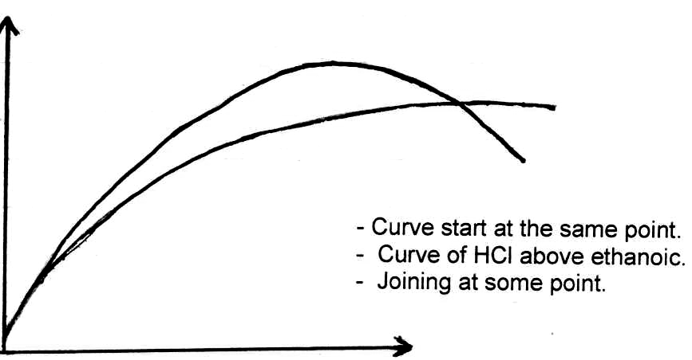

HCl

Volume of
CO² in cm³ CH₃COOH

Time (min)

- 2C_{(s)} + O_{2(g)} 2CO_{(g)}
2CO_{(s)} + Fe₂O_{3(s)} 2Fe_{(s)} + CO_{2(g)}

- Magnesium phosphide.

- IV, II, I, III

- (a) (i) B (ii) C
- D

- LUMINOUS NON LUMINOUS
- Sooty Flame Non-sooty
- Produce more light Less light
- Less heat Very hot
- Weavy flame Steady flame (any 2 mentioned @ 1mk)

- (a) Colour of solid changed from black to reddish brown.
(b) CuO_{(s)} + CO_{(g)} Cu_{(s)} + CO_{2(g)}
(c) CO is poisonous.

- (a) Under the same condition of temperature and pressure, the rate of diffusion of gas is inversely proportional to the square root of its density.

(b) RCO₂ = MNO₂ But RCO₂ = 100cm³ = 3.33cm³/per sec.
RNO₂ MCO₂ 30

3.33 = 46
RNO₂ 44

RNO₂ = 3.33 = 3.26cm³ per second
1.0225

Time taken = 150cm³ = 46 seconds
3.26cm³sec⁻¹

- (a) I. Propan - I – ol
II. 2-Methylbutan-I-oic

(b)
H C₆H₅

C = C

H H

- (a) A bright yellow precipitate formed.

- 8cm³ – the graph flattens //
- PbNO₃ used up.

- Volume lower than 8cm³of NaI, Pb(NO₃)₂ was in excess.
- At 8cm³ the ratio of moles of Pb²⁺ ions to Cl⁻ ions was 1:2
- After 8cm³ the I⁻ ions are in excess, all Pb²⁺ ions are used up.

- (a) Blue solution changes to colourless // pale blue.½
- Brown solid is deposited. ½

- ΔH = MCΔT

= 0.03kg x 4.2kJkg⁻¹k⁻¹ x 15k

= 1.89kJ

= -1.89kJ

- Increased1
HCl is reduced, thus the rate of forward reaction is favoured. 1
// NaOH neutralizes HCl hence the concentration of HCl is reduced and the reaction proceeds faster in the forward direction to produce more HCl and hence the precipitate.

- (a) Lead sulphide
Air / Oxygen ( ½ mk each)

- SO₂ leads to formation of acid rain
SO₂ causes respiratory infection. (any mentioned 1mk)
- Reduces Lead (II) oxide into lead metal.

- (a) 216 = 208 + 4M 84 = 82 + 4 + n
216 – 208 = 4M
4M = 8 84 – 86 = n
M = 2 n = -2 = 2

- t½ t½ t½ t½ t½
48 24 12 6 3 1.5

5t ½ = 270
t ½ = 270 = 54 days
5
Or
N1 = No(½) ^{T}/_{t½} 5t ½ = 270
1.5 = 48 (½) ²⁷⁰/_{t½} t½ = 270
48 5
1 = (½)²⁷⁰/_{t½} t ½ = 54 days
32
( ½)⁵ = ( ½)²⁷⁰/_{t½}

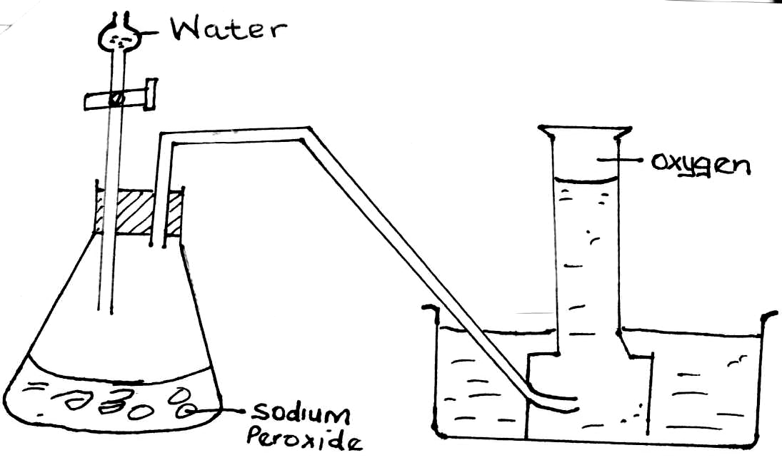
- No. of moles = m
R.f
= 15
58.5
= 0.25641 moles

Molarity = No. of moles
Volume in litres

= 0.25641
0.12

= 2.13675M

- (a) Boyles law states that the volume V₁ of a fixed mass of a gas is inversely proportional to its pressure P₁ when temperature is kept constant.

(b) P₁V₁ = P₂V₂
T₁ T₂

780 x 400 = 600 x V₂
303 323

- V₂ = 323 x 780 x 400
303 x 600

= 554.3234cm₃

- (a) Allotropy – existence of an element in more than one structural form in the same physical state.

(b) Rhombic / ½
Monoclini // β½

- (i) Blue flame(1mk) // pungent smell

(ii) Acidic(1mk) // low pH

- (a) Produced when unburnt carbon glows. 1

(b) - It is hot.
- Does not produce soot which makes apparatus dirty.

- (a) Electrolytes are melts or aqueous solutions which allow electric current to pass through them and are decomposed by it while non-electrolyte are melts or aqueous solutions which do not conduct electric current.
- Electrolytes contain mobile ions while non-electrolytes contain molecules.

(b) Graphite has delocalized electrons in its structure which carry electric current.

- Ratio M O
Moles 0.254 0.64½
63.5 16
0.04 0.04½
Ratio 1 : 1½

E.F = MO1

- (i) Prevent rusting ½
- Improve appearance ½

(ii) Q = 0.5 x 60 x 60½
= 1800C
Ag⁺ + e Ag½

96500C 108g

1800 1800 x 108½
95600

= 2.0145g½
- - Add water to Lead (II) nitrate to obtain Lead (II) nitrate solution. ½
        - Add water to sodium carbonate to obtain sodium carbonate solution. ½
        - Mix the two solutions to ppt Lead (II) carbonate. 1
        - Filter to obtain Lead (II) carbonate as a residue.½
        - Wash the residue and dry between filter papers. ½

- (a) Propane.
- CH₃CH₂CH₂COONa + NaOH Na₂CO₃ + C₃H₈ ignore state symbols.
- (i) Green – yellow chlorine turns colourless.
      - Chloropropane

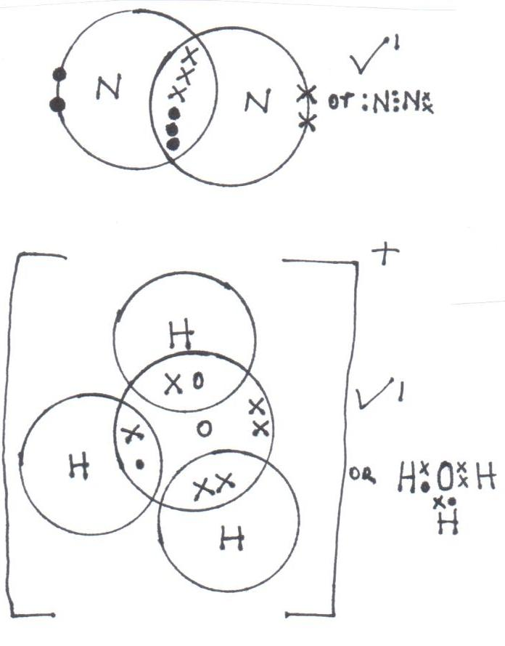

- (a) (i)

(ii)

- Aluminium has more protons than Mg, hence a greater nuclear charge than Mg, resulting in stronger metallic bases in Al than in Mg.
- During the manufacture of nitrogen and oxygen gases. (2mks)

- (i) To displace the air in the aspirator.
(ii) A black solid (1mk); copper (II) oxide is formed // copper is oxidized to copper (II) oxide.
(iii) Magnesium nitride. (1mk).

