NAME: …………………………………………. INDEX NO: ……………………………….

DATE : …………………………………..

CANDIDATE’S SIGNATURE:………………..

Kenya Certificate of Secondary Education (K.C.S.E.)
CHEMISTRY
PAPER 1
TIME: 2 HOURS
OCT/NOVEMBER 2021

INSTRUCTIONS TO CANDIDATES
- Write your Name, Index Number and School in the spaces provided above.
- Sign and write the Date of the examination in the spaces above.
- Answer all the questions in the spaces provided in the question paper.
- Mathematical tables and silent scientific calculators may be used.
- ALL the working must be clearly shown where necessary.

FOR EXAMINER’S USE ONLY

QUESTIONS | MAX SCORE | CANDIDATE’S SCORE
1 – 28 | 80

- The set-up below represents apparatus that may be used to separate a mixture of two miscible liquids “C” and “D” whose boiling points are 80⁰C and 100⁰C respectively.
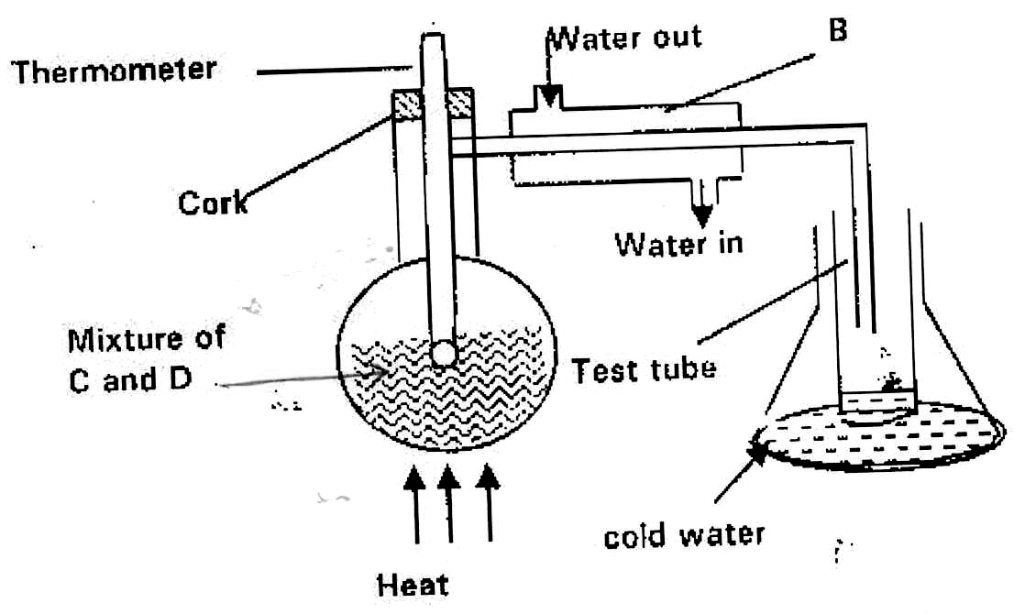

- Name B. (1mk)

- What is the purpose of the thermometer? (1mk)

- Which liquid is collected in the test tube? (1mk)

- The table below gives some properties of gas D and E.
Gas | Density | Effect on H₂SO₄ | Effect on NaOH
D | Lighter than air | React to form salt | Dissolve without reacting
E | Heavier than air | Not affected | Not affected

- Describe how you would obtain a sample of gas E from the mixture of gas D and E. (2mks)

- Suggest a possible identity of gas D. Give reasons for your answer. (2mks)

- (a) What is meant by a strong base? (1mk)

  - In an experiment, 20cm³ of 2M hydrochloric acid was reacted with excess sodium carbonate and the volume of carbon (IV) oxide produced recorded with time. In another experiment, the same volume and concentration of ethanoic acid was also reacted with excess sodium carbonate and the volume of carbon (IV) oxide produced recorded with time.
On the grid below, sketch and label the curves if the volumes of carbon (IV) oxide were plotted against time. (2mks)
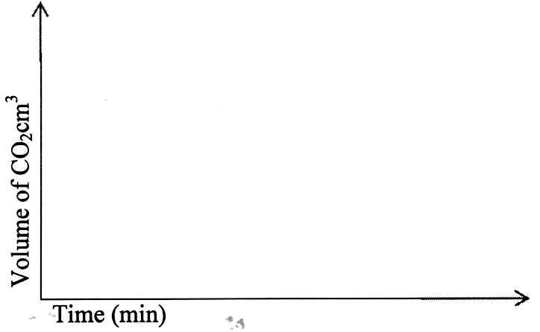
- The set-up below was used to obtain a sample of Iron.

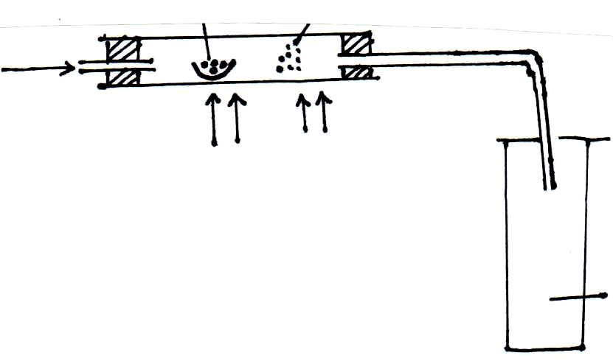
Carbon Excess Iron (III) oxide
Oxygen

Heat Heat

Gas

Write two equations for the reactions which occur in the combustion tube. (2mks)

- Give the name of the product formed when magnesium reacts with phosphorus. (1mk)

- The table below gives the energy required to remove the outer most electrons from same group.
Elements | I | II | III | IV
Energy kJ / Mole | 494 | 418 | 519 | 376

Arrange the elements in the order of their reactivity starting with the most reactive. (2mks)

- The electronic structures for elements represented by letters A, B, C and D are:-
A = 2:8:6 B = 2:8:2 C = 2:8:1 D = 2:8:8
- Select the element which forms:
  - Double charged cation. (1mk)

  - A solobule carbonate (1mk)

- Which element has the smallest atomic radius? (1mk)

- State any two differences between luminous flame and non luminous flame. (2mks)

- The apparatus shown below was used to investigate the effect of carbon (II) oxide on Copper (II) oxide.
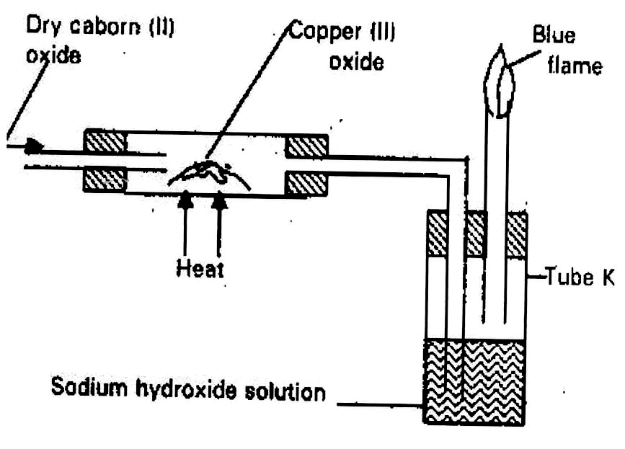

- State the observation that was made in the combustion tube at the end of the experiment. (1mk)

- Write an equation for the reaction that took place in the combustion tube. (1mk)

- Why is it necessary to burn the gas coming out of tube K? (1mk)

- (a) State Graham’s Law of Diffusion. (1mk)

  - If it takes 30 seconds for 100cm³ of carbon (IV) oxide to diffuse across a porous plate, how long will it take 150cm³ of nitrogen (IV) oxide to diffuse across the same plate under similar conditions? (C = 12.0, N = 14.0, O = 16.0) (2mks)

- (a) Given the IUPAC names of the following compounds:- (2mks)

- CH₃(CH₂)CH₂OH

- CH₃CH₂CH(CH₃)COOH

(b) Given the following polymer, draw the structure of the monomer. (1mk)

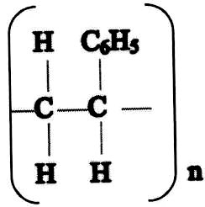

- In an experiment, various volumes of 1M sodium iodide solution was added to the same volume of 1M lead (II) nitrate solution. The height of the precipitate were measured and plotted against volume of 1M sodium iodide used. The graph below was obtained.

28

24

20

16

12

8

4

0 2 4 6 8 10 12 14 16
Volume of sodium iodide (NaI) in cm³
  - State the observation made when sodium iodide solution is mixed with lead (II) nitrate solution. (1mk)

  - What volume of sodium iodide was required to react completely with lead (II) nitrate? Explain. (1mk)

  - Explain the shape of the curve. (1mk)

- When excess zinc powder is added to 30cm³ of solution containing copper (II) ions and the mixture stirred, the temperature is noted to have risen by 15⁰C.
- State the observation made after stirring the mixture. (1mk)

- Calculate the heat change for the reaction (specific heat capacity of H₂O = 4.2KJkg⁻¹k⁻¹) (2mks)

- When bismuth (III) chloride is added to water, a reaction occurs and a white precipitate forms as shown below.
BiCl_{3(aq)} + H₂O_{(l)} BiOCl_{(s)} + 2HCl_{(aq)}

What would be the effect on the amount of the precipitate formed if sodium hydroxide solution is added to the equilibrium mixture? Explain your answer. (2mks)

- The flow chart below shows some process in extraction of lead metal. Study it and answer the questions that follow.
Coke CO₂
SO_{2(S)}

Unit I
Roasting
Chamber

Unit II
Raw
materials PbO(s)

Pb
- Name two raw materials that were fed into Unit I. (1mk)

- State one environment hazard associated with the process in Unit I. (1mk)

- What is the function of coke in unit II? (1mk)

- (a) Radioactive Polonium – 216 decays as shown below.

216 208 + M + nβ
84 82
Determine the value of m and n. (2mks)

(b) The table below gives the rate of decay of a radioactive element y.
Calculate the half-life of the radioactive element y. (2mks)
Number of days | Mass in g
0 | 48
270 | 1.5

- Water reacts with sodium peroxide forming sodium hydroxide and oxygen gas. Draw a well labelled diagram showing how a sample of oxygen gas can be prepared and collected in the laboratory using the above reagents. (3mks)

- 15g of sodium chloride was dissolved in 120cm³ of distilled water. Calculate the concentration of the resulting solution in moles per litre. (Na = 23, Cl = 35.5) (3mks)

- (a) State Boyle’s law. (1mk)

  - The volume of a gas at 30⁰C and 780mmHg is 400cm³. What will be its volume at 50⁰Cat 600mmHg. (2mks)

- Sulphur exhibits allotropy.
- What is allotropy? (1mk)

- Name the two allotropes of sulphur. (1mk)

- Sulphur powder was placed in a deflagrating spoon and heated on a Bunsen burner.
  - State the observation made. (1mk)

  - The product obtained was dissolved in water. Comment on the PH of the solution formed. (1mk)

- (a) A luminous flame has a yellow zone. Explain how the yellow zone is produced. (1mk)

(b) Explain why a non-luminous flame is preferred for heating substances in a laboratory.
(2mks)

- (a) State two differences between the terms electrolyte and non-electrolyte. (2mks)

(b) Graphite is a non-metal yet it conducts electric current. Explain. (1mk)

- 0.318g of an oxide of metal M was completely reduced by hydrogen gas to 0.254g of metal. Calculate empirical formula of the metal oxide. (M = 63.5, O = 16). (3mks)

- In an experiment to electroplate iron with silver, a current of 0.5A was passed through a solution of silver nitrate for 60 minutes.
- Give two reasons why it is necessary to electroplate iron with silver. (1mk)

- Calculate the mass of silver that was deposited on iron. (Ag = 108, 1 Faraday = 96500C).
(2mks)

- Given the following reagents: solid sodium carbonate, water, solid lead (II) nitrate. Describe how a sample of lead (II) carbonate can be prepared in the laboratory. (3mks)

- The set-up below was used to prepare a sample of an organic compound X.

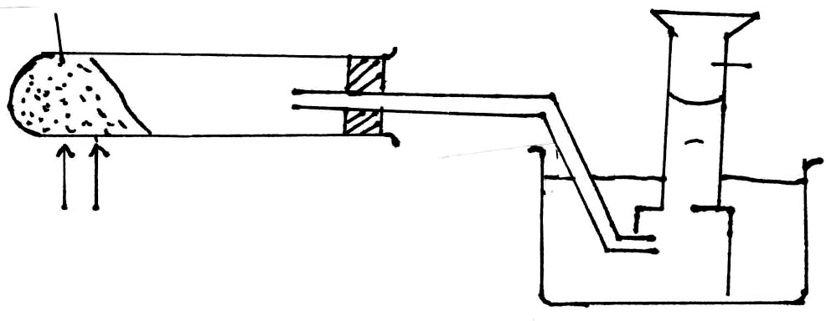
sodalime + Sodium butanoate

Gas

Heat

  - Identify gas X. (1mk)

  - Write the equation for the reaction that produces gas X. (1mk)

  - 1 Mole of Chlorine was reacted with gas X in presence of sunlight.
    - State one observation made. (½mk)

    - Name the major product formed. (½mk)

- Draw dot (•) an cross (x) diagram to show bonding in:
  - Nitrogen molecule (N₂) (1mk)

  - Hydroxonium ion. (H₃O⁺) (1mk)

- Study the diagram below and answer the questions that follow.
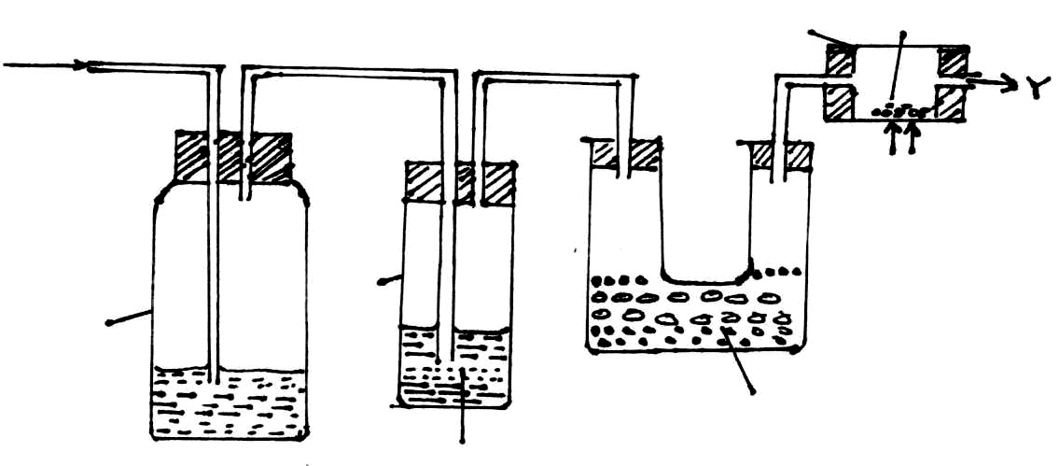
Tube M Copper turnings

Tap water

Heat

Tube
Air aspirator K

Solid X

Sodium Hydroxide

    - What is the purpose of passing tap water through the air aspirator? (1mk)

    - State and explain the observation that would be made in tube M after sometime. (1mk)

    - The sample of nitrogen collected at point Y had greater density than expected. What conclusion could be made about the gas? (1mk)

