KITUTU CENTRAL JOINT EXAMINATION
Kenya Certificate of Secondary Education

FORM 4, TERM 2, DECEMBER 2021

233/1 CHEMISTRY Paper 1
Time: 2 Hours

Name: ………………………………………………….....…… Adm No: ………..
Class: ………………Candidate’s Signature: …….………Date: …..…../12/2021.

Instructions to Candidates
(a) Write your name and index number in the spaces provided above.
(b) Sign and write the date of examination in the spaces provided above
(c) Answer ALL the questions in the spaces provided in the question paper
- KNEC Mathematical tables and electronic calculators may be used for calculations
- All working MUST be clearly shown where necessary
- This paper consists of 15 printed pages
- Candidates should check the question paper to ascertain that all the pages are printed as indicated and that no questions are missing
- Candidates should answer the questions in English

FOR EXAMINER’S USE ONLY.
Question | Maximum score | Candidate’s score
1 − 32 | 80

- Air contains gaseous pollutants.
(i) Name one gas that contributes to acid rain. (1 mark)
……………………………………………………………………………………………………………………………………………………………………………………
(ii) State one environmental consequence of an increase in the percentage of carbon dioxide in the air. (1 mark)
........................................................................................................................................
........................................................................................................................................
(iii) Explain the source of carbon monoxide in air. (1 mark)
........................................................................................................................................
........................................................................................................................................

2. The chromatogram below shows the constituents of flower extract using an organic solvent.

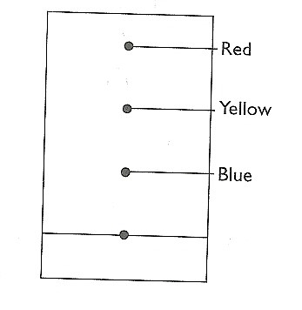
- Describe how you would obtain a solid sample of the red pigment. (2 marks)
………………………………………………………………………………………………………………………………………………………………………………………………………………………………………………………………………
- State one property that makes the red pigmet move the furthest. (1mark)
………………………………………………………………………………………………………………………………………………………………………………

3. Magnesium hydroxide is used as a medication to relieve stomach acidity.
- Write a balanced chemical equation for the reaction that occurs in the stomach when
one takes in, the medicine. (1 mark)
……………………………………………………………………………………………………………………………………………………………………………………
- What type of reaction takes place in the stomach after taking the medicine? (1 mark)
……………………………………………………………………………………………………………………………………………………………………………………
c) Sodium hydroxide cannot be used for the same purpose. Explain. (1 mark)
……………………………………………………………………………………………………………………………………………………………………………………

4. Use the information in the table below to determine the relative atomic mass of copper. (2 marks)

Isotope Fractional abundance
₆₅
Cu 0.31
₂₉

₆₃
Cu 0.69

5. Study the information in the table below and answer the questions that follow (The letters do not represent the actual symbols of the elements)
 |  | Ionization Energy_kJ/Mole
Element | Electronic configuration | 1st ionization energy | 2nd ionization energy
A | 2.2 | 900 | 1800
B | 2.8.2 | 736 | 1450
C | 2.8.8.2 | 590 | 1150

- What is ionization energy (1mark)
…………………………………………………………………………………………………………………………………………………………………………………………
- Explain why the 2nd ionization energy is higher than the 1st ionization energy. (1 mark)
………………………………………………………………………………………………………………………………………………………………………………………………………………………………………………………………………………………
6. The volume of 120cm³ of nitrogen gas diffuses through a membrane in forty seconds. How long will it take240cm³ of carbon (IV) oxide to diffuse through the same membrane?
(3 marks)
…………………………………………………………………………………………………………………………………………………………………………………………………………………………………………………………………………………………………………………………………………………………………………………………………………
7. Use the diagram below to answer the questions that follow.
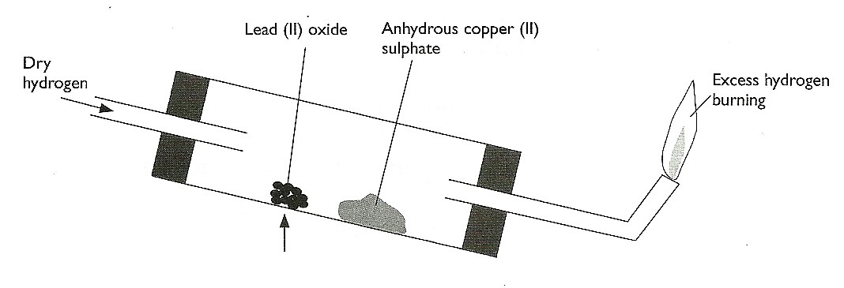

- After the experiment has been running for some time, record two major observations made in the tube. (2 marks)
………………………………………………………………………………………………………………………………………………………………………………………………………………………………………………………………………………………
- Write an equation for the reaction that takes place in the dish containing lead (II) oxide. (1 mark)
…………………………………………………………………………………………………………………………………………………………………………………………
8. Metal Q displaces metals T and U from their oxides but does not displaces metal R. Metal T displaces U form its oxide. Arrange the metals according to their reactivity starting with the strongest reducing agent. (1 mark)

……………………………………………………………………………………………………………………………………………………………………………………………………
9. The ability of temporary hard water to conduct electricity falls when the water is boiled but it is not much affected when the hardness is removed by addition of washing soda (sodium carbonate). Explain. (2 marks)

…………………………………………………………………………………………………………………………………………………………………………………………………………………………………………………………………………………………………………………………………………………………………………………………………………
10. The table below gives some information about certain chemical substances. The letters used are not the actual chemical symbols or formulae.

Substance | Melting point (⁰C) | Boiling point (⁰C) | Electrical conductivity
Substance | Melting point (⁰C) | Boiling point (⁰C) | of solid | of liquid | in water
A  B  C  D  E  F | 1540  -114  712  -39  2045  1700 | 3000  -85  1418  357  3000  2776 | Good  Poor  Poor  Good  Poor  Poor | Good  Poor  Good  Good  Good  Poor | Insoluble  Good  Good  Insoluble  Insoluble  Insoluble

a). From the list, select.
i). Two substances that cannot be elements (1mark)
……………………………………………………………………………………………………………………………………………………………………
ii) A substance that is likely to have giant atomic structure. (1 mark)
……………………………………………………………………………………………………………………………………………………………………
iii). Two substances which cannot be broken down when an electric current is passed through them. (1 mark)
……………………………………………………………………………………………………………………………………………………………………
11. The diagram below was used to study the effect of heat on copper (II) sulphate crystals.
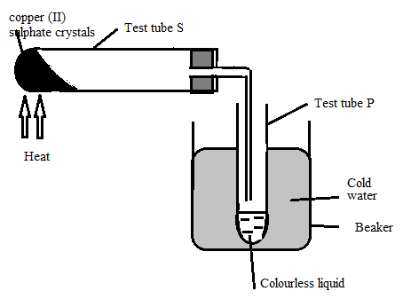
- Name the colourless liquid (1mark)
……………………………………………………………………………………………………………………………………………………………………………………
- State the criteria for ascertaining the purity of the colourless liquid (1mark)

……………………………………………………………………………………………………………………………………………………………………………………
- Classify the above change. (1mark)
…………………………………………………………………………………………
…………………………………………………………………………………………
- What observation will be made in the boiling tube S? (1mark)
…………………………………………………………………………………………
…………………………………………………………………………………………
12. A monobasic organic has the formula C_{n}H_{2n +1} COOH. 3.70 g of the acid were
found to react completely with 25cm³ of 2M sodium Hydroxide Solution.

- Write an equation for the reaction between Sodium hydroxide and the acid. (1 mark)
……………………………………………………………………………………………………………………………………………………………………………………
- Determine the value of n in the formula unit of the acid.(C=12, H=1, O=16). (2 marks)
…………………………………………………………………………………………………………………………………………………………………………………………………………………………………………………………………………………………………………………………………………………………………………
13. Use the scheme below to answer the following questions
Ethan -1,2 - dioic acid (H₂ C₂O₄)
Gaseous mixture
Conc.H₂SO₄
PbO
Conc. KOH

E
Gas C

a) Name the type of reaction which takes place between Ethan -1,2 – dioic acid and
concentrated sulphuric (VI) acid (1 mark)
……………………………………………………………………………………………………………………………………………………………………………………
b) Why is the gaseous mixture passed through concentrated KOH? (1 mark)
……………………………………………………………………………………………………………………………………………………………………………………
c) Write the equation for the reaction producing C and E (1 mark)
……………………………………………………………………………………………………………………………………………………………………………………
14. Carbon (IV) oxide and silicon (IV) are both covalent oxides but, carbon (IV) oxide is gas whereas silicon (IV) oxide is a solid with high melting point. Explain (2 marks)

…………………………………………………………………………………………………………………………………………………………………………………………………………………………………………………………………………………………………………………………………………………………………………………………………………
15. Use the equations below to answer questions that follow.
K⁺_{(g)} + Cl⁻_{(g)} KCl_{(s)} H₁ = -70kJ/mol
KCl_{(s)} K⁺_{(aq)} + Cl⁻_{(aq)} H₂ = +15kJ/mol
- What name is given to H₁ (1mark)
………………………………………………………………………………………………………………………………………………………………………………
- Calculate the heat change for the process (2marks)
H₂O
K⁺_{(g)} + Cl⁻_{(g)} K⁺_{(aq)} + Cl⁻_{(aq)}

………………………………………………………………………………………………………………………………………………………………………………
………………………………………………………………………………………………………………………………………………………………………………
………………………………………………………………………………………………………………………………………………………………………………
16. What volume of oxygen gas at r.t.p will be liberated at the anode when a current of 3 amperes is passed through Magnesium sulphate solution for 45 minutes and 30 seconds.
(Molar gas volume at r.tp= 24000cm³. Faraday constant= 96500 coulombs) (3 marks)

………………………………………………………………………………………………………………………………………………………………………………………………………………………………………………………………………………………………………

17. Two experiments were done using the cell shown in the diagram below.

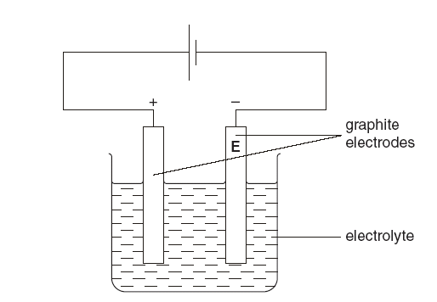
In experiment 1 the electrolyte was molten sodium chloride and in experiment 2 it was
concentrated aqueous sodium chloride. What were the products at the electrode labelled E?
(2 marks)
…………………………………………………………………………………………………………………………………………………………………………………………………………………………………………………………………………………………………………………………………………………………………………………………………………

18. Given two samples of fine powder of sodium carbonate and of sodium hydrogen carbonate describe a chemical test one would use to distinguish them. (2 marks)

………………………………………………………………………………………………………………………………………………………………………………………………………………………………………………………………………………………………………

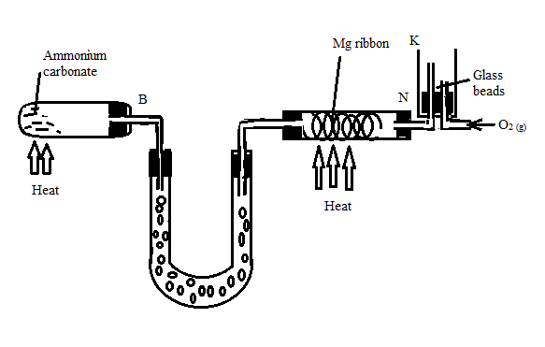
19. A student set up the arrangement shown below to prepare ammonia and burn it in pure oxygen. Study the arrangement and use it to answer the questions that follow.

- Ammonia burnt in tube K only for a short time although ammonium carbonate, magnesium ribbon and oxygen were not used up. Explain this. (1mark)
……………………………………………………………………………………………………………………………………………………………………………………
b) Suggest the function of the glass beads. (1mark)
……………………………………………………………………………………………………………………………………………………………………………………
c) Write an equation for the reaction in K (1mark)
……………………………………………………………………………………………………………………………………………………………………………………

20. When a hydrocarbon was burnt completely in oxygen, 4.2 g of carbon (IV) oxide and 1.71 g of water were formed. Determine the empirical formula of the hydrogen (H= 1.0) (C=12) (2 marks)
…………………………………………………………………………………………………………………………………………………………………………………………………………………………………………………………………………………………………………………………………………………………………………………………………………
21. State any two differences between esterification and neutralization (2 marks)

………………………………………………………………………………………………………………………………………………………………………………………………………………………………………………………………………………………………………
22. Study the standard electrode potentials in the table and answer the questions
Cu²⁺ +2e Cu +0.34

Mg²⁺ + 2e Mg -2.38

Ag⁺ + e Ag +0.80

Ca²⁺ + 2e Ca -2.87

i) Which is the strongest reducing agent (1 mark)
……………………………………………………………………………………………………………………………………………………………………………………
ii) Write an ionic equation for the reaction that takes place when magnesium is dipped in a solution of silver nitrate (1 mark)
……………………………………………………………………………………………………………………………………………………………………………………
iii) Calculate the Eo vale for the reaction above (2marks)
………………………………………………………………………………………………………………………………………………………………………………………………………………………………………………………………………………

23. Study the chart below and answer the questions that follow.
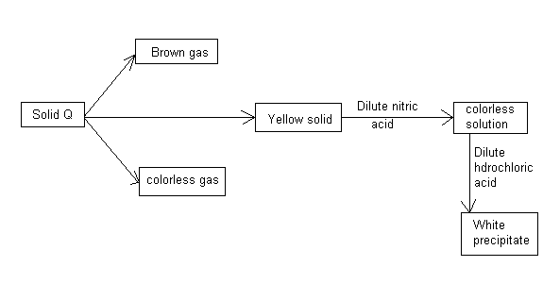
a). Name:-
i). Anion in solid Q (1mark)
……………………………………………………………………………………………………………………………………………………………………
ii) Cation present in the colourless solution. (1mark)
……………………………………………………………………………………………………………………………………………………………………
b). Write an equation for the reaction that occurred between the colourless solution and dilute hydrochloric acid to form the white precipitate. (1 mark)

……………………………………………………………………………………………………………………………………………………………………………………
24. Use the information in the table below to answer the questions that follow. (The letters do not represent the actual symbols of the elements.)
Element | B | C | D | E | F
Atomic number | 18 | 5 | 3 | 5 | 20
Mass number | 40 | 10 | 7 | 11 | 40
a). Which two letters represent the same element? Give a reason. (1 mark)
………………………………………………………………………………………………………………………………………………………………………………………………………………………………………………………………………………

b). Give the number of neutrons in an atom of element D. (1mark)
…………………………………………………………………………………………
…………………………………………………………………………………………

25. The diagram below shows the structure of a certain compound Y.

O
║
H₂C O C (CH₂)₁₆CH₃

O
║
H C O C (CH₂)₁₆CH₃

O
║
H₂C O C (CH₂)₁₆CH₃

- Name the family of compounds to which Y belongs ……………………… (1mark)

- Give the structural formulae of the compounds which react with each other to form Y.

Formula 1 ………………………………. Formula 2 …………………… (2marks)

26. A crystal of iodine was placed at the bottom of a beaker containing the solvent cyclohexane.
After 2 days, a purple colour had spread throughout the cyclohexane.

Explain these observations using the kinetic theory model. (2 marks)
………………………………………………………………………………………………………………………………………………………………………………………………………………………………………………………………………………………………………………………………………………………………………………………………
27. a) State the condition under which sodium hydroxide reacts with chlorine to form
sodium hypochlorite (1mark)
……………………………………………………………………………………………………………………………………………………………………………………………………
b) State two uses of sodium hypochlorite (2 marks)
………………………………………………………………………………………………………………………………………………………………………………………………………………………………………………………………………………………………………
…………………………………………………………………………………………………
28. Draw a dot (.) and cross (x) diagram to show bonding in a molecule of carbon (II) oxide (atomic number of C=6 and O=8) (2 marks)

29. Describe how a pure sample of lead chloride can be obtained starting with lead (II)
carbonate. (3 marks)
……………………………………………………………………………………………………………………………………………………………………………………………………………………………………………………………………………………………………………………………………………………………………………………………………………………………………………………………………………………………………………………………………………………

30. a) Hydrogen sulphide gas is bubbled through bromine water.
i) Give two observations made. (1 mark)
....................................................................................................................................................................................................................................................................................................................................................................................
ii) Write an equation for the reaction that takes place. (1 mark)
........................................................................................................................................................................................................................................................
b) State the test for hydrogen sulphide gas. (1 mark)
................................................................................................................................................................................................................................................................................

