KITUTU CENTRAL JOINT EXAMINATION
Kenya Certificate of Secondary Education

FORM 4, TERM 2, DECEMBER 2021

233/2 CHEMISTRY PAPER 2
TIME: 2 Hours
Name: ………………………………………....…… Adm No: ……….……
Class: ………………Candidate’s Signature: …….……Date: …..…/12/2021.

INSTRUCTIONS TO CANDIDATES
- Write your name, class and admission number in the spaces provided above.
- Answer all the questions in the spaces provided in the questions paper.
- Mathematical tables and silent electronic calculators may be used.
- All working must be shown where necessary.

For Examiners Use Only
Question | Maximum score | Candidates score
1 | 10
2 | 11
3 | 14
4 | 10
5 | 12
6 | 10
7 | 13
TOTAL 80

This paper consists of 14 printed pages Check the Question paper to ensure that all pages are printed as indicated and no question are missing.

1. The figure below represents trends of some properties of period three elements. Study it answer the questions that follow.

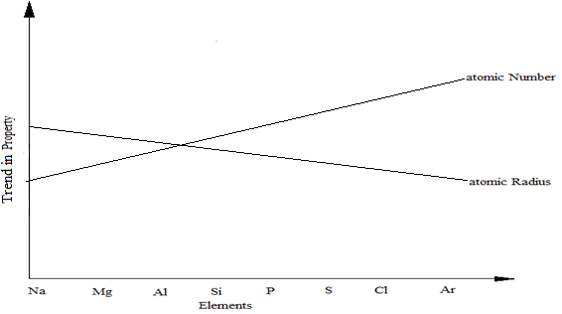

a). Explain the trends shown by the atomic numbers and the atomic radii
i). Atomic number (1 mark)
........................................................................................................................................................................................................................................................................................................................................................................
ii). Atomic radii (2 marks)
........................................................................................................................................................................................................................................................................................................................................................................
b). On the same axes, sketch the trend of reactivity across the period (1mark)

c). Write down the electronic configuration of phosphorous and sulphur in the following compounds
i). H₃PO₄ (P=15) (1 mark)
........................................................................................................................................................................................................................................................................................................................................................................

ii). Na₂S₂O₃ (S=16) (1 mark)
........................................................................................................................................................................................................................................................................................................................................................................
d). i). One of the elements given in the figure above is stored under water.
Identify the element and give a reason as to why it is stored under water (1 mark)
........................................................................................................................................................................................................................................................................................................................................................................
ii). State one use of aluminium that can be associated with its malleability.
(1mark)
........................................................................................................................................................................................................................................................................................................................................................................
e). Explain the observation that would be made if the chloride of Phosphorous is exposed to moist air. (2 marks)
............................................................................................................................................................................................................................................................................................................................................................................................................

2. a). Sulphur is extracted from sulphur beds below the earth’s surface. Super-heated
water is pumped down a pipe into the sulphur beds.

- What is super-heated water and how is it obtained? (2marks)

………………………………………………………………………………….

……………………………………………………………………………….....

………………………………………………………………………………….

- Why does the water used here have to be superheated, and not use boiling water? (1mark)

………………………………………………………………………………….

…………………………………………………………………………………..

- When molten sulphur is pumped to the surface, it solidifies. Which allotrope of sulphur forms first? (1mark)

……………………………………………………………………………………………………………………………………………………………………
- Name the form of sulphur obtained when liquid sulphur is poured into a beaker of cold water (1mark)

…………………………………………………………………………………..
…………………………………………………………………………………..
b) The diagram below represents a set up that can be used for electrolysis of aqueous
copper (II) sulphate. Use it to answer the questions that follow.

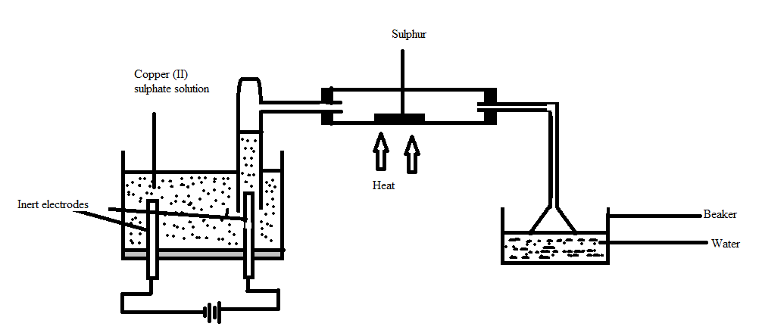

- What do you understand by the term inert electrode? (1mark)

…………………………………………………………………………………..

- What is the purpose of the filter funnel? (1mark)

…………………………………………………………………………………..

- Explain what happens to the pH of the:
- Water in the beaker. (1mark)
…………………………………………………………………………

…………………………………………………………………………..

- Copper (II) sulphate solution (1mark)
……………………………………………………………………………………………………………………………………………………
- Write ionic equation for the:
- Oxidation reaction (1mark)
…………………………………………………………………………..
…………………………………………………………………………..
- Reduction reaction, in above set up. (1mark)
…………………………………………………………………………..
…………………………………………………………………………..

3. a). (i) Define the term ‘molar enthalpy of formation of a compound;
(1mark)
………………………………………………………………………………………………………………………………………………………………

- Calculate the molar enthalpy of formation of ethane using the following information:

C₂H_{6(g)} + $\frac{ 7 }{2}$O_{2(g)} 2CO_{2(g)} + 3H₂O_{(l)}, ∆H_{f}^{ϴ} = -1561 kJ/mole

C_{(s)} + O_{2(g)} CO_{2(g)} , ∆H_{f}^{ϴ} = -394 kJ/mole

H_{2(g)} + $\frac{1}{2}$O_{2(g)} H₂O_{(l)} , ∆H_{f}^{ϴ}= -286 kJ/mole

…………………………………………………………………………………………

…………………………………………………………………………………………

…………………………………………………………………………………………

………………………………………………………………………………………….
(3marks)

b) Study the reactions below and answer the questions that follow:
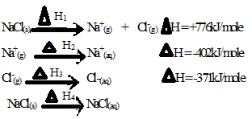

- State the name given to :

a) ∆H₁ ……………………………………………………….(1mark)

b) ∆H₂ ………………………………………………………(1mark)

- Draw an energy cycle diagram illustrating the reactions above.
(2marks)

- Determine the value of H₄ (2marks)

………………………………………………………………………………

………………………………………………………………………………

………………………………………………………………………………

- Joy placed 100cm³ of 0.1M CuSO_{4(aq)} in a plastic beaker , covered it with some cotton wool and recorded its initial temperature. She then added excess zinc powder to the solution and stirred it using a stirrer. She noted down the following data:
Initial temperature 20.5ºC
Final temperature 30.0ºC
Density of solution 1.0g/cm³
Specific heat capacity of water 4200J/kg/k

- Apart from the temperature rise, state one other observation made while she was stirring. (1mark)
………………………………………………………………………………………………………………………………………………
- Calculate the heat change for the reaction above (1mark)
………………………………………………………………………………………………………………………………………………
- Determine the number of moles of ions of copper reacting
(1mark)
………………………………………………………………………………………………………………………………………………
- Hence, determine the molar enthalpy of the reaction. (1mark)

………………………………………………………………………………………………………………………………………………

4. a) An experiment was set up to investigate the effect of temperature on the rate of
reaction between 1.0g calcium carbonate and excess hydrochloric acid. The temperature was varied from15⁰C, 20⁰C and 25⁰C; and data obtained for the 3 sets of reagents.

- Sketch a graph of volume of carbon (IV) oxide gas produced against time for each temperature on the axes below. Label each graph with corresponding temperature. Consider all gas volumes measured at same temperature and pressure. (2 marks)

ii) Explain the shape of graphs you’ve drawn in (a) above. (2marks)
………………………………………………………………………………………………………………………………………………………………………………………………………………………………………………

b) In an experiment, equal amounts of magnesium powder were placed into test tube 1 and 2 as shown below.

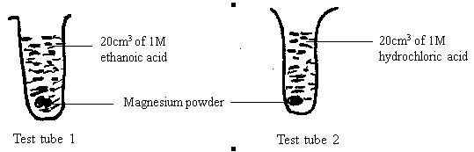

i) Explain why the magnesium powder in test tube 2 gets used up faster than
that in test tube 1. (3 marks)
………………………………………………………………………………………………………………………………………………………………………………………………………………………………………………………………………………………………………………………………
ii) Other than concentration, state one factor that affects the rate of a reaction. (1 mark)
………………………………………………………………………………………………………………………………………………………………………………………………………………………………………………

c) Consider the equilibrium of the reaction below

A(g) + B(g) D(I) + E(g); DHq = -ve.

In which direction will the equilibrium position shift as a result of each of the following changes? Explain.

i) Raising the temperature (1 mark)
………………………………………………………………………………………………………………………………………………………………………………………………………………………………………………………………………………………………………………………………
ii) Reducing the volume of the container. (1mark)
………………………………………………………………………………………………………………………………………………………………………………………………………………………………………………………………………………………………………………………………

5. a) Sodium -20 is a radio isotope and decays by beta emission as shown in the
equation below.
a
0
20
Na
e
+
X

-1
11
b

- Define the term radio isotope. (1 mark)
………………………………………………………………………………………………………………………………………………………………………………………………………………………………
- Find the value of a and b. (1 mark)
………………………………………………………………………………………………………………………………………………………………………………………………………………………………
- Identify the actual symbol of element x. (1 mark)
………………………………………………………………………………………………………………………………………………………………………………………………………………………………

b) The half-life of sodium -20 is 0.3 seconds. P grams of sodium -20 decays to 6 grams in 0.9 seconds.
- Calculate the initial mass P, of the isotope. (2 marks)
………………………………………………………………………………………………………………………………………………………………………………………………………………………………………………
- With reference to sodium -20, give one use of radio isotopes in medicine. (1 mark)
………………………………………………………………………………………………………………………………………………………………………………………………………………………………………………
c) In the Down’s process, (used to manufacture sodium) a certain salt is added to lower the melting point of sodium chloride from 800⁰c to 600⁰c.
- Name the salt that is added. (1 mark)
………………………………………………………………………………………………………………………………………………………………………………………………………………………………………………
- State why it is necessary to lower the temperatures. (1 mark)
………………………………………………………………………………………………………………………………………………………………………………………………………………………………………………
d) Explain why aqueous sodium chloride is not suitable as an electrolyte for the
manufacture of sodium in Down’s process. (2 marks)
………………………………………………………………………………………………………………………………………………………………………………………………………………………………………………………………………………………………………………………………………………………………
e) Sodium metal reacts with air to form two oxides; give the formulae of the two oxides (1 mark)
………………………………………………………………………………………………………………………………………………………………………………
f) Why is sodium used in nuclear reactors? (1 mark)
………………………………………………………………………………………………………………………………………………………………………………

6. The process of extraction of Aluminium is summarized as below:

Ore X
Residue
Solution R
Aluminium Oxide
Molten Aluminium Oxide

Molten Aluminium

Step I
Substance
Q Step II Step III

Substance S

  - (i) Write the formula of the main Ore X which is used in extraction of
Aluminium. (1 mark)
………………………………………………………………………………………………………………………………………………………………
- Name:
  - The main residue formed after filtration in step I. (1 mark)
………………………………………………………………………………………………………………………………………………
  - Substance Q. (1 mark)
………………………………………………………………………………………………………………………………………………

- How is the sodium Aluminate in Solution R separated from the impurity
silicon (iv) oxide. (2 marks)

………………………………………………………………………………………………………………………………………………………………………………………………………………………………………………
- What is the purpose of addition of substance S in step III. (2 marks)
………………………………………………………………………………………………………………………………………………………………………………………………………………………………………………

  - (i) Explain why the Anode in extraction of Aluminium is replaced
periodically. (2 marks)
………………………………………………………………………………………………………………………………………………
(ii) Write an equation for the formation of Aluminium at the cathode.
(1 mark)
…………………………………………………………………………………………………………………………………………………….

  - Explain why Duralum an alloy of Aluminium is used in construction of aircraft
parts and car window frames. (1 mark)
………………………………………………………………………………………………………………………………………………………………………………

7. a) State two types of polymerization. (2marks)
........................................................................................................................................................................................................................................................................
b) Name the compound with the formula below:
CH₃CH₂CH₂ONa (1mark)
........................................................................................................................................................................................................................................................................

c) Study the scheme below and use it to answer the questions that follow:-
n
P

CH₃CH₂CH₃

Step J

V

CH₃CH = CH₂

Step

W

CH₃CH₂CH₂OH
CH₃CH₂COOH
Step R

Gas F
CH₃CH₂COONa
NaOH
Step J

K₂CO₃

Step X

NaOH
Heat

CH₃CH₂COOCH₃
G
Product T
+ Na₂CO₃
C - C
H H
CH₃ - H
K

- Name the following compounds:- (2marks)
I. Product T ………………………………. II. K ………………………………
- State one common physical property of substance G. (1mark)
........................................................................................................................................................................................................................................................................................

- State the type of reaction that occurred in step J. (1mark)
..........................................................................................................................................................................................................................................................................................
- Give one use of substance K. (1mark) .........................................................................................................................................................................................................................................................................................
- Write an equation for the combustion of compound P. (1mark)
..........................................................................................................................................................................................................................................................................................
- Describe how compounds CH₃CH₂COOH and CH₃CH₂CH₂OH can be distinguished chemically. (2marks)

.......................................................................................................................................................................................................................................................................................................................................................................................................................................
- If a polymer K has relative molecular mass of 12,600, calculate the value of n (H=1 C =12) . (2marks)
..............................................................................................................................................................................................................................................................................................................................................................................................................................................................................................................................................................................................................................................................................................................................................................................................................................................................................

This is the last printed page

