NAME: …………………………………………. INDEX NO: ……………… CLASS:……
CANDIDATE’S SIGNATURE:………………… DATE:…………………….

233/1
CHEMISTRY
PAPER 1
(THEORY)
DECEMBER, 2021
TIME: 2 HOURS

LANJET JOINT EXAMINATION – 2021
Kenya Certificate of Secondary Education
233/1
CHEMISTRY
PAPER 1
DECEMBER, 2021
TIME: 2 HOURS

INSTRUCTIONS TO CANDIDATES

- Write your name and index number in the spaces provided.
- Answer all questions in the spaces provided
- KNEC mathematical tables and silent electronic calculators may be used for calculations.
- All workings must be clearly shown where necessary.
- Candidates should check the question paper to ascertain all the pages are printed as indicated and no questions are missing.

For Examiners Use Only

Questions | Maximum Score | Students Score
1-28 | 80

This paper consists of 12 printed pages. Candidates should check the question paper to ascertain that all pages are printed as indicated and that no pages are missing.
- A certain element Y has atomic number 15 and mass number of 31.
- How many electrons are in this element? (1mk)
……………………………………………………………………………………………
……………………………………………………………………………………………
- Write the electron arrangement of the ion formed by element Y. (1mk)
…………………………………………………………………………………………….

- How would the atomic size of the above element compare with another atom X whose atomic number is 11 and mass number 23? Explain. (2mks)

……………………………………………………………………………………………
……………………………………………………………………………………………

- Explain why the pH of 1.0 M hydrochloric acid is 2.0 while that of 1.0M ethanoic acid is 5.0. (2mks)
……………………………………………………………………………………………
……………………………………………………………………………………………

- Ethanedioic acid (COOH)₂ is used instead of methanoic acid (HCOOH) to prepare carbon (II) oxide in the laboratory. It gives equal volume of carbon (II) oxide and carbon (IV) oxide.
- If water is one of the products write an equation for the dehydration of elthanedioic acid. (1mk)
……………………………………………………………………………………………
……………………………………………………………………………………………

- How can pure carbon (II) oxide be obtained from the mixture of the two gases? (2mks)
……………………………………………………………………………………………
……………………………………………………………………………………………

- State the Charles’ law. (1mk)

……………………………………………………………………………………………
……………………………………………………………………………………………

b. A volume of 120cm³ of nitrogen gas diffused through a membrane in 40 seconds, how long will 180cm³ of carbon (IV) oxide take to diffuse through the same membrane? (2mks)
……………………………………………………………………………………………
……………………………………………………………………………………………
- A solution of chlorine in tetrachloromethane turns colourless when propene gas is bubbled through it.
- What type of reaction takes place? (1mk)

……………………………………………………………………………………………
- Write an equation for the above reaction. (1mk)

……………………………………………………………………………………………
……………………………………………………………………………………………
- State one use of ethane gas. (1mk)
……………………………………………………………………………………………
……………………………………………………………………………………………
- Study the information in the table below then answer the question that follow.
Bond Bond energy (KJmol⁻¹)
H – H 435
Cl –Cl 243
H – Cl 431

- Calculate the enthalpy change for the following reaction. (2mks)
H₂(g) + Cl₂(g) 2 HCl (g)

- On the axis given below draw an energy level diagram for the reaction above. (1mk)

Energy KJ

Reaction path
- 22.2cm³ of sodium hydroxide solution, containing 4.0 g per litre of sodium hydroxide were required for complete neutralization of 0.1g of a dibasic acid. Calculate the relative formula mass of the dibasic acid. (Na = 23.0, O= 16.0, H= 1.0) (3mks)

……………………………………………………………………………………………
……………………………………………………………………………………………
……………………………………………………………………………………………
……………………………………………………………………………………………
……………………………………………………………………………………………
……………………………………………………………………………………………

- The melting and boiling point of molecular substances increase with increase in relative molecular mass. Explain why water with a lower relative molecular mass of 18 has a higher boiling point of 100ºC than hydrogen sulphide with relative molecular mass of 34 and a boiling point of -61ºC. (2mks)

……………………………………………………………………………………………
……………………………………………………………………………………………
……………………………………………………………………………………………
……………………………………………………………………………………………

- In an experiment to determine the solubility of solid Y in water at 30^{O}C the following results were obtained:
Mass of evaporating dish = 26.2.
Mass of evaporating dish + saturated solution = 42.4g
Mass of evaporating dish + dry solid Y = 30.4g
Using the information, determine the solubility of solid Y at 30^{O}C in grams per 100g. (2mks)

- A, B, C and D are dyes present in a mixture. C is more soluble than B. A is more soluble than C while D is the least soluble in a given solvent. Draw a round paper chromatogram showing how they would appear when separated using the solvent. (2mks)

- The diagram below shows a section of a model of the structure of element T.

+
+
+
+
+
+
+
+
+
+
+
+
+
+

Key
+
Charged nucleus
An electron
-

- State the bonding type that exists in element T. (1mk)

……………………………………………………………………………………………

- In which group of the periodic table does element T belong? Give a reason. (1mk)
……………………………………………………………………………………………

- Determine the values of the scalars X and Y in the nuclear equation shown below.

²³⁵ ¹⁴¹
Ba + ^{x} Kr + 3¹ n
U +¹ n
92 0 56 y 0

b. State one application of this type of reaction. (1mk)
……………………………………………………………………………………………
c. State one danger associated with exposure of human beings to radioactive substances. (1mk)

……………………………………………………………………………………………
- The diagram below shows an incomplete set up of the laboratory preparation of dry carbon (IV) oxide. Complete it. (2mks)

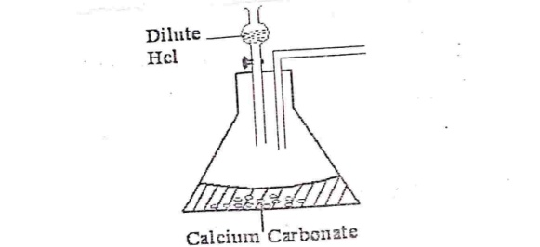

- Write down the property of concentrated sulphuric (VI) acid shown in the following reaction. (2mks)
H₂SO₄(i)
- CuSO₄. 5H₂O(s) CuSO₄(s) +5H₂O(i)
Blue White

……………………………………………………………………………………………

- C(s) + 2H₂SO₄(I) CO₂(g) + 2H₂O(I) + 2SO₂(g)

……………………………………………………………………………………………
- When excess chlorine gas is bubbled through dilute sodium hydroxide solution, the resulting solution acts as a bleaching agent.
- Write an equation for the reaction between chlorine gas and sodium hydroxide solution. (1mk)
……………………………………………………………………………………………
……………………………………………………………………………………………
- Explain how the resulting solution acts as a bleaching agent. (2mks)

……………………………………………………………………………………………
……………………………………………………………………………………………
- An element P has a relative atomic mass of 88. When a current of 0.5 ampheres was passed through the fused chloride for 32.16 minutes, 0.44g of P were deposited at the cathode. Determine the charge on an ion of P. (1 F = 96500 coulombs) (3mks)

……………………………………………………………………………………………
……………………………………………………………………………………………
……………………………………………………………………………………………
……………………………………………………………………………………………

- Matter exists in three states which can be related as shown in the diagram below.

P
Solid
Liquid
Gas

R Q

- Name processes P and R. (2mks)
P……………………………………………
R……………………………………………

- Explain whether process Q is exothermic or endothermic. (1½ mks)
……………………………………………………………………………………………
……………………………………………………………………………………………
……………………………………………………………………………………………
……………………………………………………………………………………………
- Study the diagram below.

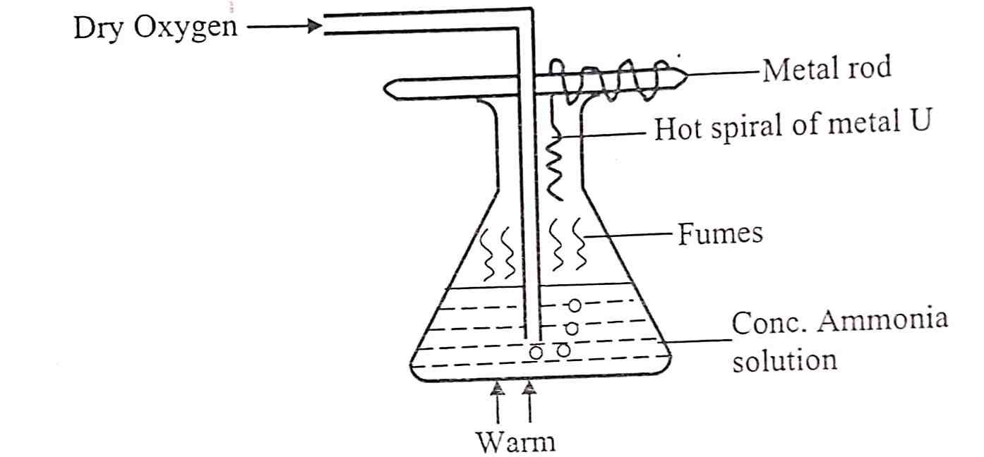
- Give the most likely identity of metal U. (1mk)

……………………………………………………………………………………………
- State two observations made in the conical flask. (2mks)
……………………………………………………………………………………………
……………………………………………………………………………………………
……………………………………………………………………………………………
……………………………………………………………………………………………

- Write an equation for the reaction which took place between ammonia and oxygen inside the flask. (1mk)

……………………………………………………………………………………………
……………………………………………………………………………………………

- In an experiment, soap solution was added to three separate samples of water. The table below shows the volumes of soap solution added in order to form lather with 1000cm³ of each samples before and after boiling.
 | Sample I | Sample II | Sample III
Volume of soap added to unboiled sample (cm³) | 27.0 | 3.0 | 10.6
Volume of soap added after boiling the sample (cm³) | 27.0 | 3.0 | 3.0

- Identify the sample that was likely to be soft water. Explain. (1mk)

……………………………………………………………………………………………
……………………………………………………………………………………………

- Explain the change in the volume of soap solution in sample III. (1mk)

……………………………………………………………………………………………
……………………………………………………………………………………………

- Give one disadvantage of hard water. (1mk)

……………………………………………………………………………………………
……………………………………………………………………………………………

- In an experiment to monitor the rate of reaction of magnesium and hydrochloric acid a student recorded the volume of hydrogen produced at regular time intervals and obtained the graph shown below.

- On the same set of axes sketch the curve expected if the experiment is repeated with a few crystals of copper (II) sulphate added to the reactants. (1mk)
- Explain the shape of your curve. (1mk)
……………………………………………………………………………………………
……………………………………………………………………………………………
……………………………………………………………………………………………
……………………………………………………………………………………………

- State the factor that can increase the rate of a reaction. (1mk)

……………………………………………………………………………………………
……………………………………………………………………………………………

- The grid below is a section of the periodic table. Study it and answer the questions that follow.

 | A |  |  |  |  |  | D
B |  |  | C |  |  |  | F
E

- State the name given to the family of B and E. (1mk)
……………………………………………………………………………………………

- Identify the most reactive metal. (1mk)

……………………………………………………………………………………………
- Which type of bond exists in the compound formed by A and F. Explain. (1 ½ mks)
……………………………………………………………………………………………
……………………………………………………………………………………………
……………………………………………………………………………………………

- Write the formula of the chief ore (bauxite) from which aluminum is extracted. (1mk)
……………………………………………………………………………………………
……………………………………………………………………………………………

b. Explain the role of molten cryolite in aluminum smelting. (1mk)
……………………………………………………………………………………………
……………………………………………………………………………………………
……………………………………………………………………………………………
……………………………………………………………………………………………

- Aluminum does not apparently react with dilute nitric (V) acid to liberate hydrogen gas. Explain. (1mk)

……………………………………………………………………………………………
……………………………………………………………………………………………

- Study the diagram below.
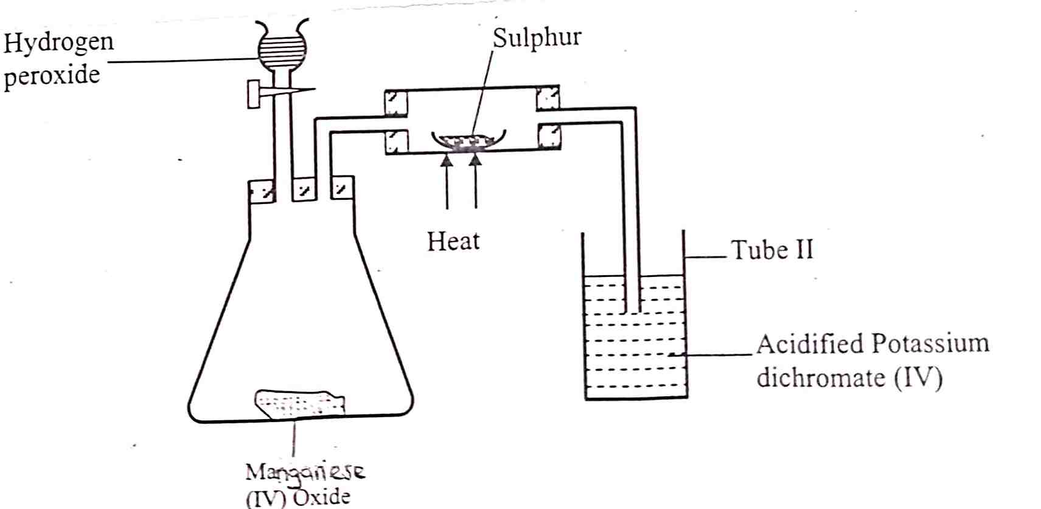

- State the role of manganese (IV) oxide in the set up shown above. (1mk)

……………………………………………………………………………………………
- State and explain the observation made in tube II. (2mks)

……………………………………………………………………………………………
……………………………………………………………………………………………
……………………………………………………………………………………………

- Two manila papers were placed at different levels of a non- luminous flame. Paper A was placed at the lowest part of the flame, while B was placed at the top.
- Indicate the observations made on each manila paper. (1mk)
……………………………………………………………………………………………
……………………………………………………………………………………………
- Explain the observation made on paper A. (1mk)
……………………………………………………………………………………………
……………………………………………………………………………………………
- Starting with 50cm³ of 2.8M sodium hydroxide, describe how a sample of pure sodium sulphate crystals can be prepared. (3mks)
……………………………………………………………………………………………
……………………………………………………………………………………………
……………………………………………………………………………………………
……………………………………………………………………………………………
……………………………………………………………………………………………
……………………………………………………………………………………………
……………………………………………………………………………………………
……………………………………………………………………………………………
- In an experiment to determine the percentage of magnesium hydroxide in an anti-acid a solution containing 0.5g of the anti-acid was neutralized by 23.0cm³ of 0.10M hydrochloric acid. Given the relative formula mass of magnesium hydroxide is 58. Calculate the:
- Mass of magnesium hydroxide in the anti-acid. (2mks)

……………………………………………………………………………………………
……………………………………………………………………………………………
……………………………………………………………………………………………
……………………………………………………………………………………………
- Percentage of magnesium hydroxide in the anti-acid. (1mk)
……………………………………………………………………………………………
……………………………………………………………………………………………
- Study the standard electrode potentials in the table below and answer the questions that follow.
EѲvolts
Cu²⁺(aq) + 2e⁻ Cu(s) + 0.34

Mg²⁺(aq) + 2e⁻ Mg (s) - 2.38

Ag⁺(aq) + e⁻ Ag(s) +0.80

Ca²⁺ (aq)+ 2e⁻Ca(s) - 2.87

- Which of the metals is the strongest reducing agent? (1mk)

……………………………………………………………………………………………
- What observations will be made if a silver coin is dropped into an aqueous solution of copper (II) sulphate? Explain. (2mks)

……………………………………………………………………………………………
……………………………………………………………………………………………
……………………………………………………………………………………………
- A student used the figure below to investigate the action of dilute sulphuric (VI) acid on some metals. Beaker I and II contained equal volumes of dilute sulphuric (VI) acid. To beaker I, a clean iron rod was dipped and to beaker II, a clean copper rod was dipped.

Dilute sulphuric (VI) acid
Iron rod copper rod

I II

- Describe the observations made in each beaker.
Beaker I (1mk)
……………………………………………………………………………………………
Beaker II (1mk)
……………………………………………………………………………………………
- Explain observations in (a) above. (1mk)
……………………………………………………………………………………………
……………………………………………………………………………………………

