NAME……………………….……………………………………CLASS……ADM:.............
SCHOOL…………………………….……………… INDEX NUMBER…………………...
312/1
GEOGRAPHY Paper 1
DECEMBER, 2021
TIME: 2¾ HOURS

LANJET CLUSTER JOINT EVALUATION
Kenya Certificate of Secondary Education
312/1
GEOGRAPHY Paper 1
DECEMBER, 2021
INSTRUCTIONS TO STUDENTS
- This paper has two sections: A and B
- Answer ALL the questions in section A.
- In section B answer questions 6 and any other TWO questions.
- All the answers must be written on the foolscaps provided.
- Candidates must answer the questions in English.
FOR EXAMINER’S USE ONLY

Section | Questions | Maximum  Score | Candidate’s  Score
A | 1 - 5 | 25
B | 6 | 25
 |  | 25
 |  | 25
Total Score |  | 100

This paper consists of 6 printed pages. Candidates should check the question paper to ascertain that all pages are printed as indicated and that no pages are missing.

SECTION A
Answer all questions in this section.

- The diagram below represents the structure of the atmosphere. Use it to answer question (a)
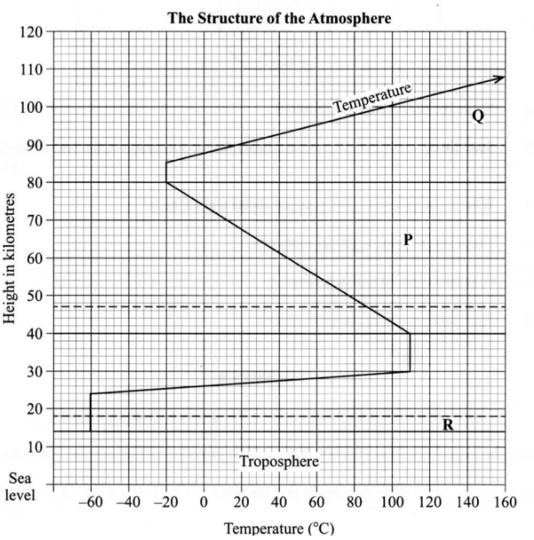
(a)Name:
(i) The parts marked P and Q. (2mks)

(ii) The layers of discontinuity marked R. (1mk)

(b) State two characteristics of the weather conditions in the troposphere. (2mks)

- (a) What is a metamorphic rock? (2mks)

(b) Give three examples of metamorphic rocks. (3mks)

- (a) What is an earthquake? (2mks)

(b)Identify the scale used to measure:
(i) The intensity of earthquakes; (1mk)

(ii) The magnitude of earthquakes. (1mk)

- (a)Identify the main characteristics of the ocean water. (2mks)

(b)Give three factors that influence wave deposition. (3mks)

- (a)Name three features that make up the hydrosphere. (3mks)

(b)Explain how the movement of magma causes earth movement. (2mks)

SECTION B
Answer question 6 and any other two questions from this section

- Study the map of Kijabe 1:50,000 provided and answer the following questions:
(i)What is the appropriate height of the top of Kijabe hill? (1mk)

(ii)Measure the length of Nairobi-Naivasha railway line from landhies (grid reference
257978) to the level crossing near Kijabe station (grid reference 308984).Give your answer in kilometers. (1mk)

(iii)What relief features on the map may have created problems in the construction of the railway line? (1mk)

(b)Describe the drainage of the area covered by the map. (4mks)

(c)Explain how relief has influenced the distribution of settlement in the area covered by the map. (4mks)

(d)Citing evidence from the map ,state four economic activities carried out in the area covered by the map. (8mks)

(e)Suppose you were a student n the school at Kinari (Kinale )and you plan to carry out a field study of Wakagwe forest,
(i)Design a working programme (schedule ) you would use during the day of the study. (2mks)

(ii)Give three reasons why it would be necessary to sample part of the forest for the study. (2mks)

(iii)State two ways in which your findings would be useful to the local community. (2mks)

- (a)(i)What is a lake? (2mks)

(ii)Name two crater lakes in Kenya. (2mks)

(b)Describe how each of the following lakes are formed:
(i)corrie lake; (4mks)
(ii) oasis; (4mks)
(iii) lagoon (4mks)

(c)(i)Give three reasons why some lakes in Kenya have saline water. (3mks)

(ii)Explain how each of the following has affected lakes in Kenya:
- Deforestation (2mks)
- Industrialization (2mks)
- Water needs (2mks)
- (a) (i)Name three types of faults. (3mks)

(ii)Apart from compressional forces, explain two other processes that may cause faulting (4mks)

(b)With the aid of diagrams, describe how compressional forces may have led to the formation of the Great Rift Valley. (8mks)

(c)Explain three ways in which faults is of significance to human activities. (6mks)

(d) suppose you are to carry out a field-study on a faulted are
i) State two methods you would use to collect data. (2 mks)

ii) Name two features resulting from faulting you are likely to observe (2 mks)

- The diagram below represents an artesian basin. Use it to answer question (a)
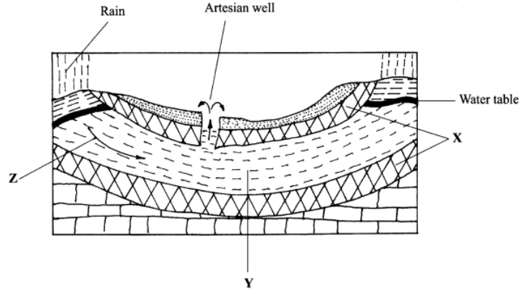
(a)Identify:
(i)the layers marked X and Y. (2mks)

(ii)the process marked Z. (1mks)
(b)Explain how the following factors influence the amount of underground water in limestone areas:
(i) rainfall; (4mks)

(ii) vegetation cover. (4mks)

(c)(i) Apart from stalagmites, name three other underground features formed in limestone
areas. (3mks)

(ii) With the aid of a diagram, describe how a stalagmite is formed. (8mks)

(d) Give three reasons why there are few settlements in Karst landscapes. (3mks)

- (a) (i) Name two major deserts found in Africa. (2mks)

The diagram below represents features resulting from wind erosion in desert. Use it to answer question a (ii).
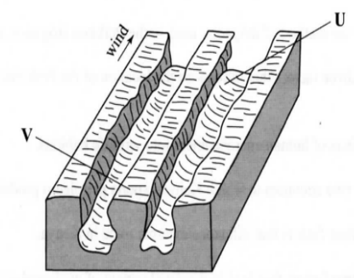
(ii)Name the features marked U and V. (2mks)

(b)Describe the three processes through which wind transports its load. (6mks)

(c)Using a well labeled diagram , describe how a barchans is formed. (7mks)

(d)Explain two ways in which desert features are of significance to human activities. (4mks)
(e) You intend to carry out a field studying an arid area.
i) Name one drainage feature you are likely to see. (1 mk)

ii) State three problems you are likely to encounter during the study (3 mks)

