NAME…………………………………… INDEX NO. ………………………..……………

DATE…….……………………………… CANDIDATE'S SIGNATURE………………..
CLASS: ……………………………………………

312/2
GEOGRAPHY
PAPER 2
DECEMBER, 2021
TIME: 2¾ HOURS

LANJET CLUSTER JOINT MOCK EXAMINATION
Kenya Certificate of Secondary Education
312/2
Paper 2
GEOGRAPHY
DECEMBER, 2021
TIME: 2 ¾ HOURS

INSTRUCTIONS
This paper has two sections: A &B.
- Answer all questions in section A.
- In section B, answer question 6 and any other two questions.
- Candidates should answer the questions in English.
- All answers to be written in foolscaps provided.

This paper consists of 4 printed pages. Candidates should check the question paper to ascertain that all pages are printed as indicated and that no pages are missing.

SECTION A

Answer all the questions in this section
- a. Name two branches of Geography. (2mks)

b. Outline three ways in which a student benefit from learning geography. (3mks)

- a. Define the term mining. (2mks)

b. Describe Hydraulic mining as a method of mining. (3mks)

- a. List two factors that determine the distribution of forest in Kenya (2mks)

b. Give three economic uses of mangrove forests. (3mks)

- a. Outline two biotic factors influencing agriculture. (2mks)

b. State three physical conditions that favour cocoa farming in Ghana. (3mks)

- a. Differentiate between management and conservation of the environment. (2mks)

b. Outline three measures being taken by people to reduce the impact of floods. (3mks)

SECTION B
6. Use the table below and answer the questions that follow in Narok County.
Name of divisions | No. of veterinary officers
Mayasho | 300
Gukaro | 150
Zachocho | 200
Mayayo | 160
Kakasho | 110
Ndikakho | 80
Totals | 1000

- Calculate the percentage of number of officers in Kakasho division. (2mks)

- Draw a divided rectangle of 10cm long to represent the number of veterinary officer per division in Narok County. (10mks)

b. i. Give the four main Beef cattle breeds kept in Kenya. (4mks)

ii. State three physical factors encouraging beef farming. (3mks)

c. Outline six effort taken by Kenya government its support beef cattle farming. (6mks)

7. Below is a sketch map of the RUhr Industrial Region. Use it to answer questions. (i) (a)
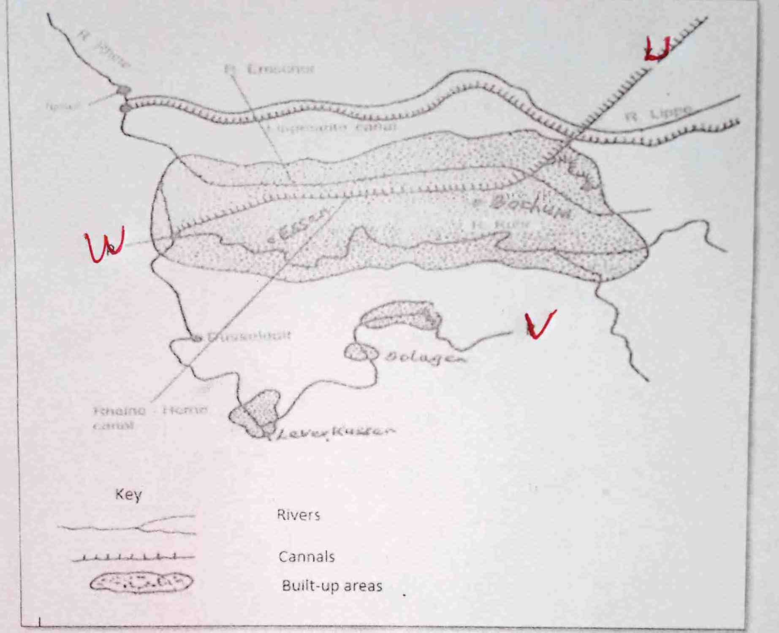

a. i. Name the canal marked U. (1mk)

ii. Name river marked V. (1mk)

iii. Name the town marked W. (1mk)

b. i. What is Industrialization? (2mks)

ii. Name the towns in Kenya where each of the following industries are located.
    - Oil refining. (1mk)

    - Paper manufacturing (1mk)

    - Motor vehicle assembly. (1mk)

c. i. Explain three factors which influenced the location in iron and steel industry in the rural
region in Germany. (6mks)

ii. Explain three factors which have favoured the development of car manufacturing industry in Japan. (6mks)

d. You intend to carry out a field study of furniture making in the local (i) state three reasons why it would be necessary for you to visit the area of study in advance. (3mks)

ii. For your field study you have prepared a working schedule. State three items you would include in the schedule. (2mks)

8 a. Define the term Eco-tourism. (2mks)

b. i. Explain five reasons why Domestic tourism should be encouraged in Kenya. (10mks)

ii. State three problems facing tourism in Kenya. (3mks)
c. Explain how the following factors influence tourism in Switzerland.
i. Climate (2mks)

ii. Geographical location (2mks)

iii. Linguistic and plurality. (2mks)

d. Explain two reasons why Switzerland receives more tourists than Kenya. (4mks)

9a. i. Define balance of payment. (2mks)

ii. Identify three major exports from Kenya to European countries. (3mks)

b. Outline reasons why trade between Kenya and other African countries is not well developed. (4mks)

c. Explain four reasons why a country should impose trade barriers. (8mks)

d. You intend to carry out field study in Nakuru Top Market.
i. Formulate the work schedule that you can use for the study. (4mks)

ii. State the follow up activities you are likely to undertake after the study. (4mks)

10. a. List three electric devices garget that relay through sound and pictures through the
satellites. (3mks)

b. Explain two advantages of using the mobile phones. (4mks)

c. Outline four problems facing the mobile users. (4mks)
d .i. List three trans-continental roads in Africa. (3mks)

ii. Explain three advantages of using road transport over railway transport. (6mks)

e. Describe factors which have led to the fast growth of Rotterdam as a major seaport in Europe. (5mks)

