NAME:……………………………………… INDEX NO.……………..…….…

SIGNATURE: ………………….... ……….. DATE: ...........................................

121/1
MATHEMATICS
PAPER 1
DECEMBER, 2021
TIME: 2 ½ HOURS

LANJET JOINT EVALUATION TEST 2021
Kenya Certificate of Secondary Education (K.C.S.E)

INSTRUCTIONS TO CANDIDATES
- Write your name and Admission number in the spaces provided at the top of this page.
- This paper consists of two sections: Section I and Section II.
- Answer ALL questions in section 1 and ONLY FIVE questions from section II
- All answers and workings must be written on the question paper in the spaces provided below each question.
- Show all the steps in your calculation, giving your answer at each stage in the spaces below each question.
- Non – Programmable silent electronic calculators and KNEC mathematical tables may be used, except where stated otherwise.

FOR EXAMINERS USE ONLY
SECTION I
1 | 2 | 3 | 4 | 5 | 6 | 7 | 8 | 9 | 10 | 11 | 12 | 13 | 14 | 15 | 16 | TOTAL
SECTION II GRAND TOTAL

17 | 18 | 19 | 20 | 21 | 22 | 23 | 24 | TOTAL

This paper consists of 15 printed pages. Candidates should check the question paper to ascertain that all pages are printed as indicated and that no pages are missing.

SECTION I
Answer all the questions in the spaces provided.
- Evaluate without using tables or calculators (2mks)
⁶/₇ of ¹⁴/₃ ÷ 80 x ⁻²⁰/₃
-2 x 5 ÷ (14 ÷ 7 ) x 3

- The line y = 3x + 3 meets the line L1 at the point (2, 9) and at right angles. Find the points at which the two lines intersect with the x- axis. (3mks)

- Given that p=5a – 2b where a = 3 and b = 4 , find :
2 1

- Column vector p. (2mks)

- P΄ the image of p under a translation vector -6 (1mk)
4

- Solve the following inequalities and represent the solution on a number line. (3mks)
4x – 3 ≤ 6x -1 < 3x + 8

- The figure below shows a triangular prism of uniform cross section. AF=FB= 4cm. AB=7cm, BC= 12cm. given that angle BAF=30º, find the total surface area of the prism. (3mks)
C
F
A
B
D
E

- Use tables of cubes, cubes roots and reciprocals to evaluate; (4mks)

23.5³- 3 4411 + 1
0.0071

- The density of a substance A is given as 13.6g/cm³ and that of a substance B as 11.3g/cm³. Determine, correct to one decimal place, the volume of B that would have the same mass as 50cm³ of A. (3mks)

- Find x in 2(4^{x}) – 10 (2^{x}) + 8 = 0 (3mks)

- The sum of interior angles of a regular polygon is 24 times the size of the exterior angle.
Find the number of sides of the polygon. (3mks)

- Triangle ABC has its vertices at A(3, 0), B(2,3) and C(5,1) if A΄(5, 0), B΄(3,6) and C΄(9,2) is the image of ABC under enlargement. On the same axes and grid provided below, determine the centre of enlargement and linear scale factor. (3mks)

- The following measurements were recorded in a field book of a farm using XY as the base line XY=400M.
Y
C60 340
300 120D
240 100E
220 160F
B 100 140
A 120 80
X

Using a suitable scale, draw an accurate map of the farm. (4mks)

- Waceke is a saleslady. She is paid Ksh15,375 per month. She is also paid a commission of 4 ½ % on the amount of money she makes from her sales. In a certain month, she earned a total of Ksh. 28,875. Calculate the value of her sales that month. (3mks)

- Two buses P and Q leave Kisumu at 7.30am and 9.30am respectively. If their speeds are 60km/h and 100km/h respectively,find when Q catches up with P. (3mks)

- The figure below shows a solid cone. It has a cylindrical hole drilled into it. The diameter of the hole is 7cm and its height 8cm. The radius of the cone is 10.5cm and its vertical height is 15cm.

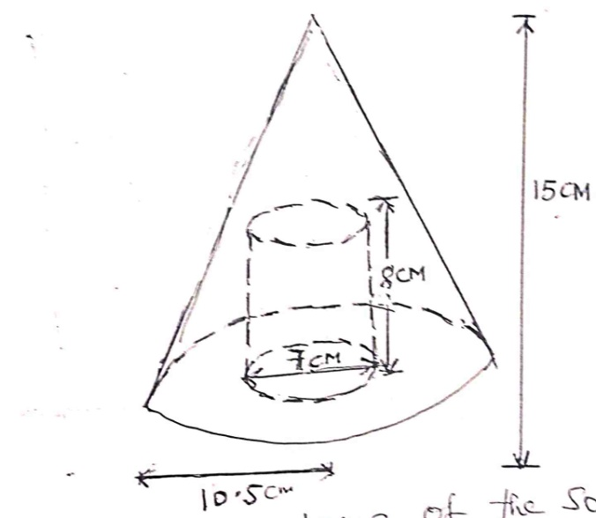

Calculate the volume of the solid. (3mks)

- Simplify completely: (3mks)

(a +2b)² – ( 2a – b)²
ab² – a²

- The figure below represents a speed time graph for a cheetah in 40 seconds.
Calculate the total distance covered by the cheetah. (3mks)
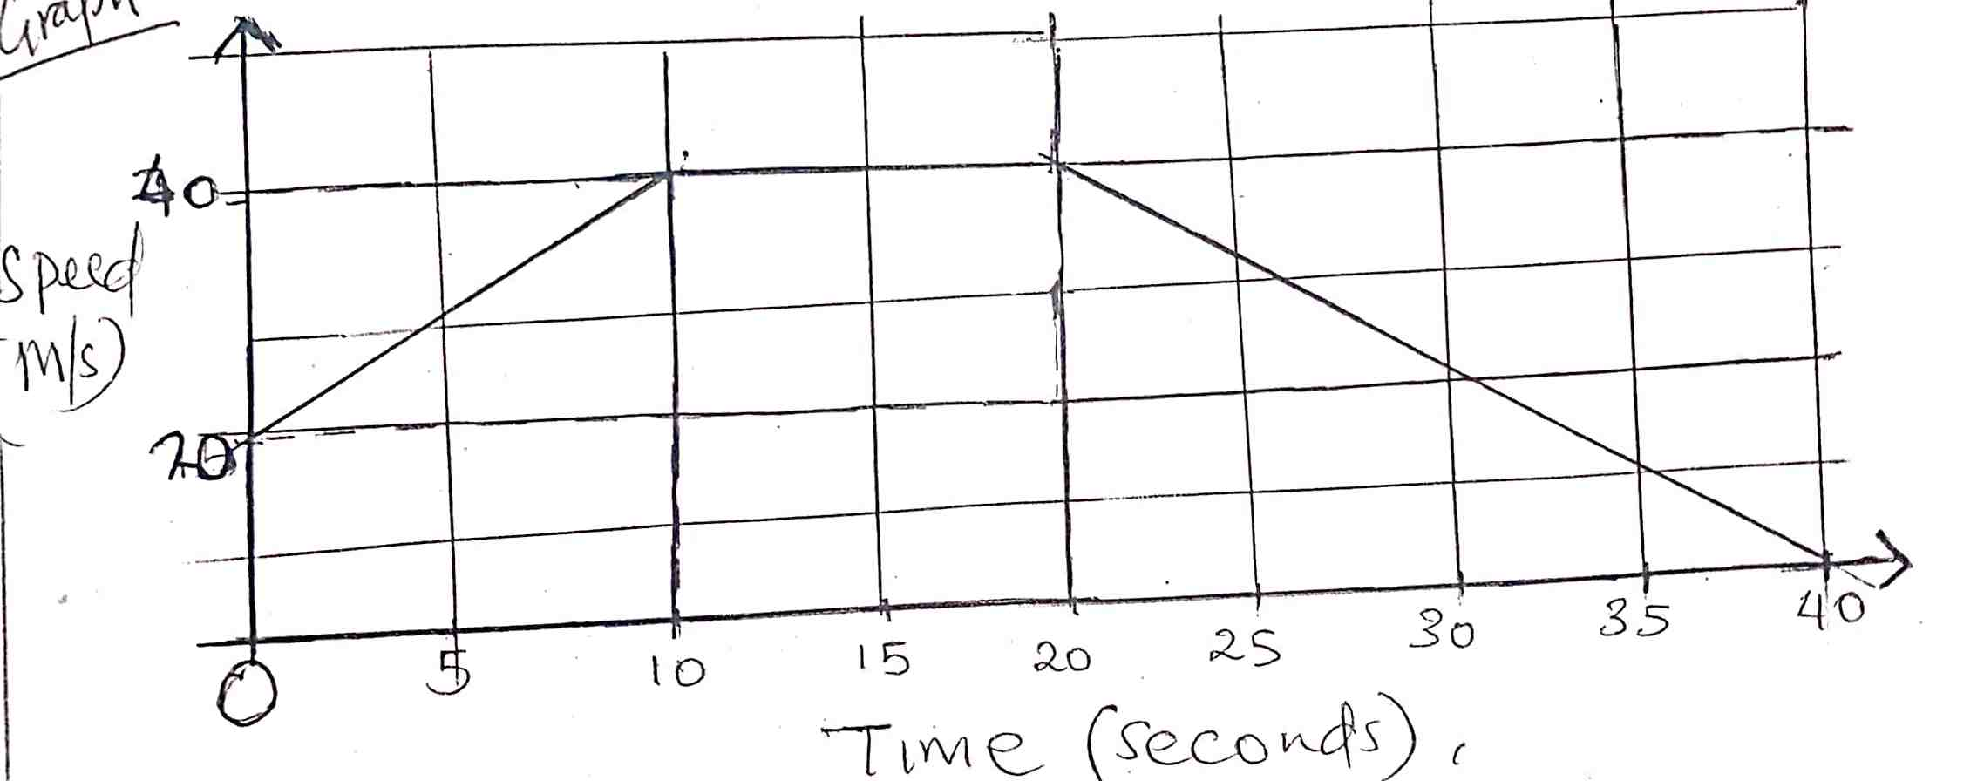

SECTION II
Answer any five questions in this section.

- A rectangular tank whose internal dimensions are 2.4m by 2.5m by 3.7m is two thirds full of juice.
a. Calculate the volume of the juice in litres. (3mks)

b. The juice is parked in small packets in a shape of right pyramid with equilateral triangles of sides 20cm. the height of each packet is 15cm. a full packet is sold at kshs. 50 per packet.
Calculate:
- The volume of the juice in cm³ of each packet to the nearest whole number. (3mks)

- The number of full packets of juice. (2mks)

- The amount of money realized from the sale of juice. (2mks)

- The masses in kilograms of patients who attended a clinic on a certain day were recorded as follows.
67 | 49 | 57 | 58 | 69 | 58 | 39 | 61 | 51 | 47
38 | 59 | 46 | 52 | 60 | 72 | 59 | 49 | 54 | 52
69 | 62 | 58 | 67 | 63 | 59 | 65 | 58 | 49 | 44
49 | 41 | 70 | 58 | 54 | 60 | 60 | 59 | 42 | 41
79 | 52 | 51 | 48 | 54 | 59 | 62 | 73 | 48 | 54
- Starting with the class 35-39, make a frequency distribution table for the data. (2mks)

- Calculate the mean mass. (3mks)

ii) Calculate the median mass. (3mks)

- On the grid provided draw a frequency polygon to represent the data. (2mks)

- The position vectors of A, B and C are 3i – 2j, -6i + 4j and -9i – 3j respectively.
- State the column vectors.
- AB (2mks)

- CB (2mks)

- Find the distance from A to C. (2mks)

- Find the coordinates of the mid point of AC. (2mks)

- If point C΄ is the image of C under translation vector 1
-3
Find the co-ordinates of C΄. (2mks)

- Complete the table below for the function y= x²– 3x + 6 in the range -2 ≤ x ≤ 8. (2mks)
X | -2 | -1 | 0 | 1 | 2 | 3 | 4 | 5 | 6 | 7 | 8
Y

- Use the trapezium rule with 10 strips to estimate the area bounded by the curve, y=x²- 3x + 6, the lines x = -2, x =8 and the x – axis. (3mks)

- Use the mid – ordinate rule with 5 strips to estimate the area bounded by the curve, y = x² – 3x + 6, the lines x = -2, x = 8 and the x- axis. (3mks)

- By integration, determine the actual area bounded by the curve y = x² – 3x + 6, the lines x = -2, x = 8, and the x – axis. (3mks)

- The corner points A, B, C and D of a ranch are such that B is 8km directly East of A and C is 6km from B on a bearing of 30º. D is 7km from C on a bearing of 300º.
- Using a scale of 1cm to represent 1km, draw a diagram to show the positions of A, B, C and D. (4mks)

- Use the scale drawing to determine:
- The bearing of A from D. (1mk)

- The distance BD in kilometers. (2mks)

- The perimeter of the ranch in kilometers. (3mks)

- Johana and MuchirucontributesKsh. 150,000 and Ksh. 180,000 every year respectively for a business, after one year Jacob joined the business and contributed Ksh. 135,000.
- Calculate the ratio of their investment after three years of business. (3mks)

- They agreed that 30% of the profits after 3 years be used to cater for the costs of running the businesses while the remaining would be shared proportionally. Calculate each person’s share if the profit after 3 years was shs. 240,000. (4mks)

- If each re-invested their shares back into the business, find the new individual investment at the beginningof the fourth year. (3mks)

- The figure below shows the end wall of a building with the axes shown and 1M as the unit of measurement. The roof line is given by y= a + bx², where a andb are constants.
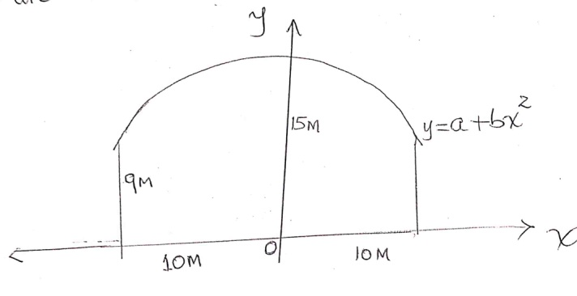

- State the value of a. (1mk)

- Calculate the value of b. (3mks)

- Calculate the values of y for x = 2, 4, 6, 8 and compete the table below. (2mks)
X | -10 | 0 | 2 | 4 | 6 | 8 | 10
Y | 9 | 15 |  |  |  |  | 9

- Calculate the area of the wall. (4mks)

- A ball is thrown upwards and its height after t seconds is 5 meters, where s = 20t – 5t². Find
- The greatest height reached and the time when it is reached. (3mks)

- The time when it returns to the original level. (3mks)

- Its velocity after 3 seconds. (2mks)

- Its acceleration during the throw. (2mks)

