NAME: …………………………………………. INDEX NO: ……………………………….

DATE : …………………………………..

CANDIDATE’S SIGNATURE:………………..

GEOGRAPHY P1
OCT/NOVEMBER 2021

SECTION A
Answer all questions in this section
- a) Name the biggest planet in the solar system. (1mk)
b) State three characteristics of the core. (3mks)
- a) Define the following terms.
- Dew point (1mk)
- Temperature inversion (1mk)
b) Identify three sources of carbon dioxide in the atmosphere. (3marks)
- a) State three causes of earth movements. (3mks)
b) Name two main earthquake zones in the world. (2mks)
- The diagram below shows a an example of a local wind
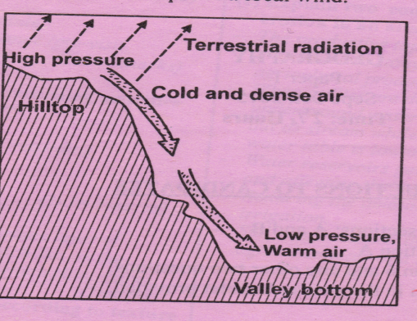
- Identify the local wind . (1mk)
- Describe how the wind is formed. (4mks)

- Identify two sources of underground water. (2mks)
b) State three conditions that favour the formation of artesian walls. (3mks)

SECTION B
Answer question 6 and any other two questions from this section

- Study the map of Oyugis 1:50000 [sheet index 130/1] provided and answer the following questions
- i) Give the four figure grid reference of the trigonometrical station at Matieka (2mks)
ii) Identify three man made features in the grid square 7628. (3mks)
iii) Identify the adjoining sheet to the North –east of Oyugis (1mk)
- Draw a rectangle measuring 12cm by 8cm to enclose the area between northings 23 and 25 and between eastings 70 and 73 (2mks)
On the rectangle, mark and label the following
- River Nyamaura (1mk)
- All weather loose surface road (1mk)
- Bridge/bridges (1mk
- forest . (1mk)

- i) Describe the drainage of the area covered by the map. (5mks)
ii) Describe the relief of the area covered by the map. ( 5mks)
- Identify three social functions found in the area covered by the map. (3mks)
- a) i) What is fog. (2mks)
ii) State two conditions necessary for the formation of fog. (2mks)
b) i) With the aid of a labeled diagram, describe how relief rainfall is formed. (7mks)
c) Use the map of Africa below to answer the questions that follows.
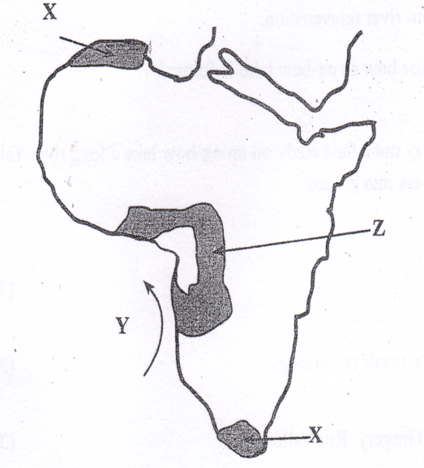
Name
- Type of climate experienced in the region marked X. (1mk)
- The ocean current marked Y. (1mk)
- Describe the characteristics of the type of climate found in shaded area marked Z. (4mks)
d) Suppose your class carried out a field study on weather around the school environment
- Explain two effects of wind on climate that they are likely to have identified. (2mks)
- Give two methods that you used to collect data in the field. (2mks)
- Give two follow up activities that you were involved in after the field study. (2mks)
- a) i) Differentiate between a watershed and a confluence. (2mks)
ii) Describe two processes though which a river erodes its channel . (4mks)
b) The diagram below shows a water fall. Use it to answer question b (i)

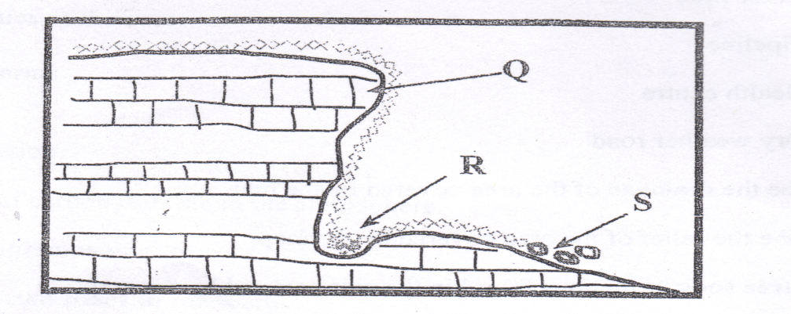
- Name the parts marked Q, R and S. (3mks)
Q – (1mk)
R – (1mk)
S – (1mk)

- Explain two causes of river rejuvenation. (1mk)
- Name two features resulting from river rejuvenation. (2mks)
c) Using well –labeled diagrams, describe how an ox-bow lake is formed. (6mks)
d) Your Geography class intends to carry out a field study on an ox-bow lake a long river Yala. Give four reasons for dividing the class into groups. (4mks)
- a i) Define the term faulting. (2mks)
ii) Name three featured formed as a result of faulting. (3mks)
b) i) State three characteristics of the Gregory Rift Valley. (3mks)
ii) Give three theories that explain the origin of the Rift Valley. (3mks)
iii) Explain four ways in which faulting influence drainage. (8mks)
c) A form 4 geography class of Mwarano High School carried out a field study on the section of the Rift Valley in Kenya.
- State three preparations they had before the study. (3mks)
- State three ways of data recording activities used during the study. (3mks)
- a) i) Define the term soil. (2mks)
ii) Name two types of soil according to texture. (2mks)
b) Briefly explain how the following factors influence soil formation.
- Climate (4mks)
- Living organisms. (4mks)
c) i) Differentiate between soil profile and soil catena. (2mks)
ii) List three processes which influence the development of soil profile. (3mks)
d) Explain how the following human activities lead to soil erosion.
- Continuous ploughing (2mks)
- Cutting down trees. (2mks)
e) Identify four consequences caused by severe soil erosion in an area. (4mks

