KITUTU CENTRAL JOINT EXAMINATION
Kenya Certificate of Secondary Education
FORM 4 END TERM 2 EXAMINATIONS

312/1 GEOGRAPHY Paper 1
December 2021 – TIME: 2¾ Hours

Name: …………………………………………....…… Adm No: ……….……
Class: ………………Candidate’s Signature: …….……Date: ……..…/12/2021.

Instructions to candidates
- Write your name, admission number and class in the spaces provided above.
- This paper has two sections: A and B
- Answer all the questions in section A
- Answer question 6 and any other two questions from section B
- All answers in section A and question 6 must be written in the spaces provided below each question.
- All answers for questions 7 to 10 must be written in the spaces provided after Question 10.
- This paper consists of 11 printed pages.
- Candidates should check the question paper to ascertain that all the pages are printed as indicated and that no questions are missing.

For Examiner’s Use Only
Section | Questions | Candidate’s  Score | Maximum  Score
A | 1 – 5 |  | 25
B | 6 |  | 25
 |  |  | 25
 |  |  | 25
 | Total Score |  | 100

SECTION A (25 MARKS)
Answer ALL questions in this section

1. (a) Describe the solar system? (2 marks)
(b) State three characteristics of crust (3 marks)

2. (a) The diagram given shows a flood plain
J
River
K
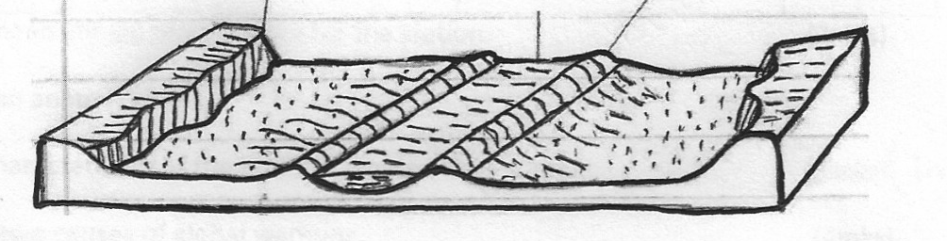

Name the features marked J and K (2 marks)
(b) Explain two positive effects of floodplains to human activities (4 marks)

3. (a) Name a lake in East Africa that was formed through the following processes.
(i) Crustal warping (1mark)
(ii) River deposition (1mark)
(iii) Glacial erosion (1mark)
- Give two effects of human-made lakes to the physical environment.
(2 marks)

4. (a) Differentiate between elluviation and illuviation soil forming processes. (2 marks)
(b) Identify two causes of chemical degeneration of soil (2 marks)

5. (a) What is natural vegetation? (2 marks)
(b) State three characteristics of the Mediterranean type of vegetation. (3 marks)

SECTION B
Answer question 6 and any other TWO questions from this section

6. Study the map of Yimbo 1:50,000 (sheet 115/1) provided and answer the following questions.
(a) (i) Give the longitudinal extent of the area covered by the map. (1 mark)
(ii) What is the approximate height of Usengi hill in the western part of the map? (1 mark)
(iii) Calculate the area of Mageta Island. Give your answer in km2. (2 marks)
(b) (i) Identify two physical features found in the grid square 3696. (2 marks)
(ii) What is the bearing of Goye School from the peak of Ramogi hill? (2 marks)
(c) (i) Give evidence that show that the area covered by the map receives low rainfall. (2 marks)
(ii) Identify three types of natural vegetation in the area covered by the map. (3 marks)
(d) Draw a rectangle measuring 10 cm by 8 cm to represent the area enclosed by Easting 20 and 30 and northing 91 and 99. (1 mark)
(i) On the rectangle, mark and name the following:
• All weather road - loose surface (1 mark)
• River Yala (1 mark)
• Majengo school (1 mark)
(ii) Calculate the scale of your map. (2 marks)
(e) Describe the drainage of the area covered by the map. (6 marks)

7. (a) Identify three characteristics of minerals (3 marks)
- What is a rock? (2 marks)
- (i) Describe two processes through which sedimentary rocks change into
metamorphic rocks (4 marks)
- Identify three changes that may occur in rocks when they are subjected to heat
and pressure (3 marks)
- Explain three conditions necessary for the growth of coral polyps that form coral
limestone rock (6 marks)
- Supposing you were to carry out a field study on rocks at the Kenyan Coast.
- Why do you think sedimentary rocks are the most widespread in the coastal plain. (4 marks)
(ii) Why would sampling part of the area be necessary as you conduct the field study?
(3 marks)

8. (a) (i) What is earth movement? (1mark)
(ii) State three causes of earth movement (3marks)
(b) The diagram shows major tectonic plates of the earth’s crust. Use it to answer the question that follow.
X
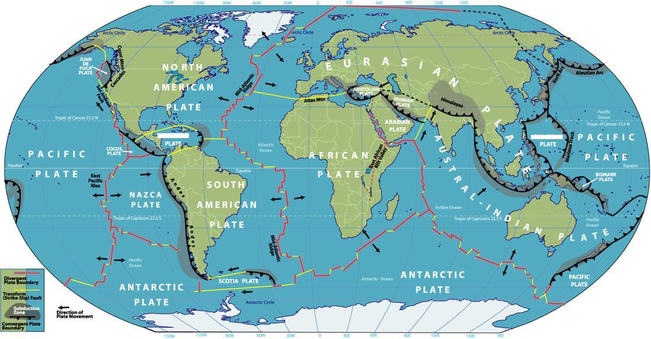
Y

- Identify the plates marked X and Y (2marks)
- Describe how the Mid Atlantic ridge was formed (3marks)
- Other than fold Mountains, give two features that result from folding.
(2 marks)
- With the aid of a well labeled diagram describe how the Alps and Atlas
mountains were Formed (8 marks)

- Explain three positive influence of Fold Mountains (6 marks)

9. a) i) Give three physical factors which contribute to the development of deserts. (3 marks)
ii) Describe two processes of wind transportation. (4 marks)
b) State three factors that facilitate wind deposition. (3 marks)
c) By use of diagrams, explain how a rock pedestal is formed. (5 marks)
d) Explain three effects of desert features on human environment. (6 marks)
e) Some students carried out a field study in Chalbi desert.
i) State two objectives of their study. (2 marks)
ii) State two problems they encountered during their study. (2 marks)

10. a) Define the following terms
i) Water table. (1 mark)
ii) Acquifer (1 mark)
b) Explain how the following factors influence the occurrence of underground water.
i) Nature of the rock. (2 marks)
ii) Slope gradient. (2 marks)
c) State three conditions necessary for the formation of an artesian well. (3 marks)
d) Draw a diagram to show a limestone cave and on it mark and name:
i) A stalactite (1mark)
ii) A limestone pillar (1mark)
iii) Stalagmite (1mark)
e) i) Explain three conditions necessary for the development of Karst scenery.
(6marks)
ii) Give two reasons why there are few settlements in the Karst region. (2 marks)
f) Students carried out a field study in a karst landscape
i) State two methods they used to record data. (2 marks)
ii) State three importance of studying a karst landscape through field work. (3 marks)
10. (a) Name two types of glaciers which are found on mountains in East Africa. (2 marks)
(b) Explain how the following factors influence erosion by a glacier.
(i) Nature of the underlying rock. (2 marks)
(ii) Speed of the glacier. (2 marks)
(iii) Thickness and weight of ice. (2 marks)
(c) With the aid of labeled diagrams, describe how an arête is formed. (6 marks)
(d) (i) Describe the process through which a Roche mountonnee is formed. (5 marks)
(ii) Explain the significance of glaciated features to human activities. (6 marks)

