KITUTU CENTRAL JOINT EXAMINATION
Kenya Certificate of Secondary Education

FORM 4, TERM 2 – 2021

312/2 GEOGRAPHY Paper 2

December 2021 - 2¾ Hours

Name: ………………………………………..…… Adm No: ……….……
Class: ………………Candidate’s Signature: …….…Date: …..…/09/2021.

Instructions to candidates:
- Write your name, admission number and class in the spaces provided above.
- This paper has two sections: A and B
- Answer all the questions in section A
- Answer question 6 and any other two questions from section B
- All answers in section A and question 6 must be written in the spaces provided below each question.
- All answers for questions 7 to 10 must be written in the spaces provided after Question 10.

For Examiner’s Use Only
Section | Questions | Candidate’s  Score | Maximum  Score
A | 1 – 5 |  | 25
B | 6 |  | 25
B |  |  | 25
B |  |  | 25
 | Total Score |  | 100

SECTION A. (25MARKS)
Answer all questions in this section.

1. a). Differentiate between market gardening and horticulture (2 marks)
b). Name three variety of vegetables exported from Kenya (3 marks)

2. a) Name three softwood trees found in Kenya. (3 marks)
b) Give three reason whys re-afforestation programs are being carried out in Kenya. (3 marks)

3. (a) Give two main inland tourist attractions in Kenya. (2 marks)
(b) State three human factors favoring tourism in Switzerland. (3 marks)

4. (a) Mention two primary sources of population data . (2 marks)
(b) State three reasons why Kenya has a high rate of population growth. (3 marks)
5. (a) What is ‘industrial inertia’? (1 mark)
(b) State two causes of industrial inertia (2 marks)

SECTION B (75 marks)
Answer question 6 and any other two questions in this section

6. Study the table below which shows production of minerals in tonnes in Kenya between 2018 to 2020.
Mineral | 2018 | 2019 | 2020
Soda Ash | 245,680 | 128,190 | 297,780
Flouspar | 93,602 | 80,102 | 118,850
Salt | 44,886 | 8,359 | 5,664
Limestone products | 32,000 | 16,000 | 32,000
Others | 106,850 | 5,323 | 13,552
TOTAL | 426,850 | 237,974 | 467,876
Source: Hypothetical Data
Use the table above to answer question (a).
(a) (i) Using a scale of 1cm rep. 200, calculate the radii to be used in
drawing proportional circles for production in 2000 and 2001. (2 marks)
(ii) Draw proportional divided circles for the two years. Show your
calculations. (8 marks)
(iii) State two conclusions that can be drawn from the proportional
divided circles drawn. (2 marks)
(iv) What percentage of the total production was contributed by flouspar
over the years. (2 marks)
(b) What is meant by:
- Renewable natural resources? (2 marks)
- Non Renewable natural resources? (2 marks)

(c) Why is mining regarded as a “Robber industry?” (2 marks)

(d) Explain five ways in which gold mining has contributed to the economic
development of South Africa. (5 marks)

7. a). i). Apart from Kenya, Mention two other countries that grow tea in
Africa (2 marks)
ii). State two varieties of tea grown in Kenya (2 marks)
b). i). Explain three physical factors that favour the growth of tea in Kenya (6 marks)
ii). Highlight three roles played by Kenya Tea Development Agency (KTDA) in Kenyan Tea industry. (3 marks)
c). Describe the processing of tea in the factory (6 marks)
d). Explain three problems facing tea farming in Kenya (6 marks)

8. a). i). Differentiate between renewable and non-renewable source of
energy (2 marks)
ii). State three advantages of Solar energy (3 marks)
b). i). List three types of coal (3 marks)
ii). Highlight three reasons why geothermal energy is not well
developed in Kenya (3 marks)
c). Explain four negative effects of Energy crisis in Kenya (8 marks)
d). Your class carried out field study of Masinga Dam along the seven folks on R.Tana.
i). State two ways in which you prepared for the study. (2 marks)
ii). State two challenges facing power generation you identified (2 marks)
iii). Mention two methods of data collection you used during the study (2 marks)

9. a) Name two methods of irrigation practiced in Mwea irrigation scheme
(2 marks)
b) Explain three significance of irrigation farming in Kenya (6 marks)
c) Describe the stages involved in land reclamation in the Netherlands through the Zuider Zee project (10 marks)
d) State the similarities between land reclamation in Kenya and the Netherlands (4 marks)
e) A form 4 geography class at Cardinal Otunga high school carried out a field study at the Mwea irrigation scheme about irrigation farming. State three follow-up activities they would be involved in (3 marks)

10. Study the photograph provided below and use it to answer questions that follow.
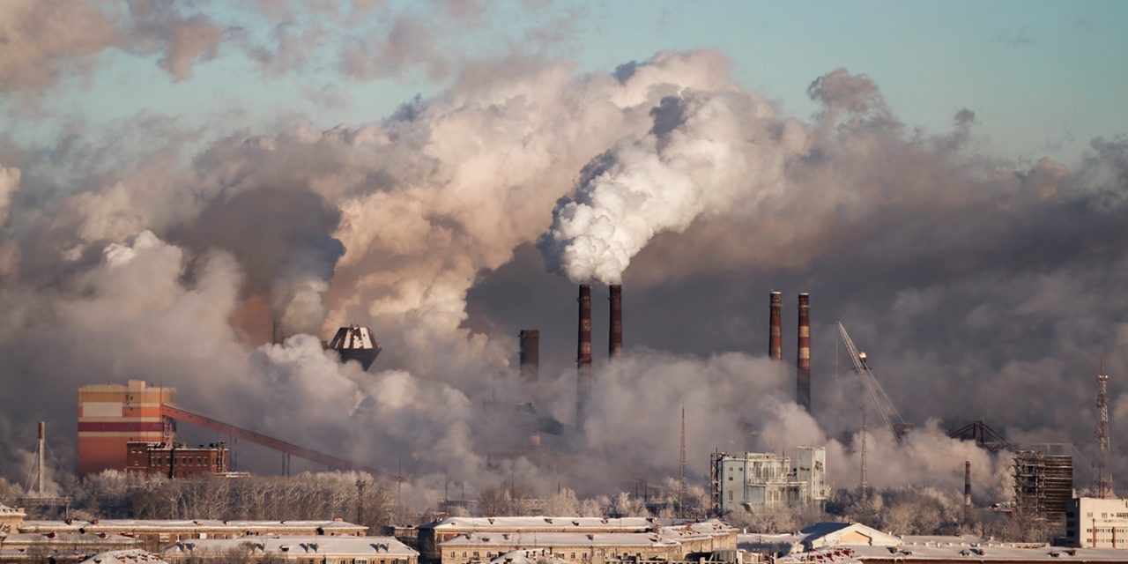

a) i). What type of photograph is shown above (2 marks)
ii). Name the type of pollution shown above and where it is commonly
found (2marks)
iii. Name the economic activity shown in the photograph. (1mark)
b) i). Name three places in Kenya where the photograph is likely to have
been taken (3 marks)
ii). Apart from the pollution shown above, mention two other types of pollution (2 marks)
iii). Explain four negative effects of the type of pollution on the
environment (8 marks)
c) Outline three measures that can be taken to control the type of pollution shown above (3 marks)
- Give four reasons why the environment should be conserved (4 marks)

