**KITUTU CENTRAL JOINT EXAMINATION**

***Kenya Certificate of Secondary Education***

**FORM 4, TERM 2, DECEMBER 2021**

**232/2 PHYSICS PAPER 2**

**TIME: 2 Hours**

**Name**: ………………………………………....…… **Adm** **No**: ……….……

**Class**: ………………**Candidate’s** **Signature**: …….……**Date**: …..…/12/2021.

**INSTRUCTIONS TO THE CANDIDATES:**

* Write your **name** **and index number** in the spaces provided above.
* Answer ***all*** the questions both in section **A** and **B** in the spaces provided below each question
* All workings ***must*** be clearly shown; marks may be awarded for correct steps even if the answers are wrong.
* Mathematical tables and silent electronic calculators may be used.

**For Examiners’ Use Only**

|  |  |  |  |
| --- | --- | --- | --- |
| **SECTION** | **QUESTION** | **MAXIMUM SCORE** | **CANDIDATE’S SCORE** |
| **Section A** | **1-14** | **25** |  |
| **Section B** | **15** | **14** |  |
| **16** | **11** |  |
| **17** | **15** |  |
| **18** | **15** |  |
| **TOTAL** | **80** |  |

***This paper consists of 17 printed pages. Candidates should check to ascertain that all pages are printed as indicated and that no questions is missing***

**SECTION A: (25 MARKS)**

***Answer ALL the questions in this section in the spaces provided***

1. **Figure 1** shows a ray of light incident on the surface of a plane mirror

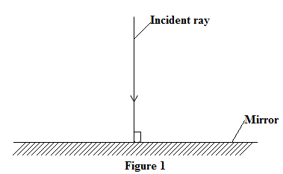

State the angle of incidence of the ray (1 mark)

**…………………………………………………………………………………………………………………………………………………………………………………………………………………………………………………………………………………………………………………………………………**

1. One of the main challenges of transmission of electric current through cables is energy losses due to electric resistance by the cables. State two ways by which such losses are reduced during transmission. (2 marks)

**………………………………………………………………………………………………………………………………………………………………………………………………………………………………………………………………………………………………………………………………………………………………………………………………………………………………………………………………………………………………**

1. **Figure 2** shows a track of radioactive emission formed in a cloud chamber

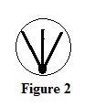

**Figure 2**

State with a reason the type of radiation that was detected by the cloud chamber. (2marks)

**………………………………………………………………………………………………………………………………………………………………………………………………………………………………………………………………………………………………………………………………………………………………………………………………………………………………………………………………………………………………………………**

1. One method of magnetizing a magnetic material is putting a magnetic material in a solenoid then pass d.c current through the solenoid continuously for some time. Using domain theory of magnetism explain how this method works (2 marks)

**………………………………………………………………………………………………………………………………………………………………………………………………………………………………………………………………………………………………………………………………………………………………………………………………………………………………………………………………………………………………………………………………………………………………………………………………………………………………………………………………**

**Figure 3** shows water waves travelling from region A to region B. Study the diagram and use it to answer the question ***5*** and ***6***.

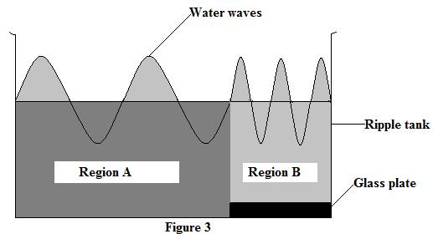

1. State the purpose of the glass plate in the ripple tank (1 mark)

**………………………………………………………………………………………………………………………………………………………………………………………………………………………………………………………………………………………………………………………………**

1. Apart from wavelength, state the other quantity that changes when the water waves travel form region A to region B (1 mark)

**………………………………………………………………………………………………………………………………………………………………………………………………………………………………………………………………………………………………………………………………**

1. An observer standing 100m from the foot of a high wall claps his hands and an echo reaches him after 0.5s. Determine the velocity of sound in air (3 marks)

**………………………………………………………………………………………………………………………………………………………………………………………………………………………………………………………………………………………………………………………………………………………………………………………………………………………………………………………………………………………………………………………………………………………………………………………………………………………………………………………………**

1. **Figure 4** shows a graph of current I (amperes) against potential difference V (volts) for a given electric device

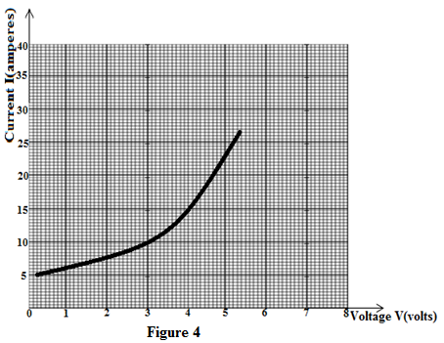

State with a reason whether or not the device obeys Ohm’s law (2 marks)

**………………………………………………………………………………………………………………………………………………………………………………………………………………………………………………………………………………………………………………………………………………………………………………………………………………………………………………………………………**

1. **Figure 5** shows a bulb and a resistor connected to a direct current source

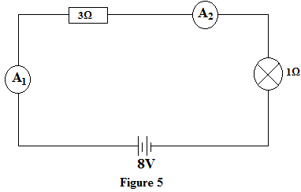

Determine the reading of ammeter A1 and ammeter A2 (2 marks)

**………………………………………………………………………………………………………………………………………………………………………………………………………………………………………………………………………………………………………………………………………………………………………………………………………………………………………………………………………………………………**

1. **Table 1** gives types of waves, detectors and applications of the waves. Fill the black spaces appropriately to match the information provided. (3 marks)

|  |  |  |
| --- | --- | --- |
| **Type of Wave** | **Method of detection** | **Application** |
| 1. ***…………………*** | Photographic plate | Detecting flaws inside metal |
| 1. Infrared | ***…………………………………*** | Used in TV and Video remotes |
| 1. Ultra-violet radiations | Electroscope | ***……………………………………..*** |

**Figure 6** showsa circuit consisting of two separate coils **P** and **Q** placed close to each other to make a transformer. The transformer is operated by opening and closing the switch S. Study the diagram and use it to answer questions ***11*** and ***12*** that follow

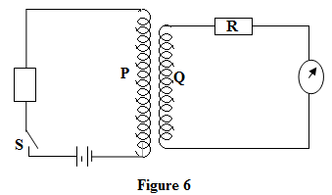

1. State the type of transformer shown in figure 6 above. (1 mark)

**………………………………………………………………………………………………………………………………………………………………………………………………………………………………………………………………………………………………………………………………**

1. When the switch S is closed, the galvanometer deflects and goes back to zero. Explain these observations (2marks)

**………………………………………………………………………………………………………………………………………………………………………………………………………………………………………………………………………………………………………………………………………………………………………………………………………………………………………………………………………………………………**

1. State one structural difference between a direct current (D.C) generator and an alternating current (A.C) generator (1 mark)

**………………………………………………………………………………………………………………………………………………………………………………………………………………………………………………………………………………………………………………………………………………………………………………………………………………………………………………………………………………………………**

1. The graph in **figure 7** shows the variation in the activity of a radioactive material against time in minutes.

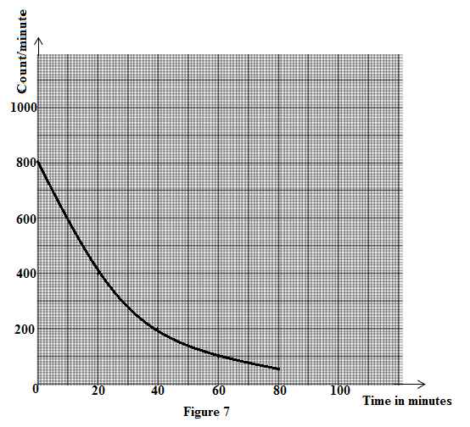

From the graph, determine the half-life of the radioactive material (2 marks)

**………………………………………………………………………………………………………………………………………………………………………………………………………………………………………………………………………………………………………………………………………………………………………………………………………………………………………………………………………………………………………………………………………………………**

**SECTION B :( 55 MARKS)**

***Answer ALL the questions in this section in the spaces provided***

1. a) One of the main reasons why a convex mirror is preferred for use as vehicle side mirror is

because it has a wider field of view than both plane and concave mirror. State the other reason why a convex mirror is preferred to concave mirror. (1 mark)

**………………………………………………………………………………………………………………………………………………………………………………………………………………………………………………………………………………………………………………………………………………………………………………………………………………………………………………………**

b) **Figure 8** shows the image of an object as formed by a pinhole camera. Study it and

answer the questions that follow

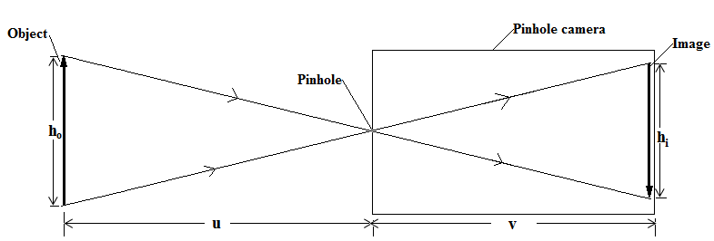

i) From the figure, show that $\frac{v}{u}=\frac{h_{i}}{h_{o}}$ (2 marks)

**………………………………………………………………………………………………………………………………………………………………………………………………………………………………………………………………………………………………………………………………………………………………………………………………………………………………………………………………………………………………………………………………**

1. State and explain what is observed on the image when the pinhole is enlarged

(2 marks)

**………………………………………………………………………………………………………………………………………………………………………………………………………………………………………………………………………………………………………………………………………………………………………………………………………………………………………………………………………………………………………………………………**

c) **Figure 9** shows a coin placed at the bottom of a beaker. At first the observer was not able

to see the coin from the position in the figure until water was slowly added to the beaker with the coin

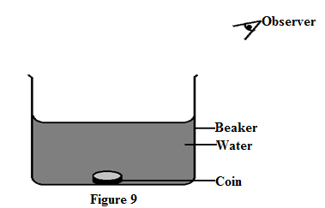

On the same diagram, show using ray diagram the position of the coin as seen by the observer after water is added to the beaker (2 marks)

**d) Figure 10** shows a ray of white light is incident at 30° on a glass prism of refractive index

1.5.

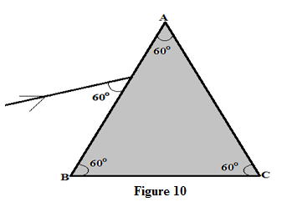

1. Determine the angle of refraction into the glass from the edge AB (2 marks)

**………………………………………………………………………………………………………………………………………………………………………………………………………………………………………………………………………………………………………………………………………………………………………………………………………………………………………………………………………………………………………………………………………………………………**

1. A pair of prisms can be used in a periscope just like mirrors. State the principle under which a periscope works in a periscope (1 mark)

**………………………………………………………………………………………………………………………………………………………………………………………………………………………………………………………………………………**

e) i) An object is placed 20cm from a converging lens of focal length 15cm. determine the

position and the nature of the image formed (3 marks)

**……………………………………………………………………………………………………………………………………………………………………………………………………………………………………………………………………………………………………………………………………………………………………………………………………………………………………………………………………………………………………………………………………………………………………………………**

(ii) The human eye is an organ that uses a lens in accomplishing its function. Name the

part of the aye that acts as the screen of the eye (1 mark)

**………………………………………………………………………………………………………………………………………………………………………………………………………………………………………………………………………………………………………………………………………………………………………………………………………………………………………**

1. **a) Figure 11** shows the main parts of a cathode ray oscilloscope. Study the diagram and

answer the questions that follow

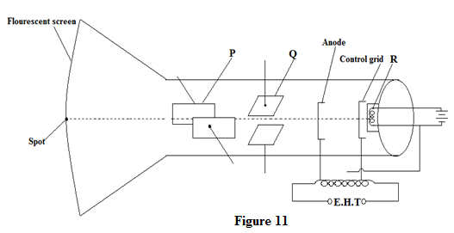

1. Name the parts marked Q and R (2 marks)

Q…………………………………………………………………………………

R…………………………………………………………………………………

1. State the function of the following parts of a cathode ray oscilloscope

(2 marks)

1. Anode

**………………………………………………………………………………………………………………………………………………………………………………………………………………………………………………………………………………………………………………………………………………………………………………**

1. Fluorescent screen

**………………………………………………………………………………………………………………………………………………………………………………………………………………………………………………………………………………………………………………………………………………………………………………**

1. Explain how the grid is used to control the number of electrons passing through it (2 marks)

**………………………………………………………………………………………………………………………………………………………………………………………………………………………………………………………………………………………………………………………………………………………………………………………………………………………………………………………………………………………………………………………………**

**(b) Figure 12** shows a pattern produced by an A.C voltage on the CRO screen when the time base is switched on. Study the diagram and answer the questions that follow

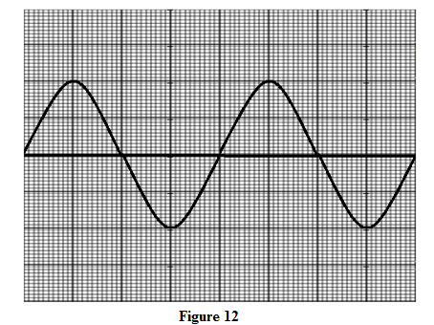

The time base and the Y-gain are set at 5ms/division and 2Volts/division respectively. Determine

1. The voltage of the ac source (1 mark)

**………………………………………………………………………………………………………………………………………………………………………………………………………………………………………………………………………………………………………………………………………………………………………………………………………………………**

1. The frequency of the a.c voltage (3 marks)

**………………………………………………………………………………………………………………………………………………………………………………………………………………………………………………………………………………………………………………………………………………………………………………………………………………………………………………………………………………………………………………………………………………………………**

1. On the grid provided, draw the pattern that would be produced on the C.R.O screen when the time base is switched off (1 mark)

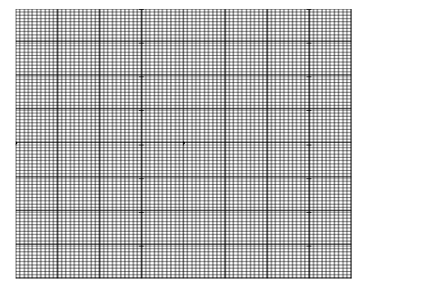

1. a) i) A certain extrinsic semiconductor is made by introducing a small quantity of

group III element into a structure of intrinsic semiconductor. Name the type of semiconductor that is formed (1 mark)

**………………………………………………………………………………………………………………………………………………………………………………………………………………………………………………………………**

1. Give one reasons for introducing group III elements to pure semiconductor

(1 mark)

**………………………………………………………………………………………………………………………………………………………………………………………………………………………………………………………………**

1. **Figure 13** shows a set-up used to investigate the behavior of good conductors of electric conductor. The good conductor marked AB was dipped in water at room temperature

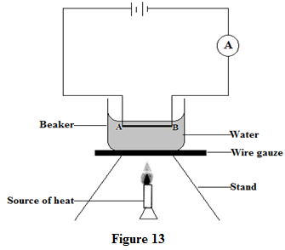

State and explain the observation on the reading of the ammeter when the water was heated to 90°C with the conductor inside (3 marks)

**………………………………………………………………………………………………………………………………………………………………………………………………………………………………………………………………………………………………………………………………………………………………………………………………………………………………………………………………………………………………………………………………………………………………………………………………………………………………………………………………………………………………………………………………………………………………………………………………………………………………………………………………………………………………………………………………………………**

**c) Figure 14** shows a type of rectification. Study it and answer the questions that follow

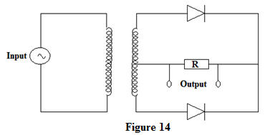

i) Name the type of rectification shown in the figure (1 mark)

**………………………………………………………………………………………………………………………………………………………………………………………………………………………………………………………………………………………………………………………………………………………………………………………………………………………………………**

ii) On the grid provided, sketch the signals for the output voltage for the rectification through the resistor R (1 mark)

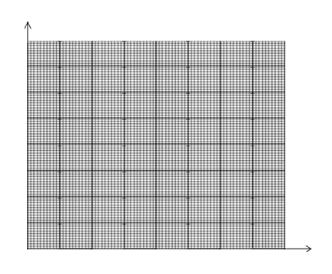

d) (i) State the meaning of the term work function as used in photoelectric emission

(1 mark)

**………………………………………………………………………………………………………………………………………………………………………………………………………………………………………………………………………………………………………………………………………………………………………………………………………………………………………**

**(ii) Figure 15** shows an uncharged electroscope with a clean zinc plate placed on its brass cap

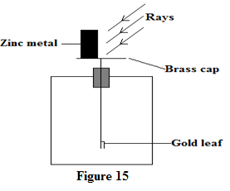

A strong U.V light is directed to the zinc plate. State and explain the observation on the gold leaf (2 marks)

**………………………………………………………………………………………………………………………………………………………………………………………………………………………………………………………………………………………………………………………………………………………………………………………………………………………………………**

e) A fresh metal surface is irradiated with a monochromatic radiation of frequency $1.4×{10}^{15}Hz.$ given that the photoelectrons emitted require a stopping potential of 1.52V, determine:

1. The work function of the metal (3 marks)

$$(Take h=6.63×{10}^{-34}Js,charge of electron=1.6×{10}^{-19}C and c=3.0×{10}^{8}m/s)$$

**………………………………………………………………………………………………………………………………………………………………………………………………………………………………………………………………………………………………………………………………………………………………………………………………………………………………………………………………………………………………………………………………………………………………………………………………………………………………**

1. The threshold wavelength of the metal (2 marks)

**………………………………………………………………………………………………………………………………………………………………………………………………………………………………………………………………………………………………………………………………………………………………………………………………………………………………………………………………………**

1. **a) Figure 16** shows a simple primary cell. Study it and answer the questions that follow

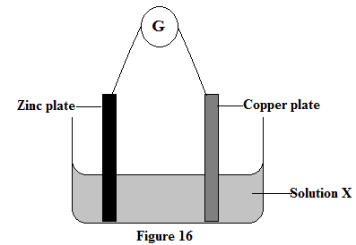

1. Name solution X that is used as electrolyte for the cell (1 mark)

**………………………………………………………………………………………………………………………………………………………………………………………………………………………………………………………………**

1. Explain how the zinc plate becomes the negative terminal of the cell

(2 marks)

**………………………………………………………………………………………………………………………………………………………………………………………………………………………………………………………………………………………………………………………………………………………………………………………………………………………………………………………………………………………………………………………………**

b) Differentiate between the terms electromotive force (e.m.f) and potential difference

(1 mark)

**………………………………………………………………………………………………………………………………………………………………………………………………………………………………………………………………………………………………………………………………………………………………………………………………………………………………………**

1. Two resistors one of resistance 8 **Ω** and another of unknown resistance R are connected in parallel in a circuit as shown in the **figure 17**

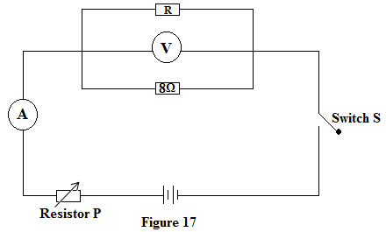

The combination of the resistors is then placed in a circuit and the current passing through the combination is measured for various values of potential difference across the combination. The results for the experiment are given in the table

|  |  |  |  |  |  |  |
| --- | --- | --- | --- | --- | --- | --- |
| Potential difference (V) | 0.2 | 0.4 | 0.6 | 0.8 | 1.0 | 1.2 |
| Current I ( A) | 0.75 | 1.50 | 2.25 | 3.00 | 3.75 | 4.50 |

1. State the purpose of resistor P in the circuit (1 mark)

**………………………………………………………………………………………………………………………………………………………………………………………………………………………………………………………………………………………………………………………………………………………………………………………………………………………………………………………**

1. From the results, plot a graph of current I (A) against potential difference (V) in the

grid provided (5 marks)



From the graph determine:

1. The combined resistance of the resistors (3 marks)

**……………………………………………………………………………………………………………………………………………………………………………………………………………………………………………………………………………………………………………………………………………………………………………………………………………………………………………………………………………………………………………………………………………………………………………………**

II. The resistance of resistor R (2 marks)

**………………………………………………………………………………………………………………………………………………………………………………………………………………………………………………………………………………………………………………………………………………………………………………………………………………………………………**